Photoshop Elements
Tutorial
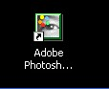
1. Launch Photoshop Elements
You can access the icon either by the desktop or by the menu bar
START/ALL PROGRAMS/ADOBE/PHOTOTSHOP ELEMENTS

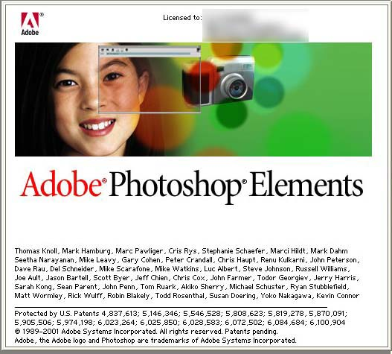

When Photoshop is successfully launched you’ll see a splash screen like so (left).

Next the main palettes will quickly load one by one.

Try not to be confused by all of them. Focus on one at a time.

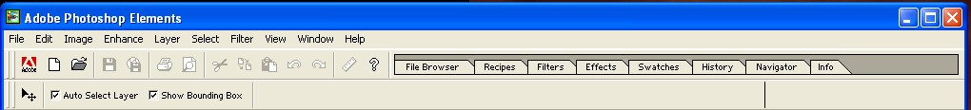

The first is the top menu bar (above) that contains quick access to all palettes, windows, file info etc. This is your main hub through which all other palettes can be opened and closed.
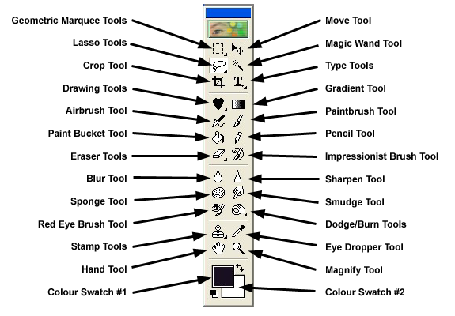
Next is the tools palette (left). This is the second most important palette you will use. There are more tools here than you will need. The MOVE tool is the first one you’ll use. Next will be the LASSO, CROP, PAINT BUCKET, and ERASER tools. You will also become familiar with the TYPE, MAGIC WAND and the STAMP tools.

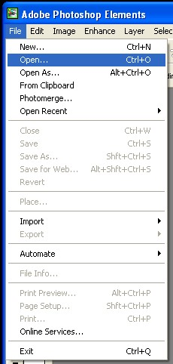
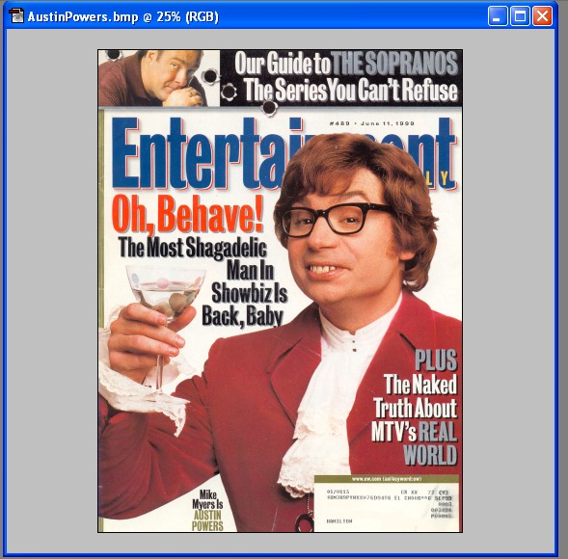
2. Now go to the top menu bar and click on FILE>OPEN and use the browser to find a magazine cover that you will like. Highlight it and select open. I’ve chosen the Austin Powers cover.

Notice that the magazine opens up in its own palette (or window) and has the same features as most windows (minimize/maximize/close etc.). You can zoom in and out by hitting CONTROL -/+. You will need to zoom in when doing fine detailing like erasing edges, etc. This allows more accuracy.

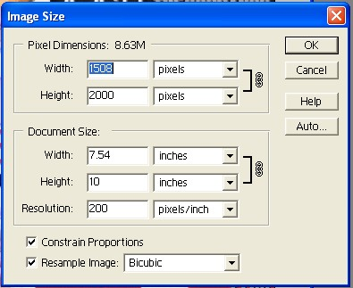
If you go up to the menu bar and select IMAGE>RESIZE>IMAGE SIZE you’ll see a menu (left) pop up that tells you the size of the image, the resolution (or dots per inch) and the width and height in inches.

The resolution is what determines the output quality. For high quality photo printing you want to be well up above 600dpi. Video on the other hand only requires 72dpi.

It is very important to set these controls at the beginning of a session. Since your magazine will be your “canvass” for this project, leave the settings as they are.

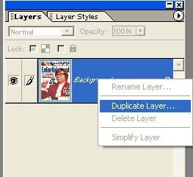
Now, if you look at the LAYER palette (left), you’ll notice that a small icon of the magazine is listed. This is another very important palette because it allows objects to be on separate layers so you can work independently with them. Images on the top have priority and will obscure layers below them.
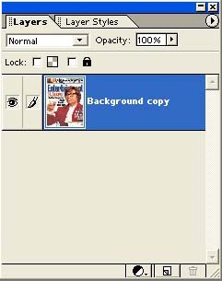
One thing to be aware of is that if you open an image that is only one layer (most image formats like JPEG, BMP, etc.) it will usually be locked. Since we’re going to use the magazine as our canvass, let’s unlock our background so it’s easier to work with. Simply click on it to highlight it, and RIGHT CLICK on it to open up the sub menu (or go up to the triangle at the top right of the palette). Select DUPLICATE layer and you will now see that a second layer has been added, a copy of the first. Drag the bottom layer into the trash can icon at the bottom right to delete it.
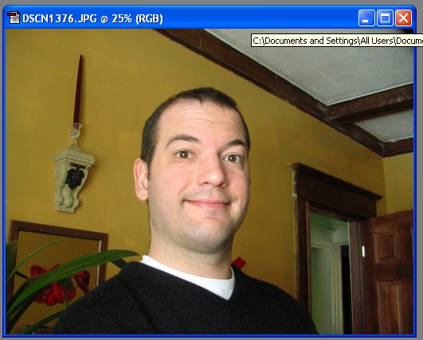
3. Now let’s open up our photograph. Go to FILE>OPEN> and then use your browser to locate your head shot. Once open select all (CTRL>A) and you’ll see a marquee (dotted, pulsing line) around the outer edge of the image. Copy this (CTRL>C) whole image.

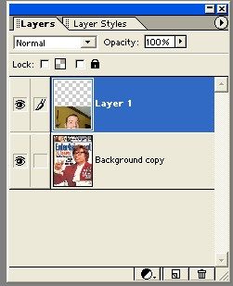
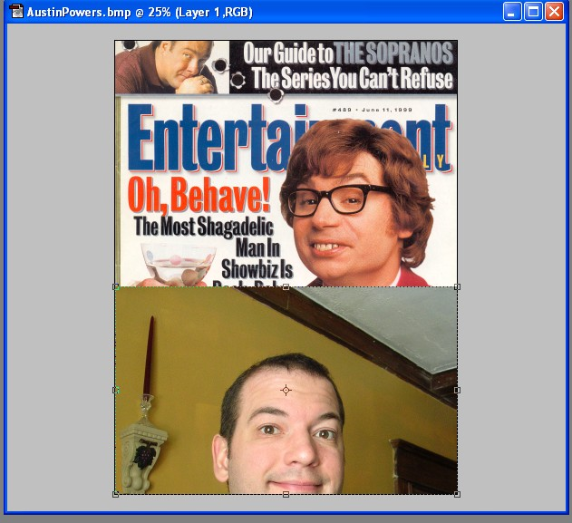
4. Now paste the photo (CTRL>V) into your magazine window and you’ll see it pop into the layer palette too. Now close the original head head-shot window.

I’ve moved it down in the magazine window so you can see some of the layer below it. Notice the head is too big and there’s all that extra space around it which we need to get rid of. To do that we’ll use the lasso tool.
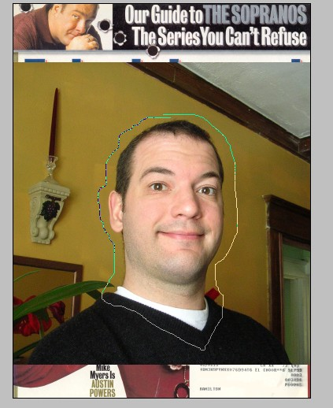
5. Select the LASSO Tool and draw a rough line around the circumference of your head, leaving a slight border (which we’ll remove with the MAGIC WAND and/or ERASER TOOLS).

Now cut the head (CTRL>X) off the background and paste it into a new layer. Drag the remainder of the photo into the trash and label the new layer (head only).
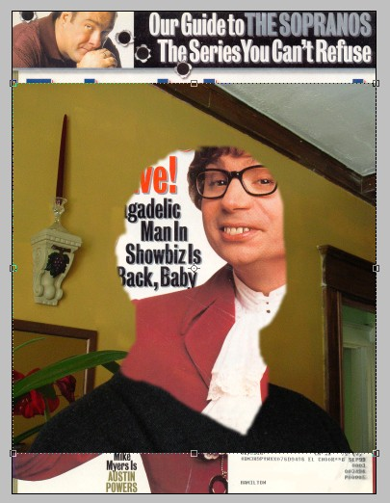
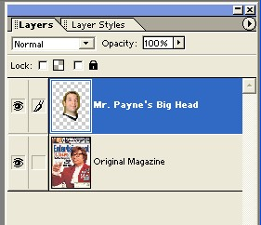
Your LAYER palette should now look like this (right). Now we need to remove the extra stuff around the head. If the
surrounding area is a simple, one color background like this, it should be easy.

It helps to turn the bottom magazine layer off so you can concentrate on the head.

6. Select the MAGIC WAND tool and click on the area to the outside of your hair. There is a TOLERANCE setting up on the top menu bar that you can adjust which will change the sensitivity of the brush; this will determine the range of colour which will be selected. The higher the tolerance, the more pixels that are different from the original selection point will be selected. If you’re lucky and the colour is relatively consistent, you can sometimes easily remove large chunks of areas with a simple click of the DELETE button.
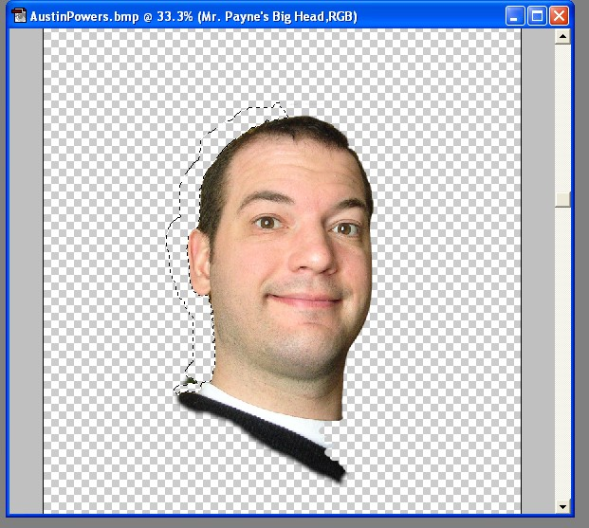
Eventually you’ll probably (based on what you will need in your magazine) remove everything but your head and neck.

ALWAYS REMEMBER, if you do something your not happy with or make a mistake, select UNDO (CTRL>Z, or from the EDIT menu) to go back a step. You will use this function many times. Also once you’ve saved your file (if you haven’t done so yet, now’s a good time) you should save (CTRL>S) at least every 5 minutes or so.
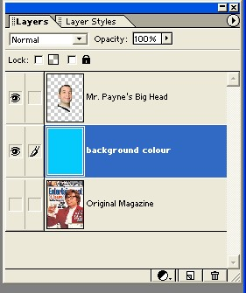
7. It’s a good idea to use a dummy layer which you can fill with a nice colour to see any remaining bits or rough edges that need to be touched up. You can add a new layer by hitting the NEW LAYER icon to the left of the trash can at the bottom right of the LAYER palette.

Once you have a new layer, select the PAINT BUCKET tool and click on the top COLOUR SWATCH #1 to select the colour you want. The paint bucket only paints the colour that is on top. The select the bottom COLOUR SWATCH #2, click on the arrows above the colours.
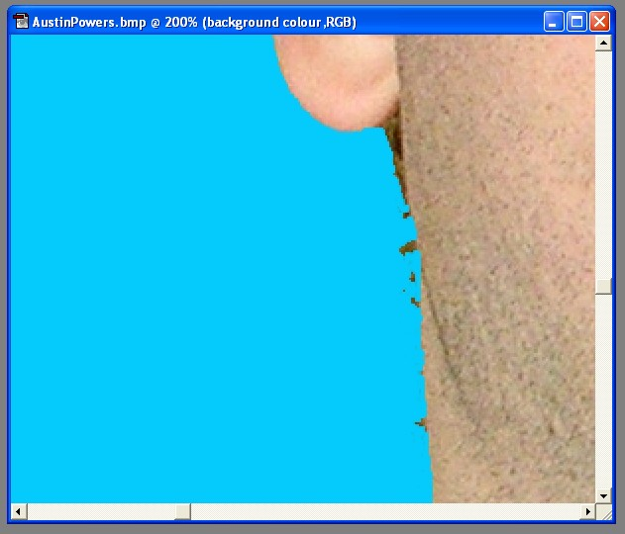
Notice the little bits along the edge of the neck here (left). You can go in and remove them using the ERASER tool.

This tool acts like a paint brush. You can select the size of the brush (usually circular in shape) and the softness (feathering on the edge). The brush controls are at the top left side of the top menu bar. There is a pull down menu that you can select from or you can click on the brush image itself to modify the existing brush attributes.
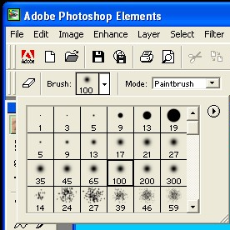
In this case I also flipped my head to match the direction of the actor in the magazine. I did this by selecting the head layer and going to IMAGE>ROTATE>FLIP HORIZONTAL.

8. Once your head is all cleaned up, you can fine tune the size. Each layer can have a different opacity level (how much you can see through it to the next layer below). The default is 100%. If you select the layer and then adjust the slider in the OPACITY box (top of LAYER palette). Try dragging it to about 75%. Now turn on (eyeball next to icon in layer)the magazine layer and turn off the colour layer we added a moment ago.
You will be able to see through the head layer to the magazine layer below.
This is helpful for lining up the eyes and mouth to see if the overall size is similar. If your head is too big or too small you’ll have to resize it.
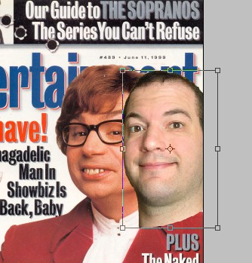
9. To resize your head, go to IMAGE>RESIZE>SCALE. Little handles will appear around your head. If you go to one of the corners you’ll get diagonal arrows which allow you to increase or decrease the size of the head. To keep the head from getting distorted (squished or stretched) hold the SHIFT key down while dragging the box smaller or larger. When your happy with the size, double click on the inside of this box to finalize the edit (if it’s too small you may have to zoom in to be able to double click and finalize).

10. Now that your head is the right size you may want
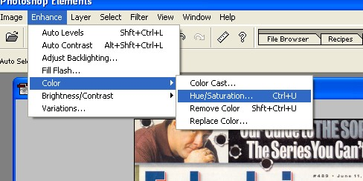
to think about it’s colour and tone and how it compares to the magazine.

To adjust colour go to ENHANCE>COLOUR>
HUE SATURATION. You can adjust the controls to try to achieve similar flesh tones.

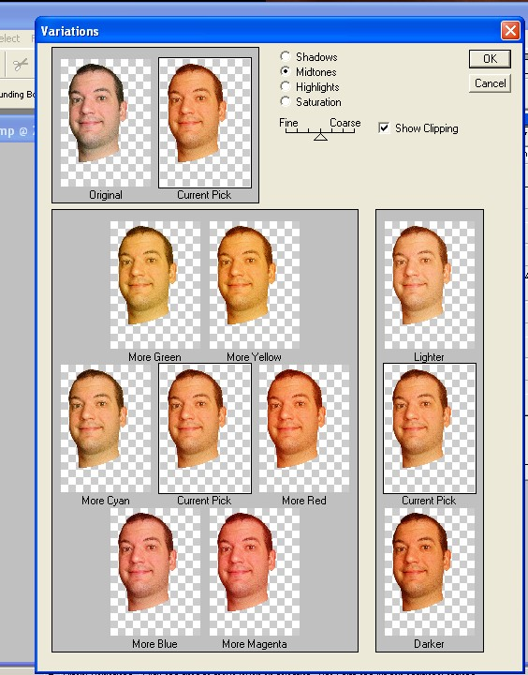
Another useful tool is VARIATIONS which is also in the ENHANCE menu.
This allows you to visually select from a series of different colour models. If you get off track, simply UNDO and start over by clicking on the original at the top left.

You can also use the BRIGHTNESS/CONTRAST controls in the ENHANCE menu to alter the tonal values in your photo.

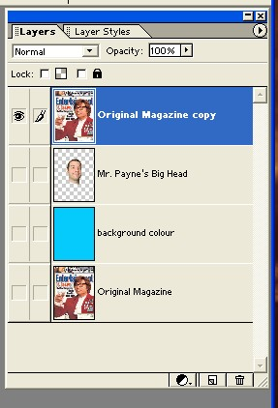
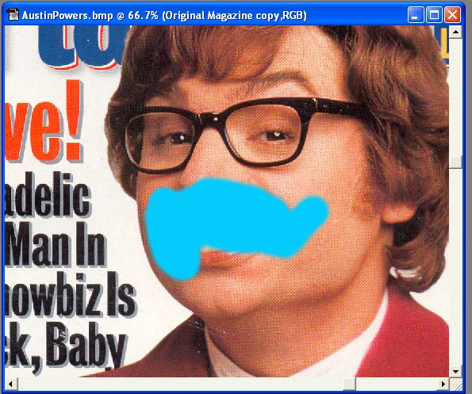
11. One of the decisions you will have to make is whether or not you are going to use the actor’s hair and/or accessories (like glasses) or your own. In my case I decided to use the actor’s hair and glasses for comedic effect and to maintain the essence of the character. To do this, I duplicated the bottom, original magazine layer and pasted it at the top. Then I started removing the facial areas of the original allowing my headshot to be seen.

You can try using the MAGIC WAND tool, but I chose the ERASER in this case due to the great difference in flesh tone colours.
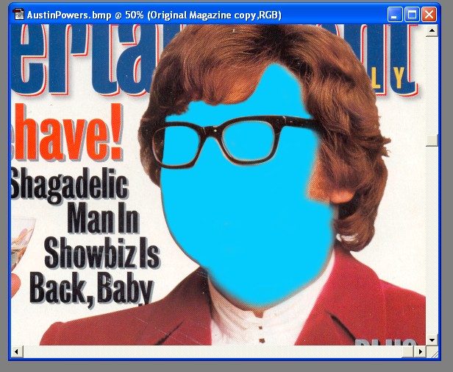
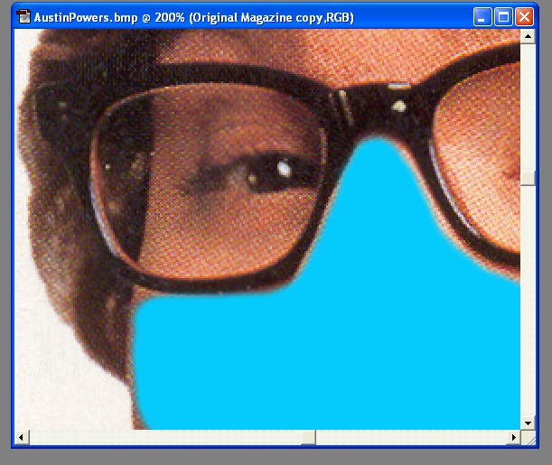
Eventually I erased the entire face of the actor allowing my face to show through. Adjustments will have to be made. For me, my face was wider and I had to cheat a bit by erasing the cheek line down to the neck and collar. Here is where you will have to experiment a bit. Every scenario is different. The closer you were able to match the angle and other attributes of the photo, the easier your job will be.
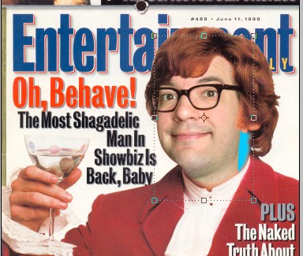
One hurdle was that my jaw didn’t line up with the actors and I had a gap to fill.

You can solve this by leaving some of the flesh of the original actor and feather-erasing it or blending it into your face.

You can also extend your flesh by copying and pasting patches (these have to be consistent in tone, colour) as if building a jigsaw puzzle.

You can then go in and adjust the odd details like hairs etc. to make the final effect more convincing.

12. For repairing wrinkles and wear and tear you can use a fine brush, select a matching colour (use the eyedropper to select the colour such as the black in the text below) and paint over the imperfections.
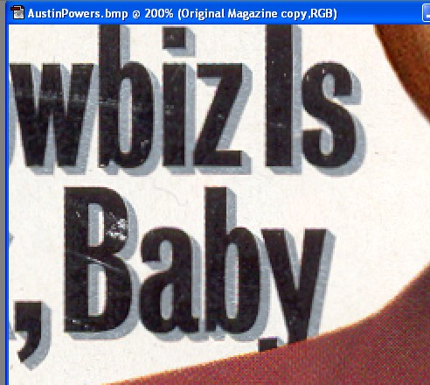

You can also use the stamp tool by holding the ALT key down and clicking a few centimeters away from a blemish. This clones that area (according to the size of the brush you have selected) and allows you to then click and paint over the blemish using the offset area. This can get a little tricky as you have to remember that you are using the original image as paint and if you move far enough away from your touch up point you will see some interesting “mind blowing” effects. You can only learn to use this tool effectively by USING it.

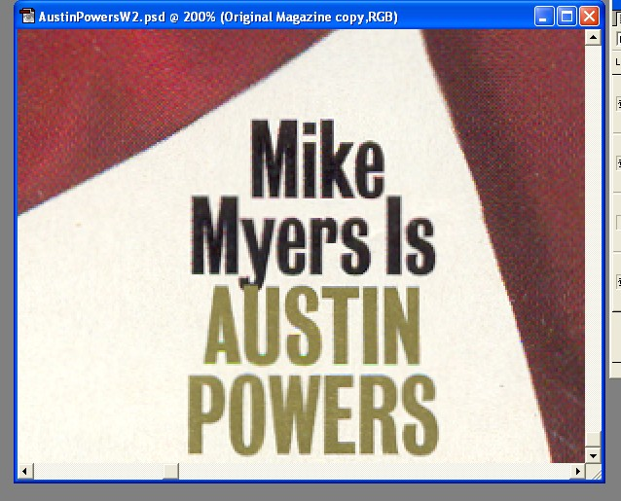
13. You will also have to incorporate your name into the original magazine. To do this you’ll have to examine the area underneath the text because you’ll have to rebuild it to add your name. You can use the LASSO or the STAMP tool to do this.

Here I used the STAMP tool to copy and paste big areas of the creamy area to erase Mikey’s name in order to replace it with mine.

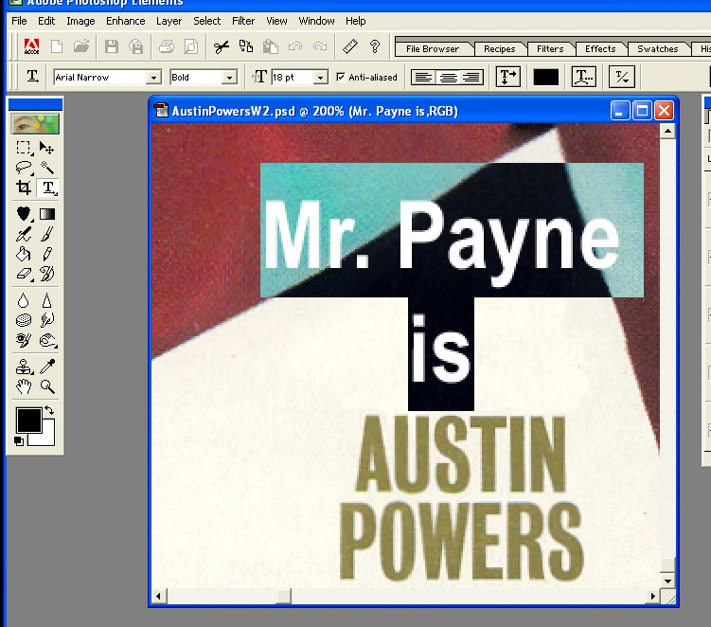
The TEXT tool is a useful tool for
generating custom looking text.

You can alter the font type, size, colour, justification and other attributes to match the original text on the magazine (your goal!).

You can also use the LAYER STYLES palette or the EFFECTS palette to affect the text in interesting ways. These you’ll have to experiment by adding and undoing.
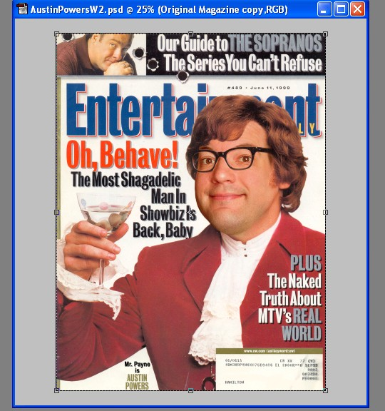
Try not to get overwhelmed with all the tools. It will get better. Focus on one tool at a time and don’t be afraid to ask for help. This is really cool technology that didn’t exist 10 to 15 years ago so have fun with and be your own star!

When you’re done you can get approval. After this you will flatten all your layers down to one and save it as a JPEG or other standard file format. This can be emailed to friends, etc for fun. They’ll be amazed at what you’ve accomplished.

