Erek Croteau James B. Francis College of Engineering
Mechanical Engineering Student One University Ave
Lowell, MA 01854
Nelson Lezama Erek_Croteau@student.uml.edu
Mechanical Enginering Student Nelson_Lezama@student.uml.edu



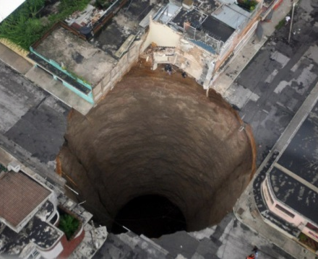
Structural Health Monitoring System for Sinkholes

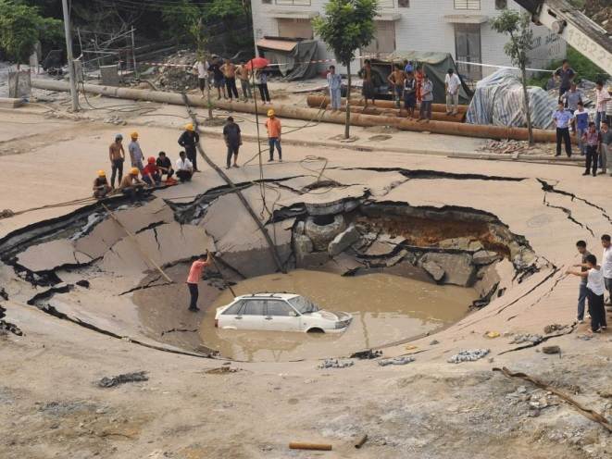

(Photo by Moises Castillo)

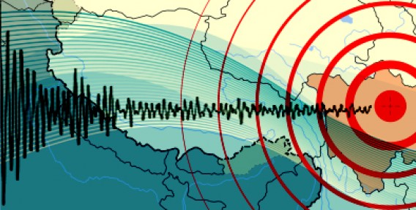
(Photo by Reuters/China Daily)

By

Erek Croteau and Nelson Lezama

MECH 5230: Structural Health Monitory
Professor Zhu Mao

May 2, 2016
TABLE OF CONTENTS

- Introduction .................................................................................................................. 3
- Operational Evaluation ................................................................................................ 4
2A. Definition of Damage ................................................................................... 4
2B. Economic and Life-Safety Justification to Perform a NDE …...................... 8
2C. Environmental and Operational Variability ................................................ 10
2D. Limitations on Acquiring Data ………....................................................... 10
- Hardware System ....................................................................................................... 11
3A. Gauges and Sensors..................................................................................... 11
3B. Computational Core .................................................................................... 11
3C. Wireless Transmitter .. ................................................................................ 12
3D. Source of Power .......................................................................................... 12
3E. Station-Mounted PC .............................................................. ..................... 12
- Damage Detection Features ....................................................................................... 13
4A. Learning Approach………………………………………………………...13
4B. Detection Technique……………………………………………………….13
4C. Statistical Model and Establishment of Thresholds…….………………….14
4D. Variability and Data Normalization ………….…………………………... 15
4E. Training of Models…………………………………………………………16
- Challenges and Issues ................................................................................................ 16
5A. Economic Pressures – Installation and Maintenance .................................. 16
5B. Liability ....................................................................................................... 17
5C. Hardware/Software Integration ………....................................................... 18
5D. Error Detection and Decision-Making Confidence .................................... 18
5E. Verifying Damage Detection Capability ………......................................... 19
6. Summary and Conclusion ............................................................................................ 10
7. References .................................................................................................................... 21
INTRODUCTION
Sinkholes have become a growing concern in the list of worldwide “natural disasters,” particularly with the overconsumption of local ground water and pipe deteriorations that can cause bursts in water mains or sewage systems. Sinkholes can occur both naturally and artificially, and they can lead to the loss of life and property with little warning. Sinkholes are formed through the processes of dissolution and suffosion. Dissolution occurs when groundwater dissolves rock below the land surface, such as limestone. Suffosion occurs when cavities develop underground. Sinkholes are dangerous because the land surface usually remains intact. It is only when the cavities grow and the land above the cavities are without sufficient support that the land surface collapses in on itself. Human-induced sinkholes are formed when groundwater levels are lowered due to groundwater pumping, and other construction and development practices. Sinkholes are also more likely to occur in areas with rocks types that are susceptible to dissolution. Figure 1 shows a map of the United States with rock types that are susceptible to dissolution.
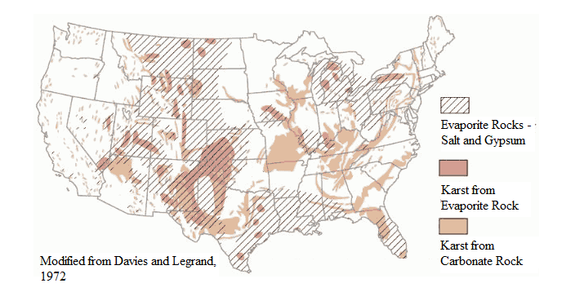
Figure 1 – Areas in United States with Rock Types Susceptible to Dissolution [1]
Sinkholes’ widths and depths can vary from a few feet to hundreds of feet, allowing their effects to range from mild to severe.
OPERATIONAL EVALUATION OF SINKHOLES
The following four issues associated with the operational evaluation of sinkholes are considered: (1) the definition of damage, (2) the economic and life-safety justification to perform a nondestructive evaluation (NDE), (3) the environmental and operational variability, and (4) the limitations on acquiring data.
Definition of Damage
When it comes to sinkholes, defining damage is a difficult process. The types of data (damage definitions) to be acquired for a sinkhole include: (1) patterned formation of cracks and severity of cracking, (2) ground slumping and elevation changes, and (3) erosion of the land. Defining cracking severity is difficult, as severity would be more realistically defined by both the crack lengths and the quantity, particularly of cracks which form a pattern. Types of cracking patterns include block cracking, fatigue cracking, longitudinal cracking, and transverse cracking. However, due to the complexity of both the geometries and material properties (as with pavement, for example), exact values identifying critical crack lengths and critical erosion loss cannot be determined.
The following properties were assumed as an example of a calculation of a critical crack length: a fracture toughness, K_{I}, of about $0.6 MPa\sqrt{m}$, a yield strength of 20 MPa (~3000 psi), and a critical stress, σ_{c}, that is equal to the yield stress, σ_{y}, (assuming that it would never be that high) were assumed for Equation 1 and Equation 2 [2, 3].
$K_{I}=σ\sqrt{πaβ}$ (1)
A thickness of at least 2.25 mm is required for Equation 2, which is most certainly reasonable in this application.
$β≥2.25{\left(\frac{K_{IC}}{σ_{Y}}\right)}^{2}$ (2)
Using Equation 1 and Equation 2, the resulting estimated crack length, a, is 0.3 mm. Cutting this value in half for a safety factor of 2, the estimated crack length is 0.15 mm.
Cracking severity, however, can be characterized by a distress identification report, highlighting the severity level of the distress based on either observation or using measurements of length and/or area [4]. This report contains a description of the types of patterns described previously. Here, only the Type-A Distress (cracking) will be of focus, along with water bleeding (under miscellaneous distress). Therefore, a more detailed severity measurement will include:
- The area, concentration, and crack width of block cracking
- The area, concentration, and crack width of fatigue cracking
- Amount of breakup and material loss with respect to 10% of the affected length of edge cracking
- Crack width of longitudinal cracking and reflection cracking at joints
- Length and crack width of transverse cracking
- For water bleeding, the number of occurrences affecting a minimum 1-meter length of pavement
An example of severity levels in block cracking is illustrated in Figure 2.
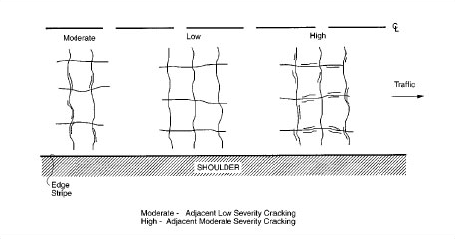
Figure 2 - Example of Block Cracking Severity Levels
Ground elevation changes and slumping depends on how much of the material underneath it is compressed and/or lost. With cement or pavement, some of this can usually be caused by air or fluid pockets between layers which manage to escape, typically at higher temperatures. (For this reason, it may be best for the concept design for the SHM system to measure elevation displacements underneath the asphalt pavement roads or cement surface foundations.)
Economic and Life-Safety Justification to Perform an NDE
Sinkholes can result in significant economic losses. In August of 2013, a portion of Summer Bay Resort in Clermont, Florida was swallowed up by a sinkhole measuring 60 feet wide and roughly 15 feet deep, costing the property owners hundreds of thousands of dollars in damage and insurers up to $1.4 billion. Kentucky is well-known for its karst topography, or landscape that is formed due to the dissolving of rocks, such as limestone. In February of 2014, a smaller, but deeper sinkhole (measuring 45 feet wide and 30 feet deep) at the National Corvette Museum in Bowling Green, Kentucky, led to the damages of eight rare, million-dollar Corvettes. A SHM system would allow for preventative measures to be taken to reduce economic losses.
Sinkholes can also result in the loss of life. In May of 2010, Guatemala City experienced one of the most well-known and deadliest sinkhole events to have occurred in recorded history. The sinkhole was caused by the heavy winds and tides from Hurricane Agatha, which hit Guatemala City the day before the sinkhole event. It was determined rotted sewer pipes had caused a continuous leakage that dissolved the volcanic ash and limestone, leading to the collapse. The collapse resulted in a sinkhole measuring 65 feet wide and 300 feet deep (a depth greater than the height of the Statue of Liberty), and a death toll of 15 people. An aerial view of the Guatemala City sinkhole can be seen in Figure 3.
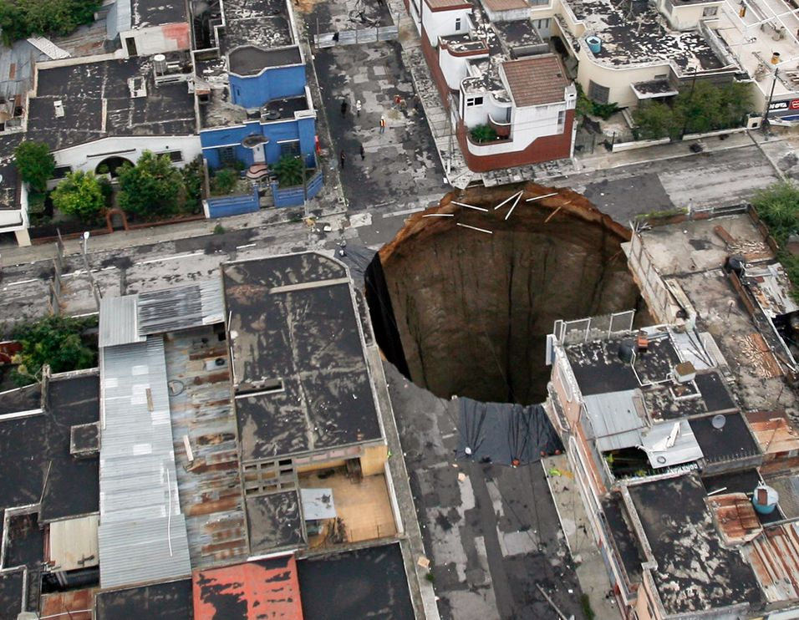
Figure 3 - 2010 Guatemala City Sinkhole
Most importantly, a SHM system would allow for preventative measures to be taken to reduce the loss of life.
The study and use of concrete and asphalt compounds goes as far back as pre-historic times. Their material properties and benefits are well-known, and their behaviors are well-understood. When it comes to sinkholes, however, road inspections are performed one or more times a week or even a month, depending on the significance of the damage, the traffic density, and the instability or weakness of the road. The consistency also varies depending on the funding to do the inspections and maintenances (if needed). A SHM would reduce the cost of inspections by reducing the number of inspections; inspections would only be performed when certain flags or warnings are raised by the SHM system.
NASA has proposed using aircrafts and radar technology in order to monitor surface deformations [5, 6]. Although the technique has proved effective, it is very expensive. Aircrafts would have to be positioned over the areas of interest in order to use the radar technology to track their elevations. Using a low-power-consumption sensing system with a sensor node may be a more inexpensive alternative, although it does present considerable costs. Although strain gages and pressure sensors can cost several hundred dollars (the SG-Link®-OEM-LXRS® sensor node costs $495.00), a properly installed sensor can function for years [7]. In general, the cost of purchasing and positioning the sensors (digging, etc.) would only have to be considered every couple of years. And with an average-size highway needing about 500 sensors [8], an average-sized home may require only about 10 sensors to measure displacements, pressure differentials, and moisture contents.
Environmental and Operational Variability
The typical climate of locations where sinkholes commonly form are usually within areas of torrential rain (tropical areas), earthquakes, or even periodic droughts, all of which are perfect environments for the land underneath to move. This includes places like Guatemala City, Brazil, and cities within California. However, this is particularly the case for naturally-developing sinkholes. Guatemala City, for example, gets an average annual rainfall of 51.8 inches under typical, high humidity and warm temperatures around 79°F [7]. It can however have short periods of dry weather.
The environmental variability must be considered with the use of a strain gage or a pressure sensor. Heavy traffic, for instance, can cause the ground to deform slightly, cause unwanted harmonic noise, or result in an increased pressure differential. This is an important consideration. A library of data can be formed and used to determine patterns (effects of hours of traffic, effects of seasons, etc.). If samples are collected hourly and averaged at the end of the day, more accurate measurements of displacement and pressure differential may be taken (reducing the effects of “outlying” data). These daily average can then be compared to an initial condition in order to determine the displacement and pressure differential variation of the ground. After studying the earth and its properties at different locations, critical conditions (or boundary layers) may be determined. If the displacement data or pressure differentials approach or exceed these conditions, intervention is required.
Limitations on Acquiring Data
Limitations on data acquisition can be narrowed down to three areas: wired versus wireless system, system placement, and timing during the course of day. Wired systems would be difficult to place underneath the concrete or pavement, but it would not be impossible to achieve. The wired system could be docked to a data acquisition system during inspections and provide analysis on the conditions of the land. Use of a wireless system, however, poses more convenience for continuous monitoring because it could provide real-time feedback.
The placement of a system would be more difficult in urban areas than in rural areas because there are more interferences, or obstacles, such as building (particularly one which would not allow sensing systems to be placed in its foundation), historical landmarks, or even restricted areas. The placement of a system would also be difficult in areas where there is only soil and where there are no foundations of reference, particularly when it comes to surviving through various weather conditions.
This system would be more effective if used when there is little traffic (i.e. outside of major business hours). In an effort to increase the SHM system’s efficiency, a low-powered system could be introduced, allowing real-time monitoring to be reduced until such a catastrophic event occurs. If the ground experiences a sudden critical failure or collapse, an emergency signal could be transmitted to warn the local Department of Transportation or warn traffic to seek an alternate route (if specific to roads).
HARDWARE SYSTEM
The hardware will consist of strain gauges, pressure sensors, and a soil moisture sensor, a computational core, a wireless transmitter, a source of power, and a station-mounted PC.
Gauges and Sensors
The primary requirements for the sensors used in the SHM system are that they are able to withstand a variety of natural weather and temperature patterns, and they must be able to withstand vibrations and pressures caused by traffic.
A sensing system (such as the one illustrated in Figures 4 and 5) involving a wireless piezoelectric (Lead Zirconate Titanate, or PZT) accelerometer, MEMS accelerometer, and bridge-type strain gage or pressure sensor will be used to gather relative data and predict the formation of a sinkhole. A wireless input sensor node can be used to measure the displacement of the ground, and another the acceleration vibration responses. This is important in the prediction of the formation of a sinkhole because large displacements, or shifts, can signify the presence of cavities. In 2012, for instance, it was determined that a sinkhole in Assumption Parish, Louisiana had moved about 10 inches a month before the ground collapsed [5]. A large shift over a short period of time as in the Assumption Parish case can be measured by an input sensor node embedded in the ground. Because sensing systems like the LORD MicroStrain LXRS Wireless Sensor Network are intended for extended use, an initial condition can be set, and displacements can be monitored and compared on a daily basis. If a large shift is noted from one day to another, a sinkhole may be forming in the area. Similarly, if a gradual, but large shift is noted from one month to another, this may also indicate the formation of a sinkhole in the area. The extended use of these sensing systems allows for one to compare data on a daily, weekly, or monthly basis.

Figure 4 - SG-Link®-OEM-LXRS® Two-Channel Analog Input Sensor Node
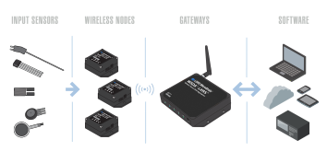
Figure 5 - LORD MicroStrain LXRS Wireless Sensor Network
Similarly, a sensing system involving a pressure sensor can also be used to predict the formation of a sinkhole. An initial condition can be set, and pressure differentials can be monitored and compared on a daily, weekly, or monthly basis. Large pressure differentials can indicate the presence of a cavity.
The sensing system may work in conjunction with a wireless soil moisture sensor (such as the sensor in Figure 6).
Figure 6 - UgMo Technologies’ Wireless Soil Moisture Sensor
The moisture sensor is capable of collecting moisture and temperature data every 10 minutes and can last for a period of 5 years. Changes in the moisture content of the ground can indicate changes in the stability of the ground.
Computational Core
To read the data, perform initial calculations, and transfer data to the wireless unit, multiple computational cores may be needed, depending on the scale of the possible sinkhole being investigated. To interpret the signals coming from the piezoelectric accelerometer transducers, analog to digital converters (ADC) will be necessary. To prevent aliasing, the ADCs should be able to sample at a rate at least twice as fast as the highest frequency of interest, and ideally it should be able to sample at ten times the highest frequency.

Wireless Transmitter
In order to minimize cost, only one wireless transmitter will be required to transmit the data collected and processed by the computational units. To transfer the data from these units to the wireless transmitter, wiring harnesses and environmental protective tubing will be needed to protect the wires running underground. According to specification, up to 2000 nodes per radio frequency channel and gateway can be utilized.
Source of Power
To ensure continuous operation of the SHM system, a separate battery should be included with each computational unit and wireless transmitter.
In addition, the system should be wired in such a way that if one battery fails, a backup one should be able to carry on the same load of that failed one. For ease of use, a single exposed plug on the surface should be used to provide recharging power for all the batteries. Because the batteries are to be charged without first being completely discharged, lithium-ion or nickel–metal hydride batteries will be the best option when it comes to re-chargeability. An additional possible option too is to just utilize the power from the power lines if any are nearby. This would eliminate the need to have to use batteries at all.
Station-Mounted PC
An independent personal computer running either a Windows or Linux based operating system may be necessary to provide the means to evaluate the data and submit any immediate safety warnings. This should provide more than enough computational power and memory to run the damage detection software. The software would need to be able to the following:
- Detect signs of damage
- Warn the city or town immediately of critical damage levels so that a road can be closed off or building evacuated
- Store the information so engineers know where to start looking to make their inspections of the environment

DAMAGE DETECTION FEATURES
It is important that the damage be both quantified and located accurately by detection. There are several possible means to do so, each with several damage detection features that could be used to quantify the existence of damage.
Learning Approach
Much of the ground in areas susceptible to the formation of sinkholes can be classified as healthy and undamaged. In the monitoring and prevention of sinkholes, ground is classified as healthy and undamaged when it is lacking cavities and significant deformations. Because sinkholes are both naturally and artificially occurring, there are years and decades of examples of sinkholes that have formed throughout the world, especially in the more recent decades, with the growth of industry and the human population (which led to an increase in plumbing). In the monitoring and prevention of sinkholes, ground is classified as unhealthy and damaged when cavities and significant deformations are present. Because there is a large amount of available data, or examples, of damaged ground and undamaged ground (in the same areas and of the same consistencies, allowing them to be considered the same samples and compared easily), a supervised learning approach should be adopted.
Detection Technique
Along with measurements of strain and water content, a useful method for detecting the cracks and holes would be through a 2D-guided ultrasonic wave scattering technique. In this case there will be actuators sending the signals through the ground and sensors receiving the responses. The wave active sensing could be performed using piezoelectric transducers, where the amounts of each of these will be dependent on size and nature of damage. Then, use of scatter matrices will measure transmission-reflection readings to determine crack size and form. This will particularly rely on baseline modeling, which can be done by taking multiple baselines, building an empirical model of it, and use it for comparison to the test measurements.
Statistical Model and Establishment of Thresholds
The statistical models of group classification and regression analysis can be used to analyze the damage state of the ground (the system). Group classification can be used to determine if the system is damaged, where the system is damaged, and the type of damage being experienced by the system. Because data exist monitoring the conditions of systems (the soil type, the region, the weather, the temperature, the deformation of the ground, etc.) leading up to a damage state, the data can be used as guidelines, or initial boundaries, for the classification of the state of the system.
An important characteristic to keep in mind is the soil type. Different soils have different material properties that can be used to analyze and predict their behaviors under different conditions. The aforementioned Guatemala City sinkhole, for instance, occurred in part because the city “is underlayed by volcanic deposits,” [10]. The volcanic pumice deposits, when hit by Tropical Storm Agatha, made the ground vulnerable to erosion and the formation of sinkholes. An investigation of the water content of the soil at this time would allow one to estimate the maximum water content for soils with high levels of volcanic pumice deposits. Locations with water contents below the critical value would allow to one classify the ground as undamaged. Locations with water contents approaching the critical value would be investigated due to the possible formation of a sinkhole.
Using existing data, initial boundaries can be set to indicate when the ground should be further investigated. Deformations or strains, pressure drops, and other characteristics can be continuously monitored and compared to critical values that classify the system as undamaged or damaged. These general, initial conditions can then be adjusted according to the incoming data specific to, not only the soil type, but the location and the local conditions. As more data are acquired, regression analysis can be used to better estimate the critical values of the system. The more conservative initial values can then be adjusted to better suit the system being monitored.
Variability and Data Normalization
Processing the data requires cleansing, normalizing, compressing and fusing. Normalization is the process of organizing data in a database. Without it, the database system can be inaccurate, slow, and inefficient, and they might not produce the data that is expected. In the real world, this is vital when dealing with variabilities in the acquisition of data, particularly for studying cracking and failures in the ground. Much of the daily variability for this case will be as a result of the environmental conditions like temperature and humidity, as well as extraneous loading sources from traffic and operation of equipment. It may be likely in this case that damaged readings will not fall within the undamaged feature distribution as a function of an environmental parameter like temperature or humidity. Therefore, the studied environmental variable will likely not be necessary, and parametric modeling may be especially difficult.
A good approach that can be implemented for this system however is the use of look-up table technique. This is because of the fact that sinkholes and their signs of damage can occur spontaneous and at random, and may be hard to correlate with the effect of ambient variations. Regression models and group classification via statistical testing can be developed, a good option knowing the complexities of the variabilities of such an environment. Use of machine learning however may be tough in itself too due to this randomness of changes and the difficulty to develop an algorithm to evolve by analyzing the training data. To also eliminate the need for utilizing training data, which is possible to also be heavily affected by this as well as multiple variable variations, the use of modified testing procedures can further be used as well, where there is a change in when data from each signal is trained and tested within the testing procedure.
The variable reduction technique that would be best for normalizing the data is through Principal Component Analysis, or PCA. This is best since it will likely be a large sample procedure with high correlated variables in this analysis, and we would want to reduce the number of such observed variables [11]. This is also good for classifying the data as rank state vectors. Exploratory Factor Analysis (EFA) may also suffice, seeing it is not much different, however with PCA there is an advantage of having an analytical solution and is more common and simpler to utilize.
Training of Models
A Levenberg-Marquardt back-propagation algorithm can be utilized to train the network, which is good for non-linear least squares fitting. Several trainings with different initial conditions can be performed to ensure that the global minimum is to be achieved.
CHALLENGES AND ISSUES
In addition to the challenges involved in determining the best damage detection method and the features to utilize, there are also those that must be considered in this SHM system design such as economic pressures, liability, and the effects of false indications of damage, hardware/software integration, and system verification.
Economic Pressures – Installation and Maintenance
Ground/Asphalt Embedding and Concrete Bonding
Ground staking, digging or embedding the circuits and battery packs into the ground surface layer would be both the most economical and reliable method for securing the SHM system to the ground, especially for ensuring ease of access and minimal re-construction costs. However, in many urban environments such as largely populated cities, much of the ground is covered with asphalt or concrete. Therefore, embedding the circuits and battery packs within the concrete base layer is another effective and economical method, assuming minimal need of maintaining them constantly. However, the only problem here is the lack in ease of access and having to provide the re-paving cost to replace them if needed. For cities however, this may be easy, since heavy traffic may likely not be a major issue to re-pave the road (detours would be easy to work out). Plus, this would actually only involve taking off and re-patching the surface asphalt layer where the sensors would be located, meaning minimal re-construction time is needed. Figure 7 shows the typical layers of pavement.
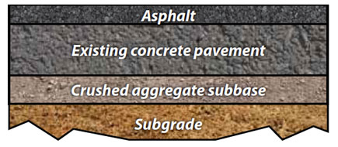
Figure 7- Road Pavement Layering [12]
A third method would be bonding to concrete foundations if performing the analysis within buildings or structures. Like the ground staking, this also requires minimal amount of modification to its environment, and it can always be removed with chemical solvents or scraping tools. Most bonding agents are commercially accessible and can be purchased at inexpensive prices.
In an economic standpoint, it may be more beneficial to have road or infrastructure engineers, specifically those within the country’s national department of transportation, be trained and certified to install and maintain the SHM system. Such people would already be familiar with the environment and will likely need to become familiar with such a system regardless. This cuts down on costs to bring in an outside source to maintain it, unless of course malfunctions of the system are to occur.
Another proposal is to make the system commercialized, by allowing for building owners to utilize the technology in their foundations for a particular benefit. This is quite like how solar companies work to allow their green technology be implemented, and would be a helpful tool particularly in urban environments.
Liability
Liability for a product refers to that of any or all parties along the chain of manufacture of any product for damage caused by that product. This includes the manufacturer of component parts at the top of the chain, an assembling manufacturer, the wholesaler, and the retail store owner, whom is at the bottom of the chain [13]. Since sinkholes are naturally unpredictable and have no specific current inspection system that can be limited by the use of the SHM system, it makes it hard for liability to be set directly in the hands of the SHM manufacturer. However, this doesn’t mean that it can’t be completely free from receiving liability, as having a town or city provide the expenditure to utilize the system means there’s still reliability on its results to improve sinkhole detection and prediction, and not just be a complete waste of money.
Hardware/Software Integration
In order to integrate computing hardware, the systems software will need to be determined first. Compatible SensorCloud™, SensorConnect™ or Node Commander® software for Windows XP/Vista/7 can be used to meet the data acquisition and data analysis needs in conjunction with both the piezoelectric and strain gage circuits and computational cores of the SG-Link OEM-LXRS model nodes. Wireless telemetry will be used for the hardware in the ground and can easily interface with the software. Also, with advancing technology, better forms of statistical analysis may be discovered, and faster, smaller forms of computational cores and software capabilities may be established. In this case, both hardware and software upgrades can easily be introduced to the SHM system through the replacement of individual elements or possibly through a new system entirely.
Error Detection and Decision-Making Confidence
Obtaining initial displacement, pressure differential, and moisture content data in which to compare the measurements to would be difficult. Large-scale sinkholes occur inconsistently and infrequently. In order to compensate for the lack of data, generalizations and estimates would initially have to be made based on the available data on “damaged ground” (areas where sinkholes have formed).
An important consideration when implementing the SHM system is with the factors of false-positive and false-negative results. False-positive results, or those which are more prone to include false damage readings along with those that are true to indicate actual damage, can cause lots of cost in road repair if embedding in asphalt or the need to frequently obtain permits if working within urban buildings or structures, but would be manageable otherwise. Since multiple sensors would be utilized to detect sinkhole-forming behavior, it is not very likely that all the sensors would detect false damage readings at one time. Additionally, although this would be time-consuming, the effects of false-positives results in minimal risk of safety threat, thus saving thousands of dollars in damage and life insurance from a sudden sinkhole incident.
False-negatives however, which describes including the risk of not detecting a damage when there actually is one, are much more difficult potential losses to take in. A false-negative can essentially cause a catastrophic failure to be ignored, resulting in the loss of lives.
In order to meet these potential flaws, a rigorous analysis of the software that will be used in the SHM system will need to be performed before and during implementation to determine the confidence levels of the system, which includes running the system in parallel with current procedures for a while until confidence is gained. The SHM system for sinkhole detection would ideally be designed to give undamaged readings with a 95% confidence level or less. Assuming that the damage matrix distributions for the damaged and undamaged situations do overlap, higher confidence levels any higher than this will run the risk of producing more of the potentially deadly false-negative readings.
Verifying Damage-Detection Capability
Utilizing an impedance based measuring technique is temperature sensitive. Special consideration must be given in order to normalize the temperature impact on the electrical impedance at each frequency so the SHM system can operate on a reliable level. This will also help reduce the amount of potential false-positive and false-negative results (as described previously).
Regularly scheduled SHM system verification can be performed on a monthly basis (though deciding on such an interval will depend on the reproducibility of the actual SHM system and the likelihood of sinkhole formation). The verification can take place during later hours where there is less traffic of people, but not late enough where it surpasses through the local noise ordinance timeframe. Testing will involve making surface cuts or holes (if given permission to do so by the city or town), and the verification of an actual alert of damage will include the observation of ground behavior and identification of standard sinkhole warning signs throughout the surrounding environment, such as evident ground slumping or sagging and wilted vegetation for example. This also would include referring to the already existing distress identification report in current engineering standards to identify a situation as being truly damaged (as explained in the “Definition of Damage” section), utilization an infrared method, or other possible methods that can confirm or deny. If the temperature is consistent, then verification of a test can be performed at least once, depending on the results of the analysis.

SUMMARY AND CONCLUSION
Implementing a structural health monitoring (SHM) system to detect potential sinkholes in the ground would be considerable challenge to tackle, however using careful consideration of every aspect of the design of the SHM system should result in a safe, reliable system. The cost and lifesavings capabilities of the proposed SHM system will more than pay for itself, as well as provide the city or town that utilizes the technology a strong sense of safety. Based on careful consideration of the environmental and operational variability, data acquisition challenges, damage detection techniques, and the ability to reliably identify a situation as damaged, there is a confidence that the proposed impedance-based damage detection system will prove to significantly reduce the potential for injury, death and/or damage costs caused by a sudden, unpredicted sinkhole.
References:
[1] "Sinkholes", from USGS Water-Science School. N.p., n.d. Web. 29 Feb 2016.
[2] Behbahani, Hamid, MohammadReza. M. Aliha, Hassan. Fazaeli, Mohammad.H. Rezaeifar. “Effect of Characteristic Specifications on Fracture Toughness of Asphalt Concrete Materials.” School of Civil Engineering, Iran University of Science and Technology (IUST), Narmak, 16846-13114, Tehran, Iran. 2013. Web. 03 Apr. 2016. <http://www.gruppofrattura.it/ocs/index.php/ICF/icf13/paper/viewFile/11105/10484>.
[3] “Concrete – Properties: Properties of Normal Strength Portland Cement Concrete.” Engineering Toolbox. Web. 03 Apr. 2016. <http://www.engineeringtoolbox.com/concrete-properties-d_1223.html>.
[4] “Chapter 1. Distresses for Pavements With Asphalt Concrete Surfaces.” Distress Identification Manual for The LTPP. Fourth Rev. Edition. N.p., n.d. Web. 03 Apr. 2016. <https://www.fhwa.dot.gov/publications/research/infrastructure/pavements/ltpp/reports/03031/01.cfm>.
[5] "NASA scientists use radar technology to predict sinkholes - CBS News." CBS News - Breaking News, U.S., World, Business, Entertainment & Video. 24 Apr 2014. Web. 03 Apr. 2016. <http://www.cbsnews.com/news/nasa-scientists-use-radar-technology-to-predict-sinkholes/>.
[6] "NASA Radar Demonstrates Ability to Foresee Sinkholes | NASA." NASA. 6 Mar 2014. Web. 03 Apr. 2016. <http://www.nasa.gov/press/2014/march/nasa-radar-demonstrates-ability-to-foresee-sinkholes/#.VwLTkvkrKt8>.
[7] VPG - Home Page. 15 Jul 2015. Web. 03 Apr. 2016. <http://www.vishaypg.com/docs/11091/tt611.pdf>.
[8] Person, and Darren Quick. "Wireless Sensor to Monitor Structural Integrity of Bridges." Wireless Sensor to Monitor Structural Integrity of Bridges. N.p., n.d. Web. 02 May 2016.
[9] Weather: Guatemala City. BBC. 2011. Web. 03 Apr. 2016. <http://www.bbc.com/weather/3598132>.
[10] Heussner, Ki Mae. "Guatemala City Sinkhole: How Did It Happen?" ABC News. ABC News Network, 01 June 2010. Web. 22 Apr. 2016.
[11] Suhr, Diana D. “Principal Component Analysis vs. Exploratory Factor Analysis.” Statistics and Data Analysis. University of Northern Colorado. Web. 22 Apr. 2016.
[12] “Advancing the Science of Composite Pavements.” CTS, University of Minnesota, 2015-16. Web. 21 Apr. 2016.
[13] “Products Liability Law: An Overview.” Cornell University Law School, Legal Information Institute. Web. 21 Apr. 2016. <https://www.law.cornell.edu/wex/products_liability>.

