349368 |  | 1 | A
 | North West_Local Offer Peer Review Workshops_February 2017_Summary_DRAFT
 | Mott MacDonald
Mott MacDonald
10 Fleet Place
London EC4M 7RB
United Kingdom
T +44 (0)20 7651 0300
F +44 (0)20 7248 2698
mottmac.com
Local Offer Workshops
North West SEND Peer Network
February 2017
Mott MacDonald Limited. Registered in England and Wales no. 1243967. Registered office: Mott MacDonald House, 8-10 Sydenham Road, Croydon CR0 2EE, United Kingdom

Issue and Revision Record
Revision | Date | Originator | Checker | Approver | Description
A | 07/03 | MW | KH | KH | Final

Document reference: | 349368 | 1 | A

Information class: | Standard

This document is issued for the party which commissioned it and for specific purposes connected with the above-captioned project only. It should not be relied upon by any other party or used for any other purpose.
We accept no responsibility for the consequences of this document being relied upon by any other party, or being used for any other purpose, or containing any error or omission which is due to an error or omission in data supplied to us by other parties.
This document contains confidential information and proprietary intellectual property. It should not be shown to other parties without consent from us and from the party which commissioned it.
This report has been prepared solely for use by the party which commissioned it (the ‘Client’) in connection with the captioned project. It should not be used for any other purpose. No person other than the Client or any party who has expressly agreed terms of reliance with us (the ‘Recipient(s)’) may rely on the content, information or any views expressed in the report. We accept no duty of care, responsibility or liability to any other recipient of this document. This report is confidential and contains proprietary intellectual property.
No representation, warranty or undertaking, express or implied, is made and no responsibility or liability is accepted by us to any party other than the Client or any Recipient(s), as to the accuracy or completeness of the information contained in this report. For the avoidance of doubt this report does not in any way purport to include any legal, insurance or financial advice or opinion.
We disclaim all and any liability whether arising in tort or contract or otherwise which it might otherwise have to any party other than the Client or the Recipient(s), in respect of this report, or any information attributed to it.
We accept no responsibility for any error or omission in the report which is due to an error or omission in data, information or statements supplied to us by other parties including the client (‘Data’). We have not independently verified such Data and have assumed it to be accurate, complete, reliable and current as of the date of such information.
Forecasts presented in this document were prepared using Data and the report is dependent or based on Data. Inevitably, some of the assumptions used to develop the forecasts will not be realised and unanticipated events and circumstances may occur. Consequently Mott MacDonald does not guarantee or warrant the conclusions contained in the report as there are likely to be differences between the forecasts and the actual results and those differences may be material. While we consider that the information and opinions given in this report are sound all parties must rely on their own skill and judgement when making use of it.
Under no circumstances may this report or any extract or summary thereof be used in connection with any public or private securities offering including any related memorandum or prospectus for any securities offering or stock exchange listing or announcement.

Introduction and Agreed Actions

Introduction
In February 2017 two Local Offer workshops were held in the North West on the 9th and 21st of February, Local Authority and Parent Carer Representatives attended these. These workshops followed the approach outlined below:
- Department of Education (DfE) SEND Advisor provided an overview of statutory requirements in the SEND Code of Practice, relating to the Local Offer and feedback on learning from Local Area Inspections
- In advance of the session, Local Areas were provided with case studies and used their own Local Offers to provide responses to the scenarios set out in these case studies
- During the workshop, Local Areas worked through the different case studies and shared their experiences (positive and negative) of using their Local Offers to find information such as available provision and support
- Local Areas action planned their next steps for developing their Local Offers

Agreed Actions
- Mott MacDonald (MM) to share resources from the events with attendees
- Local Areas to share relevant resources with MM, which will be shared with the wider region
- Attendees fed back that they would value a regional Local Offer peer group. This could include virtual networking (via email), group meetings on a regular basis (either cluster or full region) and Local Area to Local Area peer review. MM were asked to support the region in facilitating this
- The Regional Steering group to consider these actions and agree next steps

Key Themes
The following is a summary of the key themes that were identified by attendees during both workshops.
Theme | Examples of feedback
Communication – a number identified that they needed to continue to promote the Local Offer and provide ongoing communications to stakeholders | - “Better sign posting, need to make things clearer and narrow some areas down to be more specific”  - “Need to improve promotion of LO as many not aware of it – will speak to other sectors such as health workers to try and improve this“
Terminology – a key area for many was that users often found it hard to navigate or find parts of the Local Offer due to differences in terminology used, the use of the case studies helped to identify these gaps | - “Variance of terminology, need to do research around the different terminologies that may be used”  - “Need to think more about what others will search as some of the terminology used on the site is very different to what others may search, unless you know exactly what you are looking for it proves difficult to find information”  - “Will use the case studies provided today for training staff on using the local offer”
Not user friendly – some Local Authorities found that whilst their Local Offer contained vast amounts of information the website was not easy to navigate and use | - “A lot of information on the site but haven’t got enough links and need to condense information due to lots of information being on the site”  - “Appearance on phone is not user friendly, would like to redo the site for phone users as a large percentage of the time people are using their phones rather than a computer or laptop”
Keywords – a number found that keyword searches worked well as well as including a glossary page within the Local Offer which other Local Authorities highlighted they will look at going forward | - “Found keyword searches worked well when looking at specifics”  - “Glossary in the our Local Offer that has been added recently proved to be very useful”
Training – a number highlighted how going forward they will be looking at providing training within their Local Authority from the areas of improvements found in the case study reviews | - “Will use the case studies provided today for training staff on using the local offer”  - “Will be looking at targeting some training for school staff (such as receptionists) as they tend to be the first point of contact for enquiries”  - “We are going to run a workshop in the library and get people to use the search function, note how they use this and record what works/doesn’t work and take back findings from this to improve the efficiency of search bar function”

Attendee Feedback from both events

1. How would you rate the day?

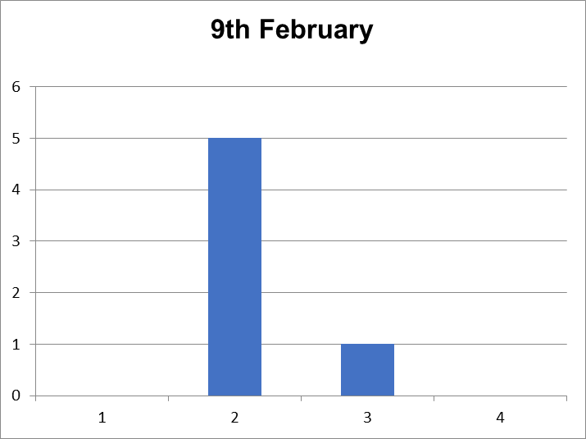
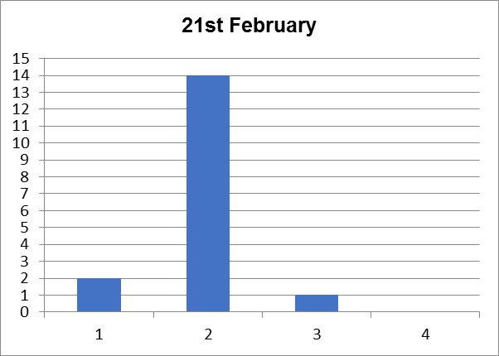

Figure 1: 1 = Very Useful, 2 = Good, 3 = Satisfactory, 4 = Not at all useful

2. Is there anything you will do differently having attended this event?

- Replicate the workshop approach locally by arranging forums and review sessions including parent carers, young people in addition to Local Authority and Health representatives. This would cover the Local Offer but also broader areas such as customer journey.
- Review specific areas of individual Local Offers based on individual reviews and also learning from other areas including:
- “Consider feedback mechanisms on the Local Offer that way we can hopefully get some more instant feedback to either inform how information is accessed or to bridge gaps in the offer”
- “Review how the Local Offer is categorised so that key words can be used which identify with the search being made. Liked the discussion about question based searches which we need to look again to check that searching in this way gets results back from the Local Offer”
- “Think more about the promotion of the Local Offer rather than things like the name etc”
- “Constant data cleanse of records to check information is correct and links to websites/documents are working correctly, put processes in place to gain feedback from users of Oldham Council’s website and professionals”
- “14-19 age group needs attention as does transition and support for broad group of SEN support only”
- Ensure parents are aware and involved in the Local Offer as much as possible including:
  - “Raise awareness with professionals ensuring they let parents know how to access the information services available”
  - “Push for reviews from parents/carers as this is not something that is normally done within the borough”
- Use the case studies as part of the reviewing process and to help implement changes and identify areas of improvements going forward.

3. Have you any suggestions for improvements or is there anything additional you would have like to have covered in the session?
- Whilst the case studies were a useful exercise it would have been useful to also have a peer review looking at and comparing local offers
- Plan more time into reviewing the case studies by having a longer day

4. Any other comments?
- Useful and positive day, including:
  - “Overview from SEN Adviser was useful in terms of drawing out the positives/development areas from the Local Area Inspections so far”
  - “Beneficial and welcoming day, the parents I brought along with me pointed out how well delivered the information was by the presenters”
  - “The session was very informative and helpful, great linking with other Local Authorities”
  - “The facilitators were very approachable and answered any questions raised”
- Valuable to network with other Local Authorities, Parent Carers and other partners
- Keen to start networking and to sett up a group as soon as possible
- Helpful to identify the areas that can be fixed quickly, and the areas that need to be taken back and focused on with other teams
mottmac.com

Feedback forms were not provided at the event on the 9th February, but were shared electronically afterwards. As such, there are fewer responses for the event on the 9th compared to the 21st February.

