German Saturday School Teaching Award
We would like to invite nominations for the
3rd annual German Saturday School Teaching Award (GSSTA).
Aims:
- to reward enthusiastic and dedicated teachers
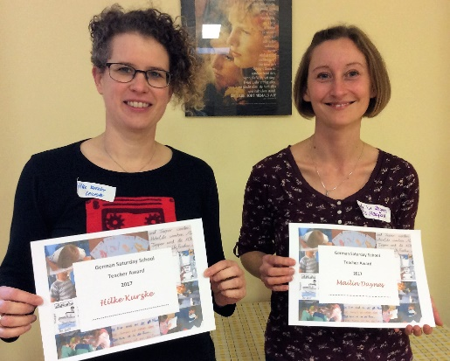
- to identify innovative, motivating, effective and imaginative teaching projects
- to reward teaching that specifically meets the needs of Saturday School pupils,
and has an effect beyond the Saturday School
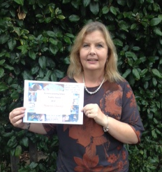
Background:
We recognise that the German Saturday Schools in the UK are
a heterogeneous group of schools and follow a range of different
approaches to German language teaching in informal settings.
This diversity, we believe, is their specific strength.
We would like to identify imaginative projects from
enthusiastic and resourceful German teachers, which make a real
difference for the Saturday School children.
We are deliberately open for any successful teaching projects from any teacher, irrespective of their professional background. All are welcome to take part. Projects could be an innovative lesson plan, a teaching project covering several lessons, a project using a specific technological or creative approach or anything else which you have tried out with your class!
The three winners will present their projects at the annual teacher training day (20 October 2018), and the projects will also be published on the VDSS website.

The three winners of the GSSTA will each receive £100! One of the three awards is sponsored by the German Embassy London.
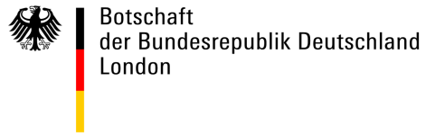

How do I apply?
Your head teacher should propose you and write a brief statement about you. You then describe your project in detail. The project should have taken place in the past 12 months.
How many applicants per school?
The limit for the number of applicants per school is roughly proportional to the number of teachers (but not supply teachers or classroom assistants): 1-5 teachers (up to 1 application), 6-10 teachers (up to 2 applications), 11+ teachers (up to 3 applications).
Application deadline: 30th September 2018
Please submit applications in English to: charlotte.schulze@btopenworld.com

Application for the German Saturday School Teaching Award (GSSTA)
Name of school
Name of head teacher
and contact email address
Name of nominated teacher
and contact email address and telephone number
Head teacher’s statement
Up to 100 words – a brief statement about the nominee and her background
Nominee’s statement
Up to 500 words – a description of your project in any format including pictures, or even a short film (max. 1 min.). Try to address the following points:
- What was the aim of the project?
- Which age groups were involved?
- Please provide a brief description – possibly with illustrations – of your project.
- How did the project advance/motivate the pupil’s German language learning?
- What was special about your teaching style?
- Explain how successful you judge this project to be.
- In how far does this project address other areas of culture or knowledge?

