Low power open narrowcasting
Use it or lose it (UIOLI) conditions
SEPTEMBER 2020
Canberra
Red Building
Benjamin Offices
Chan Street
Belconnen ACT
PO Box 78
Belconnen ACT 2616
T +61 2 6219 5555
F +61 2 6219 5353
Melbourne
Level 32
Melbourne Central Tower
360 Elizabeth Street
Melbourne VIC
PO Box 13112
Law Courts
Melbourne VIC 8010
T +61 3 9963 6800
F +61 3 9963 6899
Sydney
Level 5
The Bay Centre
65 Pirrama Road
Pyrmont NSW
PO Box Q500
Queen Victoria Building
NSW 1230
T +61 2 9334 7700 or 1800 226 667
F +61 2 9334 7799
Copyright notice
https://creativecommons.org/licenses/by/4.0/
With the exception of coats of arms, logos, emblems, images, other third-party material or devices protected by a trademark, this content is made available under the terms of the Creative Commons Attribution 4.0 International (CC BY 4.0) licence.
We request attribution as © Commonwealth of Australia (Australian Communications and Media Authority) 2020.
All other rights are reserved.
The Australian Communications and Media Authority has undertaken reasonable enquiries to identify material owned by third parties and secure permission for its reproduction. Permission may need to be obtained from third parties to re-use their material.
Written enquiries may be sent to:
Manager, Editorial Services
PO Box 13112
Law Courts
Melbourne VIC 8010
Email: info@acma.gov.au

Executive summary 1
Why is this important? 1
About this paper 2
Important note 2
Introduction 3
LPON compliance 3
UIOLI conditions 5
You must start a service within six months 5
You must use the service with reasonable regularity 5
Services should be happening on a frequent or habitual basis 5
Services need to be occurring more than once a year 6
Services must be provided for listeners 6
You must keep service records 6
Conclusion 7
Your narrowcasting licence—at a glance 8
More information 9
Appendix A 10

Executive summary
Low power open narrowcasting (LPON) is used for niche radio broadcasting services.
It allows services to be delivered to specific locations or at certain times, or to be targeted to special interest groups, such as tourist information and ethnic and religious programming. The Australian Communication and Media Authority (ACMA) issues LPON licences and regulates them to ensure compliance with licence conditions.
The use it or lose it (UIOLI) conditions are ‘other conditions’ applied to LPON apparatus licensed services operating in the frequency range 87.5 to 88 MHz and are intended to deter ‘hoarding’ of LPON licences.
These arrangements broadly require licensees to:
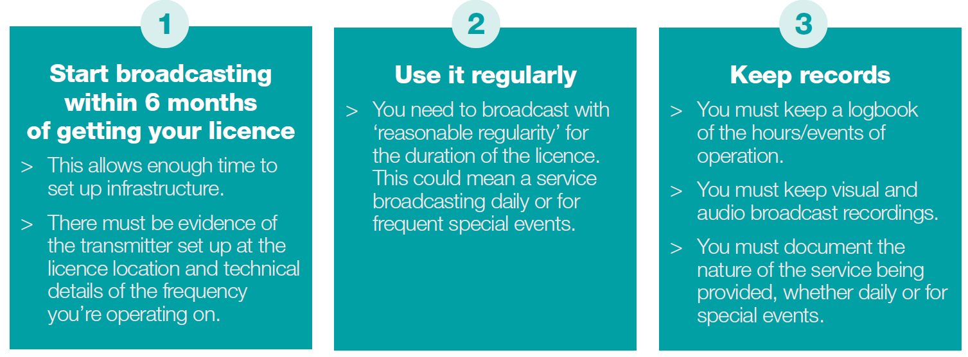

Why is this important?
Breaching the UIOLI conditions may result in refusal to renew licence or cancellation of a licence by the ACMA.

About this paper
This paper has been developed and published in response to recent decisions about LPON services by the Administrative Appeals Tribunal (AAT). The judgements in these matters provide guidance for LPON licensees on how to interpret the application of the use it or lose it (UIOLI) conditions.
This paper:
gives an overview of the use it or lose it (UIOLI) conditions
helps LPON licensees to better understand the requirements about reasonable regularity, commencement of a service and record keeping.

Important note
The information contained in this paper is provided as a guide for LPON licensees and should not be relied on as the only source of information nor does it constitute legal advice.
LPON licences are subject to regulatory provisions in the following legislation:
Broadcasting Services Act 1992
Radiocommunications Act 1992
Australian Communications Authority (LPON Transmitter Licences) Direction No. 2 of 2000
Radiocommunications Licence Conditions (Broadcasting Licence) Determination 2015
Other helpful links are also given in the More information section of this paper.

Introduction
Low Power Open Narrowcast (LPON) services are subject to a range of licence conditions, including:
exclusion zones
power and coverage limitations
limited protection from interference
no security of tenure
minimum separation distance requirements
not being operated as a community or commercial radio broadcasting service
> use it or lose it requirements.
This paper focuses on the use it or lose it (UIOLI) requirements in paragraph 4.11 of the Radiocommunications Licence Conditions (Broadcasting Licence) Determination 2015 and the Australian Communications Authority (LPON Transmitter Licences) Direction No. 2 of 2000.
The Administrative Appeals Tribunal (AAT) has recently decided on two matters, which provide guidance on how it interprets the application of UIOLI conditions. Given these decisions, it’s important that licensees are aware of the UIOLI conditions and how to put them into practice.
The key purpose of these requirements is to ensure that services are provided to the public under LPON licences and that licences are not hoarded or remain unused.
This supports the primary objects of the Broadcasting Services Act 1992, one of which is to maximise the overall public benefit derived from using the radiofrequency spectrum by ensuring the efficient allocation and use of the spectrum.
This paper focuses on the UIOLI conditions, specifically the concepts of commencement of service, reasonable regularity and record keeping.
The relevant provisions in the Radiocommunications Licence Conditions (Broadcasting Licence) Determination 2015 and the Australian Communications Authority (LPON Transmitter Licences) Direction No. 2 of 2000can be found in Appendix A.

LPON compliance
The ACMA may investigate when:
we become aware a licensee may be in breach of a licence condition; and/or
a valid complaint is made to the ACMA.
We generally only investigate the operation of an LPON service when a formal complaint is made about the service. However, if we discover that a licence for an LPON service is not being used, we may initiate an investigation.
In considering whether a licensee has failed to continue to provide a service, or whether a service was provided at all, we look at:
the period for which a service has not been provided, in relation to the period in which it could have been provided
whether any circumstances existed that were beyond the reasonable control of the licensee, which resulted in a failure to continue to provide a service
the number of other apparatus licences for LPONs held by the licensee and the level of services provided under those licences
other matters that we consider relevant.
The outcome of any ACMA investigation of non-compliance will depend on the facts and circumstances of the case.

UIOLI conditions
The UIOLI conditions are very important for the operation of an LPON licence.
There are three important criteria in the UIOLI conditions:
you must start broadcasting within six months of getting your licence
you need to use it regularly
you must keep records.

You must start a service within six months
Unless you have a reasonable excuse for not doing so, the licensee must commence the service within six months from the day the licence was issued. This is intended to allow enough time to set-up infrastructure for broadcasting.
You must have evidence of:
transmitter set-up at the specified location
technical details of the frequency the service is being provided on.

You must use the service with reasonable regularity
A licensee must provide the service with reasonable regularity for the duration of the licence.
To meet the ‘reasonable regularity’ requirement, there are couple of key factors you should consider:

Services should be happening on a frequent or habitual basis
In the decision by the Administrative Appeals Tribunal (AAT), Futrends Pty Ltd and Australian Communications and Media Authority in April 2020 the ACMA’s application of ‘with reasonable regularity for the duration of the licence’ in cancelling LPON licences was considered and upheld. The decision noted the ordinary meanings of the word regular but concluded that the context in which regularity is used in subsection paragraph 4.11(1)(b) of the Direction.
Used, done, or happening on a frequent or habitual basis.
This reflects the purpose of the UIOLI conditions in ensuring LPON services are not hoarded or unused.
This meaning of reasonable regularity was further supported by the AAT’s decision in July 2020 of this year in the case of W&A Willmington and Australian Communications and Media Authority, which again agreed with the ACMA’s cancellation of LPON licences as they were not being used with reasonable regularity and defined reasonable regularity as a frequent or habitual service.
We note that there is no fixed minimum number of hours as to what makes up ‘reasonable regularity’. Rather, what is ‘reasonable’ will be informed by all the circumstances of the licence. However, the ‘reasonable’ requirement should be informed by the purpose of the condition, which is to ensure that people are making meaningful use of the licence.

Services need to be occurring more than once a year
The decision in the case of Futrends Pty Ltd and Australian Communications and Media Authority notes that the provision in paragraph 4.11(1)(a) of the Direction requiring commencement of a service within six months of the issue of the licence, strongly suggests, that services provided at intervals of longer than six months would not meet the ‘reasonable regularity’ requirement.
The decision by the AAT in W&A Willmington and Australian Communications and Media Authority notes that transmissions a year apart cannot be considered to have been provided with reasonable regularity.

Services must be provided for listeners
The recent decisions by the AAT also demonstrate that transmissions for short periods may not satisfy the requirement of ‘reasonable regularity’, as transmitting for short periods or making test transmissions to meet licence conditions is not a provision of a service to listeners.
The requirement is for the licensee to provide the service to which the licence relates.

You must keep service records
The licensee must maintain records of the commencement, hours of operation and provision of the service.
This means that you must:
keep a logbook of the hours/events of operation
keep visual and audio broadcast recordings
document the nature of the service being provided, whether daily or for special events.
The recent decisions by the AAT in the cases of Futrends Pty Ltd and Australian Communications and Media Authority and W&A Willmington and Australian Communications and Media Authority demonstrate the importance of record keeping in providing evidence of when the service commenced, its hours of operation and what types of services are being provided for LPON licensees.

Conclusion
The recent AAT decisions should help guide the ACMA and LPON licensees to better understand the meaning of reasonable regularity, commencement of service and record keeping in the context of the UIOLI conditions.
It is clear from the AAT decisions that the intention of the UIOLI conditions are that:
LPON services must be turned on within six months of acquisition
a service must be provided to listeners regularly
records of transmission must be kept.
The ACMA is bound by the AAT decisions in considering UIOLI matters, and we encourage LPON licensees to reflect this in the operation of your services.
The ACMA provides a range of information to LPON licensees, including this paper, to make it easy to understand and comply with the licence conditions.

Your narrowcasting licence—at a glance
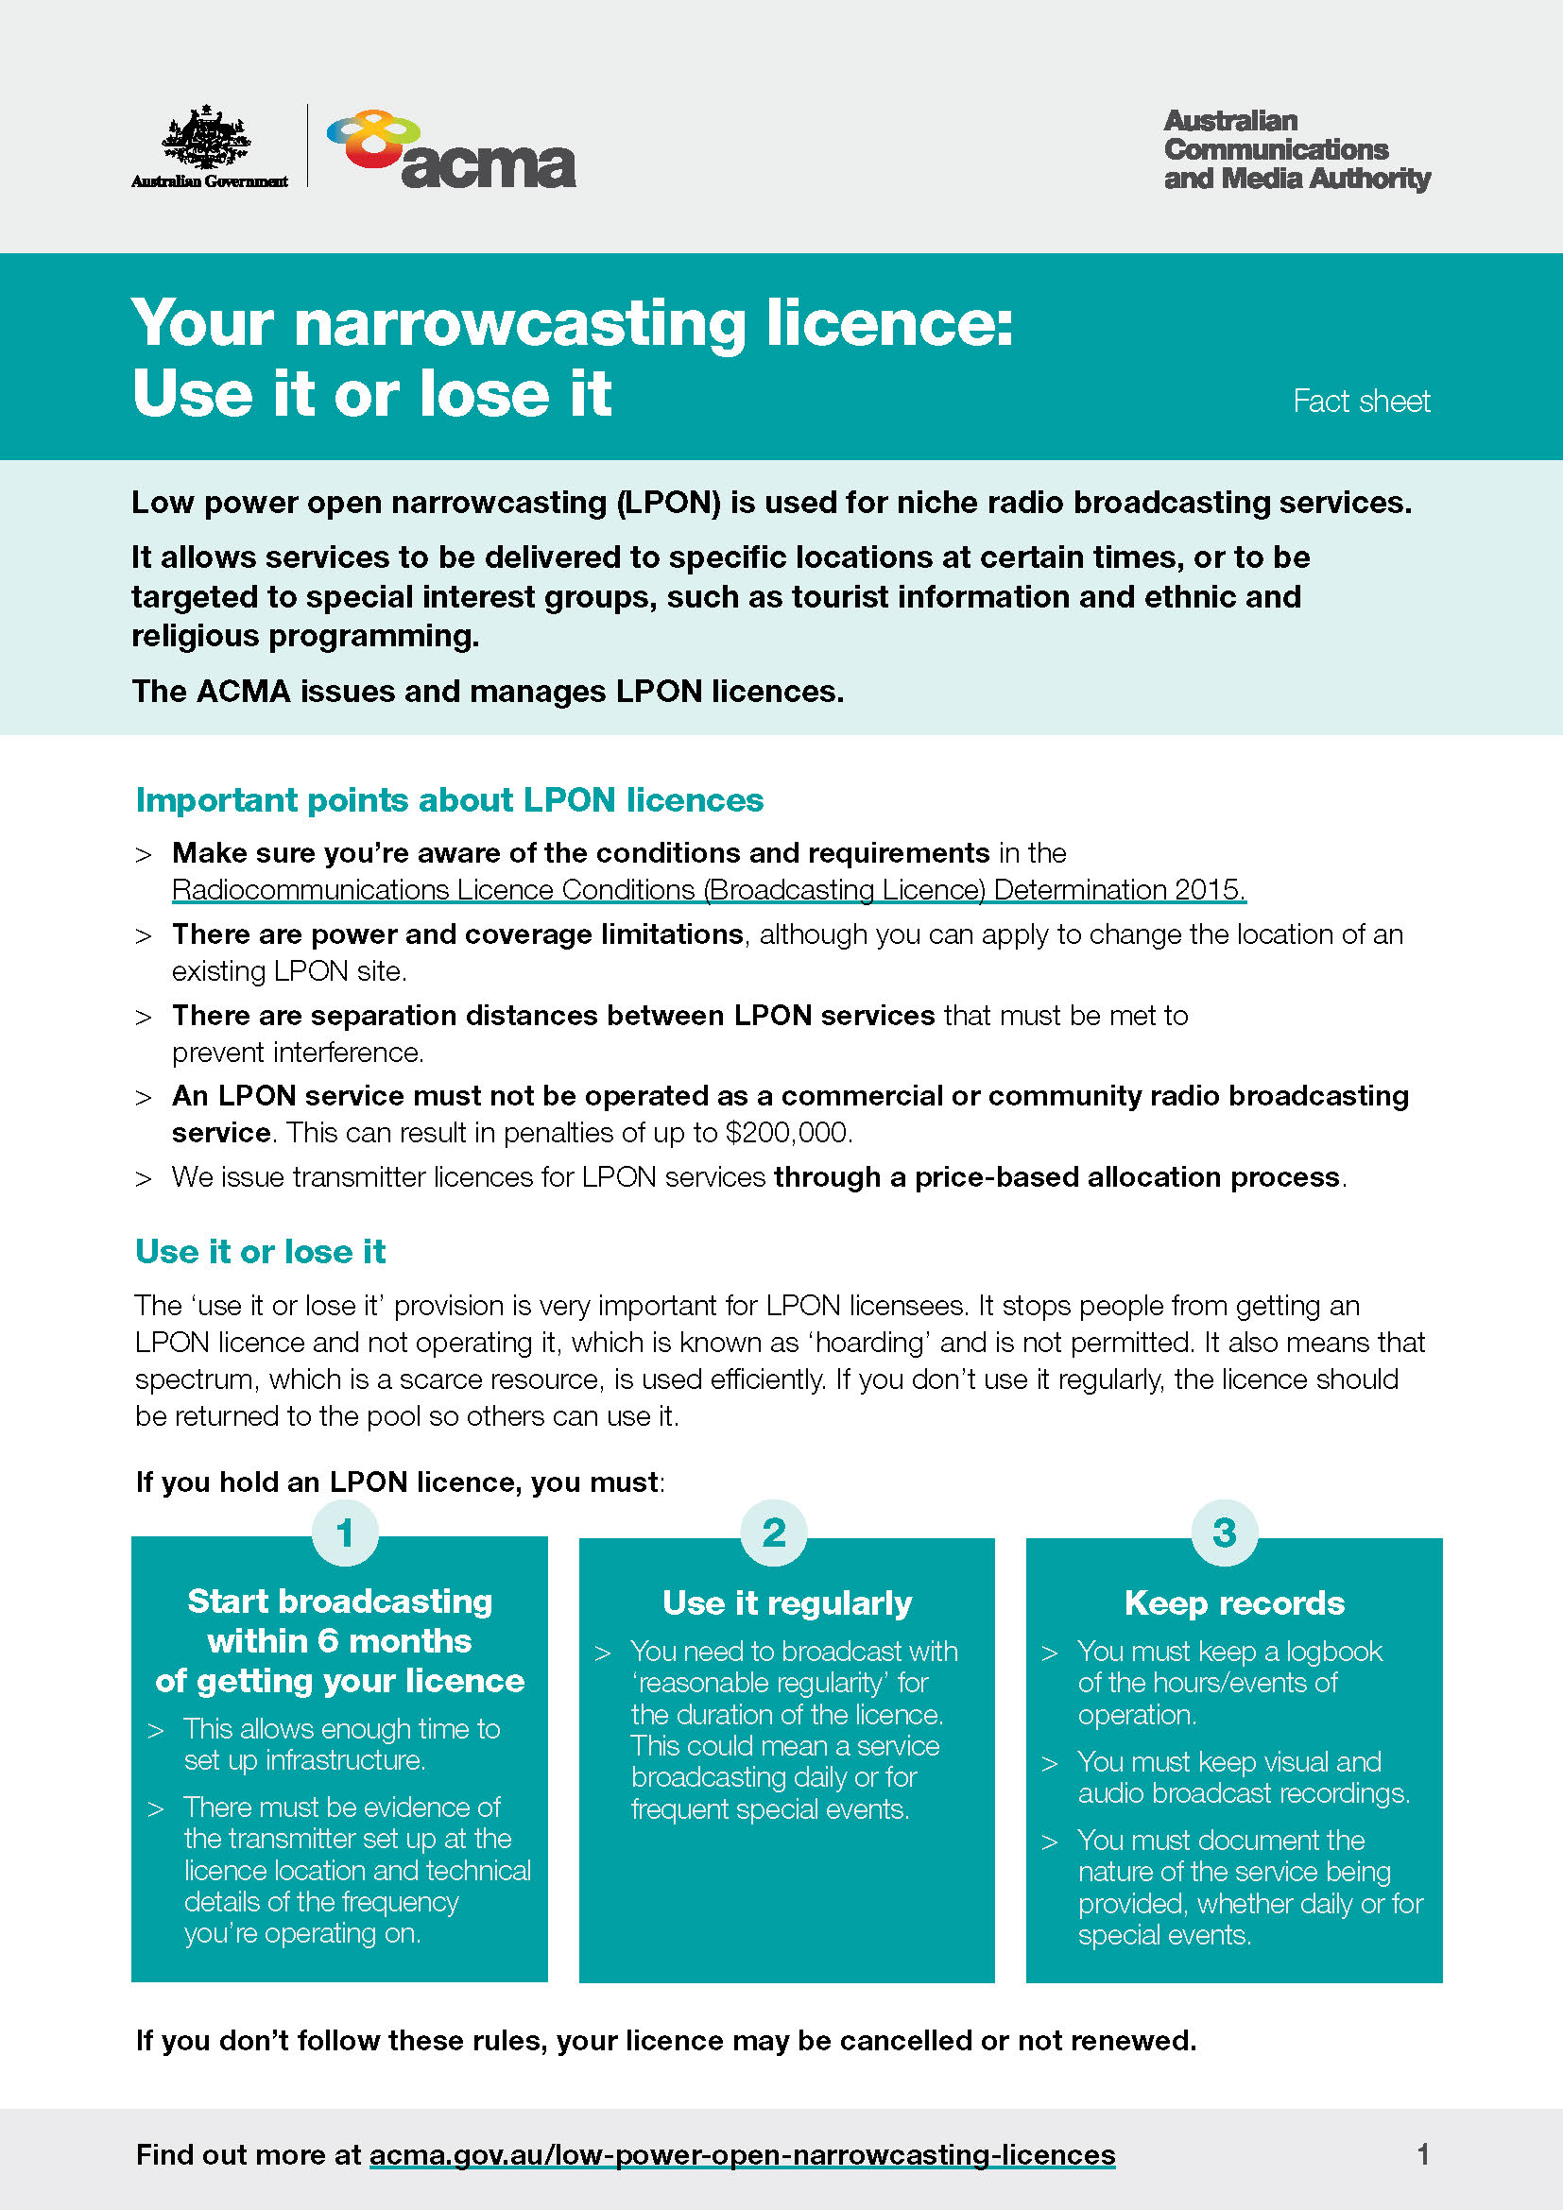

More information
LPON licence information
- Go to www.acma.gov.au/low-power-open-narrowcasting-licences
The Administrative Appeals decision reports
- W&A Willmington and Australian Communications and Media Authority
- Futrends Pty Ltd and Australian Communications and Media Authority
Keep up-to-date
- Subscribe to an ACMA newsletter at www.acma.gov.au/subscribe-our-newsletters
- Follow us on www.twitter.com/acmadotgov
- ‘Like’ us on www.facebook.com/acmadotgov
- View us on www.youtube.com/user/acmadotgov
Contact ACMA
- Email: info@acma.gov.au
- Phone: 1300 850 115

Appendix A
Radiocommunications Licence Conditions (Broadcasting Licence) Determination 2015
4.11 Certain low power open narrowcasting services — other conditions
(1) A licence that authorises the operation of a narrowcasting service station at a carrier frequency within the range 87.5 to 88.0 MHz (inclusive) to provide a low power open narrowcasting service is subject to the following conditions:
(a) if the licence is issued otherwise than upon renewal under section 130 of the Act – unless the licensee has a reasonable excuse for not doing so, the licensee must commence the service within 6 months beginning on the day the licence is issued;
(b) subject to paragraph (a), the licensee must provide the service with reasonable regularity for the duration of the licence;
(c) the licensee must maintain records of the commencement, hours of operation and provision of the service.
Note See clauses 6 and 9 of the Australian Communications Authority (LPON Transmitter Licences) Direction No. 2 of 2000.
(2) The ACMA may extend the 6-month period referred to in paragraph 4.11(1)(a) if, in the ACMA’s opinion, there is a valid reason for a delay by a licensee in complying with that paragraph.
Note See subclause 8(1) of the Australian Communications Authority (LPON Transmitter Licences) Direction No. 2 of 2000.
(3) For the purposes of subsection (2), valid reason for a delay does not include:
(a) that the licence was obtained within the 6-month period within which to comply with the condition, pursuant to a transfer from a relative or associate of the licensee;
(b) financial reasons;
(c) that the licence is subject to an arrangement contingent on the disposal of another licence held by the licensee.
Note See subclause 8(2) of the Australian Communications Authority (LPON Transmitter Licences) Direction No. 2 of 2000. Subclause 8(3) provides that this list of matters that are not valid reasons for a delay “is not-exhaustive and there may be other reasons that do not constitute valid reasons for a delay”.
(4) In this section:
associate means:
(a) in relation to a body corporate:
(i) a director or secretary of the body corporate; or
(ii) a related body corporate; or
(iii) a director or secretary of a related body corporate; or
(iv) a business partner of the body corporate; or
(v) an individual who controls at least 15% of the voting power in, or holds at least 15% of the issued shares of, the body corporate; and
(b) in relation to an individual:
(i) a business partner of the individual; or
(ii) a body corporate in which the individual controls at least 15% of the voting power or of which the individual holds at least 15% of the issued shares; or
(iii) a body corporate of which the individual is a director or secretary; or
(iv) a body corporate that is a related body corporate of a body corporate of which the individual is a director or secretary.
related body corporate has the same meaning as in the Corporations Act 2001.
relative, in relation to a person, means:
(a) the person’s spouse; or
(b) the person’s parent, grandparent, brother, sister, uncle, aunt, nephew, niece, lineal descendant or adopted child; or
(c) the spouse of a relative mentioned in paragraph (b).
spouse, in relation to a person, includes a de facto partner of the person, within the meaning given by section 2D of the Acts Interpretation Act 1901.
Note On 20 December 2000, the Minister gave to the Australian Communications Authority the Australian Communications Authority (LPON Transmitter Licences) Direction No. 2 of 2000 (Direction), under subsection 12 (1) of the Australian Communications Authority Act 1997. The Direction is continued in force under item 8 of Schedule 4 to the Australian Communications and Media Authority (Consequential and Transitional Provisions) Act 2005. The Direction makes provision for how the ACMA exercises its powers and performs its functions in relation to imposing conditions on certain licences.

Australian Communications Authority (LPON Transmitter Licences) Direction No. 2 of 2000
7. Direction – renewal of LPON licences within 6 months
The ACA must make any apparatus licence for a low power open narrowcasting service issued upon renewal within 6 months of the commencement of this Direction subject to conditions that have the effect of requiring a licensee of a low power open narrowcasting service to:
(a) commence to provide a service using a transmitter authorised under the licence within 6 months of the renewal of the licence unless the licensee has a reasonable excuse for not doing so; and
(b) continue to provide a service throughout the term of the licence with reasonable regularity; and
(c) maintain records of the commencement, hours of operation and provision of a service under the licence.
8. Direction – extension of 6-month start-up period
(1) The ACA may allow for an extension of the 6-month period referred to in clause 5(a), 6(a) or 7(a) if in the ACA's opinion there is a valid reason for a delay by a licensee complying with those clauses.
(2) The following, inter alia, shall not constitute valid reasons for a delay:
(a) the licence has been obtained within the 6-month period pursuant to a transfer to a relative or associate; or
(b) financial reasons; or
(c) the licence is subject to an arrangement contingent on the disposal of another licence held by the licensee.
(3) To remove any doubt, subsection (2) is not exhaustive and there may be other reasons that do not constitute valid reasons for a delay in commencing to provide a service.
10. Direction – cancellation of LPON licences
(1) The ACA may consider cancelling an apparatus licence for a low power open narrowcasting service for contravention of any conditions included in the licence because of section 5, 6, 7 or 9 where it has received a written statement from any person (“the complainant”) specifying the following details:
- the name and contact details of the complainant and their interest in the matter; and
- the purported breach of condition and the supporting evidence.
(2) The statement must be made on the form approved by the ACA for this purpose (the complaint form) and must be accompanied by a statutory declaration as to the truth of the contents of the statement.
(3) The ACA must give the licensee written notice that it has received a complaint and must provide details of what is contained in the complaint which gives the licensee a clear understanding of the substance of the complaint. The licensee must be given 30 days from the date on which the licensee is advised of the complaint in which to respond.
(4) In considering whether or not to cancel an apparatus licence for a low power open narrowcasting service for contravention of any conditions included in the licence because of sections 5, 6, 7 and 9 of this Direction, the ACA must have regard to:
- arrangements made by the licensee for access and use of a site for the purpose of providing the service;
- ownership, purchase, lease or hire, or other arrangements made by the licensee for the use of a transmitter on the site for the purpose of providing the service;
- arrangements made by the licensee to obtain programs for use in providing the service;
- the regularity and continuity of programs broadcast by the licensee from the site;
- the nature of the service to which the licence relates and which is being provided by the licensee;
- the maintenance of records of the commencement, hours of operation and provision of a service under the licence; and
- other such matters as the ACA considers relevant.
(5) In considering whether a condition included in an apparatus licence because of clauses 5(b), 6(b), 7(b) or 9(b) requiring continued provision of a service has been complied with, the ACA must have regard to:
- the period for which a service has not been provided in relation to the period in which it could have been provided;
- whether any circumstances existed which gave rise to a failure to continue to provide a service that were beyond the reasonable control of the licensee or persons with whom arrangements existed under paragraph 10(4)(b);
- the number of other apparatus licences for low power open narrowcasting services held by the licensee and the level of services provided under those licences;
- such other matters as the ACA considers relevant.
11. Direction – no issue of a licence on similar terms
The ACA must not grant an apparatus licence for a low power open narrowcasting service on similar terms or including similar details to that of an existing licence during the period in which a complaint is being assessed in relation to the existing licence. This applies to an application by any person.

Refer to the Australian Communications Authority (LPON Transmitter Licences) Direction No. 2 of 2000.
Subsection 4.11(1)a) of the Radiocommunications Licence Conditions (Broadcasting Licence) Determination 2015.
Refer Subsection 4.11(1)b) of the Radiocommunications Licence Conditions (Broadcasting Licence) Determination 2015.
Futrends Pty Ltd and Australian Communications and Media Authority.
Futrends Pty Ltd and Australian Communications and Media Authority
W&A Willmington and Australian Communications and Media Authority
Futrends Pty Ltd and Australian Communications and Media Authority
W&A Willmington and Australian Communications and Media Authority
Subsection 4.11(1)c) of the Radiocommunications Licence Conditions (Broadcasting Licence) Determination 2015.

