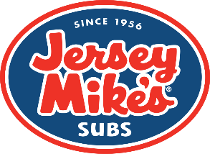
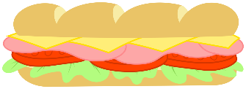
Greenwood Forest Children’s Center
“Let’s Eat Out” at
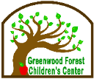
Jersey Mike’s Subs at 701 Cary Towne Blvd.
(Behind McDonald’s on Maynard/Cary Towne Blvd.)
Wednesday, October 23, 2019
5:00-8:00 PM
Enjoy a sub for supper before you come to Open House! For Dad’s running here from work…get one to go for him!
When you present this flyer or tell them you are a GFCC parent, they will donate a % of your sale.

Greenwood Forest Children’s Center
“Let’s Eat Out” at
Jersey Mike’s Subs at 701 Cary Towne Blvd.
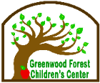
(Behind McDonald’s on Maynard/Cary Towne Blvd.)
Wednesday, October 23, 2019
5:00-8:00 PM
Enjoy a sub for supper before you come to Open House! For Dad’s running here from work…get one to go for him!
When you present this flyer or tell them you are a GFCC parent, they will donate a % of your sale.
Greenwood Forest Children’s Center
“Let’s Eat Out” at
Jersey Mike’s Subs at 701 Cary Towne Blvd.
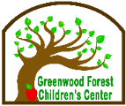
(Behind McDonald’s on Maynard/Cary Towne Blvd.)
Wednesday, October 23, 2019
5:00-8:00 PM
Enjoy a sub for supper before you come to Open House! For Dad’s running here from work…get one to go for him!
When you present this flyer or tell them you are a GFCC parent, they will donate a % of your sale.

