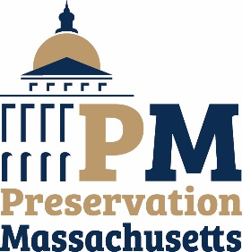
Storytellers
An Inspirational Series

Storytelling is an integral part of history. Stories teach, they inspire, they motivate, they caution. Stories tell where you have been and where you are and where you hope to go in the future.

Preservation Massachusetts is excited to launch a new bi-monthly feature called Storytellers. Storytellers will share a local preservation story that can serve to educate and inspire others. It may be the tale of saving an historic church, of community outreach and constituency building or the bricks and mortar of an actual restoration project.

Preservation Massachusetts wants to share local individuals and group’s successes, challenges and yes, even failures. Because there is always a silver lining and that lesson can help someone facing a similar issue.

Tell your story and through us, educate and empower fellow advocates all across Massachusetts and beyond!

To submit to Storytellers, fill out the form below and return it along with 3-5 images to Erin Kelly (ekelly@preservationmass.org) or mail to our office at 34 Main Street Extension, Suite 401, Plymouth MA 02360.

Note: PM will not publish a person’s address, email or telephone number, this information is for our internal records only. We will only publish contact information if permission is specifically requested and granted. All submissions (text and images) to Storytellers become the property of Preservation Massachusetts for our use for Storytellers and other organizational promotion and publications. Contact takes full responsibility for the validity of all statements and information provided to Storytellers. Preservation Massachusetts retains the right to approve and/or deny any submissions.

Contact Information
Name:
Address:
City/State/Zip
Email:
Telephone:
Organization or Business Affiliation
Website:
PM Staff who assisted you (if any)
What is your relationship to the project or issue (private citizen, elected official, commission member, etc.)

A.) Share with us (in approximately 500 – 1000 words) your story (i.e.,: the preservation project/issue/campaign that you worked on in your community). What was the resolution, if any?

B.) What was the biggest “lesson learned” from your experience with this preservation project/issue/campaign?

C.) What service(s) or guidance did Preservation Massachusetts or other local groups provide to you or your work. Was it helpful? What resources did you need?

D.) What advice would you give to others facing a similar issue?

E.) Would you like to share anything else about you, your community or your work? Anything unique or inspiring?

F.) Can PM use you as a referral for others facing similar issues?

Help Us Connect You?
We find that “liking” our partners Facebook pages, following on Twitter and other social media can be very useful, especially when sharing breaking news or gathering support! Share with us any means of connecting with you so we can further grow our community and network!

Help Us Connect You!
Facebook
Twitter
Instagram
E-Newsletter
Tell Us: What does preservation mean to you?

Thank You!

