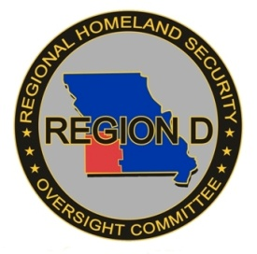
REGION D RHSOC ANNUAL MEETING
Wednesday, October 21, 2020
9:00 A.M.
Mt. Vernon Arts & Recreation Center
822 W Mount Vernon Blvd.
Mt. Vernon, MO

MEETING AGENDA (Revised)

Open Meeting Chris Berndt
- Opening Comments/Pledge of Allegiance
- Roll Call/Introductions
- Approval of Consent Agenda
OCTOBER 21, 2020 MEETING AGENDA
MINUTES OF JULY 15, 2020 MEETING
(RHSOC ACTION REQUESTED TO APPROVE CONSENT AGENDA)

RHSOC Membership Changeover Chris Berndt
- Introduction of New Members

Committee Reports
- RHSOC Chair Meeting Chris Berndt
- Exercise/Training Report Melissa Duckworth
- TICP/WebEOC Working Groups Jonathan Ayres
- Strategic Plan Working Group Ted Martin

Old Business
- SHSP Procurement Updates Dorothy Wittorff-Sandgren
- Inventory Disposition Requests Dorothy Wittorff-Sandgren

New Business
- Region D RHSOC By-laws Addition Dorothy Wittorff-Sandgren
(RHSOC ACTION REQUESTED TO APPROVE CYBERSECURITY TO BY-LAWS DISCIPLINES)
- 2020 THIRA Chris Berndt

Federal/State/Regional Partners
- OHS/HSGP Updates Chelsey Call
- Interoperable Communications Bryan Courtney
- Cybersecurity Angie Robinson
- DHSS Update Douglas Baker
- DNR Update Wendell Hall/Carl Harris
- Agriculture Bill Pittenger
- Mutual Aid Kevin Virgin/Eric Hartman
- Incident Support Team Scott Moore

Annual Reporting Chris Berndt

Disciplinary Group Reports

Other Business/Open Discussion

Next Meeting Date

Adjourn

