**Rummikub Played by Fame**

**Gal Gadot**

<https://www.youtube.com/watch?v=OJJMVLPdAwY&feature=emb_share&fbclid=IwAR0-pHBVpOqEhHc78Ccn-FbkrdyDMbjk6OszcCZgqW5fjinmq6DgLhQQRd4>

Favorit board game: Rummikub



**Camilla Parker Bowles**

<https://www.pinterest.com/pin/404198135280012394/>

The Duchess of Cornwall Camilla looked a bit overwhelmed when the kind ladies from the "Rummikub" club set out to teach her the basic rules

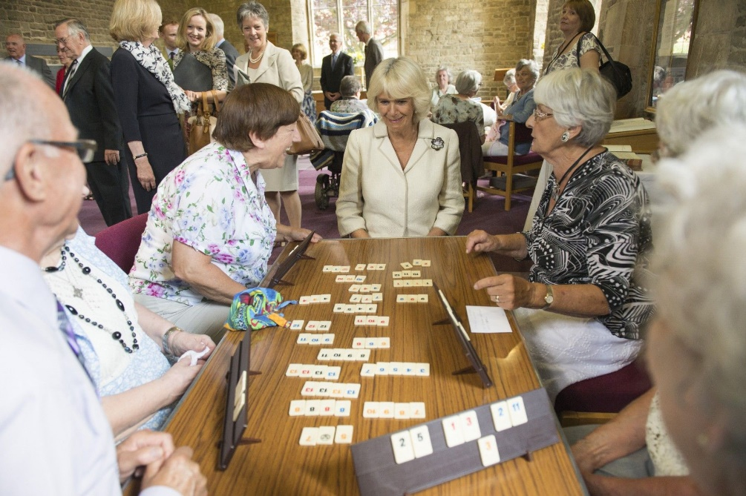

**Silvio Berlusconi**

<https://www.theguardian.com/media/2011/feb/08/wikileaks-cables-diplomacy-madhouse>

sometimes prefers a quiet night in playing Rummikub with fellow septuagenarians.



**Rebel Wilson**

<https://celebrity.nine.com.au/latest/rebel-wilson-holiday-with-barbra-streisand/4ab66f1b-08f3-443b-ba9f-dae72872557c>

"She taught me how to play this game called Rummikub. It's like a little board game and she taught me and now I'm like a master at it. It's good, I just actually ordered one from Big W for my Australian house," Wilson said.



**Barbra Streisand**

<https://www.realclearpolitics.com/video/2018/11/03/streisand_on_trump_i_couldnt_sleep_nights_i_eat_a_lot_and_play_card_games.html>

You have to play Rummikub



**Nicole Richie**

<https://ca.style.yahoo.com/nicole-richie-wants-david-foster-worst-stars-reveal-biggest-holiday-shopping-secrets-nowwith-launch-001655103.html>

Gifting is important to Richie, who said that the most thoughtful present she’s opened recently came from a close girlfriend of hers. “She got me a really nice **Rummikub** set. We play a lot of games at my house. **We bring a lot of people together, so I thought it was a thoughtful gift,” she disclosed**.



**Hilary Duff**

<https://stylecaster.com/beauty/operation-recharge-hilary-duff-self-care/>

"I love to play **Rummikub**"



**Elizabeth Hurley**

<https://www.spearswms.com/diary/>

I like games and my other obsession is Rummikub.

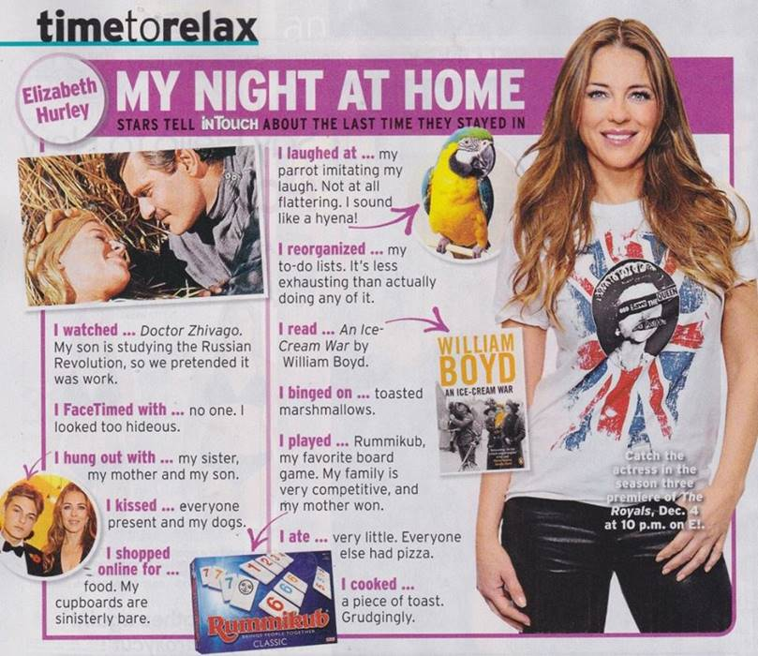

**Lauren Graham**

<https://www.goodhousekeeping.com/life/entertainment/a41777/lauren-graham-how-to-be-happy/>

They enjoy outdoorsy activities like skiing, cycling and snowshoeing, but at home, life is simple: They grill, play the parlor game **Rummikub** and ...



**Reba McEntire**

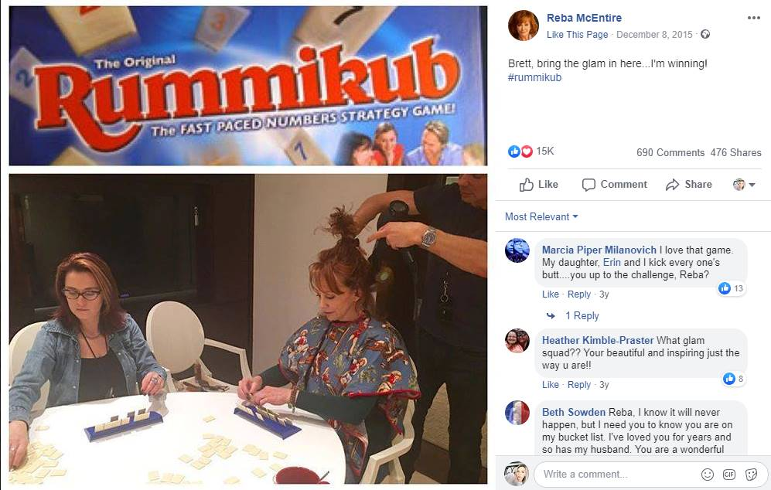

**Mirai Nagasu**

<https://www.cosmopolitan.com/entertainment/celebs/a13796605/mirai-nagasu-figure-skater-olympics/>

**13. And she's a big fan of board games.**Rummikub and Settlers of Catan are particular favorites, Mirai [told U.S. Figure Skating](https://www.youtube.com/watch?v=lN_NX7wCXEI).



**Katherine Johnson**

<https://www.thegazette.com/subject/news/nation-and-world/nasa-human-computer-katherine-johnson-turns-100-20180831?fbclid=IwAR18x7eb_3Fe9tQd3rPf20aorMSDlM4Ov4LB5RtyeNhxBgANZOwGZPo7C00>

NASA's 'Human computer' turns 100 Katherine Johnson: 'I'm just lucky'  
She is hearing-impaired and soft of voice, but Johnson loves company and conversation and she still displays a playful wit. She enjoys playing bridge, as well as board games. [#Rummikub](https://www.facebook.com/hashtag/rummikub?source=feed_text&epa=HASHTAG&__xts__%5B0%5D=68.ARCa4baKoPHBujS3uMbMUFOcKLZeLkp1V6Qauuf9jFAVpgn9pwG9cof5qc0-BvDcJ47Om5VAHins52shz0vQrGA0JMZCb9fpStAlGot8rrtJUPjOSoJvVbg6NxyNv4EDIisx05OiFsvrOEGOkbwjKxu19AMihLu2nOsvsRoJeUTDVJEdBBZ-IyUT6kBfoVIh-P-wf3v-37Mye3-f_2m0j9H5KHAQT_BiqDv-IJem7QHWjVRK0yZGNVoDsbmCEn8JBec2-dNk0JYjAbJU7JICzua9pGhYuRQIhzMozFbcFjGs9wNqcXSAEuyBYPn_7FnxO9l8WVbKK3Uo_jGJY76fNSO6dw&__tn__=%2ANK-R) is a current favorite.

<https://vistyr.org/photoalbums/sisters-at-play>

