P.A.G.R Prescriptions

EirSystems’ first product, P.A.G.R. Prescriptions (Prescription. Abuse. Greatly. Reduced.), is an e-prescribing and medicine reconciliation platform leveraging Hyperledger’s Fabric blockchain. The focus of our product is to combat the Prescription Drug Crisis and to improve medical data interoperability. P.A.G.R. Prescriptions is an e-prescribing product that has safety measures built into the prescribing process and is also a secure third-party database that aggregates relevant historical patient data. P.A.G.R. Prescriptions’ secure and interoperable platform allows credentialed healthcare officials to write prescriptions, perform medicine reconciliation, and accurately track the movement of all prescriptions in one easy to use web interface. Our database can be used by certified organizations for analyzing prescription activity and inform medical officials about appropriate safety measures and care for patients receiving prescriptions.

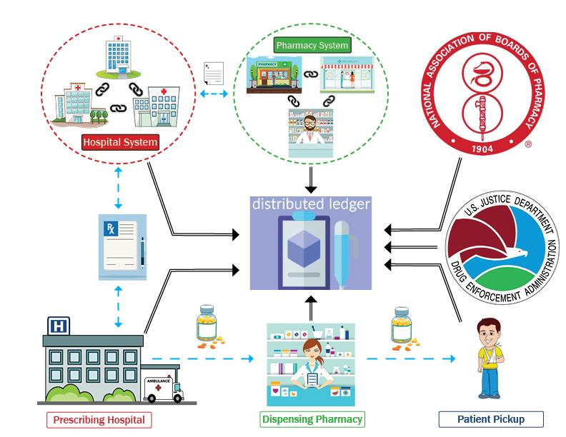
The Figure below demonstrates the entire prescribing process of P.A.G.R. Prescriptions. P.A.G.R. tracks every movement of a prescription drug on a distributed ledger that is viewable by all verified parties on the blockchain.

The Opioid Crisis killed 116 people every day and created an economic burden of $115 billion in 2017. That same year, it was declared a national health epidemic by President Donald Trump. This cost is projected to reach $200 billion by 2020. The systems in place today are manipulated by addicts and pill mills. E-Prescription platforms are difficult to manage, causing hospitals, pharmacies, and government agencies to regularly make mistakes. These errors allow those who are acting maliciously or out of desperation to get their hands-on opioids. The healthcare market needs a new technology to stop this from happening.

P.A.G.R Prescriptions utilizes blockchain technology to produce its e-prescribing system. This system acts as a supply chain manager for prescribing that brings three unique benefits to hospitals, pharmacies, and government agencies:
- Prior-Authorization – Before P.A.G.R Prescriptions submits a prescription to the pharmacy, our software checks the medicine against the patient’s insurance coverage and notifies the prescriber whether or not the medication is covered and affordable. Studies suggest that physicians spend up to 16 hours and their staff almost 55 hours a week, on average, interacting with payers, at a cost of up to $31 billion annually.

- Identifying Medication Issues – Our system automates the prescribing process, and in turn alleviates allergy-to-drug and drug-to-drug interactions that occur due to human error. Drug-to-drug interactions lead to exponentially increased cost of care, especially when opioids are involved. Postsurgical patients experiencing opioid-related adverse drug events have 55% longer hospital stays, 47% higher payment rates associated with their care, 36% increased risk of 30-day readmission, and 3.4 times higher risk of inpatient mortality compared to those with no opioid-related adverse drug events.

- Supplying Appropriate Data at the Point of Prescription – Our software allows doctors to have instantaneous access to PDMP data, arrest records related to narcotics, and relevant past prescription information in a web-based portal at the point of prescribing. Maintaining immutable records of this aggregated information allows doctors to feel confident they are remaining compliant with all state and federal controlled substance prescribing guidelines and laws when prescribing medications.

P.A.G.R Prescriptions is a system that improves every sector of the healthcare industry; from hospitals looking to save time and money in the prescribing process, to pharmacists’ trying to better monitor their patients’ prescriptions, to the federal government which has declared the Opioid Epidemic a national public health crisis. Our product saves the healthcare industry time and money.
There are a wide range of competitors in this industry. At the top of the list are massive medical software companies like Epic, Cerner, and Allscripts. We plan on partnering with these companies through their app-orchards to gain access to their data and use their networks to send prescriptions to the appropriate pharmacies. Other companies like CoverMyMeds and Dr.First are more direct competitors. However, what differentiates us from our competition is our ability to provide e-prescribing access with safety standards integrated into the framework as well as our robust medicine reconciliation platform. Many costly errors have stemmed directly from the inefficiencies inherent to the software these companies utilize.
EirSystems is uniquely focused on marketing our product to physicians in small and rural areas that are greatly affected by prescription misuse and do not currently have any e-prescribing systems in place. Our business model is aimed at marketing our software as a service to hospitals, pharmacies, and the government.
P.A.G.R Prescriptions can be API integrated into any current system in hospitals and pharmacies or operate as a stand-alone platform. All healthcare providers need to do is pay a small installation fee to upgrade their current system. If no system is currently in place, EirSystems will send IT consultants to set up the node ecosystem on our cloud environment.
It is time for healthcare to catch up with technology and implement a product that provides immediate value.
P.A.G.R Prescriptions is ready to revolutionize the healthcare industry! To learn more about P.A.G.R Prescriptions and how it operates check us out at www.eirsystems.net

