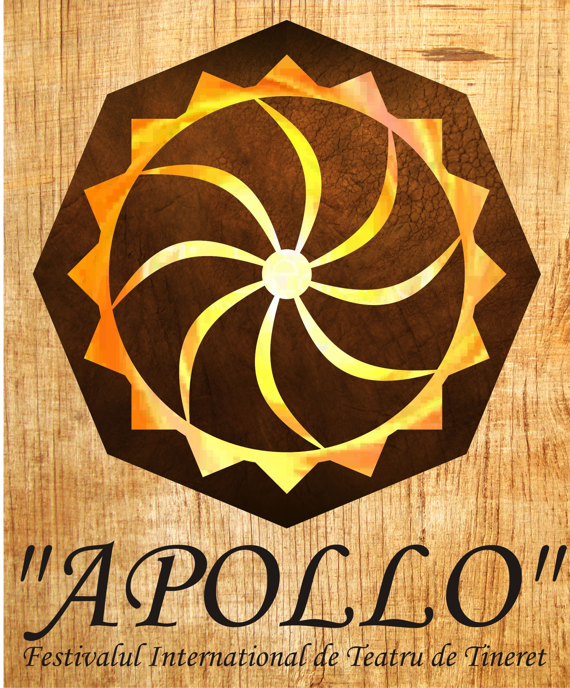
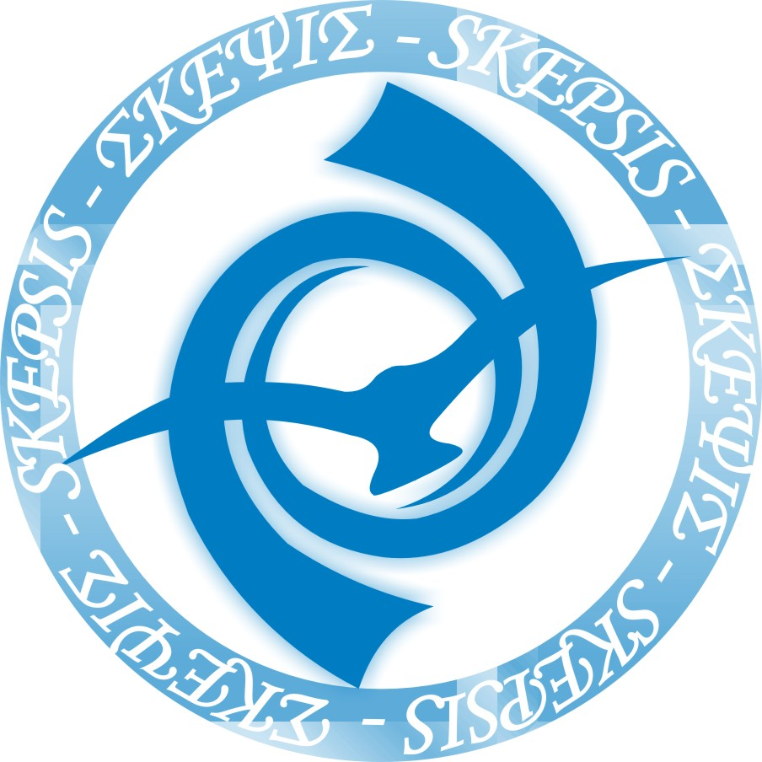
Skepsis Group
Facebook: teatrul skepsis
Mail: teatruskepsis@yahoo.com
Tel. - +40722604402

APOLLO International Youth Theatre Festival
6th edition
09.05.2019 - 13.05.2019
Alba Iulia, Romania

Rules of the festival

” In the Greek mythology, the god Apollo is the patron of the arts, healing and prophecy. We decided to give the name of the ancient god Apollo to our festival – we believe that the art can help us discover subtle meanings of reality, that art heals and may be a source of revelations under the mysterious meeting of the artist and the public. We wish that this festival become a permanent invitation to expression and discovery for all those who are young at hearts. Apollo is not just a festival, is an exploration of the human spirit, a celebration of its creativity and passion.”-
- Skepsis - project team

Considerations:

APOLLO festival is organized by Skepsis Group Association on a social partnership, with the support of local authorities and institutions, media partners and local sponsors. The main goal is to promote Alba Iulia as a citadel of arts, as a landmark in the international youth cultural events.
APOLLO Festival is an invitation for young theatre groups (age range of the group: 18 to 35) to come together, learn and perform in Alba Iulia, Romania.
During the festival’s days, different performances will be presented for the public – as the invited groups come from different schools and orientations in their theatre vision, having different backgrounds. Workshops conducted by a professional and discussions are to be held also, so that participants will have the chance to improve their abilities, to learn new ideas of development and to get a useful feedback - as APOLLO encourages intercultural dialogue.
Each year APOLLO proposes an idea, a concept that represents a symbolic theme of the event. The festival it is not a competition, it’s main goal being to offer to the participant groups the chance to present their work and to build bridges, to develop collaboration relationships and to share experiences by exploring together in the artistically spirit of opening and understanding. APOLLO is not a competition - there are no big prizes, no rewards in money, and no special hierarchy distinctions. Every group present will receive the public’s appreciation, participation diplomas and a personalized trophy – original works of art signed by Stefan Balog (Artist).

APOLLO: General Rules

The organizing committee has concluded to the following guide lines for the festival:

- Keep the whole event informal as much as possible - Apollo challenges the participants to express themselves, make friends and learn from each another;

- The theme concept for 2019 edition of the festival is “Fire”- The Festival will host an International Poster Exhibition on the theme (The Rules and Application for participating are promoted separately by “Inter-Art” Foundation, Aiud)

- Apollo encourages respect for the work of each participant group - participants should attend all parts of the program;

- The festival is not to be considered in any way a contest – all groups will compete only for conquering the public;

- Participant groups must not exceed 8 members (Director, Artists, Tech.Pers., Drivers) – all groups will notify the Organizer on extra-members and will assume costs for their food and accommodation (for extra);

- The age range of the group must be 18 to 39 years old – the age range is directly linked on the group as a whole. You may have persons under 18 or over 39 as long as the group, as a whole, keeps an age range between 18-39;

- Every group will do a traditional, experimental, classical or modern performance, preferably without an intermission with duration of 45-60 (exceptions may be approved only by the Organization committee). As a general idea, performances will be addressed to an international public;

- Preparations for the performance must not exceed 60 min;

- Deadline for application forms: 31.01.2019;

- The groups will be notified and will confirm their participation no later than SUNDAY 17.02.2019.

- The official opening will be on 09.05.2019 and the official closing of the festival will be 13.05.2019;

- The day of arrival will be 09.05.2019 and day of departure will be 13.05.2019 –. Participant groups will notify ahead the Organizer on arrival and departure. In the eventuality of extra-days the participant groups will assume costs for food and accommodation of their members;

- Each participating group will provide its members with health insurance and will take full responsibility for any underage members;

- Participant groups will take all steps in obtaining official documents for entering Romania – the Organizer will assist the legal process within legal frame and will send official invitations to all selected groups.

Expenses/funding:

1. APOLLO festival funds will cover:
– all parts of program
- everyday meal (3 meals/ day) and accommodation for all the participants, according to Application Form received, during the festival days only.- if you have any food limitations, please write it into the application form.

NOTE: Funding and organizing the festival must ensure everyone’s needs and a lot of financial decisions have to be made properly. All groups invited will discuss ahead with the Organizer on arrival and departure – once confirmed and fixed, any extra-day (food and accommodation) will be covered by participant groups;

2. Participant Groups
- Participant groups cover their travel expenses to Alba Iulia and the cost for additional members (if there are more than 8).

Selection of performances:

- APOLLO will have a separate dimension for University groups from Romania
-APOLLO will select mainly performances that have the ability to reach to an international audience;
-Preparation time for your performance can’t be longer than 60 minutes;
-You must send us your technical requirements (audio, sound and props) in the application form so that the Organizer will confirm;
- You can perform in a large, classical theatre hall (320 places capacity), a studio hall (60 places capacity) non-conventional location (small art cafe) or in the open-air. Please let us know in the Application which one you would prefer.

Any questions you might have: teatruskepsis@yahoo.com

We welcome you to Alba Iulia, the most important historical city in Romania, to join APOLLO International Youth Theatre Festival! A young at heart public awaits your performance!

Usefull links for more informations:

- On Alba Iulia:
Short video: https://www.youtube.com/watch?v=GLXVM4E0Yvk
About: https://www.facebook.com/visitalbaiulia/?hc_ref=PAGES_TIMELINE

- About the Organizer: https://www.facebook.com/skepsis2002/

- About APOLLO festival, past editions and history: https://www.facebook.com/Apollo-International-Youth-Theatre-Festival-Alba-Iulia-515279921909080/

Partners: Alba Iulia Municipality; Alba Iulia Student’s House of Culture; “Inter-Art” Foundation Aiud; Alba Community Foundation; National Museum of Unification Alba Iulia; „1st December 1918” University Alba Iulia.

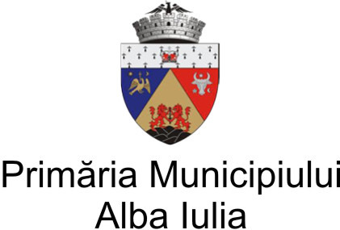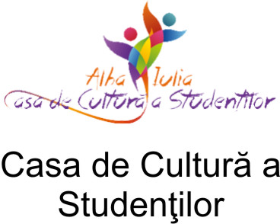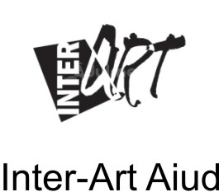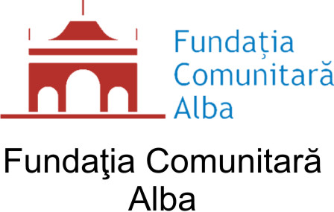

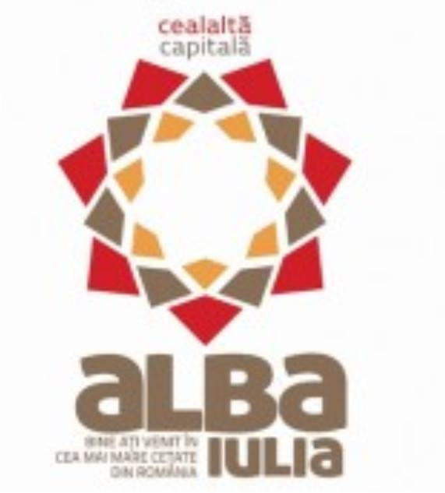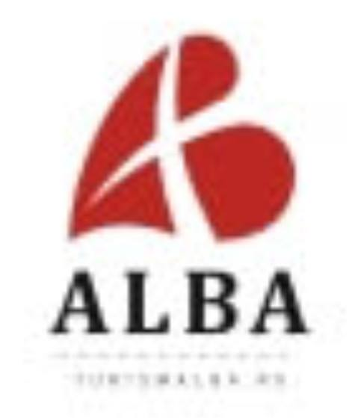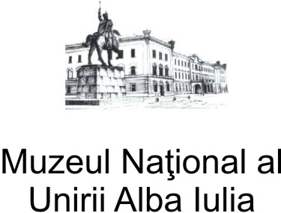

Parteneri Media/Media Partners:; Ziarul Unirea;Radio Reîntregirea;; Radio Unirea FM; Radio Cluj; Plaiuluminatu; ProAlba; Alba 24; Urbea Mea; Albastiri.ro.; viziteazaalbaiulia.ro; Cugir Media; Moldova 9

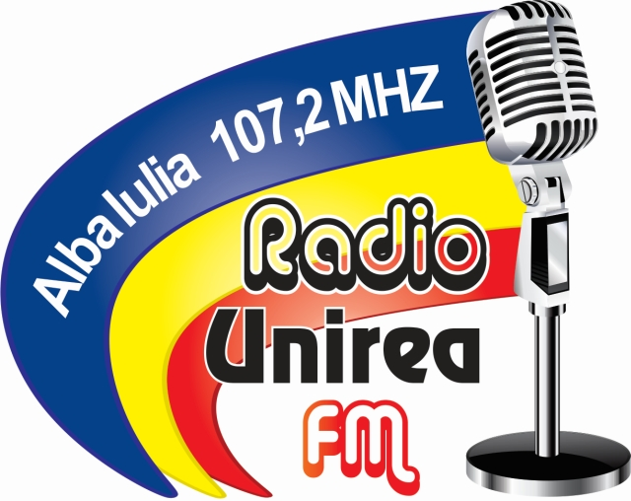

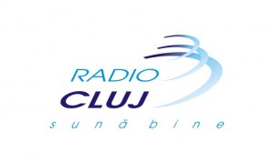



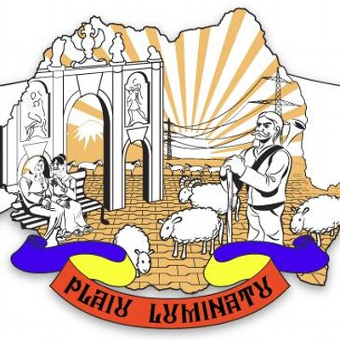



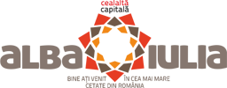
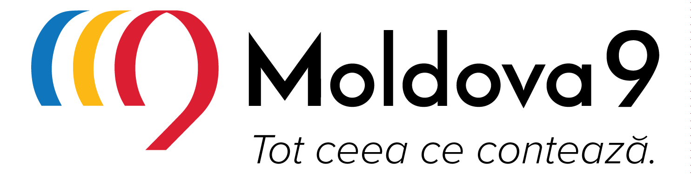


Sponsori/Sponsors: S.C Tipo-Rex S.R.L.; S.C. Supremia Grup S.R.L; Loco Profiles; SC Eurokaf Marketing SRL; Active Service Corp SRL; Restaurant Steak House


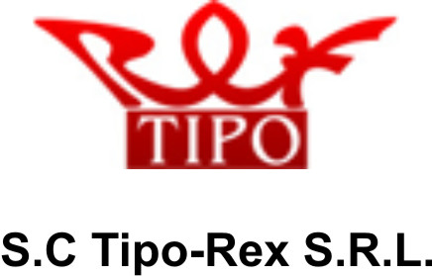

Organizer: Skepsis Group Association

