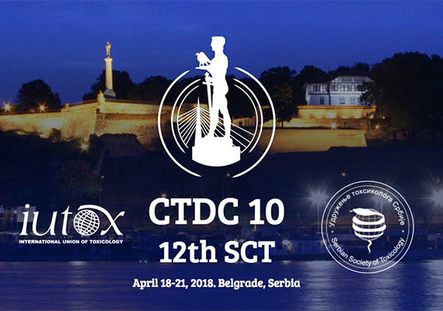

Travel Awards to Attend the
10th Congress of Toxicology in Developing Countries (CTDC 10) and the 12th Serbian Congress of Toxicology will be held on April 18–21, 2018
in Belgrade, Serbia

The Serbian Society of Toxicology (SETOX) and IUTOX announce the availability of fellowship awards to attend the 10th Congress of Toxicology in Developing Countries. The meeting will be held in Belgrade, Serbia, April 18-21, 2018.

The awardees may be either junior or senior scientists from a country where toxicology is underrepresented and have an active research program or currently be active in the practice of toxicology. The following criteria will be used to select award recipients:

• A brief statement indicating how the awardee will benefit from the fellowship;
• Curriculum vitae including e-mail address and, if available, a fax number;
• A strong letter of recommendation from the home Society. If the applicant
does not have a national toxicology society, a strong letter of recommendation
from his/her department may be substituted;
• Demonstration of the ability to meet other expenses to attend the meeting (the
travel awards available range from $500 to $2,000); and
• Copy of abstract submitted to CTDC10/12th Serbian Congress of Toxicology for review.

Award submissions must be received no later than 15 November 2017. Previous award recipients of 2014, 2015, 2016, 2017 or 2018 ICT, CTDC, or other IUTOX Fellowships are NOT eligible to apply. Awardees will be notified in December 2017. Awards will be issued at the CTDC10 meeting.

Award information is available on the IUTOX and Congress websites:
www.iutox.org
http://www.ctdc10.rs

CTDC10/12th Serbian Congress of Toxicology Travel Award
2018 Application

First Name: M.I.: Last Name:
Organization:
Department:
Address 1:
Address 2:
City: State: Zip Code:
Country:
Phone: Fax:
Email:

Is the candidate a Junior Scientist? Yes No
Is the candidate a Senior Scientist? Yes No
Year PhD Received:
Is Toxicology underrepresented in the candidate’s Country? Yes No
Which Country?
Does the candidate have an active research program? Yes No
Is the candidate currently active in the practice of Toxicology? Yes No

Has the candidate submitted: (attach files to submission email)
1. A brief statement indicating how awardee will benefit from the fellowship? Yes No
2. Curriculum Vitae including an email address and fax (if available)? Yes No
3. A strong letter of recommendation from the home society? Yes No
4. Statement certifying ability to meet other expenses to attend the meeting? Yes No
5. An abstract for the meeting? Yes No

