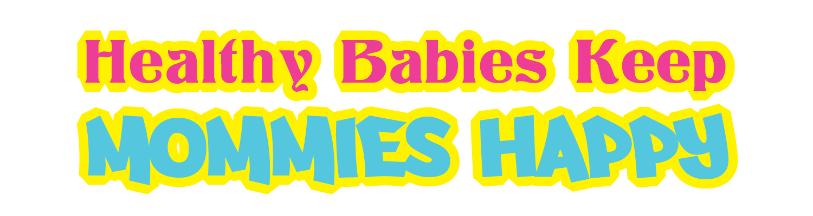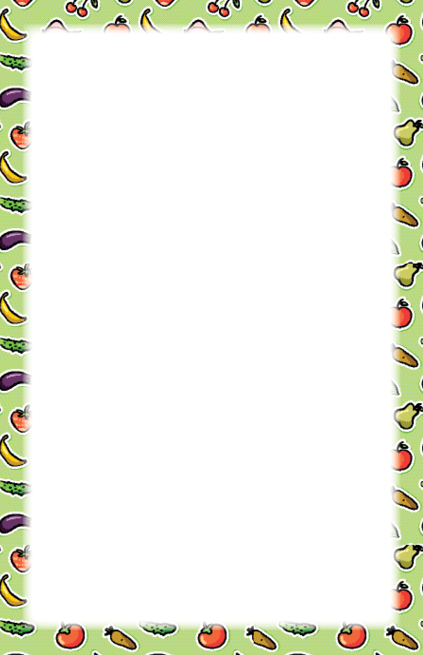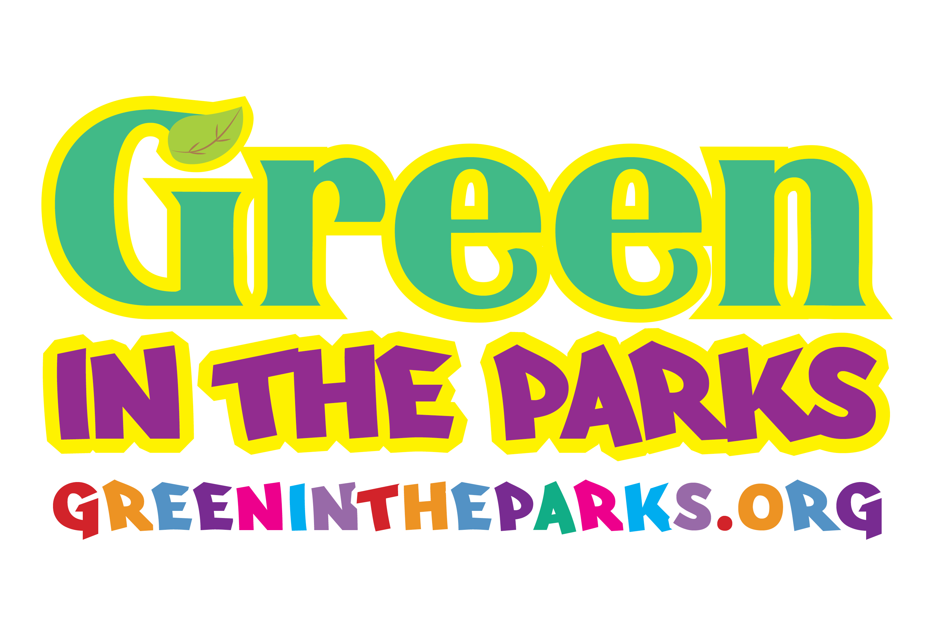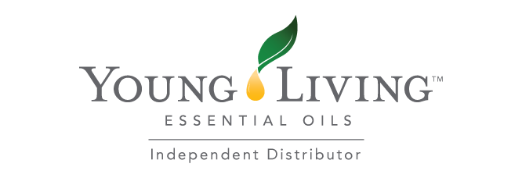

Come join us for a **free fun filled** event  
 on what it means to be **healthy** with your kids! They get to **play,** paint, hula hoop, or participate in a make & take. While you create **non toxic baby wipes**, cleaning wipes,   
hand soap, or something else great for the family! **Chemical awareness,** **cooking   
tips, recipes** & so much more!

Come join us for a **free fun filled** event  
 on what it means to be **healthy** with your kids! They get to **play,** paint, hula hoop, or participate in a make & take. While you create **non toxic baby wipes**, cleaning wipes,   
hand soap, or something else great for the family! **Chemical awareness,** **cooking   
tips, recipes** & so much more!