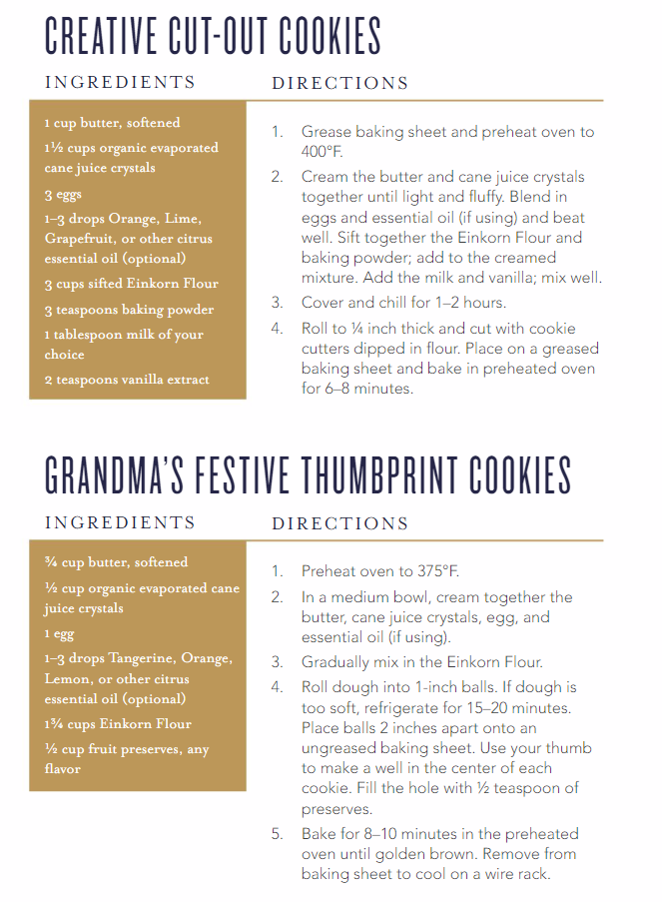
Find these recipes at: https://issuu.com/youngliving/docs/einkorn_cookbook_issuu

