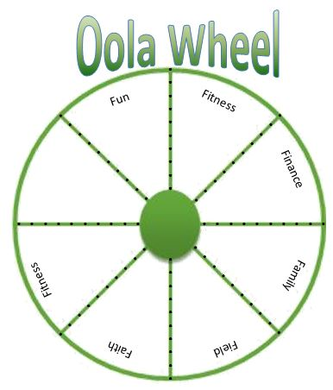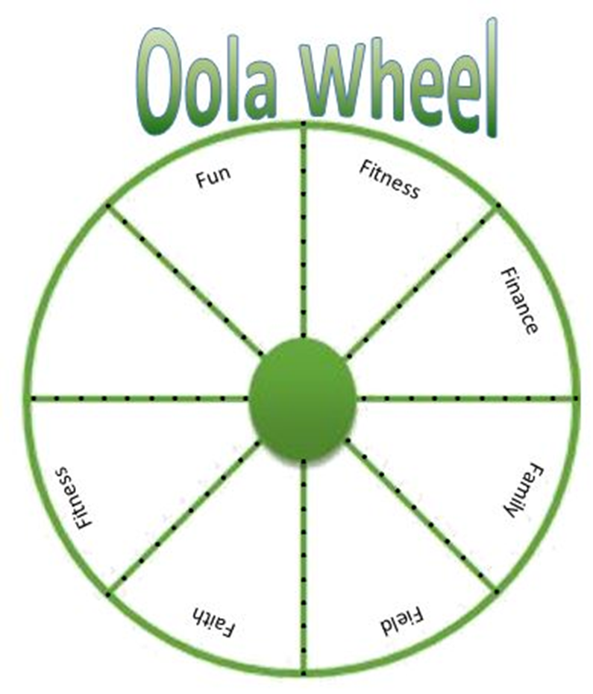

**Date: __________**

**Date: __________**