Commission Artwork and Support Your Rescue
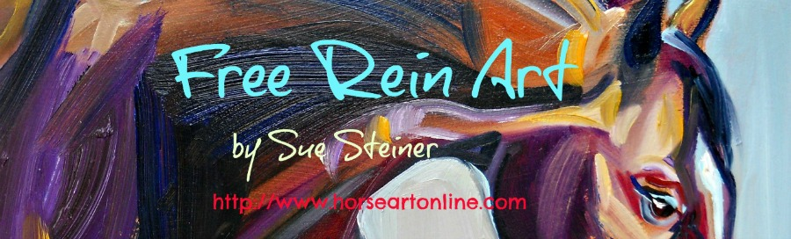
Here’s how:

- Go to http://www.horseartonline.com/custompetportraitart to see price list and artwork examples. Choose artwork size and medium (oils, watercolor or mixed media).
- Send your favorite rescue or charitable organization a donation. I am suggesting 25% of the artwork but the amount is up to you.
- Contact Sue Steiner at freereinart@outlook.com and send:
  - Conformation of donation
  - Photos of your pet or horse
  - Size and medium of artwork (I can help with this also if you’d like help in what to choose).
  - Any specific deadline dates (birthday etc.)
- Your donation will be considered my deposit. The balance of the 25% off price and shipping is due upon your final approval of artwork. Upon receipt of payment artwork is shipped.
  - This offer is excluded in the months of Oct. Nov. and Dec.
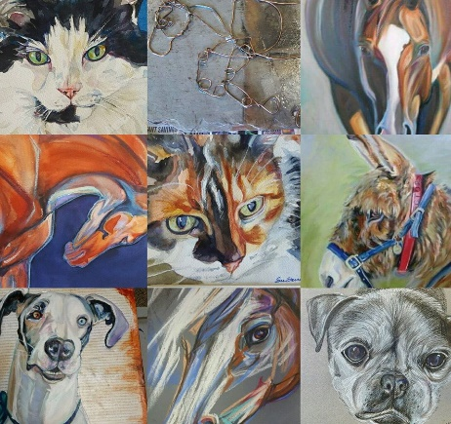
For questions or comments contact Sue Steiner at freereinart@outlook.com

