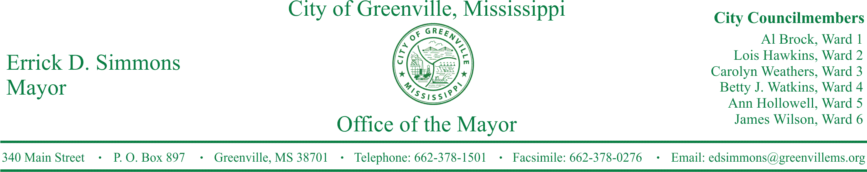
PRESS RELEASE
FOR IMMEDIATE RELEASE For more information contact:
Nikki Landrum
nlandrum@greenvillems.org
662-378-1534

Mayor Simmons announces the 2nd Grade Extravaganza

GREENVILLE, Miss. (May 6, 2016) Today, Mayor Simmons announces the first of a series of tours with second graders to learn about their government and community. The tour includes a lunch and learn at Stein Mart Square and visits to City Hall, Fire Department, Police Department, History Museum, Flood Museum, and William Alexander Percy Library. This event is one of the many events supported by the Mayor’s Educational Roundtable.
The Educational Roundtable was established to strengthen the relationship among all of our schools, the City of Greenville, and community. While partnering with organizations, economic development agencies, and educational institutions, to create and promote policies that will spur innovation and support for our students, parents, and teachers. The first set of second graders are from Riverside Elementary and O’bannon Elementary. Tours with second graders from Greenville Christian School, Greenville Public School District, Washington School, and Our Lady of Lourdes Catholic School will follow.
The itinerary is as follows:
8:45 Students will arrive at City Hall

9:00 – 10:00 Meet the Mayor and Tour City Hall

10:15 – 11:15 Visit the Library

10:15 – 11:15 Tour the History and Flood Museums

11:15 Lunch at Stein Mart Square

11:45 Visit the Post Office

11:55 – 12:15 Break

12:20 – 1:30 Visit the Police Station and Fire Station

1:30 Depart

STATEMENTS
Errick D. Simmons, Mayor I am very excited have a lunch and learn with 2nd graders with our public, private, and parochial schools. I’m very appreciative of Mrs. Pierce coming to the Mayor’s Office to present such fun and education idea. Learning about your government and community fits right into the 2nd grade curriculum in social studies. Second graders know more than you think they know.

Amanda Pierce, 2nd grade teacher from Riverside I’m extremely happy about the community coming together and working for the betterment of all children. It makes my heart smile to know that Mayor Simmons and his staff are so open.

###

