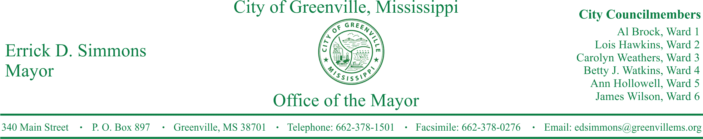
PRESS RELEASE
FOR IMMEDIATE RELEASE For more information contact:
Kenya L. Collins
kcollins@greenvillems.org
662-379-3543

Greenville Fire Department Investigates Local Church Burning As Hate Crime
Local, state, and federal authorities investigate church burning as hate crime.
GREENVILLE, Miss. (November 2, 2016) At 9:16 p.m. last night, Greenville Fire Department was dispatched to Hopewell M.B. Church located at 640 North Delesseps in Greenville for a reported church fire. Four units responded to the scene to discover a church engulfed in flames. The church was vandalized with the words, “Vote Trump” spray-painted on the side of the church. Local, state, and federal authorities have been contacted.
The church burning is being investigated as a hate crime. City officials are limited to what may be disclosed. The city is asking that if anyone has information about this church burning, please contact the city at 662-378-1616 and 662-378-TIPS (8477).
STATEMENTS
Mayor Errick D. Simmons
We have contacted local, state, and federal authorities of this hateful and cowardly act. This matter is being investigated as a hate crime. This act is a direct assault of people’s right to freely worship. Moreover, this matter is being investigated with all deliberate speed and we will not rest until the culprit is found and prosecuted to the fullest extent of the law.
###

