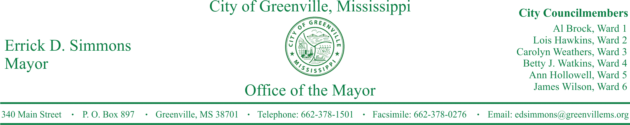
PRESS RELEASE
FOR IMMEDIATE RELEASE For more information contact:
Nikki Landrum
nlandrum@greenvillems.org
662-378-1534

Mayor Errick D. Simmons and Pastor Steven Cantu to Host First Responders Honor Event
Mayor Errick D. Simmons and Pastor Steven Cantu announce event to honor First Responders.
GREENVILLE, Miss. (September 7, 2016) Today the City of Greenville and Grace Fellowship Church announces the “First Responders Honor Event” to be held at Grace Fellowship Church, 3210 Hwy 82 E. Greenville, on Sunday, September 11, 2016 at 3:00 p.m. All first responders and their families are invited to attend.
STATEMENTS
Mayor Simmons said, “I salute and thank our first responders who aid people in this community 24 hours a day, seven days a week to maintain safety and order while protecting and serving with the utmost courtesy, dignity, and honor.”
Pastor Cantu said, "I wish to thank all of our first Responders for their continued dedication in making our community safer. The many hours of hard work and tireless effort are greatly appreciated! We honor you!"
Furthermore, the Honorable Mayor Errick D. Simmons will be declaring September 11th as ‘First Responders Day” in the City of Greenville to honor all of our men and women who serve to protect and defend our community. This event will serve to encourage, strengthen, and honor all of our first responders who daily place their lives in harm’s way to keep us safe.
Participants include: Air-Evac, Med-Stat, Emergency Management Service providers, Greenville Police Department, Greenville Fire Department, Leland Police Department, Leland Fire Department, Metcalfe Police Department, Arcola Police Department, Arcola Fire Department, Hollandale Police Department, Hollandale Fire Department, Indian Mounds Fire Department, Riverside Volunteer Fire Department, and the Washington County Sherriff’s Department.
###

