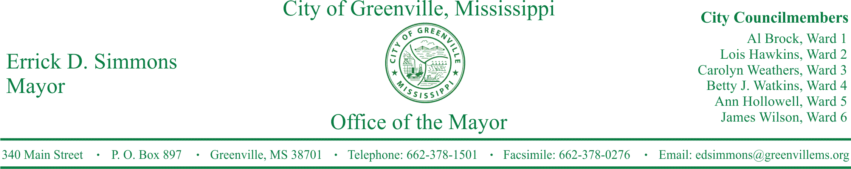
PRESS RELEASE
FOR IMMEDIATE RELEASE For more information contact:
Kenya L. Collins
kcollins@greenvillems.org
662-379-3543

Secretary Delbert Hosemann Announces Online Auction of Properties in Washington County
City, County, and State officials announce online auction of Washington County properties
GREENVILLE, Miss. (June 8, 2017) Bidding begins June 21 in an online auction of 1,085 tax-forfeited prope1iies in Washington County valued at an estimated $4.1 million, Secretary of State Delbert Hosemann announced at a press conference in Greenville today. Almost all of the parcels up for auction in Washington County are within Greenville city limits.
Bids may be submitted online in both auctions on the Secretary of State's online auction portal until Wednesday, July 19, 2017, by 5 p.m. CST. To place a bid, a user is required to register online. Users may view property details such as parcel location, pictures, and an auction map. Other info1mation, such as auction dates, bid notices, and market values of property are also available online. Successful bidders will be notified by e-mail as soon as possible after the auction closes, and payment of the bid amount must be paid within fifteen (15) days of notification. Buyers will also be permitted to pay a "Buy It Now" price on any parcel, which allows them purchase a property immediately instead of waiting until the end of the auction.
STATEMENTS
Secretary Delbert Hosemann
These online auctions are great for local communities because they make it easier for citizens to purchase property forfeited to the State for nonpayment of ad valorem taxes. Formerly neglected properties are restored to the tax rolls and money raised is distributed to cities, counties, and schools.

Mayor Errick D. Simmons
This partnership with the City of Greenville and Secretary of State to dually put tax-forfeited properties back on the tax roll and eliminate the blight that has plagued our community for many years is a great wealth building opportunity for our citizens here in Greenville and Washington County. Additionally, this opportunity will relieve the stress on our budget for lot cleaning and overgrown grass. We are grateful for Secretary Hosemann and his office for their hard work and dedication.
To learn more about tax-forfeited properties, visit the Secretary of State's website or call the Public Lands Division at (601)-359-5156.
###

