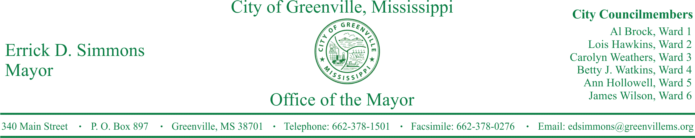
PRESS RELEASE
FOR IMMEDIATE RELEASE For more information contact:
Kenya L. Collins
KCollins@greenvillems.org
662-378-1501

Mayor Errick D. Simmons’s Statement Regarding Incident at Greenville High School
Mayor Simmons’s statement regarding incident between a teacher and student at Greenville High School.

GREENVILLE, Miss. (October 7, 2016) Mayor Errick D. Simmons made the following statement regarding incident between a teacher and student at Greenville High School.

STATEMENTS
October 6, 2016, the Mayor's Office became aware of an incident that occurred between a teacher and a student at Greenville Public School District. The issue was one that raised concerns about staff professionalism and the safety and treatment of our students. As a parent of a student who attends Greenville High, I am deeply concerned like many of you.
Rest assured that all impacted individuals are aware of this situation and the School District has already begun to take appropriate actions to continue its efforts to guarantee the safety, protection, and integrity of our educational environment. No students have been expelled and personnel matters will be handled in accordance to the law to guarantee procedural due process.

I appreciate the swell of interest, concern, and dialogue among the community that continues to indicate the support and zeal for our students.

###

