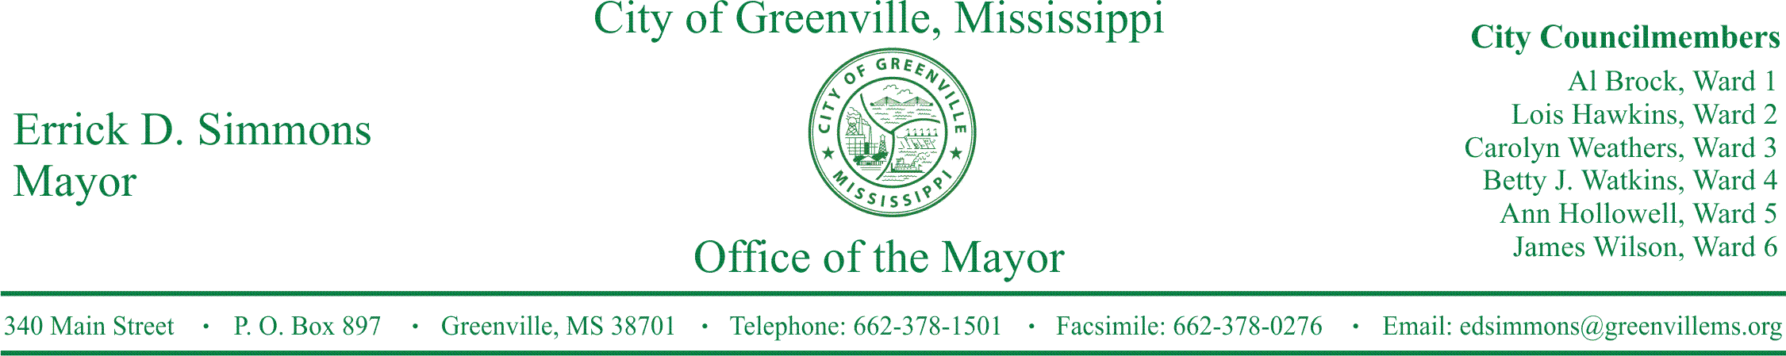
PRESS RELEASE
FOR IMMEDIATE RELEASE For more information contact:
Nikki Landrum
nlandrum@greenvillems.org
662-378-1534

Mayor’s Youth Council announce Clothing Drive for House Fire Victims”

GREENVILLE, Miss. (December 28, 2016) Today, The City of Greenville Mayor’s Youth Council is announcing clothing drive for house fire victims. On Wednesday, December 28, 2016, there was a house fire on East Ollie Circle. The family lost everything. We are asking the community to please donate clothes, shoes, and under garments.
The clothes sizes needed are:
Women size 2x-3x shirts, 2x pants
Girl size 14
Girl size 16
Girls 5T
Boys sizes 10-12
The shoe sizes needed are:
Boys’ size 5 shoe
Women’s size 10 shoe
Women’s size 9 shoe
Women’s size 7 shoe
Girls size 1 shoe

You may drop items off at City Hall, 340 Main Street, the Police Department, 216 Main Street or Headquarter Fire station, 532 Central Street, between the hours of 8a-5p. There will be boxes labeled with each size.
Nikki Landrum, Program Coordinator states, “We want the family to know that we are here to lend a helping hand and show that true empathy and humility still exists during these hard times. We aren’t here to pass judgement but to uplift in a positive matter.
###

