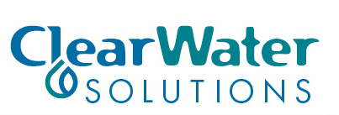
JOB ANNOUNCEMENT

SAFETY COMPLIANCE OFFICER
POSITION:
ClearWater Solutions, LLC (CWS) is currently accepting applications for our Greenville Mississippi project for Safety Officer. CWS offers a competitive salary with annual leave, sick pay, and holiday pay. Also offered are health, dental, vision, life insurance and 401K.
QUALIFICATIONS
The following requirements are needed to be considered for this positon; A High School Diploma or GED equivalent, a valid driver’s license and insurable under our existing vehicle insurance policy, pass drug screen. Applicants must have 1-3 years of experience in water, wastewater or public works or related field of business. Knowledge of State and Federal rules for water, wastewater, and public works industry, oversee and administer employee injury, Workman’s Comp., Insurance, and vehicle claims is also required. Possess good verbal and written skills; be able to conduct classroom training and ongoing training for employees and documentation of training. Knowledge of OSHA required training, documentation, and compliance with all OSHA guidelines. Good Computer skills using Microsoft office applications, Word, Excel, PowerPoint. Applicant must also have good planning and scheduling skills, willing to travel and be away from home, be a good communicator and willing to work with a team.
Send Resumes to: ClearWater Solutions, 340 Main Street, Greenville, MS 38701
Attention: Donde Baldwin or Russell Davis, donde.baldwin@clearwatersol.com or Russell.davis@clearwatersol.com
The Deadline to receive all Resumes will be April 17, 2017.

