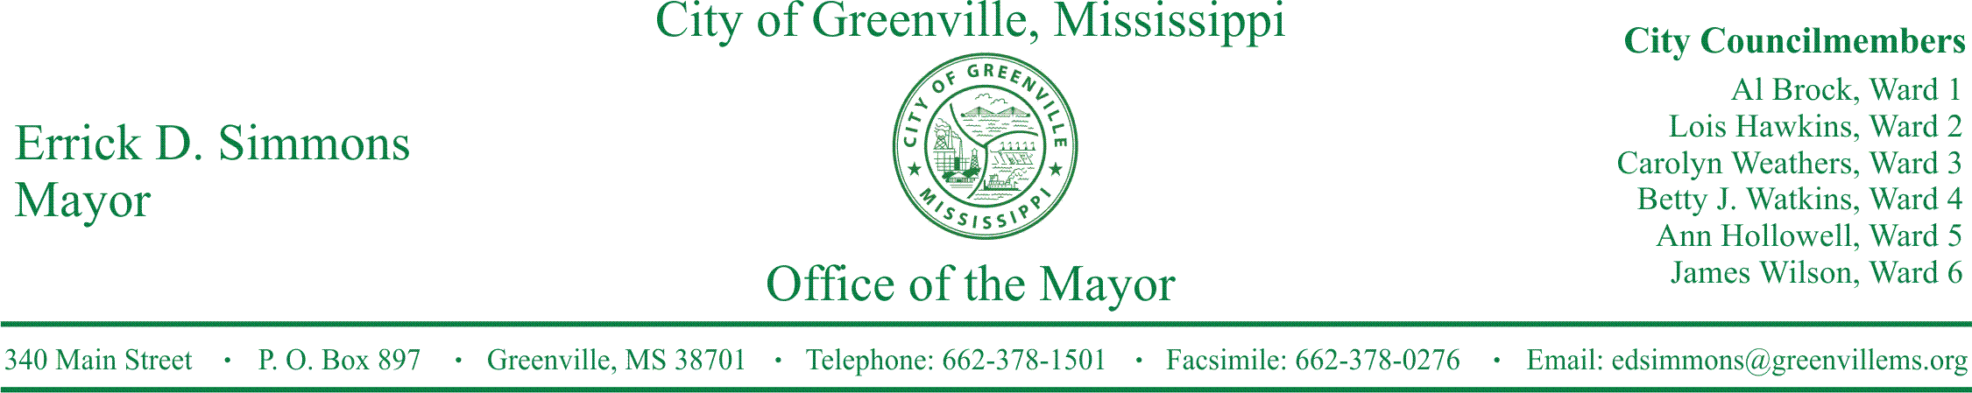
PRESS RELEASE
FOR IMMEDIATE RELEASE For more information contact:
Kenya L. Collins
kcollins@greenvillems.org
662-379-3543

2nd Annual Wood vs. Ville Mississippi Blood Services Blood Drive
Mayor’s Office announces the City of Greenville Community Blood Drive “Wood vs. Ville” Blood Drive

GREENVILLE, Miss. (May 8, 2017) Today, the Mayor’s Office announced Mississippi Blood Services is gearing up for the 2nd Annual “Wood vs. Ville” Blood Drive. The “Wood vs. Ville” Blood drive will be held Wednesday, May 10, 2017, from 10:00 a.m. to 4:00 p.m. in the parking adjacent to City Hall, 322 Main Street.
Donors will receive a T-shirt while supplies last. All donors are asked to please bring ID. MBS suggests that all donors eat at least four hours within giving blood and drink plenty of fluids prior to and after making a donation. Mayor Simmons stated, “While this is a friendly competition between Greenville and Greenwood, we can’t let them beat us again. The need for a healthy and reliable blood supply to help save lives is constant. This year we encourage all city employees, family members, community members and all surrounding areas to come out and help save lives by donating the gift of life. Let’s beat Greenwood and give to a worthy cause”.

###

