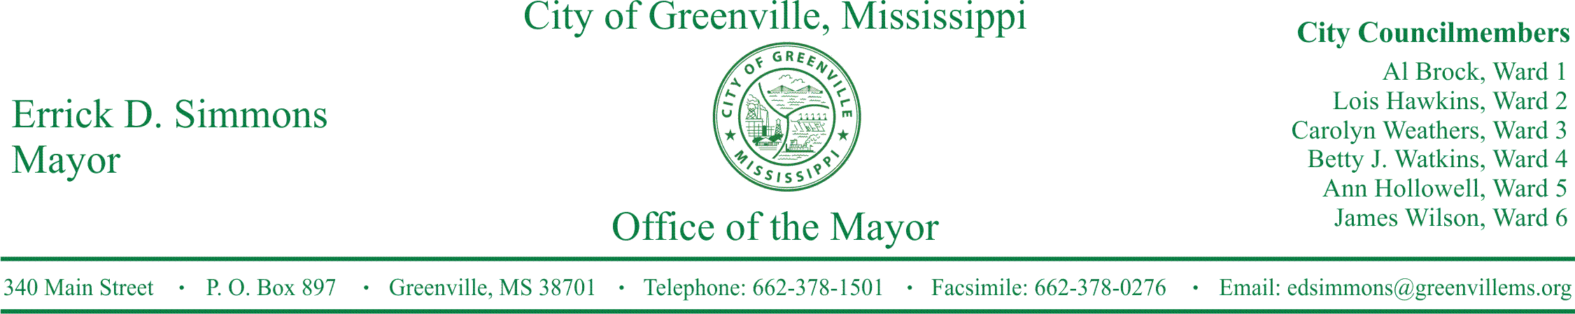
PRESS RELEASE
FOR IMMEDIATE RELEASE For more information contact:
Kenya L. Collins
kcollins@greenvillems.org
662-379-3543

Office of the Mayor Announces Applicants for Greenville Public School District Board of Trustees
Office of the Mayor Announces Applicants for Greenville Public School District Board of Trustees
GREENVILLE, Miss. (January 6, 2017) Today, the Office of the Mayor announced the applicants for Greenville Public School District Board of Trustees. The list of applicants are people who have submitted their applications to the Office of the Mayor. All applicants will have to be vetted through the City Clerk’s Office to make sure applicants are residents of the Greenville Public School District and registered voters in the City of Greenville. Mayor Errick D. Simmons stated, “I’m very pleased to see we have a large group of applicants interested and willing to serve on the school board to serve our children.” The deadline to apply was today, January 6, 2017, at 5:00 p.m. Once vetted, the final list of eligible applicants will be released by the City Clerk’s Office.
GPSD Board of Trustees Applicants
- Alyce “Betsy” Alexander
- Ezell Landrum
- Sharde A. McClure
- Barbara McCoy
- Ozell Pace, Jr.
- Earl H. Taylor
- Doris J. Thompson
- Debra Denise White
- Theautry Winters
###

