Flat Sharon in HOLLYWOOD!

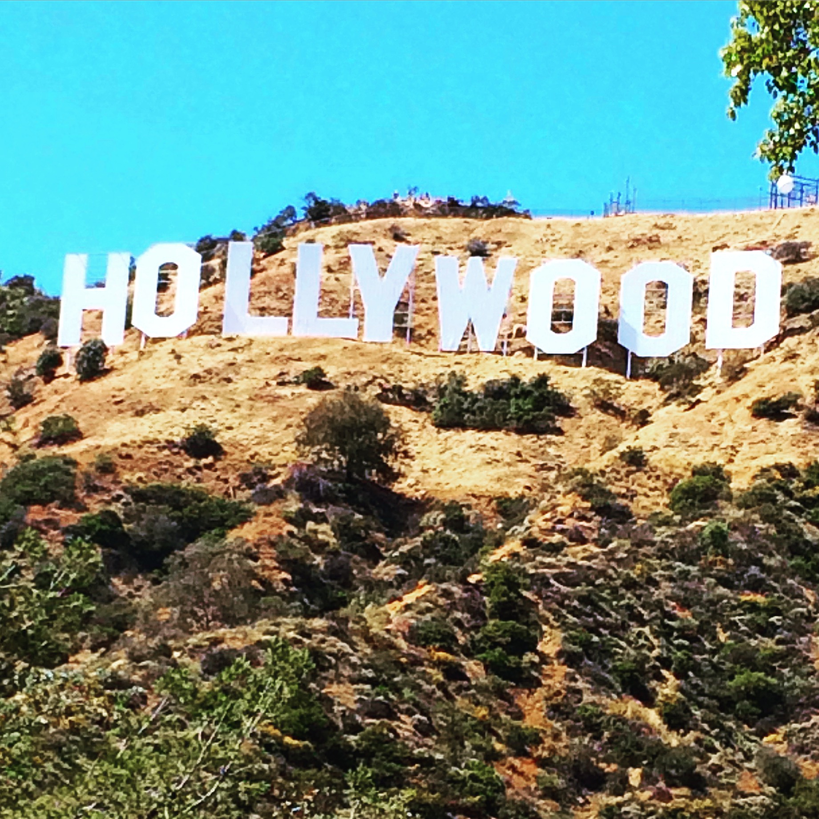
Written by: Laura Deer (aka: Auntie L)
Written for: Sharon Kauffman
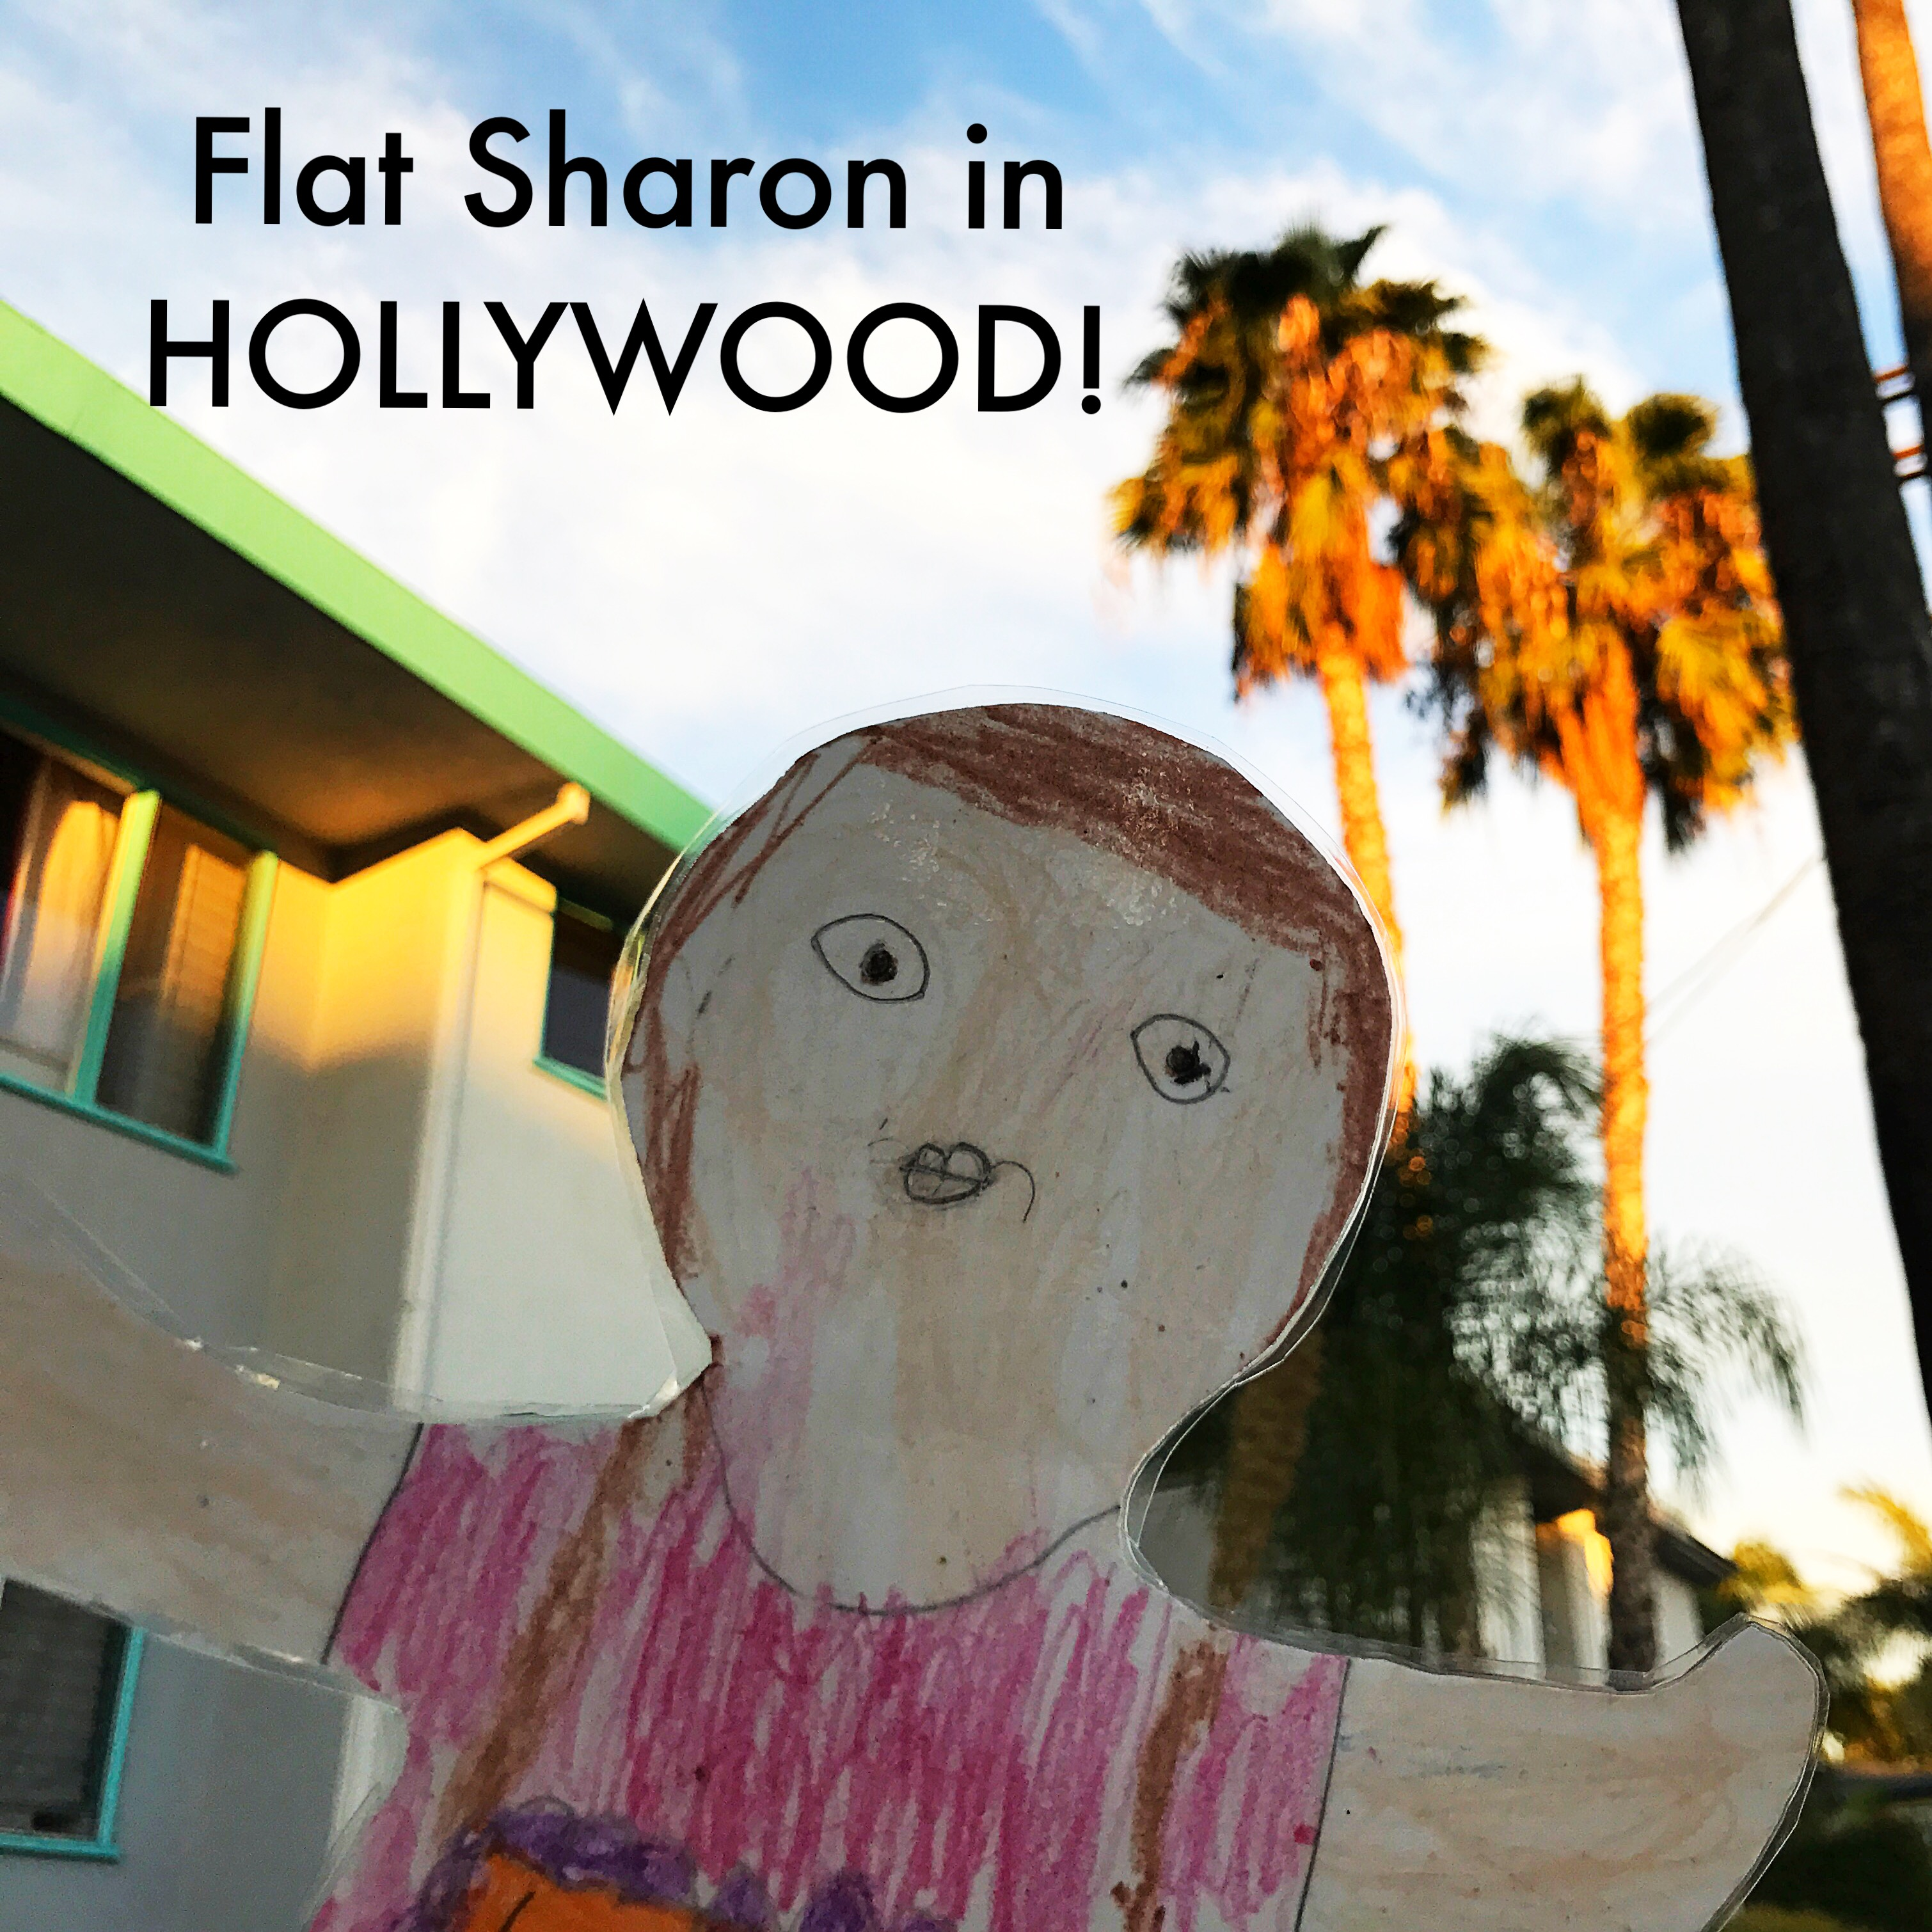
Flat Sharon went to Hollywood, CA to visit her Auntie L. She said, “I am here to watch for Rainbow Connections. These are acts of kindness that happen all around the world. I want to see what Rainbow Connections I can find in Hollywood!”

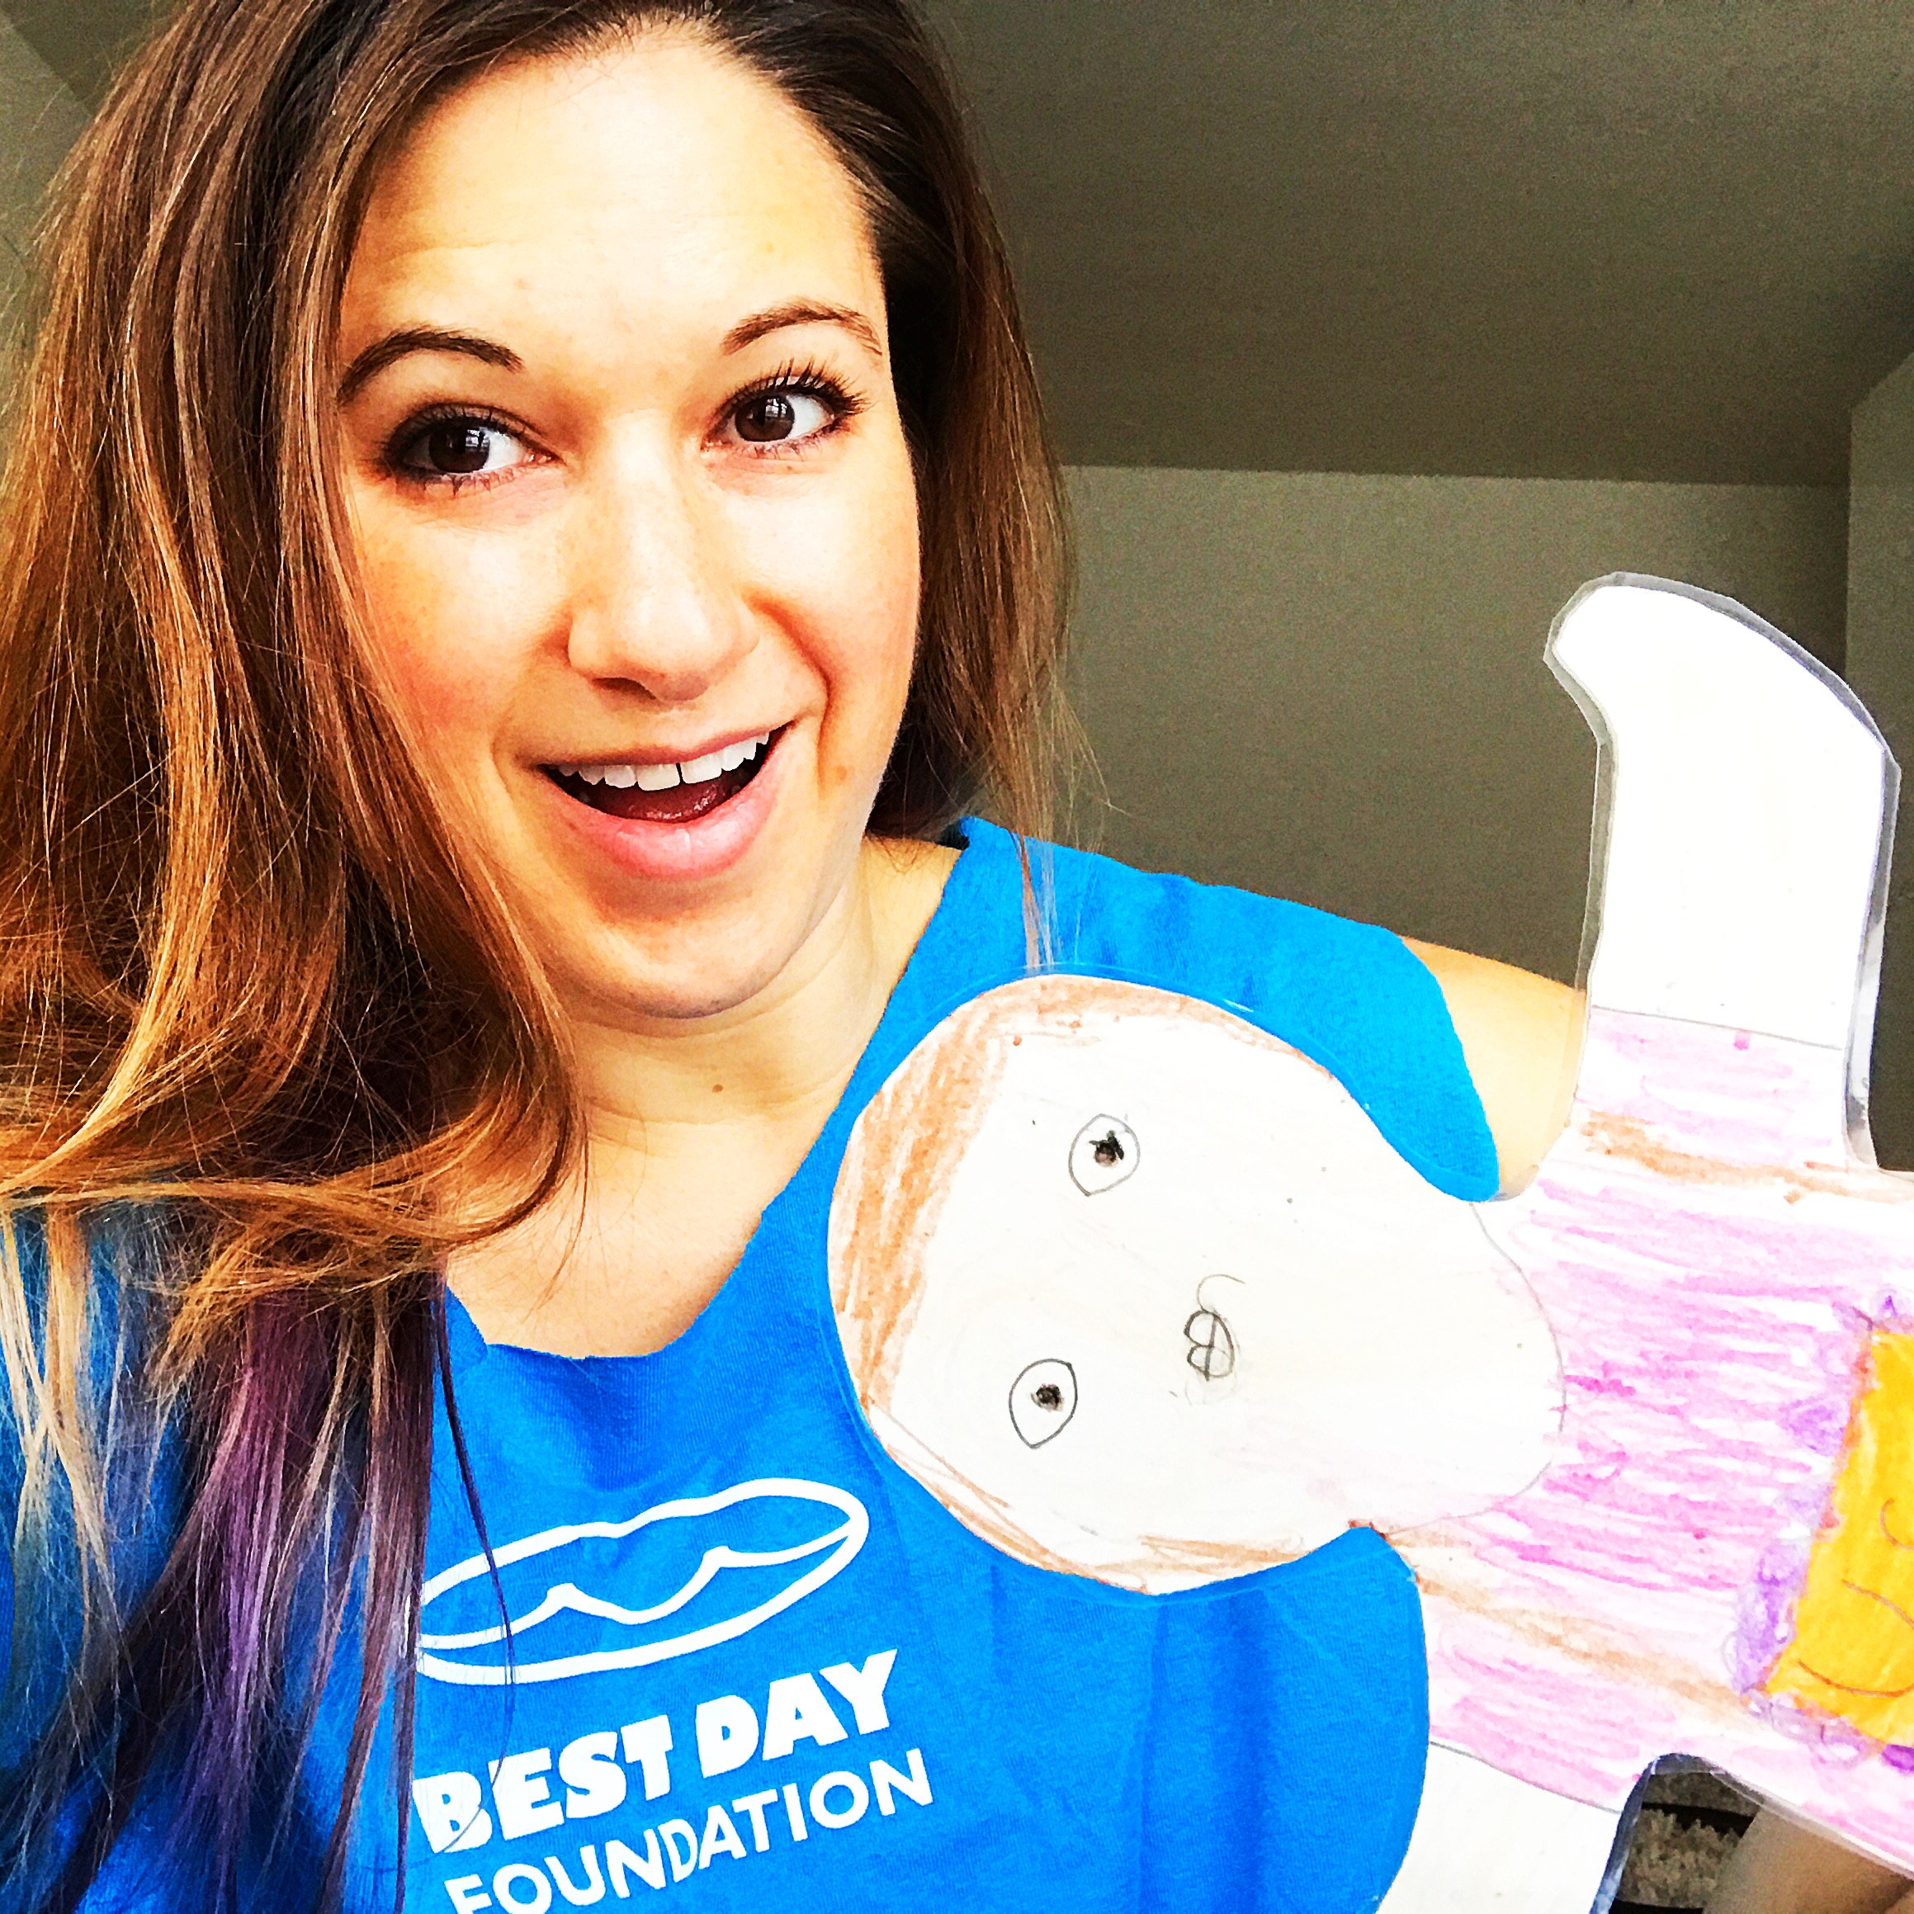
Auntie L said, “I can tell you about the Rainbow Connections I’ve seen. I have volunteered for Best Day Foundation where I helped kids with special needs enjoy surfing over the summer. I also volunteered with the Special Olympics when it was in Los Angeles. I’ve helped lost animals find their homes and I helped feed homeless people on Thanksgiving. Let’s see if I can help you find some Rainbow Connections in Hollywood.”

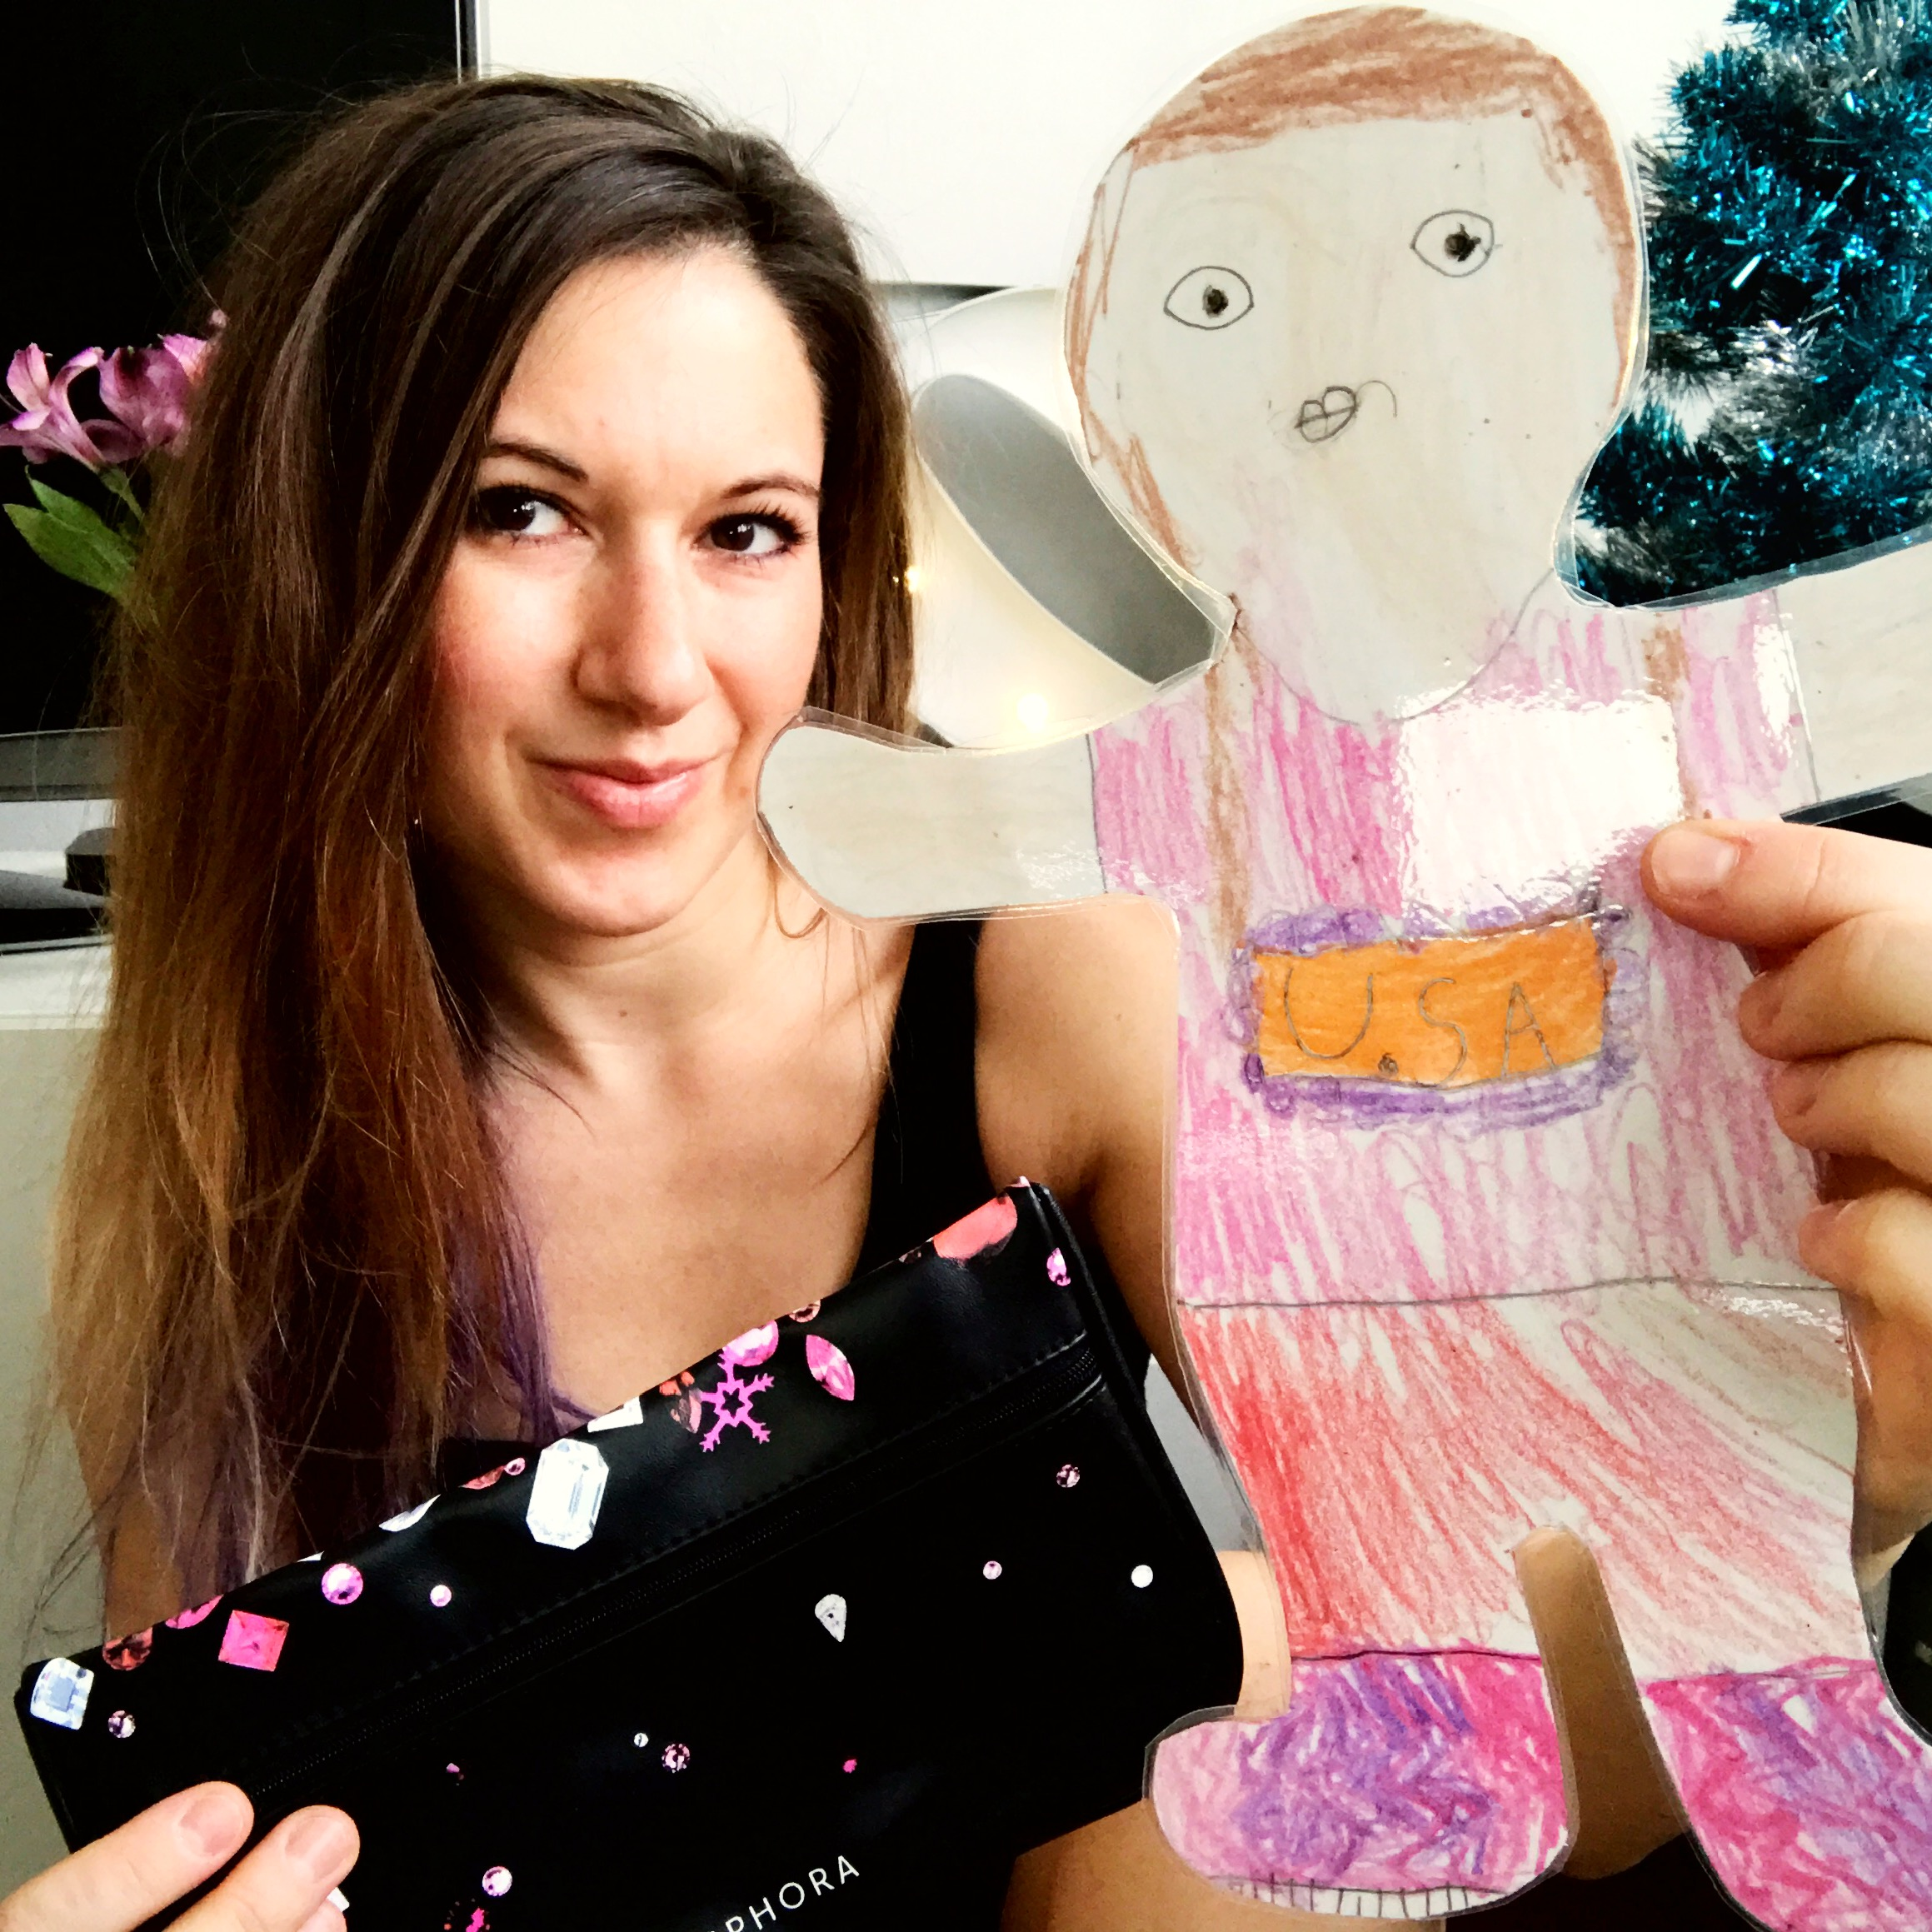Flat Sharon said, “Before we look for Rainbow Connections, you need to open your holiday gifts!” Flat Sharon didn’t realize that she was helping create Rainbow Connections. She came to deliver gifts! That is so kind and thoughtful.
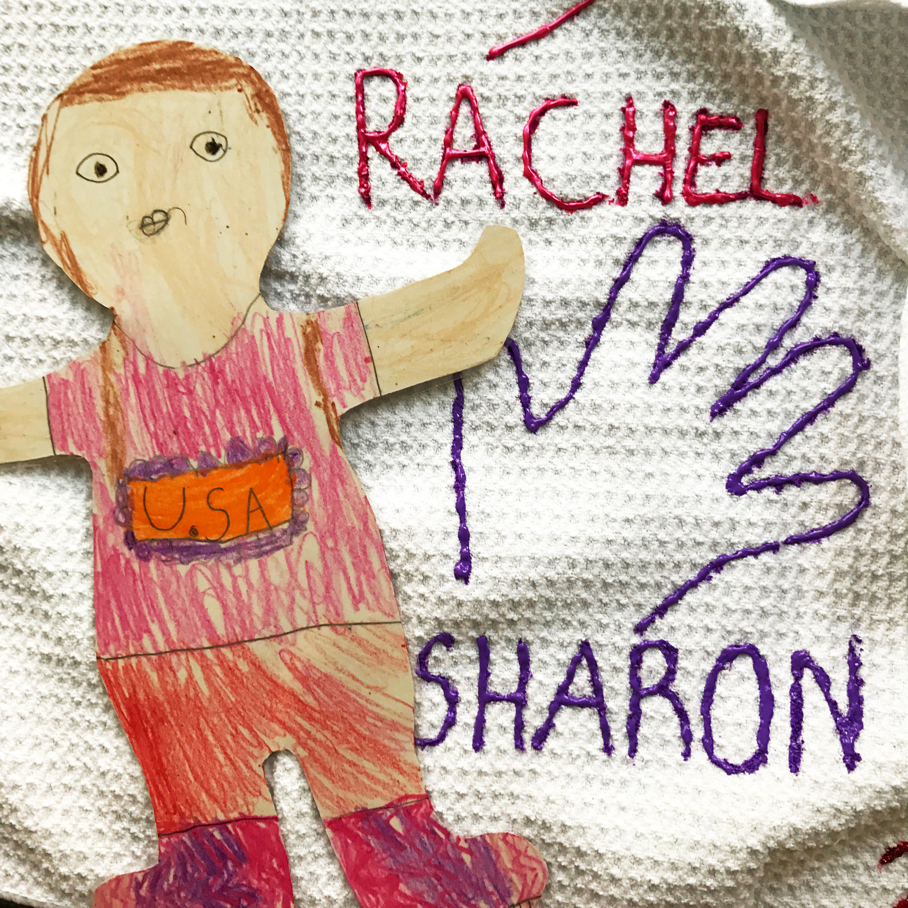Flat Sharon said, “Look at this towel I made you! I picked out the purple paint myself.” She was thinking of her Auntie L even when she was far away and made her something special. Now that is a Rainbow Connection!
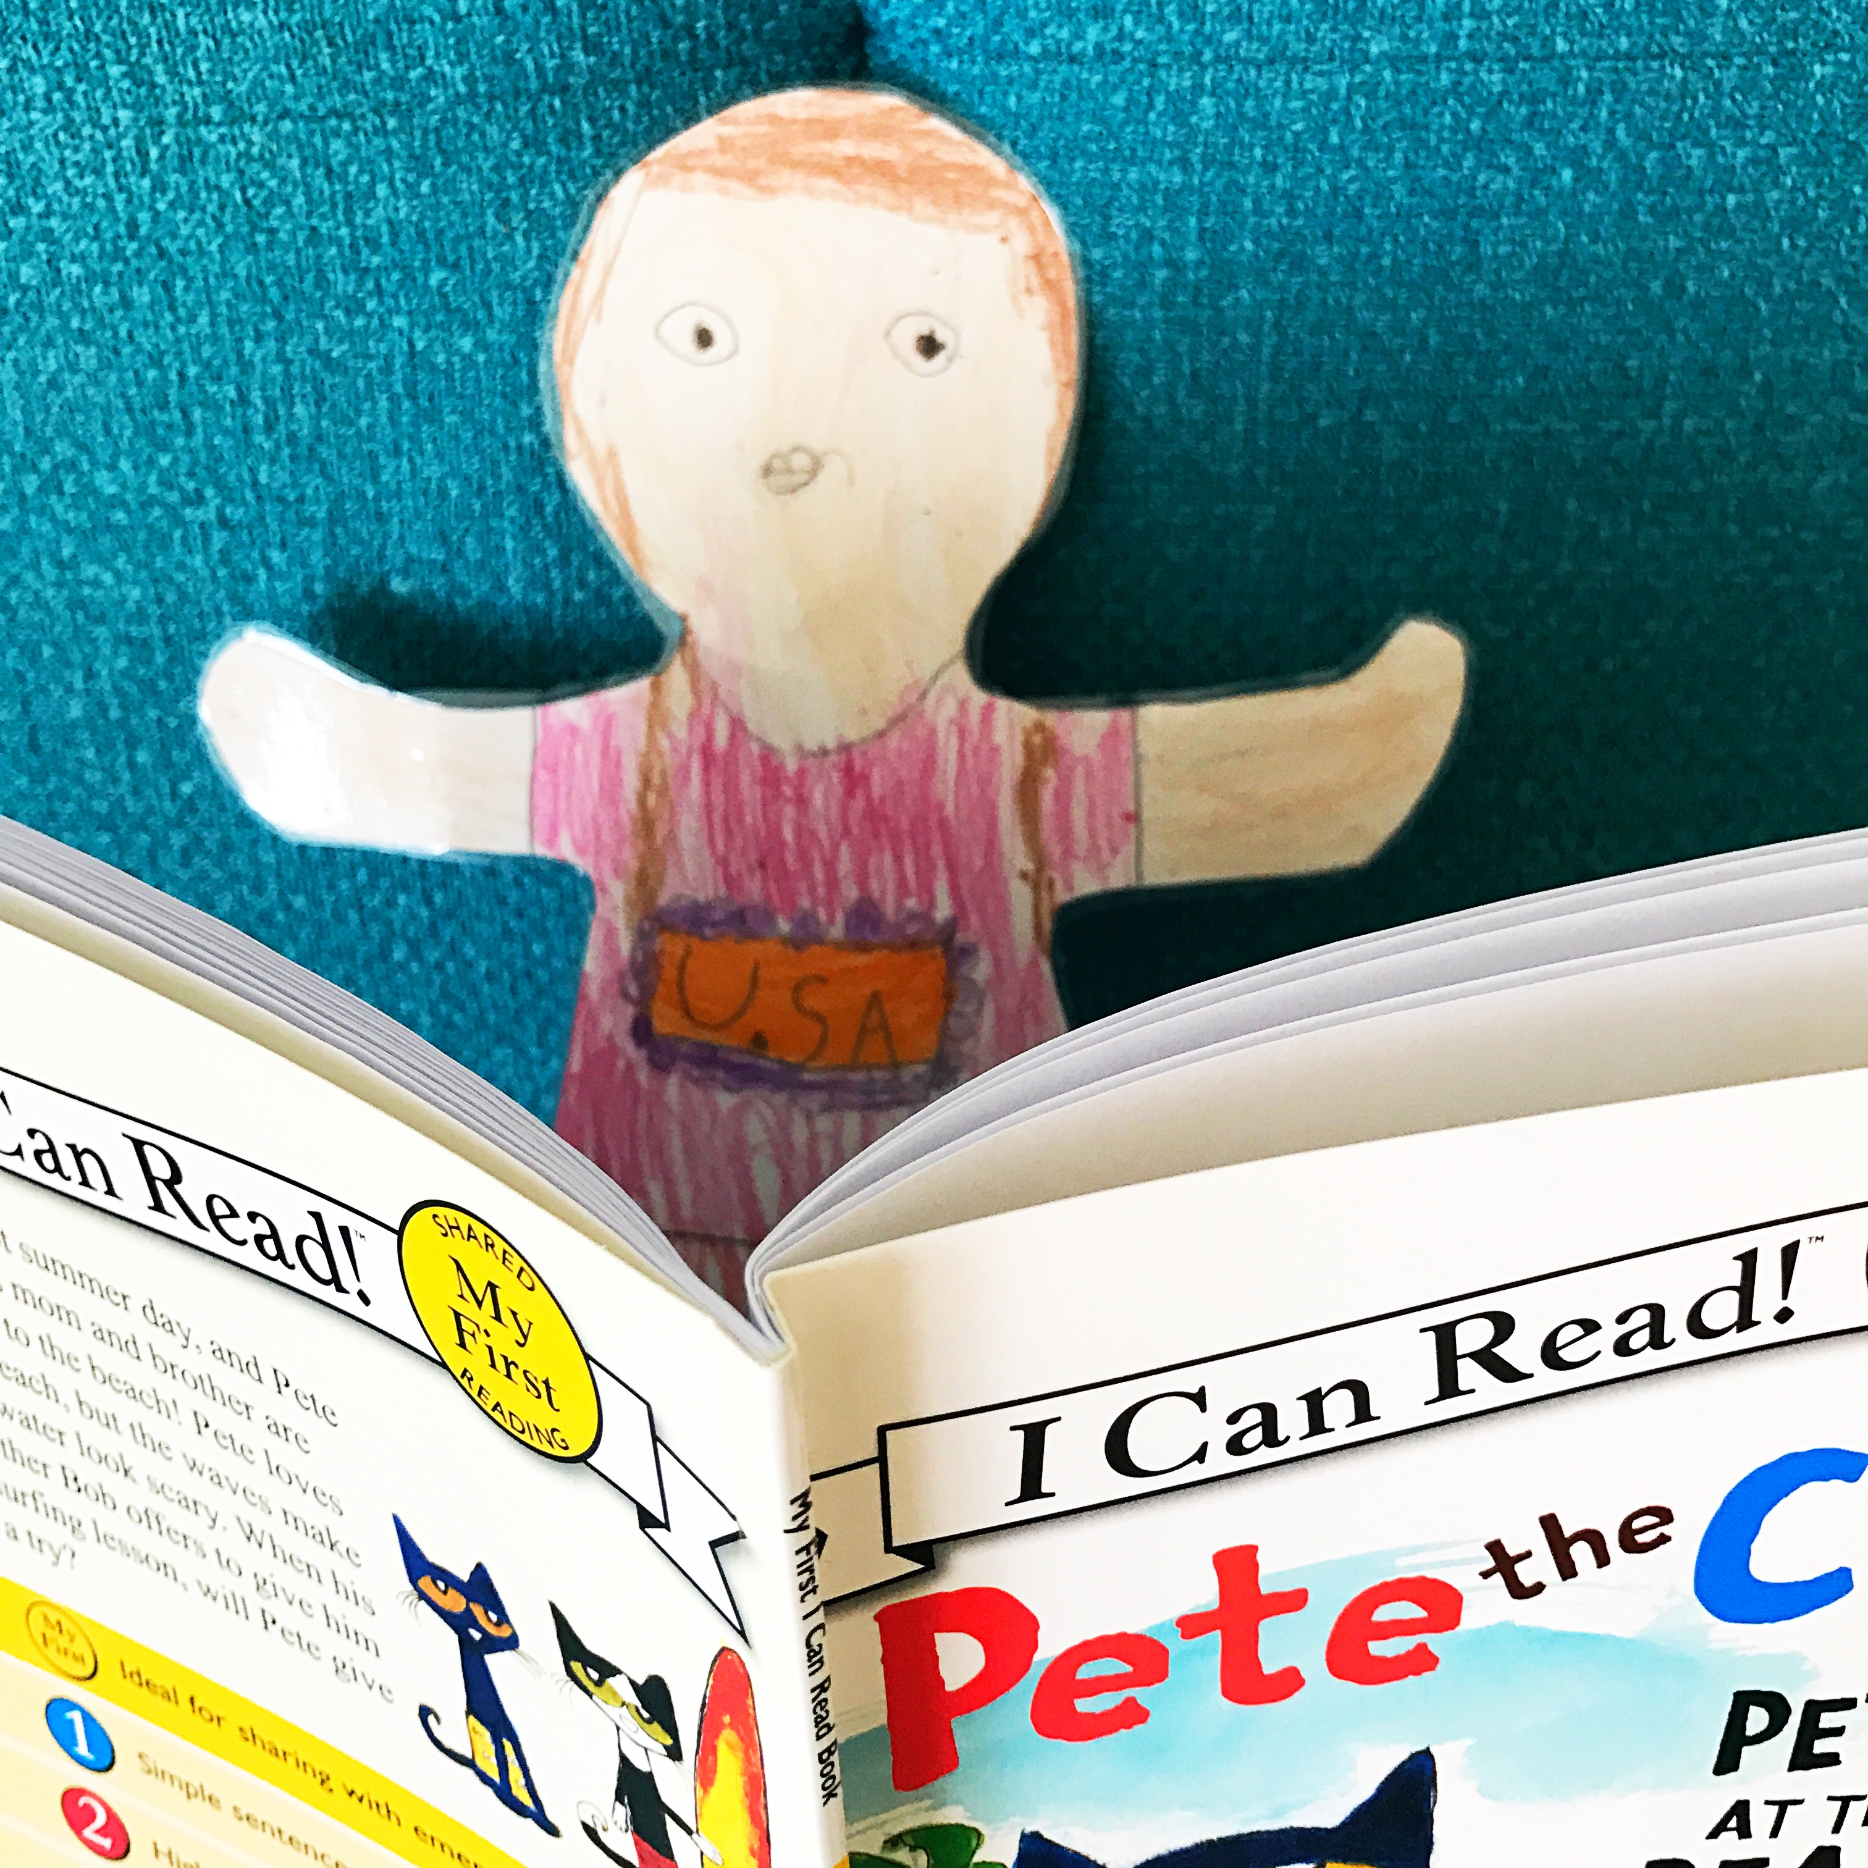
Auntie L said, “I have to go to work. I am a speech therapist and I help kids talk. Sometimes children have a hard time talking because they have autism. I help them learn how to communicate. Sometimes I read books to the children I help.” Flat Sharon said, “I want to read too.”
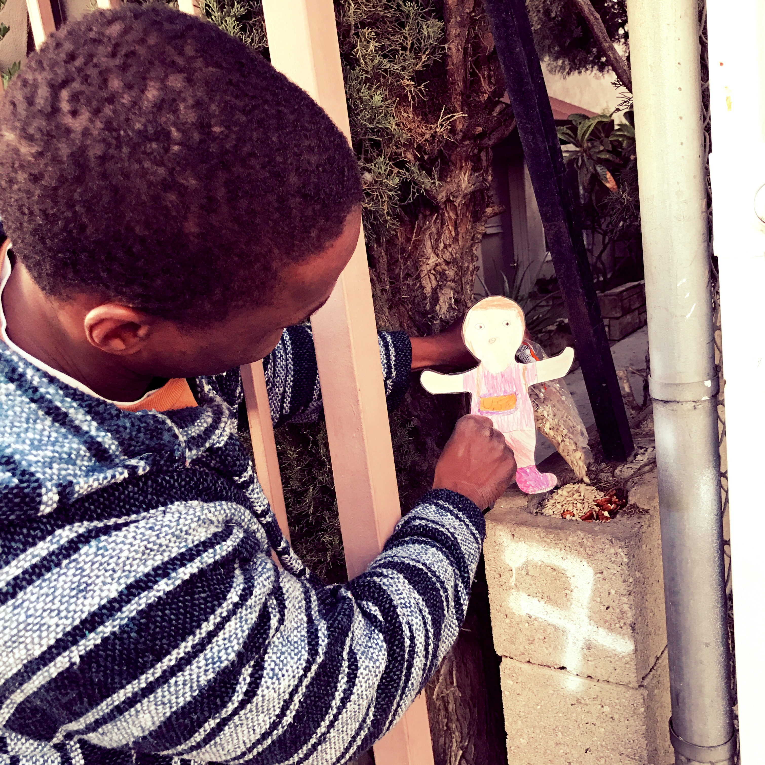
When they get back to Auntie L’s home, Flat Sharon said, “Hey, what’s he doing?” Auntie L said, “That is my neighbor Phil. He likes to feed the squirrels in the neighborhood.” Flat Sharon says, “I want to help too.”

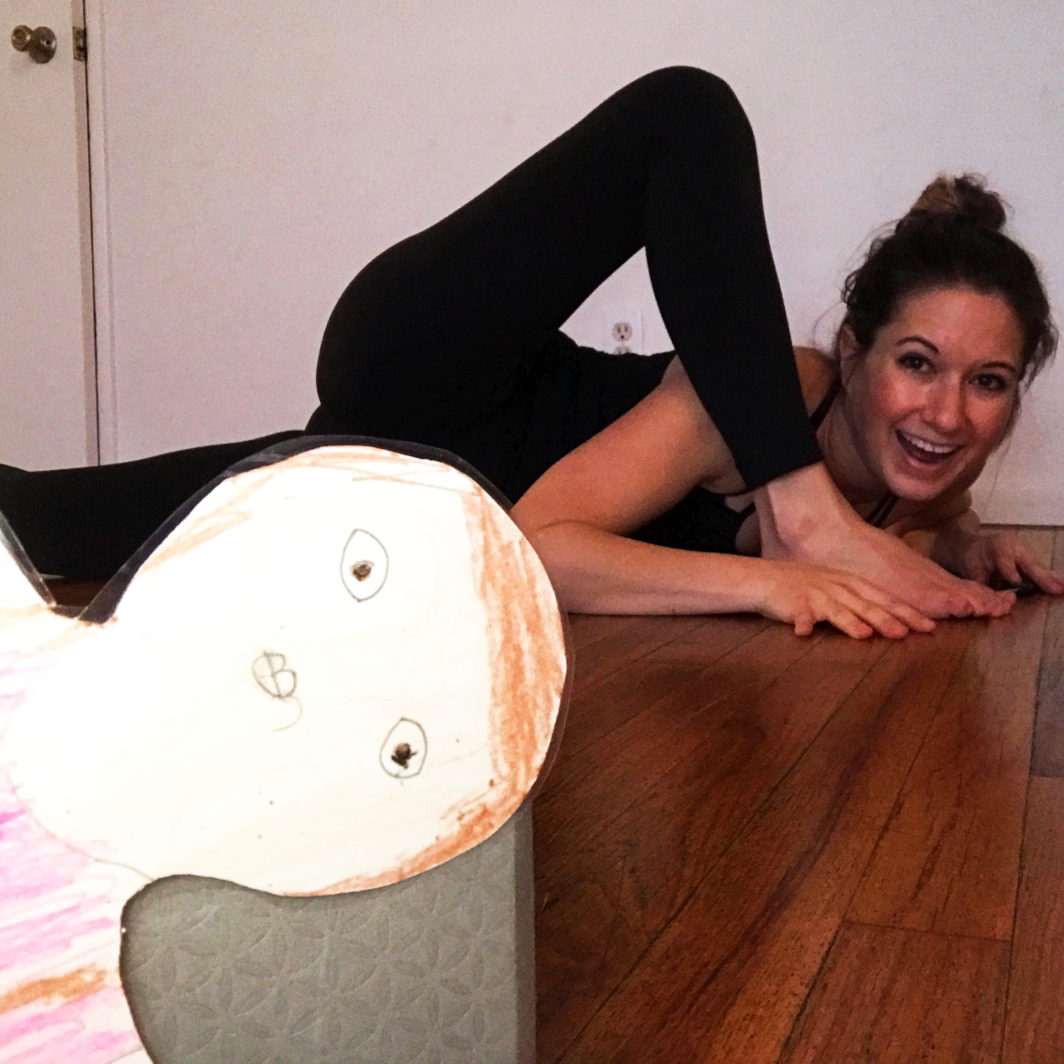”Auntie L what are you doing?” Flat Sharon asks. “This is yoga. Doing yoga is a Rainbow Connection.” Flat Sharon says, “I don’t understand. How is yoga an act of kindness?”

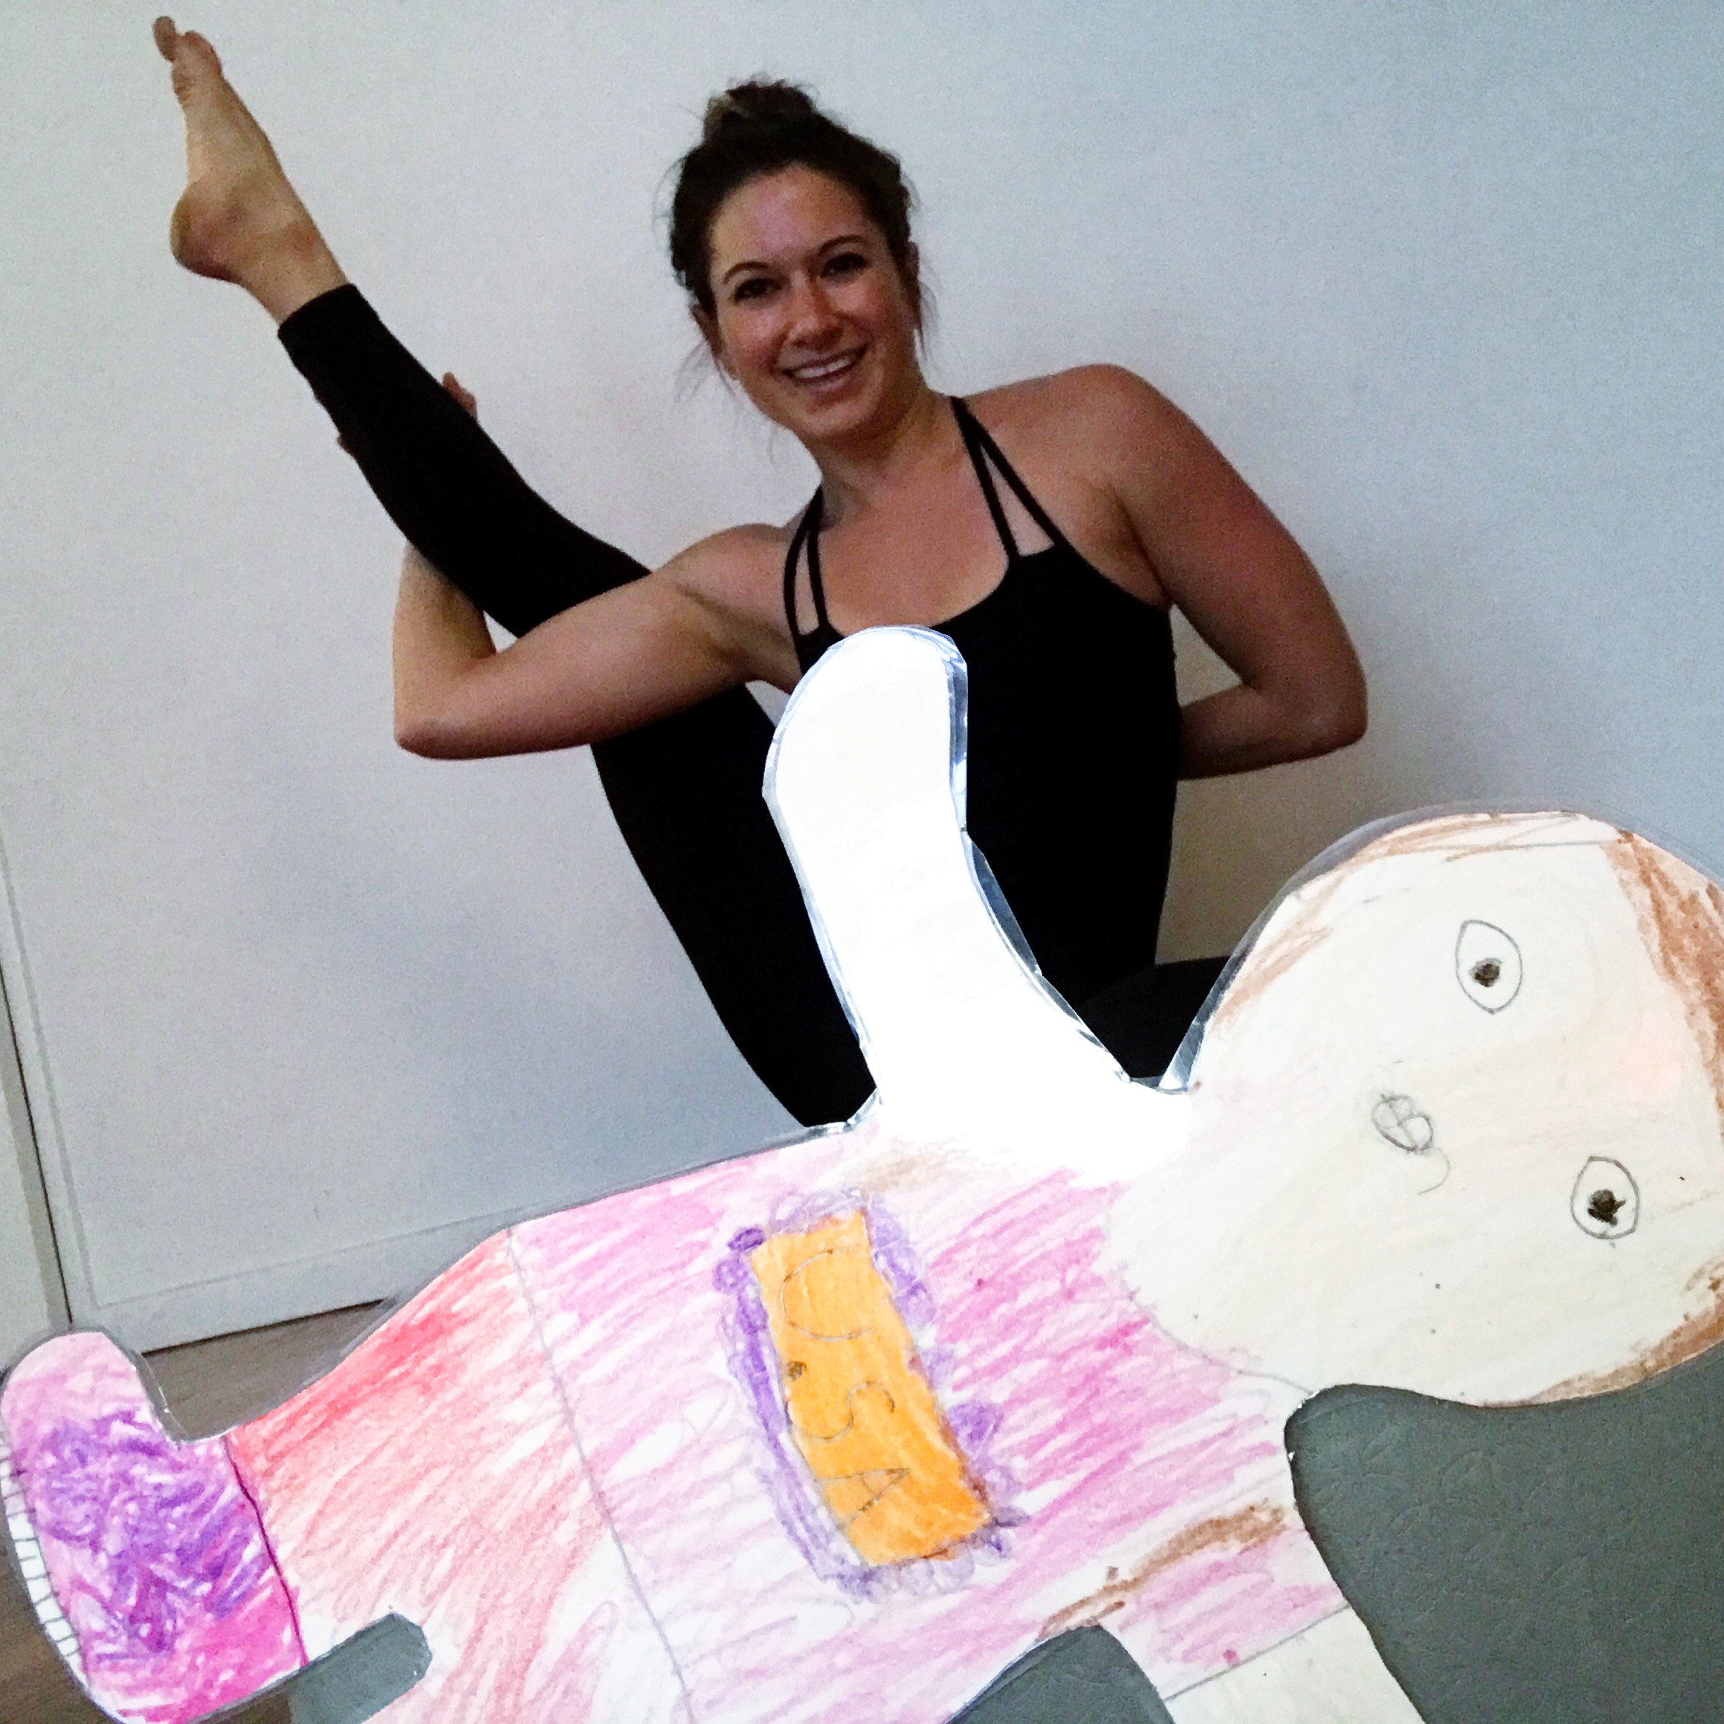
“When you do yoga you are being kind to yourself. In order to help others, you need to take care of yourself. That is why yoga is a Rainbow Connection.” Auntie L explained. Flat Sharon said, “I want to do yoga too!”

The next day, Auntie L sees a package outside of her neighbor’s door. She said, “My neighbor Alison is out of town visiting her family. She won’t be back for a while, so I will tell her I can keep her package safe until she gets home.” Flat Sharon said, “You are helping your neighbor. That is a Rainbow Connection.”

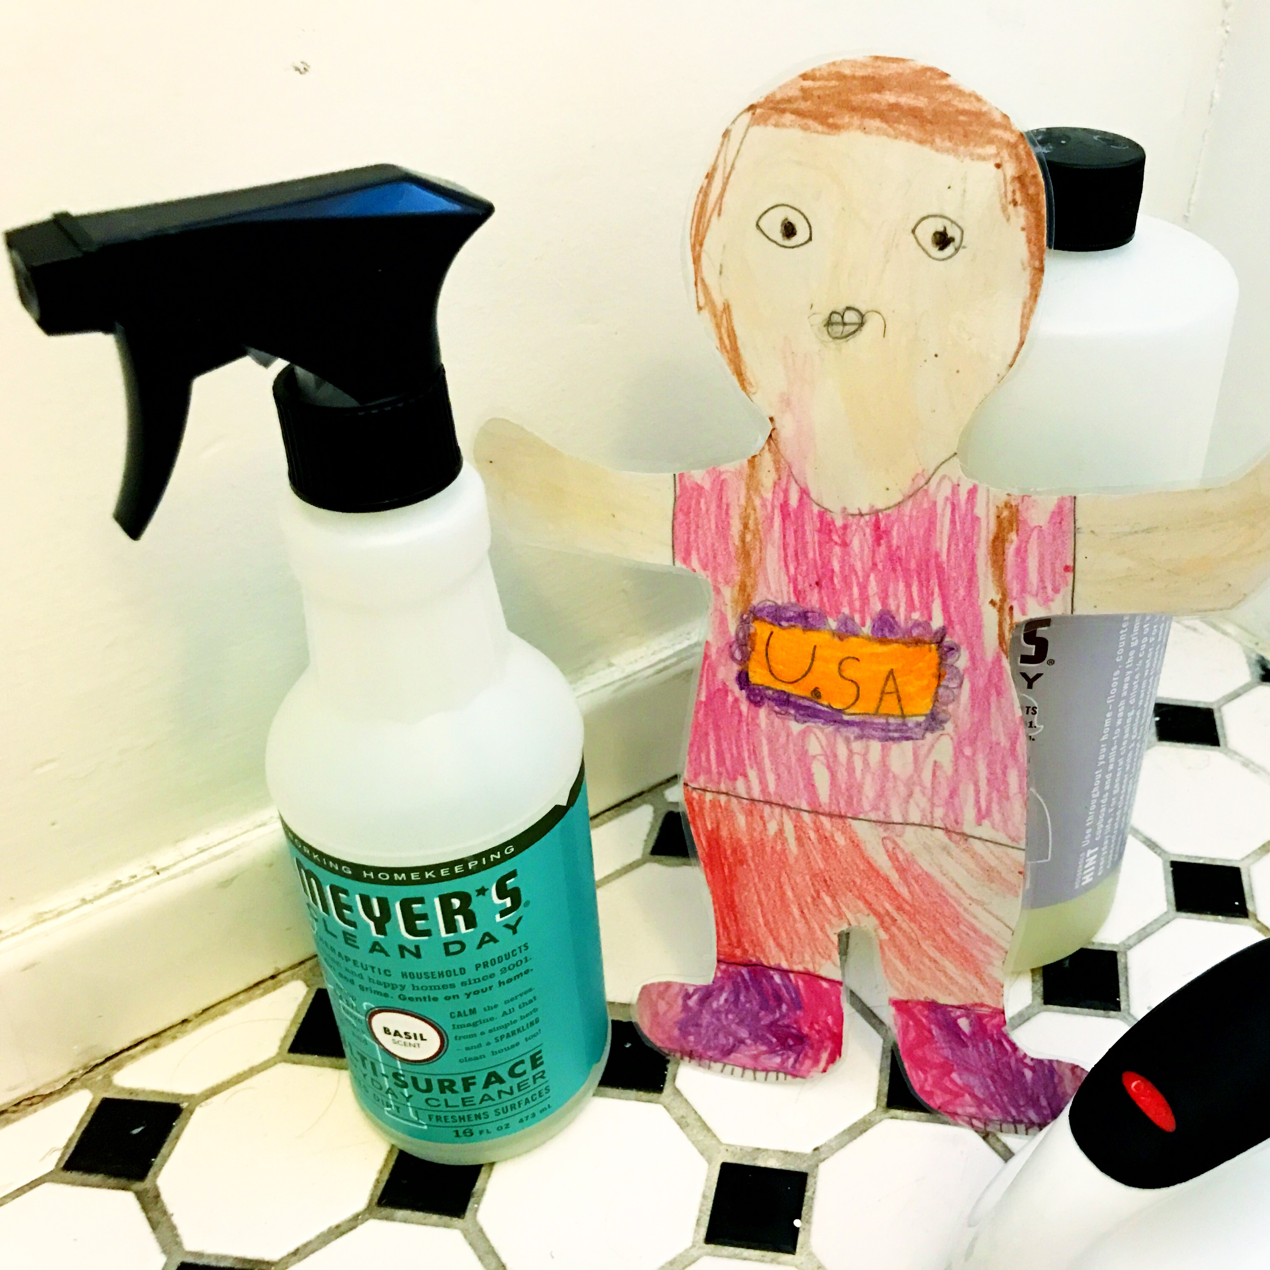
Auntie L said, “I don’t know how many Rainbow Connections we will see today. I have to stay home and clean my apartment.” Flat Sharon said, “I can help you clean!” Rainbow Connections can happen anywhere, even at home. They happen when you are being a good helper around the house.

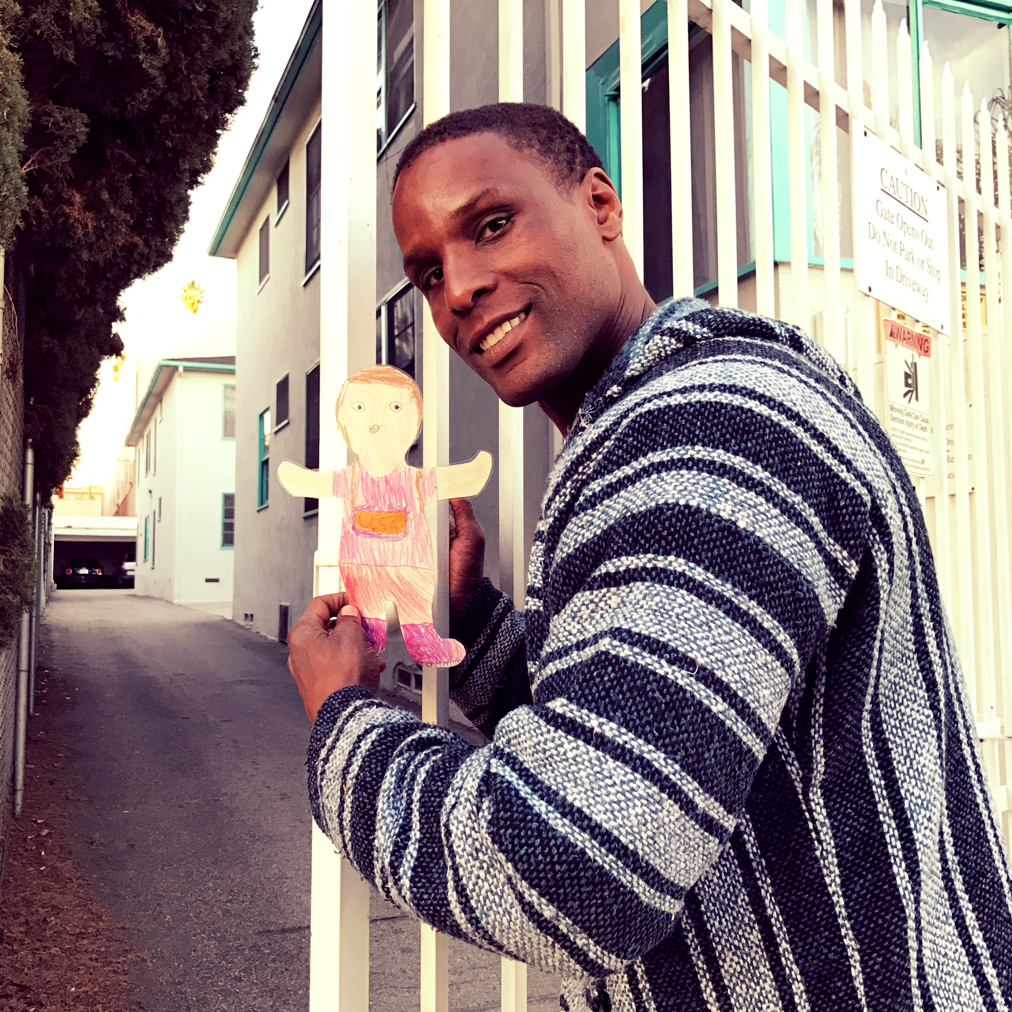
Later that day, Auntie L and Flat Sharon had to go help a friend in need. Auntie L’s friend was sad and needed to talk to Auntie L. When they got back, the parking gate was broken. OH NO! How would they get into the apartment? Neighbor Phil came to save the day and fixed the gate for them. YAY! Flat Sharon said, “Thanks for the Rainbow Connection!”
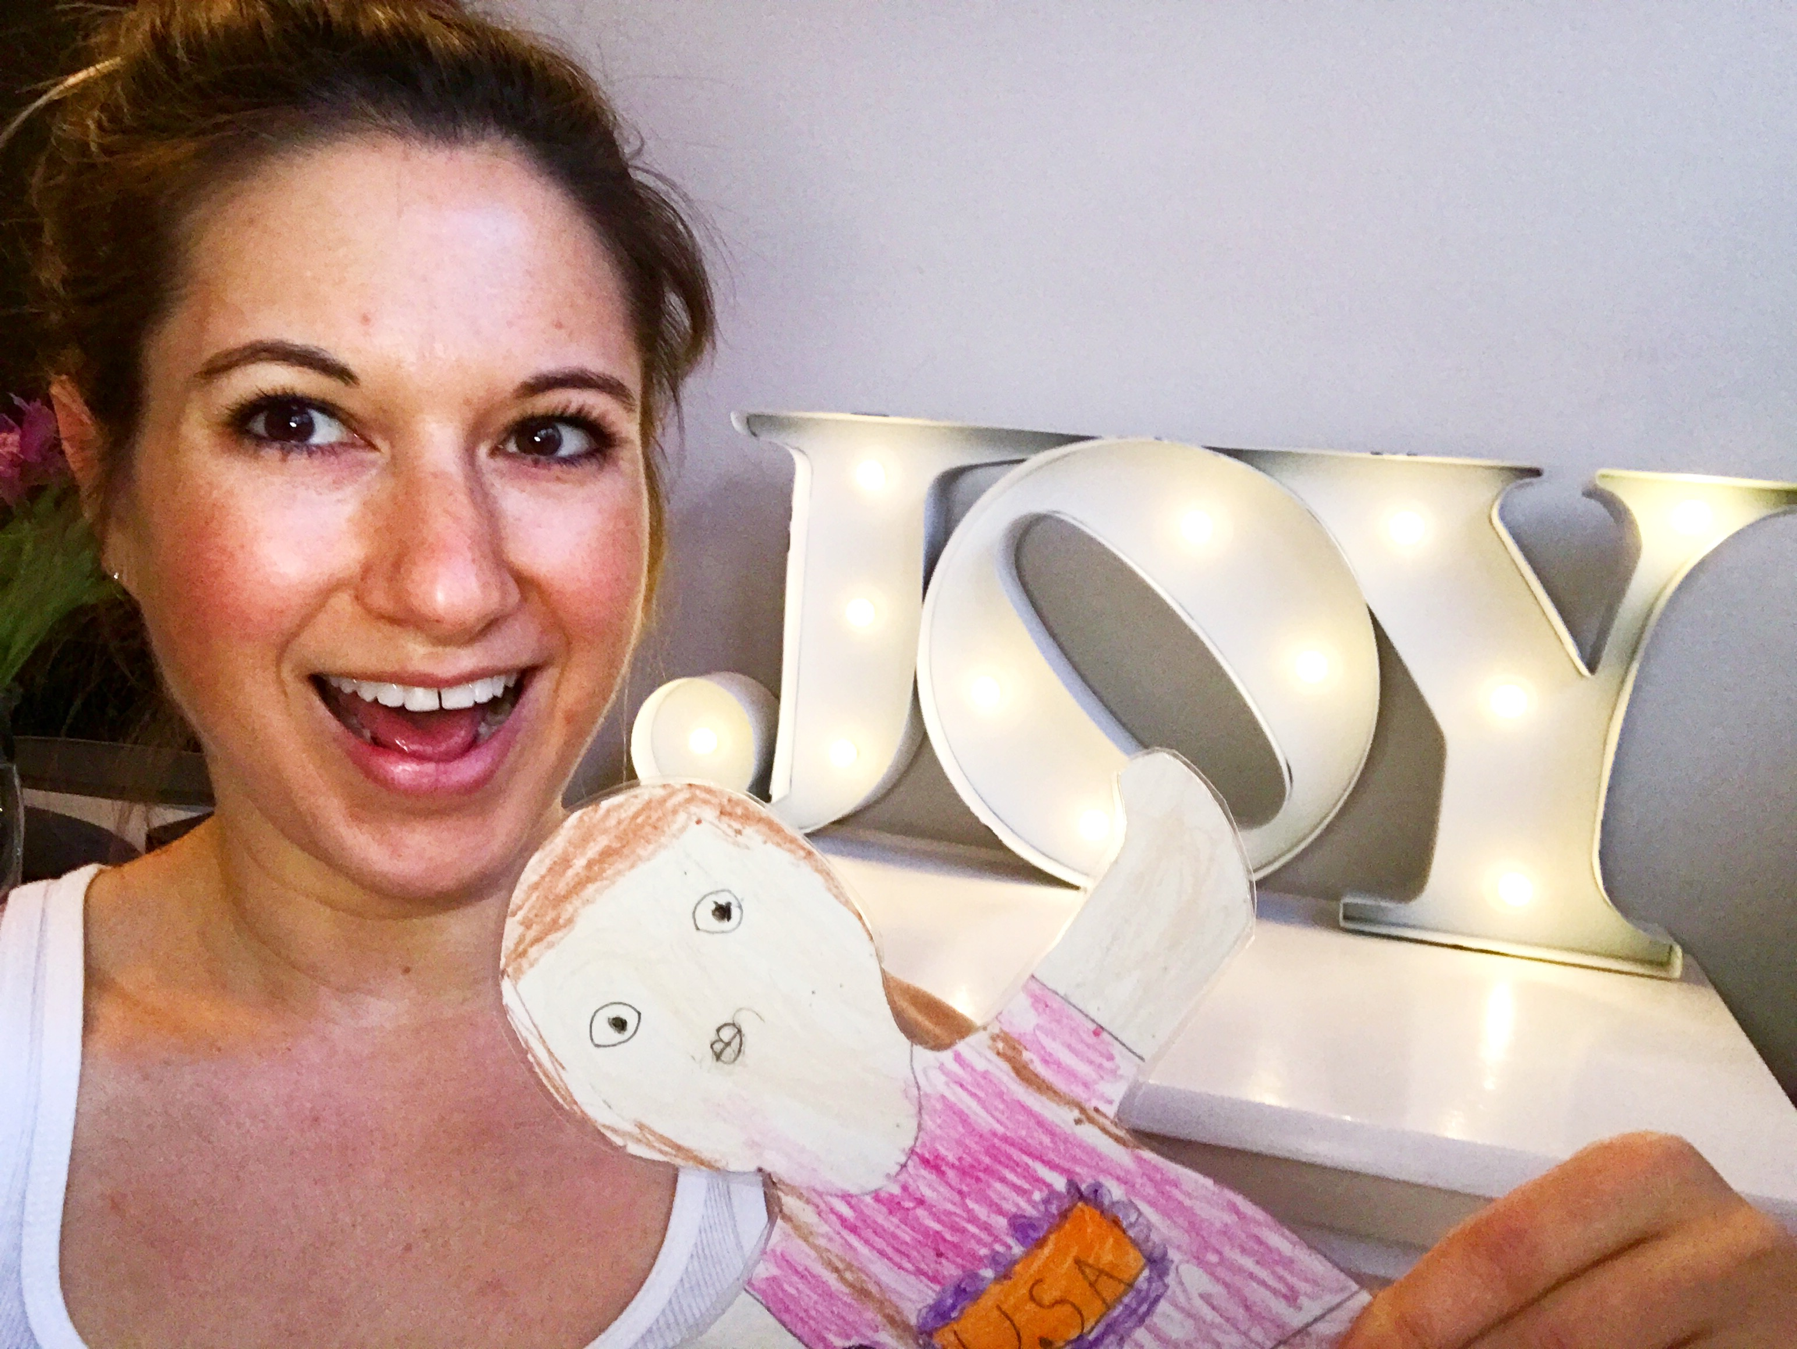
Flat Sharon said, “Thank you so much for letting me stay with you in Hollywood. I had so much fun seeing all the Rainbow Connections here. There is so much JOY in the world. I’m looking forward to going home to see my family again. 2017 will be a great year. I will share JOY and Rainbow Connections every day.”

Help others every day. Be kind to those around you. You can help create Rainbow Connections!

