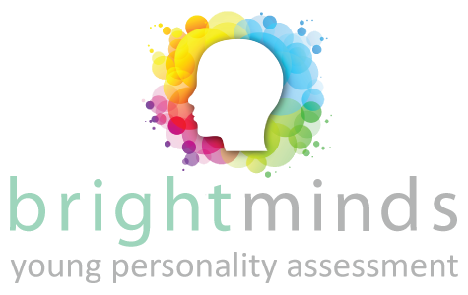

Submission for 1 Bright Minds Assessment & Free Webinar

Childs Details (NB. 1 Child Assessment per family)
Full Name including all middle names:
Date of Birth:
Time of Birth:
City & State of Birth:

Parents Details
Name:
Email Address:
Occupation:
Short explanation on why you think you and your child could benefit from this assessment:

IMPORTANT…
Please send all completed submission forms to booking@newapproachcoaches.com. All applications are treated on a first come, first served basis. We appreciate your patience, but it will be worth the wait – if any – we promise!

