BSC KOONS of SILVER SPRING PREMIER CUP
CHECK-IN INSTRUCTIONS

OPTION # 1 ON-LINE CHECK-IN:
- Check – On-line check-in due by:
  - U9-U13 Boys and Girls: November 1, 2019 by 5:00 PM (Fri)
  - U14-U19 Girls Teams: November 8, 2019 by 5:00 PM (Fri)
  - U14-U19 Boys Teams: November 15, 2019 by 5:00 PM (Fri)

- There will be no exceptions or extensions allowed!

- All teams that have successfully checked in on-line will have their stamped roster posted within their team GotSoccer account for download no later than:
  - U9-U13 Boys and Girls: November 6, 2019 by 10:00 PM (Wed)
  - U14-U19 Girls Teams: November 13, 2019 by 10:00 PM (Wed)
  - U14-U19 Boys Teams: November 20, 2019 by 10:00 PM (Wed)
- Instructions for on-line check-in can be found below:

INSTRUCTIONS ON HOW TO CHECK-IN ON-LINE:
- Print (or fill in) and sign the PDF document labeled “BSC Premier Cup Team Information Sheet.” The document can be found on the BSC Tournament Website under the team check-in tab.
- Documentation:
  - US Club Teams need to provide:
    - 1 copy of the US Club Roster (see “Frequently Asked Questions” below about adding guest players)
    - A copy of each US Club Players Passes (ONLY front must be copied)
    - A copy of each guest players US Club Player Passes (ONLY front must be copied)
    - A copy of the guest players completed application form. The document can be found on the BSC Tournament Website under the team check-in tab.
    - Read and sign the “BSC Guidelines/Policies/Rule Acknowledgement”. The document can be found on the BSC Tournament Website under the team check-in tab
  - US Youth Soccer Teams need to provide:
    - 1 copy of the State Approved Roster (see “Frequently Asked Questions” below about adding guest players)
    - A copy of each US Youth Soccer Player Passes (ONLY front must be copied)
    - A copy of each guest players US Youth Soccer Player Passes (ONLY front must be copied)
    - A copy of the guest players completed application form. The document can be found on the BSC Tournament Website under the team check-in tab.

    - Teams outside of Region 1 need to provide a signed permission to travel form if your State association requires. Check with your State association or your Club for the appropriate form. (Region 1 teams include: ME, NH, VT, MA, RI, PAE, PAW, NJ, NYE, NYW, CT, MD, DE, VA, WV)
    - Read and sign the “BSC Guidelines/Policies/Rule Acknowledgement” located on the BSC Tournament Website under the team check-in tab.
- After you have gathered the appropriate documents to register your team please scan or create PDF files for each document type (i.e., player cards, guidelines, team information sheet should all be separate files) as they will be uploaded separately. Ensure you use descriptive names so you will know which files to upload. We recommend scanning multiple player cards at one time to fill an 8.5” x 11” piece of paper and thus requiring fewer “Player Cards” attachments.
Follow the instructions below:
  - Login to www.gotsoccer.com (https://www.gotsport.com/asp/teams/login.asp?) with your team username and password.
  - Select the Bethesda Tournament
  - Select “Documents”
  - Select the labels from the drop down list and upload the corresponding files.
- As we review and approve your registration materials, we will place green check marks next to your accepted documents within GotSoccer. Any documents we have problems with, will receive a yellow mark, your team will be marked with a “yellow flag” and comments will be placed in GotSoccer for you to address. Once we have accepted all materials, we will post your approved stamped roster on GotSoccer for you to download. You should plan on checking GotSoccer at least once a week for updates and then daily as we reach the deadlines for on-line check-in.
OPTION #2 CHECK –IN ON-SITE:
On-site check-in will take place on the Friday of the tournament weekend.
U9-U13 Boys and Girls Teams: Friday, November 8, 2019
3 PM - 7 PM
DoubleTree Hilton Hotel
620 Perry Parkway
Gaithersburg, MD 20877
U14-U19 Boys and Girls Teams: On-site check in will be at the MD Soccerplex Headquarters tent. See specific times below.
Maryland Soccerplex
18031 Central Park Circle
Boyds, MD 20841
U14-U19 Girls Teams: Friday, November 15, 2019
U14-U15 is 3 PM -7 PM
U16-U19 is 8 AM - 8 PM

U14-U19 Boys Teams: Friday, November 22, 2019
U14-U15 is 3 PM -7 PM
U16-U19 is 8 AM - 8 PM
- Teams will not be allowed to check-in on Saturday
Instructions for on-site check – in can be found below
WHAT TO BRING FOR ON-SITE CHECK-IN:
- Two copies of your State Association, League or US Club approved roster to be submitted to the tournament committee
- Current Player passes for every participating player
- Guest players information should be added to the bottom of the official roster being submitted
- Permission to travel forms if applicable

FREQUENTLY ASKED QUESTIONS
Check -In Confirmation:

If I checked my team in on-line, how will I know my roster has been approved?
Approved stamped rosters will be uploaded into GotSoccer for you to download under the “BSC USE ONLY: APPROVED On-Line Roster” label. This will be your official tournament roster. You MUST bring this to the tournament with you and show it along with your original player cards to the Field Marshal (FM) prior to every game. This file will be posted no later than one week prior to the tournament start date.

NOTE: If the Stamp Bethesda stamp does not display when you print your document, you must ensure that the “Documents and Markups” is selected under the “Comments & Forms” section highlighted in the image below for you.

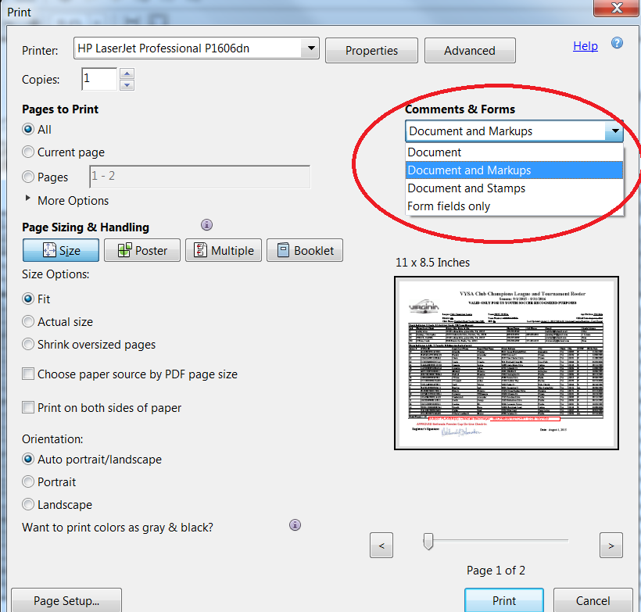

Players not attending the event:

If a player is not attending the event do I leave their name on the roster?
No, if a player is not attending the event; you need to cross their name off of the roster.
Guest Players & Roster Size:

What is the maximum number of guest players a team can bring to the event?
A max of three (3) guest players will be allowed.

The following are the maximum roster size per age groups:
U09 – U10 (7v7) – 14 players
U11 – U12 (9v9) – 16 players
U13 (11v11) – 18 players
U14 - U19 (11v11) - 22 Players, but only 18 may dress for any given game.

U9 - U19 Teams
Rostered players may play for other teams within the same club without needing guest player approval! Allowing players to move within the Club teams helps them with injury coverage as well as tiering for tournament purposes. For example, a Bethesda Green player in the U11 age group can play on the U11 Bethesda Blue team without needing guest player approval.

How do I add a guest player?
Step 1: Obtain the guest players current player card and medical release form

Step 2: Photocopy your original roster. Handwrite the guest player’s full name, unique jersey number, player identification number and birthday below the bottom of the existing rostered players.
Note: US Club Soccer teams may only take guest players registered under US Club Soccer, and USYSA teams may only take guest players registered with properly stamped USYSA player pass cards. No roster may be comprised of players with different passes from different organizations (no “mixed rosters”).

How do I add a guest player after my on-line registration was approved?
Due to the size of the tournament, teams will not be allowed to resubmit their roster online unless permission is given by the registrar. This will depend on the workload of the registrar. Teams will be allowed to resubmit their roster in person during the on-site check-in dates and times. If your team needs to modify/resubmit their roster you must do so before the deadline or follow the directions for on-site check-in.

Medical Release Forms

Do I include the medical release forms in the early registration document?
- No. All teams must have a medical release form for each player (including guest players). Please check with your club. One needs to ensure that the club or the State association has parent authorized medical release form. DO NOT include the medical release forms in the online registration package.

Do Medical Releases need to be notarized?
- No. Medical Releases DO NOT need to be notarized. However, you must have signed our rules and guideline form stating that you have medical releases for all of your players.

Age Group Structure
What Birth Years play in each age group?
(Remember, players may play up but they cannot play at an age group younger than their birth year, i.e., a player born in 2002 may play U18 or U19/20. They may not play U17.)

2001 – U19/20
2002 – U18
2003 – U17
2004 – U16
2005 – U15
2006 – U14
2007 – U13
2008 – U12
2009 – U11
2010 – U10
2011 – U9

ALL QUESTIONS ABOUT ONLINE CHECK-IN CAN BE EMAILED DIRECLTY TO Bethesda Soccer @ checkin@bethesdasoccer.org

