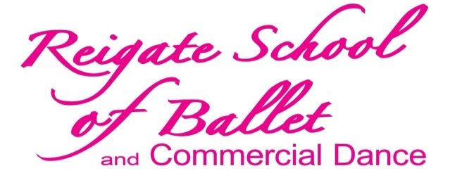
Principal: Miss Joanne Evans - LISTD dip CDE, RAD teach cert. Examiner for the Imperial Society of Teachers of Dancing
| www.reigateschoolofballet.com | 01737 247 795 | www.rsbdance.co.uk |

HIP HOP/STREET & CONTEMPORARY
WORKSHOP: TUESDAY 31st MAY 2016
We are thrilled to be able to offer a Hip-Hop / Street and Contemporary workshop with our new teacher Freya Sands. Freya currently works as a professional Hip-Hop dancer with all-girl group ‘Boadicea’, and she has toured 3 times with the hugely popular street dance crew – ‘Diversity’. Miss Benjamin, who leads our contemporary dance programme, will lead the contemporary workshop classes. The workshop is available for ages 7+ .
Bring a friend (not currently receiving dance classes at RSB or school clubs) and receive a discount.**
There will be two age-specific groups (starting from age 7+) and both groups will be taught the two styles during the workshop.
- WHEN Tuesday 31st May
- WHERE St. Bede’s School Dance Studios (next to the Sports Centre), Redhill
- TIME 10.30am - 12.30pm
- PRICE £15** each
PLEASE PROVIDE CHILDREN with a LIGHT SNACK and WATER, dance clothes, tracksuit, trainers (street), bare feet (contemporary).
**DISCOUNT - If you bring a friend (not currently having dance classes with RSB), the cost is £12 each.
Please return the tear-off slip below with payment, and hand in to your child’s dance teacher, or by post to the above address. Many thanks
----------------------------------------------------------------------------------------------------------------------------------------------------RSB HIP HOP/STREET & CONTEMPORARY WORKSHOP
TUESDAY 31st MAY 2016
Name of Pupil (s) : ____________________________________________________ Age: ____________________
Name of Parent / Guardian : _________________________________________ Date : __________________
Emergency Contact Number : ______________________________________
I enclose a cheque / cash for the amount of £ ______________ (£15 per pupil, or £12 discount ..see above), payable to “GENESIS”.
| Email - reigateschoolofballet@ntlworld.com | Email – info@rsbdance.co.uk |

