CAST-USA Annual Conferences Keynote Speakers

旅美科协年度大会特邀主讲嘉宾

2015 - 2017

诺奖主旨嘉宾
Nobel Prize Laureates

- 2017年会 Keynote Speaker (Manhattan, New York)
Dr. Joseph E. Stiglitz (Nobel Prize in Economic Sciences 2001)
2001 年诺贝尔经济学奖得主, 哥伦比亚大学教授

- 2016年会 Keynote Speaker (Salt Lake City, Utah)
Thomas C. Südhof, MD (Nobel Prize in Physiology or Medicine 2013)
2013年诺贝尔医学奖获得者、斯坦福大学教授
- 2015年会 Keynote Speaker (Washington D.C.)
Dr. John C. Mather (Nobel Prize in Physics 2006)
2006年诺贝尔物理学奖获得者、美国国家航空航天局高级天体物理学家

整理编辑：总会秘书处新闻媒体部（宣传组）
杨晓梅 孙儒杰
2018.04.19

旅美科协总会年会诺奖主旨嘉宾介绍

2017年会 Keynote Speaker

Dr. Joseph E. Stiglitz

(Nobel Prize in Economic Sciences 2001)
2001 年诺贝尔经济学奖得主, 哥伦比亚大学教授

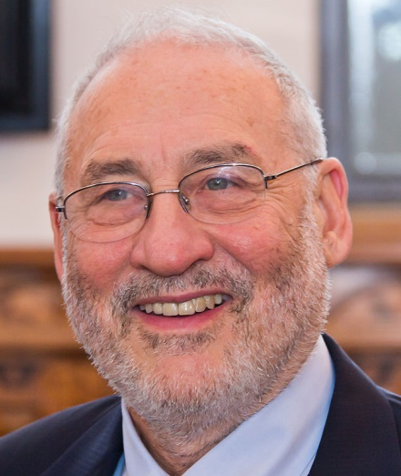
Dr. Joseph E. Stiglitz is a professor at Columbia University. Dr. Stiglitz's work focuses on income distribution from a Georgist perspective, asset risk management, corporate governance, and international trade. He received Nobel Prize in Economic Sciences in 2001 and the John Bates Clark Medal in1979 for his work. He is a former senior vice president and chief economist of the World Bank and is a former chairman of the (US president's) Council of Economic Advisers. Dr. Stiglitz is one of the most influential economist in the world today, and in 2011 he was named by Time magazine as one of the 100 most influential people in the world.

Joseph E. Stiglitz 博士是哥伦比亚大学教授，2001 年诺贝尔经济学奖得主，曾任世界银行首席经济学家，美国总统经济顾问委员会主席，现任经济合作与发展组织经济表现度量和社会发展高级专家组联席主席，罗斯福研究所首席经济学家。他的研究集中于收入分配、资产风险管理、企业管理以及国际贸易。Stiglit 教授是世界上最有影响力的经济学家之一，曾被《时代》杂志评为全球100 位最有影响力的人物。
旅美科协总会年会诺奖主旨嘉宾介绍

2016年会 Keynote Speaker

Thomas C. Südhof, MD

Nobel Prize in Physiology or Medicine 2013
2013年诺贝尔医学奖获得者、斯坦福大学教授

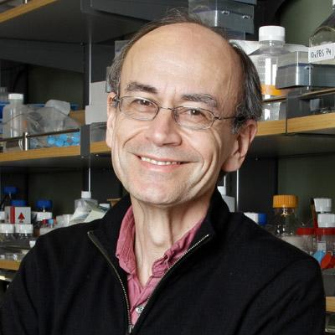
Dr. Südhof is a Nobel Prize laureate, a member of the National Academy of Sciences of the U.S.A., a member of the Institute of Medicine, and the Avram Goldstein Professor in Stanford University. Dr. Südhof studied medicine at the RWTH Aachen University, Harvard University, and then the University of Göttingen. He received his PhD in medical science (Dr. Med.) from the University of Göttingen. Since 1986 Dr. Südhof has been an investigator of the Howard Hughes Medical Institute. Dr. Südhof is currently the Avram Goldstein Professor in Stanford University School of Medicine as well as a Professor of Molecular & Cellular Physiology, Psychiatry, and Neurology. Dr. Südhof has won many awards, including W. Alden Spencer Award, Wilhelm Feldberg Award, U.S. National Academy Award in Molecular Biology, MetLife Award, Bristol-Myers Squibb Award for Distinguished Achievement in Neuroscience Research, Bernhard Katz Award, Biophysical Society, Kavli Prize, Passano Foundation Award, Albert Lasker Award for Basic Medical Research and 2013 Nobel Prize in Physiology or Medicine.

Thomas C. Südhof教授，美籍德国生物化学家，以研究突触传递知名。Thomas生于德国哥廷根。童年时光在哥廷根与汉诺威度过。年轻时曾学习过音乐，尤其是巴松，并于1975年毕业于汉诺威的瓦尔道夫音乐学校。他认为他的音乐老师Herbert Tauscher是对他“影响最大的老师”。

Thomas先后在亚琛工业大学，哈佛大学和哥廷根大学学习医学，并在哥廷根的马克思·普朗克生物物理化学研究所攻读博士学位，于1982年取得哥廷根大学医学博士学位。在马普所度过了短暂的博士后时光后，Thomas于1983转去美国，在德克萨斯大学卫生科学中心分子基因学系从事博士后研究工作。Thomas于1986年完成了博士后研究工作并成为霍华德·休格斯医学研究所的科学家。他在德克萨斯大学西南医学中心获得了独立实验室并在此工作了二十多年。2008年，Thomas转往斯坦福大学，目前是该校医学院的阿芙兰姆·哥尔特·斯泰因讲席教授。

自1986年以来，Thomas博士的研究已经阐明了许多主要的蛋白介导突触前功能。2013年，他和理查德·舍勒分享了拉斯克基础医学奖；同年又获得诺贝尔生理学和医学奖。Thomas的夫人陈路来自中国江苏，中国科大本科毕业，美国南加州大学博士，神经生物学家，美国斯坦福大学神经外科学副教授。

Title: "Understanding synaptic transmission - yesterday, today, and tomorrow"

旅美科协总会年会诺奖主旨嘉宾介绍

2015年会 Keynote Speaker

Dr. John C. Mather

Nobel Prize in Physics 2006
2006年诺贝尔物理学奖获得者、美国国家航空航天局高级天体物理学家

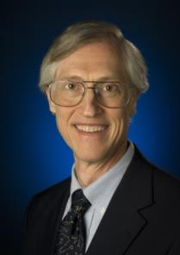
Dr. John C. Mather is an American astrophysicist, cosmologist and Nobel Prize in Physics laureate (2006) for his work on the Cosmic Background Explorer Satellite (COBE) with George Smoot. This work helped cement the big-bang theory of the universe. According to the Nobel Prize committee, "the COBE-project can also be regarded as the starting point for cosmology as a precision science." Mather is a senior astrophysicist at the U.Page 3 of 21S. space agency's (NASA) Goddard Space Flight Center (GSFC) in Maryland and adjunct professor of physics at the University of Maryland, College Park. In 2007, Mather was listed among Time magazine's 100 Most Influential People in The World. In October, 2012, he was listed again by Time magazine in a special issue on New Space Discoveries as one of 25 most influential people in space. Mather is also the project scientist for the James Webb Space Telescope (JWST), a space telescope to be launched to L2 no earlier than 2018.

Title: New technologies for new discoveries in astronomy – giant telescopes in space and on the ground

Abstract: Where did we come from, who are we, and where are we going? Astronomers worldwide are building and planning great new telescopes to see farther and better than ever before. Already under construction are the Square Kilometer Array in South Africa and Australia, the ALMA in the Chilean high desert, the Large Synoptic Survey Telescope, the Thirty Meter Telescope, the Giant Segmented Magellan Telescope, the European Extremely Large Telescope, and the James Webb Space Telescope (JWST), planned for launch in 2018. But that’s not nearly enough: we are thinking about the next generations of space telescope, like the Advanced Technology Large Aperture Space Telescope, the even more powerful Life Finder Telescope, and future X-ray and gravitational wave observatories. All of these marvels are propelled by technology advances as well as by the thrill of possible discovery, and none of them are the end of the line either. I will illustrate what these great telescopes do, talk about the new inventions at their hearts, and outline what it takes to conceive a new observatory like the JWST and take it to completion. I will talk about the open questions of astronomy, why they are still open, and what we are doing to answer them. I will speculate a little on how far astronomy can take us, about progress with robots and artificial intelligence, and about our ultimate future as the galaxies collide and stars burn out.

旅美科协总会年会主旨嘉宾介绍

2017年会 Keynote Speakers

Dr. Joseph E. Stiglitz
约瑟夫·斯蒂格利茨博士
Nobel Memorial Prize Laureate in Economic Sciences (2001)
2001年获诺贝尔经济学奖
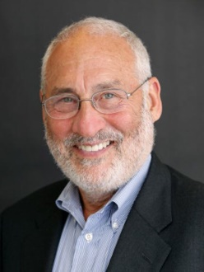
Dr. Joseph E. Stiglitz is an American economist and a professor at Columbia University. He is a recipient of the Nobel Memorial Prize in Economic Sciences in 2001 and the John Bates Clark Medal in1979. He is a former senior vice president and chief economist of the World Bank and is a former member and chairman of the (US president's) Council of Economic Advisers. In 2000, Dr. Stiglitz founded the Initiative for Policy Dialogue (IPD), a think tank on international development based at Columbia University. He has been a member of the Columbia faculty since 2001, and received that university's highest academic rank as an University Professor in 2003. He was the founding Chair of the University's Committee on Global Thought. He also chairs the University of Manchester's Brooks World Poverty Institute. He is a member of the Pontifical Academy of Social Sciences. He served as chair of the international Commission on the Measurement of Economic Performance and Social Progress and currently serves as co-chair of its successor, the High Level Expert Group on the Measurement of Economic Performance and Social Progress. Based on academic citations, Stiglitz is the 4th most influential economist in the world today, and in 2011 he was named by Time magazine as one of the 100 most influential people in the world. Dr. Stiglitz's work focuses on income distribution from a Georgist perspective, asset risk management, corporate governance, and international trade. He is the author of several books, the latest being The Great Divide: Unequal Societies and What We Can Do About Them (2015), Rewriting the Rules of the American Economy: An Agenda for Growth and Shared Prosperity (2015), and Creating a Learning Society: A New Approach to Growth Development and Social Progress (2014). He was invited to give a Keynote Speech in the China Development Forum held in Beijing in March 2017.
约瑟夫·斯蒂格利茨（Joseph E. Stiglitz）博士, 美国哥伦比亚大学教授；2001年诺贝尔经济学奖获得者。斯蒂格利茨教授是美国经济学家以及哥伦比亚大学的教授。他也是经济合作与发展组织经济表现度量和社会发展高级专家组的联席主席，以及罗斯福研究所的首席经济学家。他于2001年获诺贝尔经济学奖，1979年获约翰•贝茨•克拉克奖。他也曾任世界银行首席经济学家和高级副行长，美国总统经济顾问委员会主席。2000年，斯蒂格利茨教授建立了政策对话倡议组织，这是一个位于哥伦比亚大学的国际发展智库。他自2001年起成为哥伦比亚大学教授，并在2003年获得该校最高教职等级。根据引用量，斯蒂格利茨教授是世界上排名第四最有影响力的经济学家，并于2011年被《时代》杂志评为全球 100 位最有影响力的人物。斯蒂格利茨教授因研究信息不对称著称，他的研究集中于收入分配、资产风险管理、企业管理以及国际贸易。斯蒂格利茨教授著有多部畅销书。他最近的著作有《欧元:单一货币威胁欧洲未来》，《重构美国经济规则：增长与共享繁荣的计划书》，《大分裂：社会不平等以及我们能做什么》。2017年3月应邀出席在北京举办的“中国发展高层论坛”作主题演讲。

旅美科协总会年会主旨嘉宾介绍

2017年会 Keynote Speakers

Dr. Xiaoliang Sunney Xie
谢晓亮院士
Member of the National Academy of Sciences, and NA of Medicine
美国国家科学院与医学院双院士
fellow of the American Academy of Arts and Sciences
美国文理科学院院士

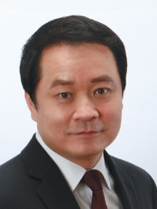
Dr. Xiaoliang Sunney Xie is the Mallinckrodt Professor of Chemistry and Chemical Biology at Harvard University. Dr. Xie has made major contributions to the emergence of the field of single-molecule biophysical chemistry and its application to biology. His team also pioneered the development of coherent Raman scattering microscopy and single cell whole genome sequencing. His honors include Albany Prize, the Harrison Howe Award, Biophysical Society Founders Award, E.O. Lawrence Award in Chemistry, Leibinger Innovation Prize, the NIH Director's Pioneer Award, and the Sackler Prize for Physical Sciences. Dr. Xie is an AAAS (American Association for the Advancement of Science) fellow, and a fellow of the American Academy of Arts and Sciences, and a member of the National Academy of Sciences and the National Academy of Medicine.
谢晓亮教授是单分子酶学（Single Molecule Enzymology）的奠基人之一，大幅发展改良了单分子荧光显微镜（Single Molecule Microscopy）技术。谢晓亮教授对coherent anti-Stokes Raman spectroscopy （CARS Microscopy 相干反斯托克斯拉曼散射显微镜）以及stimulated Raman scattering microscopy（SRS Microscopy 受激拉曼散射显微镜），做出了创造性的巨大贡献，并观察到许多重要结果。

旅美科协总会年会主旨嘉宾介绍

2017年会 Keynote Speakers
Dr. Yitang “Tom” Zhang
张益唐博士
Rolf Schock Prize Laureate in Mathematics (2014)
2014年获瑞典皇家科学院罗夫·肖克数学奖

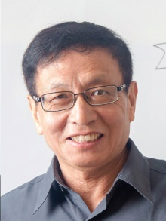
Dr. Zhang is a Professor of mathematics at the University of California, Santa Barbara. He established the first finite bound on gaps between prime numbers. This work led to a 2014 MacArthur award. Dr. Zhang’s other awards include the 2013 Morningside Special Achievement Award in Mathematics, the 2013 Ostrowski Prize, the 2014 Frank Nelson Cole Prize in Number Theory, and the 2014 Rolf Schock Prize in Mathematics. He was elected as an Academia Sinica Fellow in 2014.
张益唐博士，台湾中研院院士，加利福尼亚大学圣巴巴拉数学教授。张益唐于2013年4月17日向《数学年刊》（Annals of Mathematics）投稿证明存在无穷多对素数相差都小于7000万的重要论文《质数间的有界间隔》(Bounded gaps between primes)。同年5月21日，该篇论文被《数学年刊》接受，在2014年发表于179卷第3期，创下该刊创刊130年来论文接受时间最快的记录。并由此于2014年获得麦克阿瑟天才奖。此外，张博士还获得有多项奖项，包括2013年获得的晨兴数学卓越成就奖和Ostrowski奖，2014年获得的美国数学学会柯尔数论奖，2014年获得的罗夫·肖克奖，2016年获得的 香港“求是杰出科学家奖"等。

旅美科协总会年会主旨嘉宾介绍

2017年会 Keynote Speakers
Dr. Shoucheng Zhang
张首晟院士
Member of the National Academy of Sciences
美国国家科学院院士

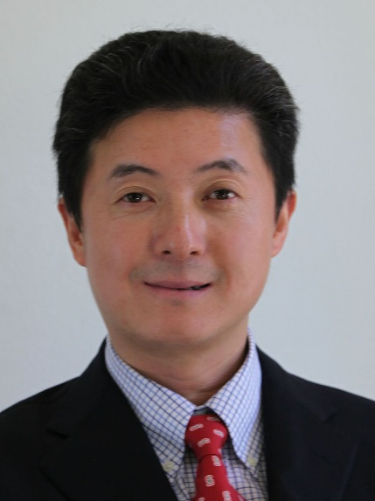
Shoucheng Zhang is the JG Jackson and CJ Wood professor of physics at Stanford University. He is a condensed matter theorist known for his work on topological insulators, quantum spin Hall effect, spintronics, quantum Hall effect and high temperature superconductivity.

Zhang was a postdoctoral Fellow at ITP in Santa Barbara from 1987 to 1989. He then joined IBM Almaden Research Center as a Research Staff Member from 1980 to 1993. Thereafter, he joined Stanford University as Assistant Professor of Physics. Since 2004, he concurrently hold (by courtesy appointment) titles of Professor Applied Physics and Professor of Electrical Engineering at Stanford University. In 2010, he was name the J. G. Jackson and C. J. Wood Professor in Physics.

Zhang is a fellow of the American Physical Society and a fellow of the American Academy of Arts and Sciences. He received the Guggenheim fellowship in 2007, the Alexander von Humboldt research prize in 2009, the Europhysics prize in 2010, the Oliver Buckley prize in 2012, the Dirac Medal and Prize in 2012, the Physics Frontiers Prize in 2013, the “Nobel-class” Citation Laureates by Thomson Reuters in 2014 and the Benjamin Franklin Medal in 2015. He is identified as one of the top candidates for the Nobel Prize by Thomson Reuters in 2014. He was elected as a member of the National Academy of Science in 2015.

张首晟博士，世界顶尖华裔科学家，斯坦福大学物理系讲座教授，美国国家科学院院士、美国艺术与科学学院院士和中国科学院外籍院士。同时，他还是丹华资本创始人。

没有读过高中，15岁的张首晟仅靠自学考入了复旦大学物理系，并于1983年获德国柏林自由大学学士学位。同年赴美国纽约州立大学石溪分校，师从著名物理学家杨振宁教授攻读博士，并于1987年获得博士学位。这之后的三年里，他在美国Santa Barbara理论物理研究所从事博士后研究工作。结束博士后研究后，他在IBM阿尔玛登研究中心任高级研究员。1993年他被斯坦福大学物理系聘为教授，研究领域为凝聚态物理。他被聘用时年仅32岁，成为斯坦福大学最年轻的终身教授之一。

2007年，张首晟发现的“量子自旋霍尔效应”被《科学》杂志评为当年的“全球十大重要科学突破”之一。基于他对拓扑绝缘体和量子自旋霍尔效应的开创性研究，张首晟已包揽物理界所有重量级奖项：2010年获欧洲物理奖，2012年荣获美国物理学会Oliver Buckley奖和国际理论物理学中心狄拉克奖, 2013年获物理前沿奖, 与著名物理学家霍金一起登台领奖，2014年荣获富兰克林奖。2017年7月21日，他与其他团队合作在《科学》杂志上发表了一项重大发现：在整个物理学界历经80年的探索之后，他们终于发现了手性马约拉纳费米子的存在。

张首晟不仅是世界顶尖的科学家，还是知名的风险投资人。2013年他创办了丹华资本，专注于投资斯坦福大学与硅谷的科技创新公司, 连接美国的科技创新与中国的广阔市场、推进中美两国的科技交流。他的投资方向包括人工智能、大数据、增强/虚拟现实、基因医疗等行业。

作为全球华人科技界的杰出代表，张首晟专程受邀为大会晚宴做主题演讲。他结合自身研究和大会主题带来主题演讲：“Electron superhighway”。并且，在次日的美中创新和发展高峰论坛上，他还将围绕科技创新做题为“Science and innovation, the endless frontier”的演讲，与大家分享自己的经验心得。

旅美科协总会年会主旨嘉宾介绍

2016年会 Keynote Speakers
Dr. Gerald Stringfellow
杰拉德·斯特林费洛院士
Member of the National Academy of Engineering
美国国家工程院院士

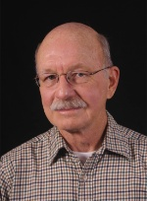
Gerald Stringfellow is internationally known for his work in developing a particular class of semiconductors, critically important in the areas of fiber-optic communications systems and solar cells. He is also considered a pioneer in his work on light-emitting diodes in order to develop a more energy-efficient, longer-lasting light source.

In 2001, Prof. Stringfellow was elected to the National Academy of Engineering, one of the most prestigious academic honors. In addition to many other awards, he has received the Humboldt U.S. Senior Science Award, the Utah Governor’s Medal of Science, the International Crystal Growth Frank Prize and the Rosenblatt Prize, the highest honor awarded to a professor at the University of Utah. He is a fellow of the Institute of Electrical and Electronics Engineers and is an editor of the Journal of Crystal Growth.

Stringfellow served as dean of the U’s College of Engineering from 1998 to 2003, and twice served as chair of the Department of Materials Science and Engineering. He received his bachelor’s degree in ceramic engineering from the University of Utah in 1964, and his master’s and Ph.D. degrees in materials science from Stanford University. He was an engineer and project manager at Hewlett Packard Laboratories before joining the University faculty in 1980.

Title: Materials and Processes for Light Emitting Diodes

Gerald Stringfellow教授，IEEE会士，Journal of Crystal Growth杂志主编，于2001年成为美国工程院院士，他曾被授予洪堡美国高级科学奖项，犹他州长科学奖和大学杰出科研奖等奖项。因研发了一类特殊的半导体材料而著名，这类半导体材料在光纤通讯系统和太阳能电池中都非常重要。Stringfellow教授也是研发发光二极管以便开发一种更高效持久的光源的先驱人物。

Stringfellow教授于1964年在犹他大学获得陶瓷工程专业学士学位，在斯坦福大学获得材料科学专业硕士和博士学位，他曾在惠普实验室担任工程师和项目经理，于1980年加入犹他大学。1998年到2003年担任犹他大学工学院院长，并两度担任材料科学与工程系系主任。

演讲题目：发光二极管的材料和处理工艺

旅美科协总会年会主旨嘉宾介绍

2016年会 Keynote Speaker
CAST-USA Award Excellence in Technology Innovation Leadership

Prof. Lieping Chen, MD, PhD
Professor of Immunobiology, Dermatology & Medicine
Yale University School of Medicine

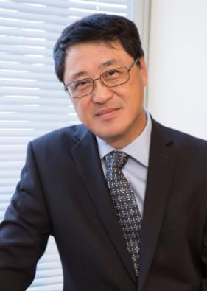
Lieping Chen is a pioneer in cancer immunotherapy. In 1992, Dr. Chen did the first proof-of-concept study showing that manipulation of the B7-CD28 family molecules could be used for cancer immunotherapy by introducing B7-1 into tumor cells to enhance tumor immunity. This study inspires subsequent studies using antibodies targeting CTLA-4, one of the B7-CD28 family molecules, for the treatment of cancer. Dr. Chen co-discovered the PD-1/PD-L1 pathway and singularly established the PD-1/PD-L1 pathway as target for cancer immunotherapy in 1999-2002. He initiated the first-in-man clinical trial of anti-PD-1 antibody for treating human cancer in 2006 and developed PD-L1 staining as a biomarker to predict treatment outcome. Dr. Chen’s studies have revolutionized cancer treatment. His discoveries directly led to the development of anti-PD-1/PD-L1 antibody therapy against broad spectrum of human cancers (first approved by FDA in 2014).

Dr. Chen has published more than 300 papers, review, book chapters and edited two books. His work in discovery of the PD-1/PD-L1 pathway in cancer therapy was cited as the #1 breakthrough of the years by Science magazine (2013). He has received several awards and professional recognitions including William B. Coley Award (2014) and AAI-Steinman Award.

Title: Adaptive resistance: From a hypothesis to anti-PD-1/PD-L1 cancer therapy

耶鲁大学陈列平教授

陈列平博士是肿瘤免疫治疗的先驱者。1992年，他的研究开创了运用共刺激和共抑制分子增强肿瘤免疫反应并以此治疗癌症的全新理念。1999年至2002年，陈列平博士首次鉴定了PD-1/PD-L1免疫调节通路并首创了用抗体阻断PD-1/PD-L1通路治疗癌症的新方法。2006年，他发起并帮助组织了全球首次抗PD-1抗体治疗癌症的临床试验。他的科研团队还发现了其他多个免疫调控通路并运用于人类疾病治疗。陈博士的研究奠定了抗PD-1/PD-L1抗体用于治疗晚期癌症以及相关广谱抗癌新药研发的基础，也促成了其他多个创新药物研发，其中抗4-1BB（CD137）抗体（治疗癌症）已进入临床试验阶段。

陈博士迄今已发表300多篇研究论文、综述及专著章节，并主编了2本学术专著。他的研究工作—发现PD-1/PD-L1通路并运用于癌症治疗—被《科学》杂志评为2013年度重大科学突破之榜首。陈博士获得的学术荣誉包括2013年耶鲁大学UTC讲席教授，2014年免疫学威廉•科利奖（William B. Coley Award）和2016年美国免疫学会斯坦曼奖（AAI-Steinman Award）。

题目：从理论假说到抗PD-1/PD-L1的实用性癌症治疗之路
旅美科协总会年会主旨嘉宾介绍

2016年会 Keynote Speaker
CAST-USA Award Excellence in Technology Innovation Leadership

Prof. Zhonglin Wang, PhD

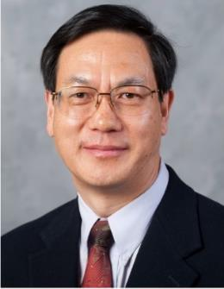
Dr. Zhong Lin (ZL) Wang received his PhD from Arizona State University in 1987. He now is the Hightower Chair in Materials Science and Engineering and Regents' Professor at Georgia Tech, and Director and Chief Scientist, Beijing Institute of Nanoenergy and Nanosystems, Chinese Academy of Sciences, Beijing. Dr. Wang has made original and innovative contributions to the synthesis, discovery, characterization and understanding of fundamental physical properties of oxide nanobelts and nanowires, as well as applications of nanowires in energy sciences, electronics, optoelectronics and biological science. His discovery and breakthroughs in developing nanogenerators establish the principle and technological road map for harvesting mechanical energy from environment and biological systems for powering a personal electronics. Dr. Wang’s publications have been cited for over 100,000 times. The H-index of his citations is 155. Dr. Wang was elected as a foreign member of the Chinese Academy of Sciences in 2009, member of European Academy of Sciences in 2002, fellow of American Physical Society in 2005, fellow of AAAS in 2006, fellow of Materials Research Society in 2008, fellow of Microscopy Society of America in 2010, and fellow of the World Innovation Foundation in 2002.
Title: Pioneering new energy technology- challenges, innovations and perspectives

中国科学院外籍院士、欧洲科学院院士、佐治亚理工学院王中林教授

王中林院士是佐治亚理工学院终身校董事讲席教授，Hightower终身讲席教授，化学系兼职教授和电机系兼职教授。王教授是首位中组部“千人计划”顶尖人才与团队入选者。他是中国科学院北京纳米能源与系统研究所首席科学家和首任所长。

王教授是中国科学院外籍院士和欧洲科学院院士，美国物理学会fellow, 美国科学发展协会(AAAS) fellow，美国材料学会 fellow，美国显微学会fellow, 美国陶瓷学会fellow。

王教授已在国际一流刊物上发表了1100篇期刊论文，200项专利，5本专著和20余本编辑书籍和会议文集。他论文被引用的H因子(h-index)是153。他是世界上在材料和纳米技术论文引用次数最多的前五位作者之一。王教授在当今世界最杰出的科学家排名榜上第25名 (http://superstarsofscience.com/scientists).

王中林是国际公认的纳米科技领域领军人物，在一维氧化物纳米结构制备、表征及其在能源技术、电子技术、光电子技术以及生物技术等应用方面均作出了原创性重大贡献。他发明了压电纳米发电机，摩擦纳米发电机，并首先提出了自驱动系统的概念，为微纳电子系统的发展开辟了新途径。他开创了纳米结构压电电子学和压电光电子学研究的先河，对纳米机器人、人-电界面、纳米传感器、医学诊断及光伏技术的发展具有里程碑意义。

题目：探索新能源技术—挑战，创新和展望
旅美科协总会年会主旨嘉宾介绍

2016年会 Keynote Speaker
CAST-USA Award Excellence in Technology Innovation Leadership

Xiang Zhang, PhD

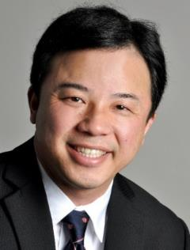
Xiang Zhang is the inaugural Ernest S. Kuh Endowed Chaired Professor at UC Berkeley and the Director of NSF Nano-scale Science and Engineering Center (NSEC). He is also the Director of Materials Science Division at Lawrence Berkeley National Laboratory (LBNL), as well as member of Kavli Energy Nano Science Institute.

Professor Zhang is an elected member of US National Academy of Engineering (NAE), Academia Sinica (Taiwan), Foreign Member of Chinese Academy of Sciences, and Fellow of four scientific societies: APS (The American Physical Society), OSA (The Optical Society of America), AAAS (The American Association for the Advancement of Science), and SPIE (The International Society of Optical Engineering).

Professor Zhang received Ph.D. from UC Berkeley (1996) and MS from University of Minnesota and MS/BS from Nanjing University, China. He was an assistant professor at Pennsylvania State University (1996-1999), and associate professor and full professor at UCLA (1999-2004) prior joined Berkeley faculty in 2004.

Professor Zhang’s current research focused on materials physics, optical metamaterials and nano photonics. He has published more than 280 journal papers including over 75 publications in Science, Nature series, PNAS and Physical Review Letters. He has given over 300 Keynote, Plenary and Invited talks at international conferences and institutions.

In 2008, Professor Zhang’s research has been selected by Time Magazine as one of “Top Ten Scientific Discoveries of the Year” and “50 Best Inventions of the Year”, Discover Magazine’s “Top 100 Science Stories” in 2007, and R&D Magazine’s top 25 the Most Innovative Products of 2006. His research was frequently featured by international media including BBC, CNN, ABC, New York Times, and Wall Street Journal.

Title: Creating materials that do not exist in Nature

美国工程院院士、加州伯克利分校张翔教授
张翔，出生于江苏南京，1985年本科毕业于南京大学物理系，1988年硕士毕业于南京大学物理系，1989年赴美国留学，1996年博士毕业于美国加州大学伯克利分校机械工程系。现任美国加州大学伯克利分校特级教授（chancellor's professor）、美国国家纳米科学中心主任，他主持研制的隐身衣，被美国《时代》杂志列入2008年十大科学发现。2010年发明世界最小纳米激光器并当选美国国家工程院院士，2012年受聘“南京大学校长人才工作顾问”，中央研究院2012年新增的2位中国大陆本科背景的院士之一。

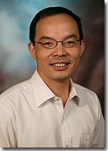
Speaker: Dr. Xuedong (XD) Huang

Distinguished Engineer and Chief Scientist of Speech at Microsoft Research

Xuedong “XD” Huang serves as Microsoft’s chief speech scientist and leads Microsoft’s Advanced Technology group, which includes Microsoft’s world-wide Advanced Technology Labs in Egypt, Israel, and Germany. XD joined Microsoft to found the company’s speech recognition team.

Title: Speech and Natural Language Progress for Enterprise Artificial Intelligence

黄学东，ACM院士(ACM Fellow)，微软首位华人“全球技术院士”、微软首席语音科学家、微软研究院孵化研究开发部总经理，IEEE院士，湖南省信息化领导小组顾问，湖南大学客座教授，湖南大学软件学院名誉院长。他先后获得湖南大学学士学位，清华大学硕士学位和英国爱丁堡大学博士学位。

题目：工业人工智能在语音及自然语言识别上的最新进展

旅美科协总会年会主旨嘉宾介绍

2015年会 Keynote Speaker

Prof. C. Daniel Mote, Jr., PhD
President of the National Academy of Engineering
美国国家工程院主席

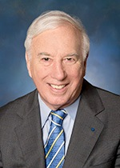
Prof. C. Daniel Mote, Jr is the current President of the National Academy of Engineering. He served as President of the University of Maryland, College Park from September 1998 till August 2010. From 1967 to 1991, Mote was a professor in mechanical engineering at the University of California, Berkeley, and served as Vice Chancellor at Berkeley from 1991 to 1998.

Dr. Mote’s recognitions include the NAE Founders Award, the American Society of Mechanical Engineers Medal, and the Humboldt Prize of the Federal Republic of Germany. At the University of California, Berkeley, he was honored with the Distinguished Teaching Award, Distinguished Engineering Alumnus Award, Berkeley Citation, and Excellence in Achievement Award. He is an Honorary Fellow of the American Society of Mechanical Engineers, and Fellow of the American Academy of Arts and Sciences, the American Academy of Mechanics, the Acoustical Society of America and the American Association for the Advancement of Science. He holds three honorary doctorates and two honorary professorships.

Title: Innovation: Risks are Necessary

Daniel Mote 教授，现任美国国家工程院主席，曾任马里兰大学校长。

演讲题目：创新：风险是必不可少的

旅美科协总会年会主旨嘉宾介绍

2015年会 Keynote Speaker
CAST-USA Award Excellence in Science Leadership

Prof. Xiaowei Zhuang, PhD
Member of National Academy of Sciences and Member of American Academy of Arts and Sciences
David B. Arnold Professor of Science, Harvard University
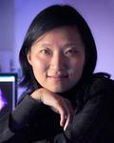
Dr. Xiaowei Zhuang is a professor of chemistry and chemical Biology, a professor of physics at Harvard University. She is also an investigator of the Howard Hughes Medical Institute.

Zhuang is a biophysicist recognized for her work in the development and application of advanced optical imaging techniques for the studies of biological systems. In particular, she invented Stochastic Optical Reconstruction Microscopy (STORM), one of the first single-molecule-based super-resolution imaging methods. She demonstrated multi-color, three-dimensional super-resolution imaging of live cells and tissues with STORM. Zhuang has also established STORM as a powerful tool for biology and discovered novel cellular structures. Recently, Zhuang invented a single-cell transcriptome imaging method, MERFISH (multiplexed, error-robust fluorescence in situ hybridization), which allows numerous RNA species to be quantified in situ in the native context of cells and complex tissues. Her lab has also developed and applied single-molecule approaches to investigate the dynamics and function of biomolecules, with emphasis on protein-nucleic acid complexes important for gene expression and regulation.

Zhuang was born in 1972. She received her B.S. degree in Physics from the University of Science and Technology of China in 1991, Ph.D. Degree in Physics from University of California at Berkeley in 1996 (Advisor Y. R. Shen), and postdoctoral training in biophysics at Stanford University during 1997-2001 (Advisor: Steven Chu). In 2001, she became an assistant professor at Harvard University, where she was promoted to associate professor in 2005 and full professor in 2006. She was selected as a Howard Hughes Medical Institute investigator in 2005.

Partial list of awards: MacArthur Fellowship, Searle Scholar, Sloan Fellowship, Packard Fellowship, Coblentz Award, American Chemical Society Pure Chemistry Award, American Physical Society Max Delbruck Prize in Biological Physics, Raymond & Beverly Sackler International Prize in Biophysics, National Academy of Sciences Award in Molecular Biology, etc.

Zhuang is a member of the National Academy of Sciences, a member of the American Academy of Arts and Sciences, a fellow of American Association of the Advancement of Science, a fellow of the American Physical Society and an honorary fellow of the Royal Microscopical Society.

Title: Illuminating Biology at the Nanoscale with Single-molecule and Super-resolution Microscopy

庄小威教授。 生物物理学家，哈佛大学讲席教授，哈佛大学高等成像中心主任，霍华德-休斯 医学研究所（HHMI）研究员。早年毕业于中国科技大学少年班，1996 年在伯克利大学师从沈元壤教授并获得物理博士学位，随后在斯坦福大学诺贝奖获得者朱棣文教授的实验室从事博士后研 究。2001 年被聘为哈佛大学助理教授。2003 年获得美国麦克阿瑟基金“天才奖”，是第一位获此荣誉的华人女科学家。34岁时成为了哈佛大学的化学和物理双学科终身正教授，是哈佛物理 系和化学系少有的双科教授。2012 年庄教授当选为美国国家科学院院士，刷新了美国科学院最 年轻华人院士的纪录，同年还当选为美国人文与科学院院士。庄教授同时还是美国科学促进会会士、美国物理学 会会士，英国皇家显微镜学会名誉会员。庄小威教授长期致力于开发和应用先进的光学成像技术，用于生物系统的研究。特别是， 她发明了随机光学重建显微镜（STORM），这是第一个基于单分子的超分辨率成像方法之一， 与诺奖得主 Eric Betzig 的成果不相伯仲。她用 STORM 展示了活细胞和组织的多色、三维超 分辨率成像，并将 STORM 建立完善成为生物学的强大工具，发现了很多新的细胞结构。近年 来，庄小威教授发明了一种单细胞转录组成像方法，MERFISH（复用、错误鲁棒荧光原位杂交），允许在细胞和复杂组织的天然环境中原位定量许多RNA 物种。她的实验室还开发和应用单分子方法来研究生物分子的动力学和功能。

旅美科协总会年会主旨嘉宾介绍

2015年会 Keynote Speaker
CAST-USA Award Excellence in Technology Innovation Leadership

Prof. Kai Li, PhD
Member of National Academy of Engineering

李凯院士
美国国家工程院院士

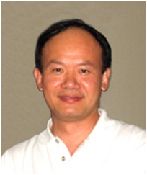
Dr. Kai Li is noted for his pioneering contributions to Distributed Shared Memory (DSM) and co-founding the leading storage deduplication company Data Domain Inc. which was acquired by EMC Corporation in 2009 at US $2.1 billion. He was elected as an Association for Computing Machinery (ACM) fellow and Institute of Electrical and Electronics Engineers (IEEE) fellow in 1998 and 2011, respectively. In 2012 he was elected to the National Academy of Engineering. He received Overseas Outstanding Contribution Award, China Computer Federation in 2008.

Title: Disruptive Research and Innovation

2015年旅美科协科技创新卓越奖: 李凯教授。计算机专家。普林斯顿大学教授。1977年毕业于吉林大学，1981年毕业于中国科学技术大学研究生院，1983年获耶鲁大学计算机科学硕士学位后，李凯师从世界上第一个“图林奖”获得者艾伦·佩利斯攻读博士学位，1986年获博士学位。其博士论文提出了分布式共享内存思想，开创了计算机科学的新领域。随后他进入普林斯顿大学任教，现任该校计算机系终身教授。在计算机领域特别是分布式计算取得杰出的研究成就，提出了分布式存储（Distributed Shared Memory,DSM）的设计思想, 对后来的分布式计算，并行计算甚至今天的云计算都有深远的影响。后来又在硅谷创办Data Domain公司，被EMC高价收购。李凯老师是当今华人计算机研究领域最有影响力的人物之一。李凯教授于2012年当选为美国工程院院士，以表彰他在数据储存和分布式计算机系统研究方面取得了重要进展。美国国家工程院院士是工程界最高荣誉。

题目：分布式计算的研究和创新
旅美科协总会年会主旨嘉宾介绍

2015年会 Keynote Speaker

Dr. Victor Yuan

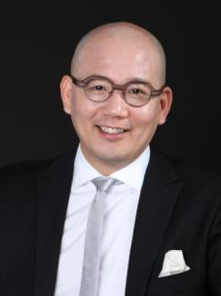
Dr. Victor Yuan is the Chairman of Horizon Research Consultancy Group, Founder of Pegasus (Angel Investment and Service), President of Horizon Center of Youth Entrepreneurship for Society (YES), Independent media professional, Member of China Angel Investor Club, Dean of Shanghai Great Business School, Ph.D. in Sociology from Peking University.

MPA from John F. Kennedy School of Government, Harvard University, Master of Law from Southwest University of Political science and Law, Yale World Fellow 2007, Aspen Fellow of China Leadership 2013-2015, Vice President of China Marketing Research Association.

Part-time professor in Tsinghua University, Zhejiang University, Southwest Jiaotong University, Communication University of China, Central Academy of Arts, etc. Part-time mentor of EMBA/MBA/MPA. More than 40 books published in respects of Management, Economics, Sociology, Politic science and Culture.

Title: The new opportunity of entrepreneurship in China: quality and feasibility

袁岳，男，江苏省盐城市大丰区人，先后毕业于南京大学、西南政法大学、北京大学、哈佛大学等，现任零点研究咨询集团董事长。

研究和著述集中于工商管理领域的品牌管理、系统营销体系、内部管理转型、领导力塑造、危机管理、终端管理、营销研究方法论。 其研究致力于传媒和政府多个方向。另外，他以自己的见解为年轻人写的各种文章和书籍，深受大众喜爱。主持《头脑风暴》节目，展现了其睿智，儒雅的幽默风格。2013年9月16日，参加由江苏卫视联合优米网共同打造的国内首档商业明星公益真人秀《赢在中国蓝天碧水间》，并担任蓝天队队长。

袁岳博士，零点研究咨询集团董事长； 创业管理服务机构飞马旅创始人、CEO； 零点青年公益创业发展中心理事长； 独立媒体人； 天使会理事； 新沪商大商学院院长； 北京大学社会学博士；哈佛大学肯尼迪政府学院MPA；西南政法大学法学硕士；2007年耶鲁世界学者；2013-2015年美国Aspen学者；中国市场研究协会副会长；清华大学、浙江大学、西南交大、中国传媒大学、西安欧亚学院、中央美术学院等高校的客座教授，EMBA/MBA/MPA兼职导师；出版管理学、经济学、社会学、法学等方面论著40多部，逾一千两百万字。

演讲题目：中国创业的新机遇：质量与可行性

旅美科协总会年会主旨嘉宾介绍

2015年会 Keynote Speaker

Dr. Qi Lu
陆奇博士

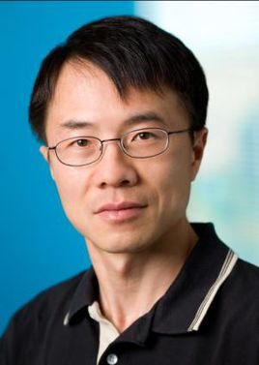
Dr. Qi Lu is the Executive Vice President, Microsoft’s Applications and Services Groups. Dr. Lu obtained his BS and MS from Fudan University in Shanghai, China, and PhD in Computer Science from Carnegie Mellon. Dr. Lu is leading the company's work on the Bing search engine, Skype and Microsoft Office. Lu formerly worked as technology developer and manager for Yahoo!'s technology search division.

Lu worked in one of IBM's research labs from 1996–98, then joined Yahoo! and eventually rose to manage 3,000 engineers and the development of search and search advertising technologies for the company. Lu's departure from Yahoo! in mid-2008. After joining Microsoft, Lu was instrumental in driving the partnership with Yahoo! in search and the launch of Bing.

2015年会CAST-USA Award Excellence in Technology Management Leadership

陆奇博士
微软集团全球执行副总裁、微软在线服务集团总裁

陆奇博士，毕业于中国复旦大学计算机系，获得学士、硕士学位。1987年毕业后留校执教。1992年陆奇留学美国卡内基梅隆大学（CMU），并于1996年5月毕业，获得计算机科学博士学位，并在CMU继续其博士后的研究工作。其博士导师为Professor M. Satyanarayanan。其博士论文题目为Improving Data Consistency in Mobile File Access Using Isolation-Only Transactions。随后加盟IBM公司的Almaden研究实验室，工作两年。1998年8月17号加盟雅虎，十年间，陆奇从一个普通工程师一步步的成长，2006年4月14日，陆奇被任命为雅虎的资深副总裁，2007被再次提升为雅虎执行副总裁。2008年12月，加盟微软任执行副总裁，担任微软Bing项目的负责人。作为微软在线业务部门总裁，陆奇现在已是微软四大业务部门负责人之一，掌管一支3000至5000多人的技术团队，并直接向CEO萨蒂亚·纳德拉汇报。据称，这是大陆华人在外资科技公司总部所任职位的最高级别。

