Louisville Build-A-Bed Volunteer Registration Form
April 14, 2018
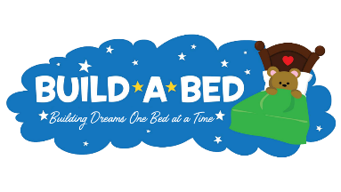
Due by March 2nd (to ensure correct t-shirt sizes are ordered)

Group Name/Organization:________________________________________________

Number of Volunteers:__________

Address (include City, State, Zip):_________________________________________

Team Leader Name:_______________________________________________________

Team Leader Contact Number:____________________________________________

Team Leader Email Address:_______________________________________________

Team T-Shirt Sizes: S ____ M ____ L ____ XL _____XXL ____ XXXL ____
.
Build-A-Bed Event Date:
Thomas Jefferson (TJ) Middle School
1501 Rangeland Rd. 40219
Saturday, April 14, 2018 at 9:00 a.m.
(Event will take place in back gym.)

BUILD TEAM REQUIREMENTS:
- Build Team must consist of a minimum of 4, but a maximum of 6 members
- Build Teams must bring:
  - 2 - cordless drills
  - 1 - Rubber Mallet
  - 1 - 7/16 Wrench
  - 3 – 1/8 wood drill bits
  - 1 – 5/16 wood drill bit
  - 2 – T25 Torx Bits
  - 1 – Sharpie Marker
(Let us know if you are unable to provide the above suggested
tools for your team.)
- Build Teams must arrive at 8:15a.m. to set up their assigned work area.
- Volunteers under the age of 18 MUST be closely supervised by an adult
- Teams comprised of children must have an equal adult/child ratio

Return completed registration form by March 16 and e-mail the JCPS Office of Community Support Services:
Ben.Langley@jefferson.kyschools.us and Leneshia.Perry@jefferson.kyschools.us

Subject:”BUILD-A-BED Volunteers”
You will receive a confirmation e-mail providing additional information about the Build-A-Bed event.
You will also receive 3-4 additional e-mails leading up to April 14th, which will provide further information.
You can also gather updates and information by viewing our Facebook Page at:
Jefferson County/REACHCorps Build A Bed

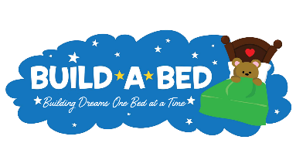

TEAM NAME:______________________________

Team Members Names & T-Shirt Size

Member Name | T-Shirt Size
1.
2.
3.
4.
5.
6.

