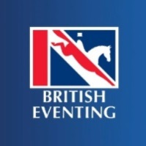
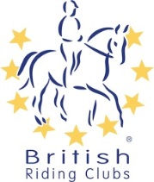
British Riding Club BE League
British Riding Clubs and British Eventing Leagues for Novice and Intermediate Levels.

British Riding Cubs (BRC) and British Eventing (BE) have once again teamed up to offer exciting opportunities to BRC members competing at Novice and Intermediate levels with BE.

These leagues will be published on the BRC website and points will be awarded to all BRC members who complete in the following classes at a BE event between 1 March and 31 October 2019.
- Intermediate
- Open Intermediate
- Intermediate U18

- Novice
- Open Novice
- Novice U18 section

BRC and BE will be awarding rosettes to 10th place. Prizes will be awarded in kind.
If you would like to opt in please fill out the details below and send this form back to jessica.payne@bhs.org.uk.
Riders Details:
BRC registered name: . . . . . . . . . . . . . . . . . . . . . . . . . . . . . . . . . . . . . . . . . . . . . . . . . . . .
BE registered name: . . . . . . . . . . . . . . . . . . . . . . . . . . . . . . . . . . . . . . . . . . . . . . . . . . . . .
BRC membership number: . . . . . . . . . . . . . . . . . . . . . . .
Horse(s) name(s) registered to BE: . . . . . . . . . . . . . . . . . . . . . . . . . . . . . . . . . . . . . .
. . . . . . . . . . . . . . . . . . . . . . . . . . . . . . . . . . . . . .
. . . . . . . . . . . . . . . . . . . . . . . . . . . . . . . . . . . . . .
. . . . . . . . . . . . . . . . . . . . . . . . . . . . . . . . . . . . . .
. . . . . . . . . . . . . . . . . . . . . . . . . . . . . . . . . . . . . . .
Please see our website for more details. The closing date to opt in is 30 September 2019, any forms sent after this date will not be included and results will not be entered into the league.
Your Personal Information:
Personal information that you supply to us may be used in a number of ways to facilitate your riding club membership. Your personal information will be shared with associates for the purpose of fulfilling your full membership benefits i.e. insurance providers.
BRC will automatically contact you about your membership: for example, to ensure you receive your membership benefits, to tell you about news, activities and events. This includes sending you a regular magazine, email updates information on other membership benefits, and publishing competition times and results in the public domain.
To see our full Privacy Policy, or if you need any further information, please write to us at; British Riding Clubs, British Horse Society, Abbey Park, Stareton, Kenilworth, CV8 2XZ or go to: http://www.bhs.org.uk/privacy

