Who we are  Chicks Ministry is a nondenominational, nonprofit ministry that acts as gathering place for young women to learn about faith in Jesus Christ.  Chicks serves a young woman during the pivotal years from adolescence into early adulthood.  Wherever she may be in her beliefs, Chicks exists as a safe place to hear sound Biblical teaching, learn how to recover from difficult situations or mistakes, and accept the invitation to build an identity in Christ.  Contact Us  Kelly Kirstein  Phone: (515)851-8332  Email: chicksministry@gmail.com  Web: www.chicksministry.org  Instagram: Chicks Ministry  Facebook: Chicks Ministry  Chicks Ministry  Clarion, Iowa 50525 |  |  | Doodle & Faith  Chicks Ministry  - Connecting to God Through Creativity

Table of Contents  Set Your Mind 1  Example Doodle & Faith Page 2  Step By Step Instructions 3  Doodle Ideas 4  Keep It Simple 4  Have Fund 4  Scripture Suggestions 5 |  |  | Daughter of the Most High  And, “I will be a Father to you, and you will be my sons and daughters, says the Lord Almighty.” 2 Corinthians 6:18 (NIV)  Do You Receive it?  “…to those who believed in his name, he gave the right to become children of God— John 1:12”  Is Jesus Your Savior?  For it is by grace you have been save, through faith… Ephesians 2:8-10
 |  |  | 5

Doodle Ideas  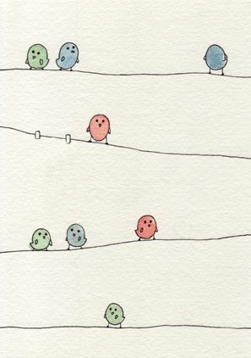  eva-ve.deviantart.com  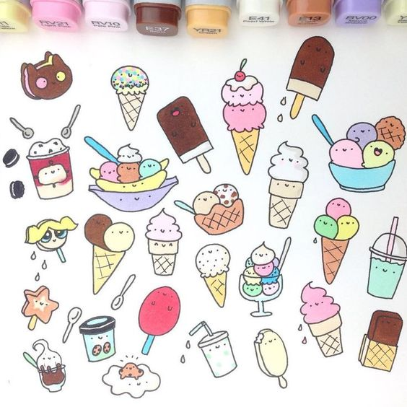  http://pergola-ideas-patio.weddingsrings.xyz/ |  |  | Keep it simple  Have Fun with it | Set Your Mind  Whether or not you are artistic doesn’t matter here!  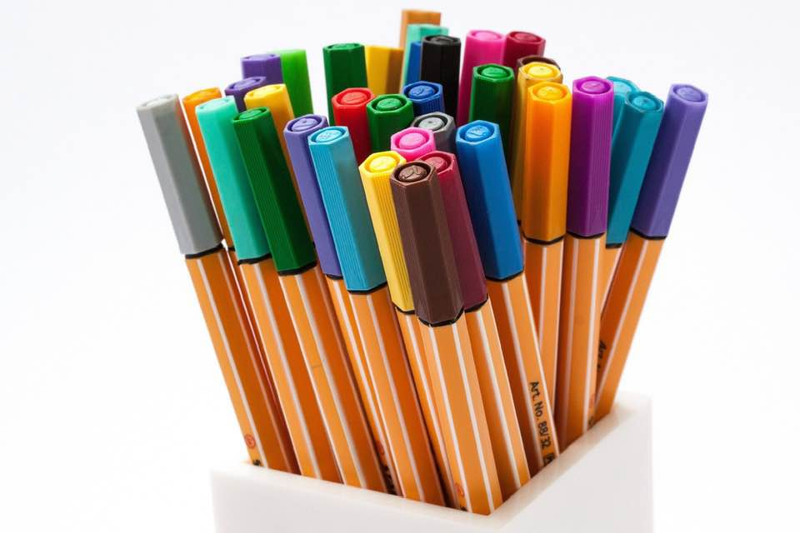  Build Faith: What do you need help with? Or want to understand better about God? Yourself? Or Life?  Doodling: The process is more about connecting with God than making a work of art.  Tips  - If you are having trouble focusing on the scripture or prayer go back to doodling and ask God to help you focus.  - Try drawing simple shapes like hearts, stars, flowers. Colorful dots and lines are great too.  - Stickers & Washi tape can add a little structure to your drawings.  - Pens, Markers, Crayons, Colored Pencils add texture
4 |  |  |  | 1

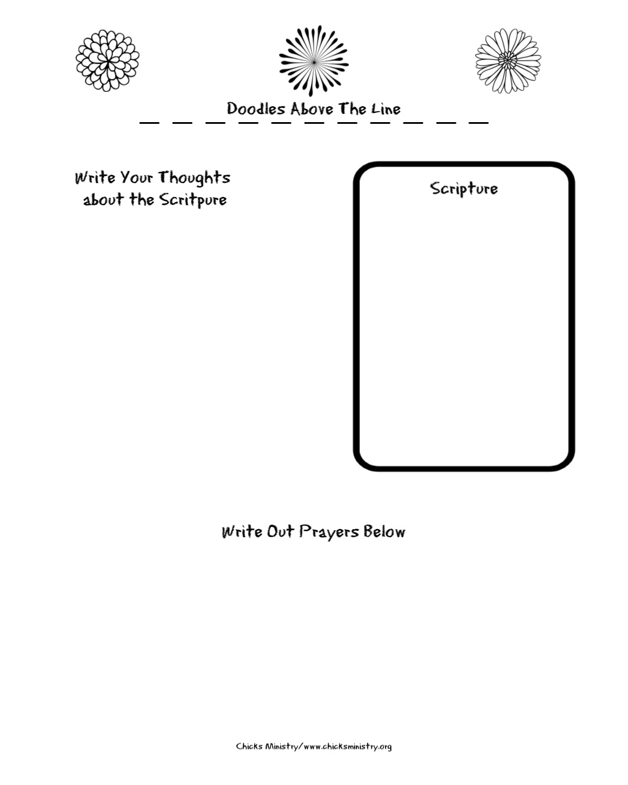 |  | How to Begin  Step 1: Pick a Scripture that Speaks to You  Step 2: Grab a notebook or a sheet of paper.  Step 3: Divide the page into 4 sections  - Top- Doodle Section  - Right Side of Page- Write Your Scripture  - Left Side of Pate- Write Your Thoughts About the Scripture  - Bottom- Prayer Requests  Step 4: Let Your Work Reflect Your Style
2 |  |  | 3

