IPWSO 2018 Travel Fellowship Application 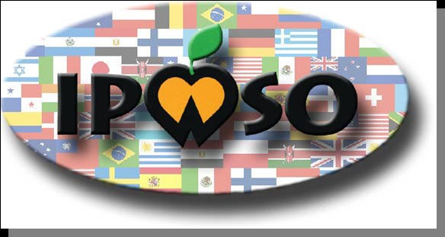
In order to share knowledge about Prader-Willi Syndrome (PWS) around the world IPWSO is delighted to offer a travel fellowship to a person who wishes to attend a PWS conference outside of her/his own country in 2018.

The expectation of the fellowship is that the successful applicant/s will use the knowledge gained at the conference to help people with PWS in her/his country.

The applicant/s must be willing, if successful, to be publicly identified by IPWSO as having received a fellowship (e.g. on the IPWSO website and in its annual report).

The applicant/s must also be willing to prepare a brief report (which IPWSO may make public) on her/his experience at the conference within 6 months of the end of the conference.

The maximum value of the fellowship is US$2,500. This may be awarded to a single candidate or divided amongst candidates.

Priority will be given to applicants who have previously supported people with PWS in their countries and demonstrate a willingness to continue to support others. Priority will also be given to candidates who come from countries in which large PWS conferences do not currently take place and where there is little awareness of PWS.

The closing date for the receipt of applications is 30 March 2018. The successful applicant/s will be chosen by the IPWSO board whose decision will be final.

The successful applicant/s will be informed by 30 April 2018.

To apply please provide the information requested below by email to information@ipwso.org

All applications must be in English and amounts stated in US$.

Applicant details
Name:
Email Address:
Telephone Number:
Street Address:
Are you a relative of someone with PWS? If so, indicate your relationship with that person (e.g. parent).
If you are not a relative of someone with PWS, indicate your job title and briefly explain your interest in PWS.

What is your first language?
If your first language is not the language of the conference, please indicate which of the following best describes your level of the conference language:
near native/fluent
excellent command
good command/good working knowledge
basic communication skills

Conference details:
Dates of conference:
Location of conference:
Conference website or other contact information:
Language of conference:

Your role in supporting people with PWS
PWS association with which you are affiliated (if any):
Briefly describe your current role in this PWS association.

Briefly describe any previous work you have done to support people with PWS.

Briefly describe how much information and what services are available to people with PWS and their families in your country, and the numbers diagnosed with the syndrome (if known).

Purpose of fellowship
How will your attendance at the this conference benefit people with PWS in your country and/or internationally? Be as specific as possible in describing your future plans for helping people with PWS.

Previous international PWS conferences you have attended
List any international PWS conferences you have attended giving the name and location of the conference and the year you attended.

Funding
How much will your travel costs for the conference be?

How much will your accommodation costs for the conference be?

How much is the conference registration fee?

How much (if any) of these costs will you (or an association or your employer) pay?

How much are you applying to IPWSO for?

