Turkey’s political prisoners at grave risk from COVID-19
In the early hours of Tuesday 14 April 2020, the Turkish Parliament passed a law which lead to the release of up to 90,000 prisoners. However, it excluded scores of journalists, human rights defenders, politicians, lawyers and others arbitrarily detained, pending trial or serving sentences following unfair trials under Turkey’s overly broad anti-terrorism laws which facilitate incarceration for exercise of free speech.
Omer Faruk Gergerlioglu, a prominent HDP parliamentarian and human rights activist wrote to the Washington Examiner as follows:
“The Turkish government’s prisoner release is the right thing in principle, but the actual bill is a human rights travesty. It is a good thing to release part of the prison population to decrease the overcrowded facilities where inmates have to survive inhumane conditions even without an outbreak. But the groups they are leaving in prison are the ones who should be let out.”
“For years, journalists and political activists have been jailed in Turkey on the charge of supporting terrorism. The counter-terrorism law defined terrorism in such a broad way that even someone who had never engaged in violence or condoned it could be charged with terrorism. Nearly 50,000, or one-fifth of the total prison population in Turkey, are journalists, civil servants, teachers, police officers, military personnel, and politicians charged with such “crimes.””
Terrorism may sound like the gravest of offenses, but in Turkey, the government misuses the charge for political ends. Many inmates are placed in lengthy pretrial detention or sentenced without evidence that they committed violent acts, incited violence, or provided logistical help to outlawed armed groups. Among them are journalists like Ahmet Altan, politicians like Selahattin Demirtas and Figen Yuksekdağ, human rights defenders like Osman Kavala, and thousands of dismissed civil servants, teachers, and others punished for association with the Hizmet (Gulen) movement.
A lawyer for some of the inmates unfairly being held in prisons on counter terrorism charges, Murat Akkoc, illustrates the dire situation in the prisons by asking the following questions:
- 43 people remain in the B-10 ward [of Silivri Prison]. You took 8 people who were not COVID-19 in the ward to the C-7 ward where there were prisoners who had coronavirus for no reason and brought them back to the B-10 ward. Who is negligent in the work done? (https://twitter.com/avmuratakkoc/status/1258152369130520579).
- In the press release of the Bakırköy Chief Public Prosecutor's Office on 8 May 2020, despite the fact that 44 detainees / convicts suffered COVID-19 disease in Silivri Prison, this number is much higher according to our colleagues and families who reached us. (https://twitter.com/avmuratakkoc/status/1259693175595249666).
- Silivri No. 7 L Type Prison B-10 and B-12, Silivri No. 8 L Type Prison C-6, C-7 and C-8 wards are for only 7 inmates but currently hold between 39 and 43. (https://twitter.com/avmuratakkoc/status/1259693245631795201)
- Retweeted: Journalist Çetin Çiftçi, who has been in prison for 6 years and 3 months and has been in Sincan Prison for 8 months, has been diagnosed with Covid 19. It was learned that Çiftçi, who has kidney and heart diseases, is under treatment. #JournalismIsNotACrime Hundreds of Corona in Prisons (https://twitter.com/jailedjournos/status/1260666529722531846)
The prominent former editor-in-chief for the now non-existing Today’s Zaman newspaper, which was the highest circulating newspaper published in English in Turkey before being ceased and shut down by the government, tweeted this:

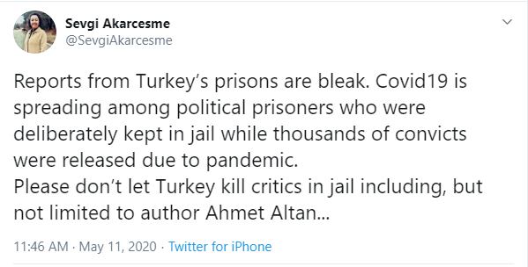
https://twitter.com/SevgiAkarcesme/status/1259661139597832193
Several international human rights bodies have appealed on Turkey to ensure the release from prison of the excluded prisoners; 27 human rights and freedom of expression NGOs have issued a joint statement and tens of thousands in Turkey and elsewhere have signed a petition urging the Minister of Justice to broaden the scope of the proposed measures.
Council of Europe Commissioner of Human Rights https://www.coe.int/en/web/commissioner/-/covid-19-pandemic-urgent-steps-are-needed-to-protect-the-rights-of-prisoners-in-europe
Bar Human Rights Committee of England and Wales https://www.barhumanrights.org.uk/political-prisoners-in-turkey-in-the-face-of-the-covid-19-pandemic/
NGOs Joint statement: https://www.amnesty.org/en/documents/eur44/2047/2020/en/
https://www.amnesty.org/download/Documents/EUR4420472020ENGLISH.pdf
According to the joint statement:
“Turkey is subject to the authority of both the UN Subcommittee on Prevention of Torture and the European Committee on the Prevention on Torture who respectively have issued calls to “reduce prison populations and other detention populations, wherever possible” and said concerted efforts by all relevant authorities to resort to alternatives to deprivation of liberty “ is imperative, in particular, in situations of overcrowding.”
The Advocates for Dignity join the chorus of the above human rights organisations and demand the Turkish Authorities enact immediate measures to release all those arbitrarily detained, whether in pre-trial detention or after conviction, particularly given many are vulnerable to Covid-19 due to their age or underlying health conditions. We urge the authorities to move now to prevent a humanitarian disaster. Failure to release those detained and imprisoned on spurious charges, which would help reduce the spread of a deadly disease in detention, would show further alarming disregard for human rights by the Turkish government.

