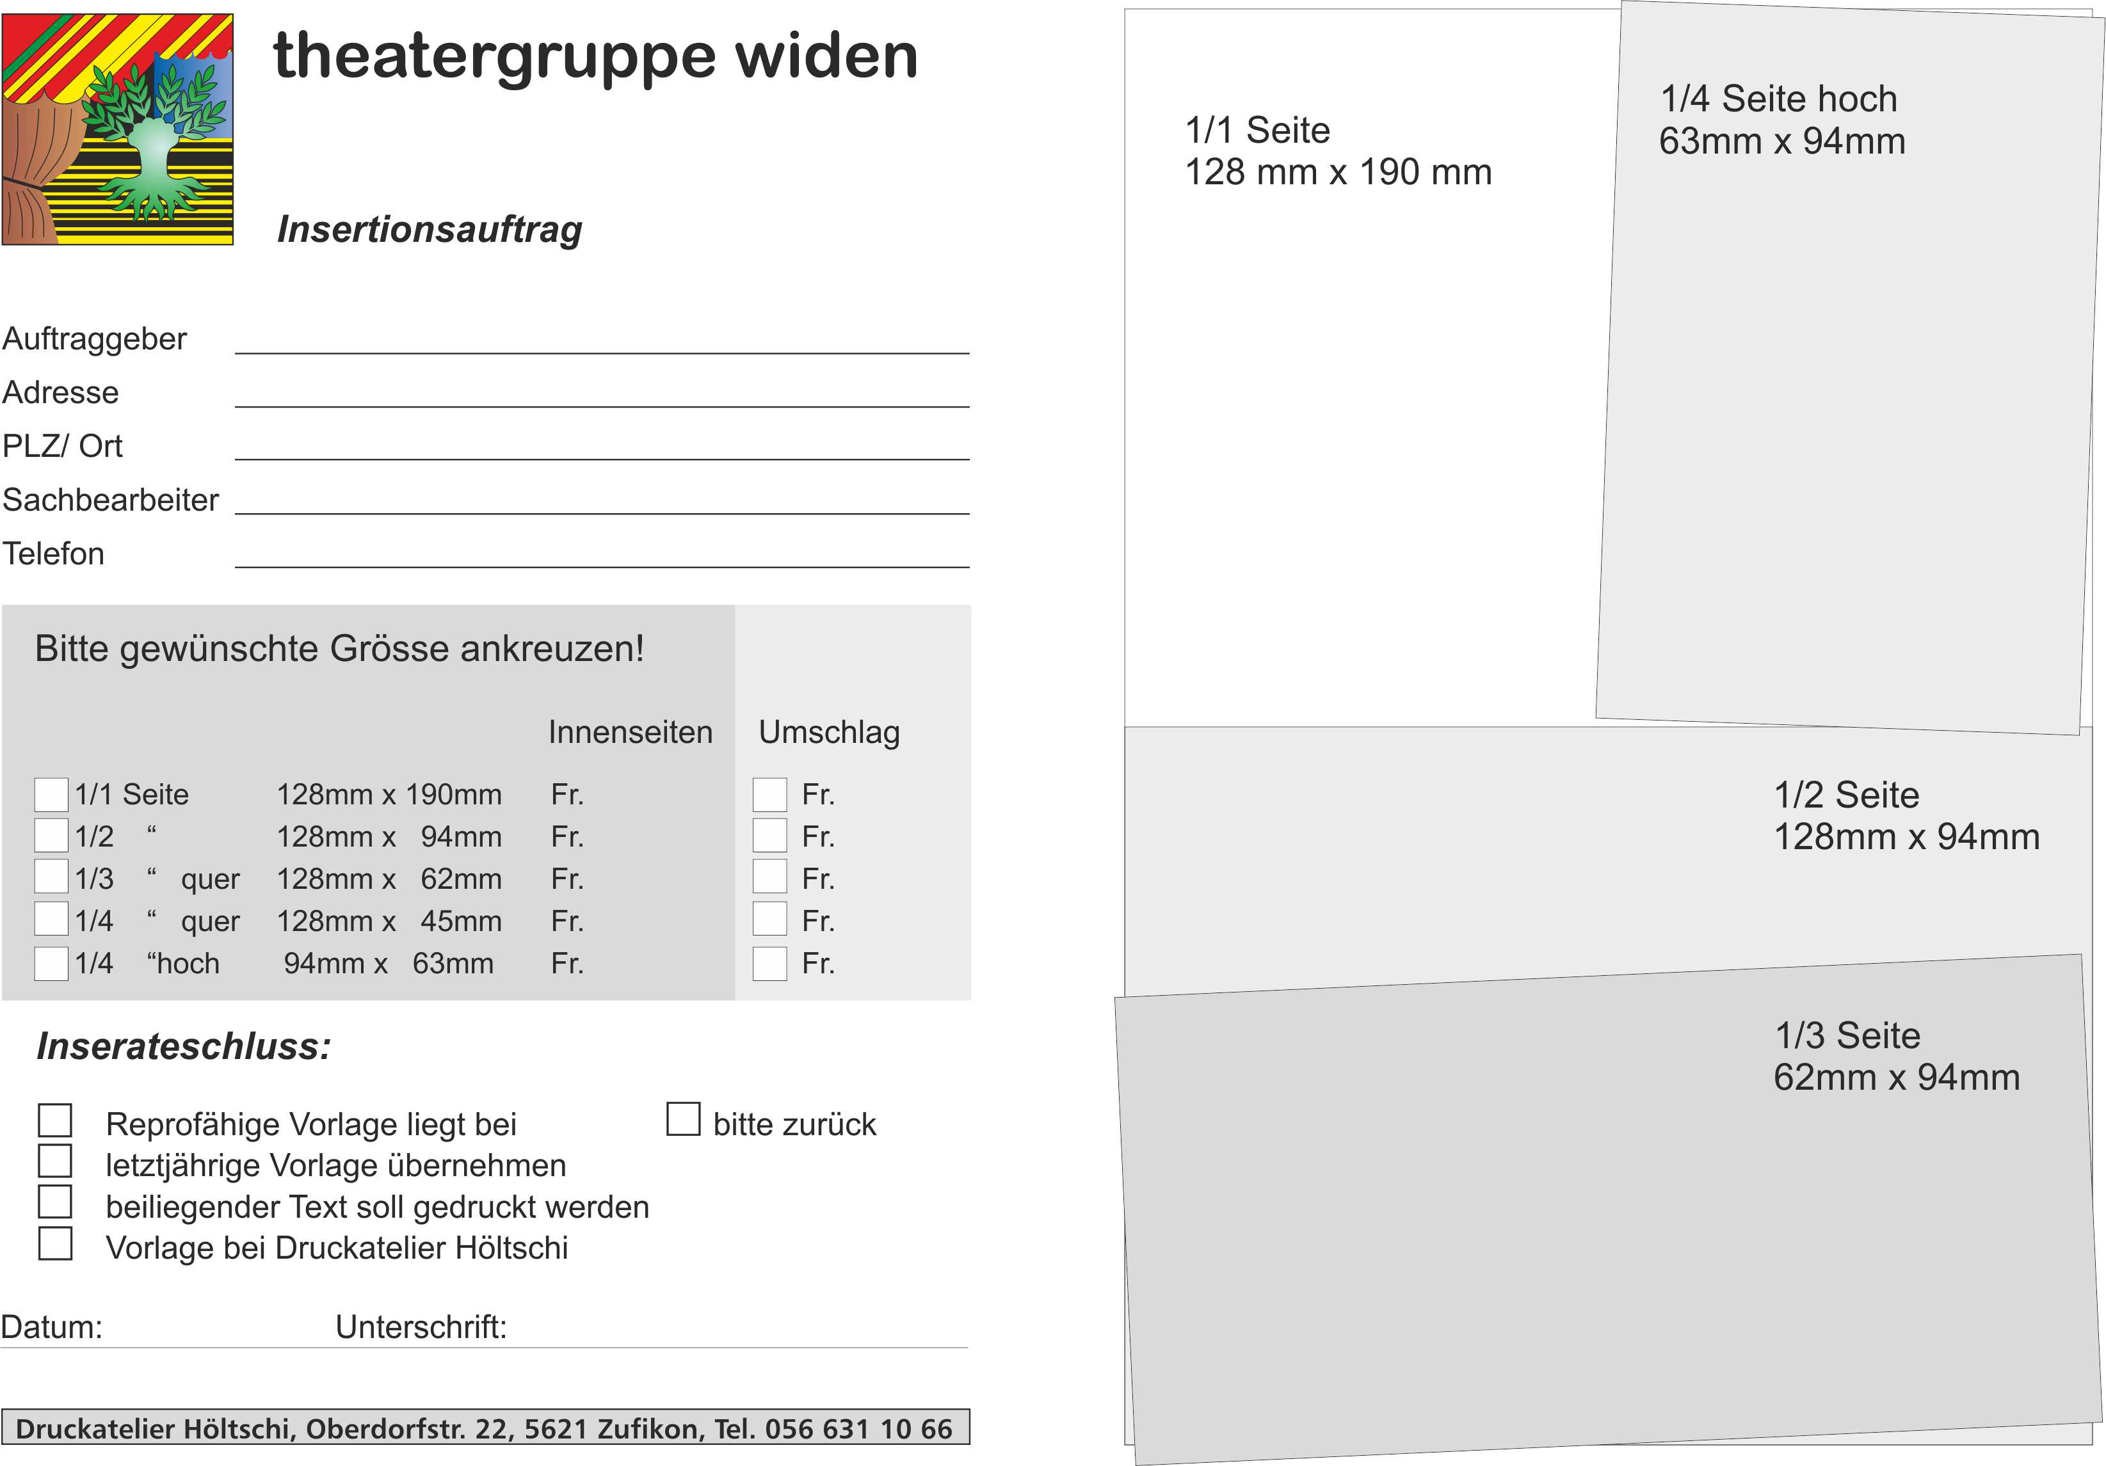

Prakash Gysel, Dorngasse 33, 8967 Widen, prakashgysel@yahoo.de

500.00 600.00 250.00 350.00

200.00 300.00 150.00 250.00

150.00 250.00