Document Classification
X | Public Domain
 | ITAR Controlled
 | Internal Only

Instrumentation Amplifier
Project Report



Date: 11/8/2017

Quinn Mikelson
Electrical Engineering
Cal Poly, SLO
qmikelso@calpoly.edu

CHANGE HISTORY LOG
Effective Date | Revision | Description of Changes
11/8/17 | 1.0 | Initial document creation
11/12/17 | 1.1 | Added section on gain network modifications
12/3/17 | 1.2 | Added conclusion and finished report for initial release

- Objective
The purpose of this paper is to outline the design and fabrication of an instrumentation amplifier. Following discussions with EE dept. Professor, Dr. Bridget Benson, this design satisfies the requirements of the final project template outlined in EE-211/241(03) modified for introduction of a PCB design section.

The design itself is meant to replicate the functionality of a common instrumentation amplifier using single operational amplifier devices and a feedback network. The schematic and layout were created with the goal of providing a 10x signal amplification on differential input frequencies from DC to ~700MHz; this would allow the measurement of low-voltage differential signals with in systems with both common and differential mode signals.

This objective was modified during the testing phase to 120MHz at 1000x gain.

- Theory of Operation
A traditional difference amplifier provides a single-ended output that is directly proportional to a factor of the difference of the two inputs based on the generalized equation $Vout = G_{V}*ΔVin = G_{V}*({Vin}_{A} - {Vin}_{B})$.

By adding a second, high-impedance, input stage utilizing additional op-amp voltage followers, and by adjusting the feedback network, we create the common instrument amplifier.

This provides a method of measurement for differential signals while rejecting inherent common-mode components. Typically, common-mode components in differential signals are consequences of a circuit’s reference to a non-ideal power supply and ground loop.

From Wikipedia:
“When referenced to the local common or ground, a common-mode signal appears on both lines of a two-wire cable, in-phase and with equal amplitudes. Technically, a common-mode voltage is one-half the vector sum of the voltages from each conductor of a balanced circuit to local ground or common. Such signals can arise from one or more of the following sources:
• Radiated signals coupled equally to both lines,
• An offset from signal common created in the driver circuit, or
• A ground differential between the transmitting and receiving locations.”

- Requirments
Because my original idea was to create a high-gain measurement device, I wanted my input signal to be practical. I chose to attempt measurement of the fluctuations on a common reference plane. Had I understood the time constraints on the project better I would never have attempted something so technical, and would have instead focused on a simpler test case. Because of these time constraints I was forced to make wide assumptions about some of the more esoteric phenomena.
Following very limited investigation into the nature of ground-plane noise, and after discussion with various colleagues, I decided to assume the input signal would be no greater than a millivolt in amplitude. This assumption was later modified, and the final device requirements were to be calibrated for a signal amplitude in the microvolt range; this ultimately required a 1000x differential gain and extremely high impedance as not to affect the behavior of the noise signal.

- Design

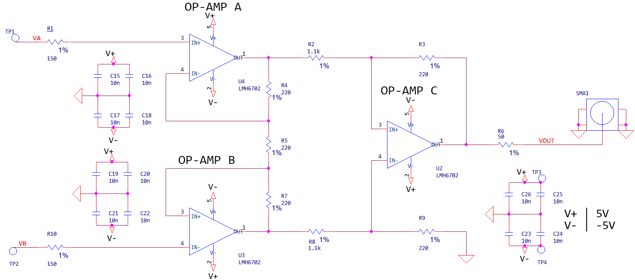
The following schematic is my initial design and assembly intended to be used as a 10x differential signal amplifier probe.
Op-amp A and B are both configured as high-impedance voltage followers designed to limit the non-ideal current flow into the device from the source signal. Ideally, this allows us to replicate and amplify the input signal without affecting its shape or amplitude. R4, R5, and R7 form a dividing ladder between each op-amp and their respective in/outputs. This divider network is the heart of the gain-setting circuitry and determines the ultimate output amplification of the final amplifier. This network’s primary function is to set the differential gain of the system; the is the part of the signal that is unreferenced, again ideally, to ground.

The outputs of the amplifiers are fed into the final op-amp; configured as a differential amplifier. This network, as I discovered after testing my circuit, controls the common mode gain. Because this amplifier *is* referenced to ground, and because it is not configured for unity gain (gain=1), the circuit did not perform as I expected. The resulting change to the schematic involved replacing the 1.1Kohm resistors with 220ohm and reconfiguring the differential gain for better signal amplification.

The differential amplifier is used to convert the two, amplified differential signals, into one common referenced signal. This allows us to use an ordinary ADC, oscilloscope, or other similar piece of equipment to read otherwise unmeasurable differential signals.

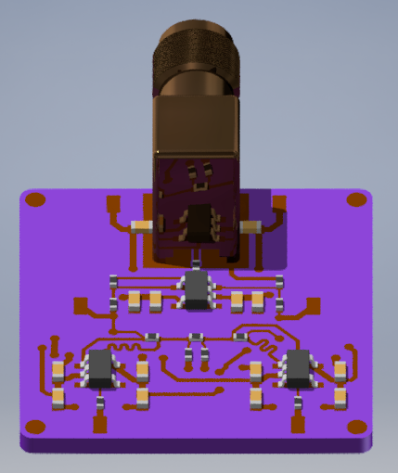

Fig 2.4
3D render of enclosure designed to protect the probe assembly during use

Fig 2.2
3D render created using Autodesk Inventor and Allegro’s STEP output function
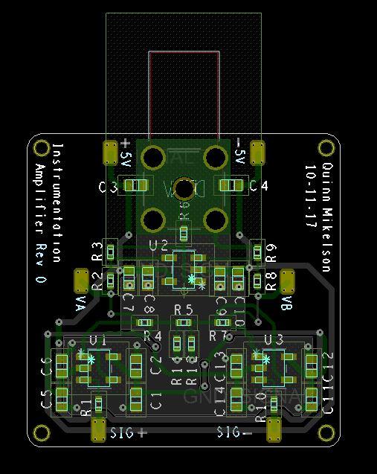
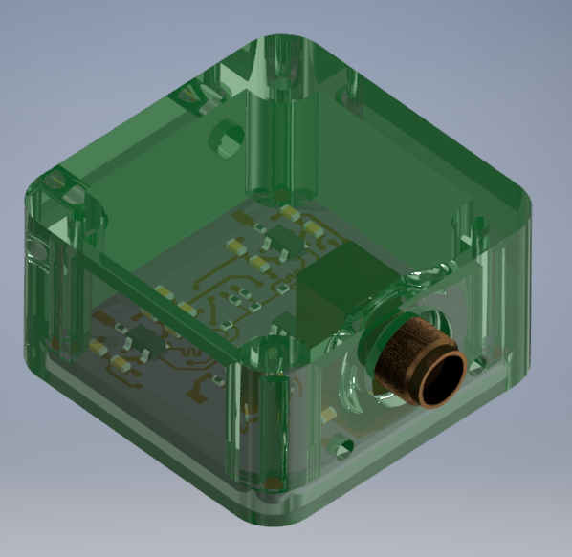
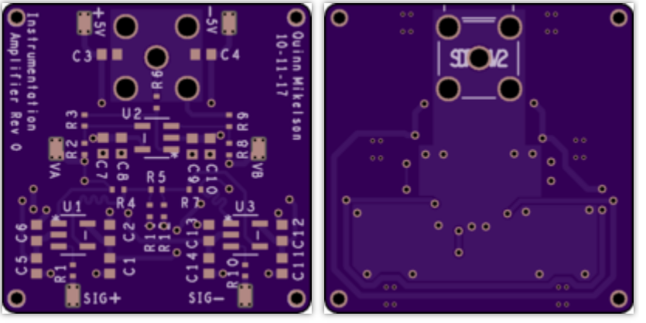
Fig 2.1
Layout plot of circuit from Allegro
Fig 2.3
Rendering of the board layout provided by OshPark’s DFM

- Assembly Procedure

Inspect wiring board and verify layout features were manufactured as expected | 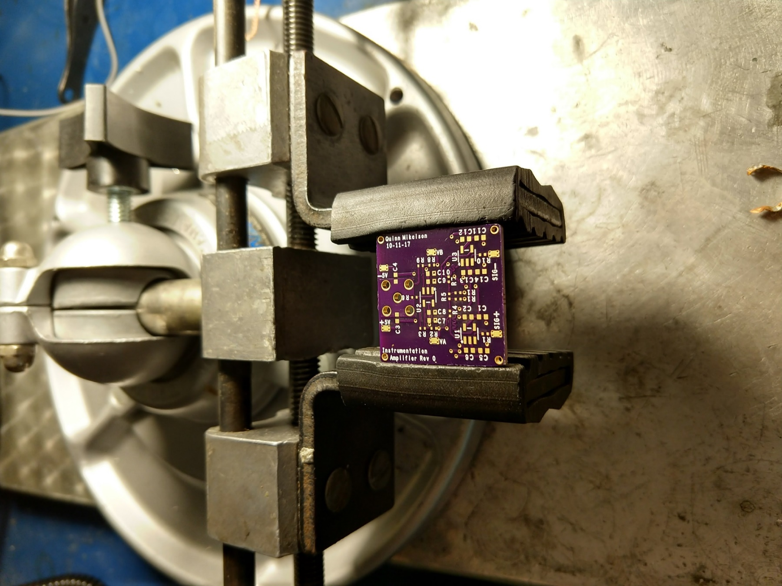
Gather the following equipment for SMD assembly:  - Fine point tweezers  - PCB vice  - Optical inspection microscope  - Liquid or tacky flux  - Reflow gun  - Soldering iron  - Soldering wire  - Desoldering braid  - Isopropyl Alcohol  - Stranded copper wire  - Paintbrush | 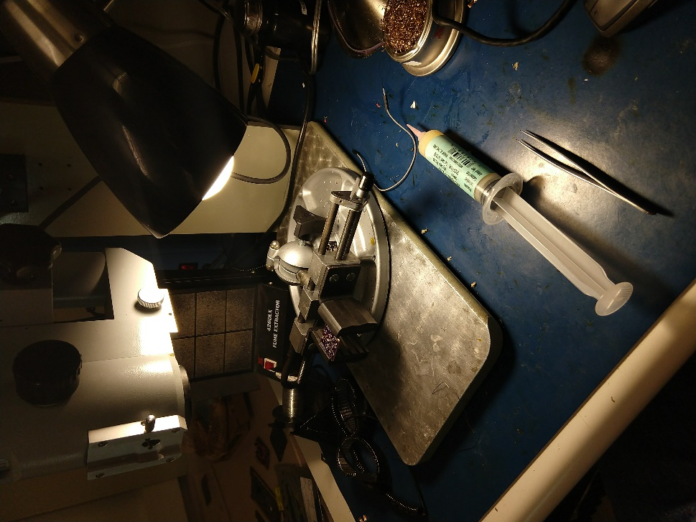
Prepare pads by pre-tinning all solder points. Apply generous amount of flux.  The following process can be performed in “waves”. It may be easiest to leave off ICs and reflow just the passives first.  Carefully align components on wiring board, don’t worry about being too accurate, the surface tension of the liquid solder will align the chip during reflow. | 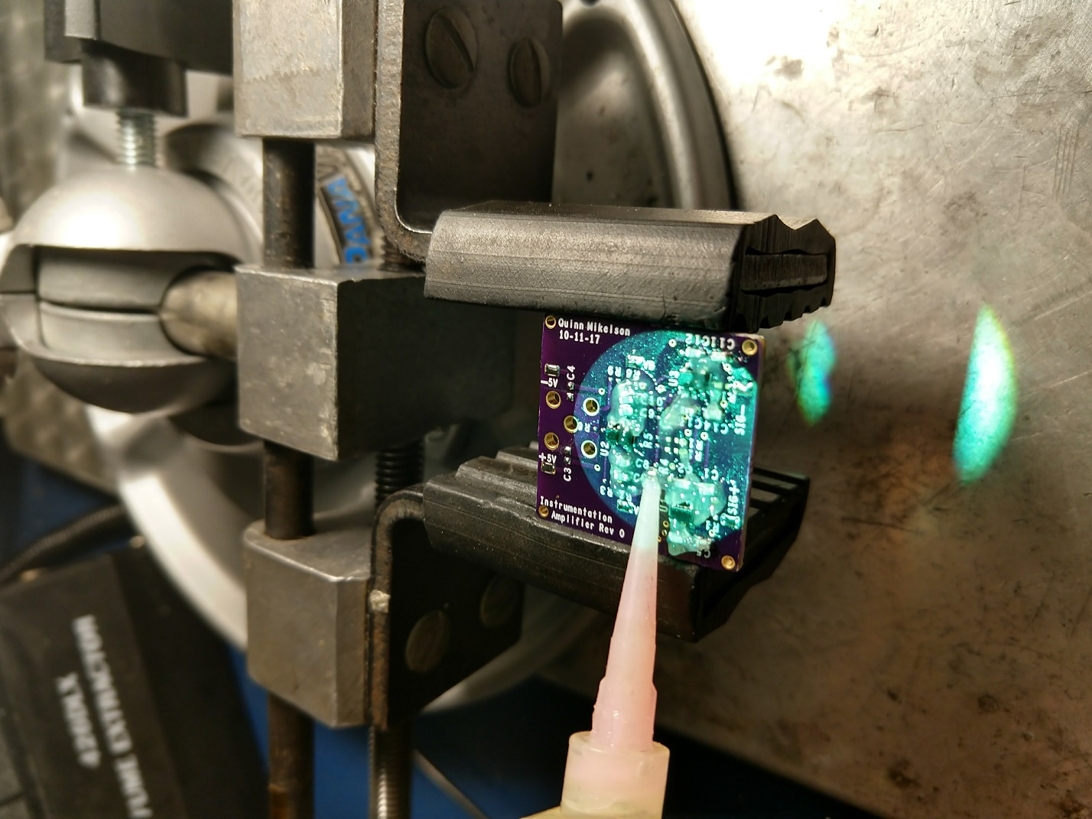
Optional: Use a soldering iron to tack one pin on each component to the board. This will keep the reflow gun from disloding the components and blowing them off the board. Inspect manual solder junctions and verify that there are no possibilites for shorts. | 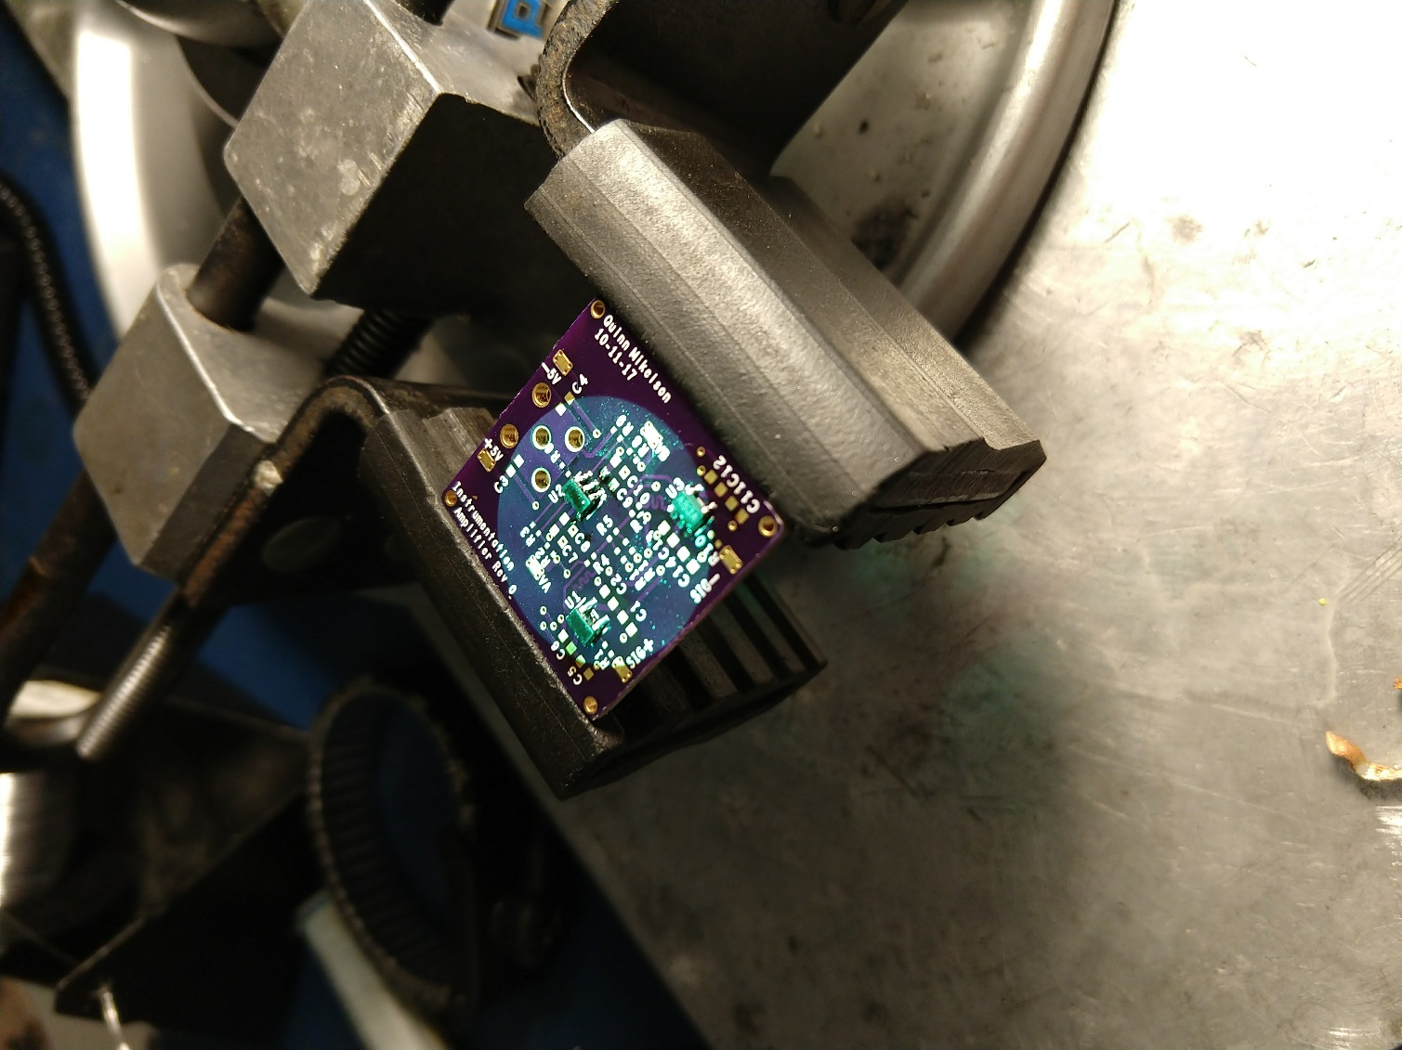
Use reflow gun to heat PCB evenly until all solder joints liquify.  Be careful to keep the temperature of the air between 280ºC and 310ºC. | 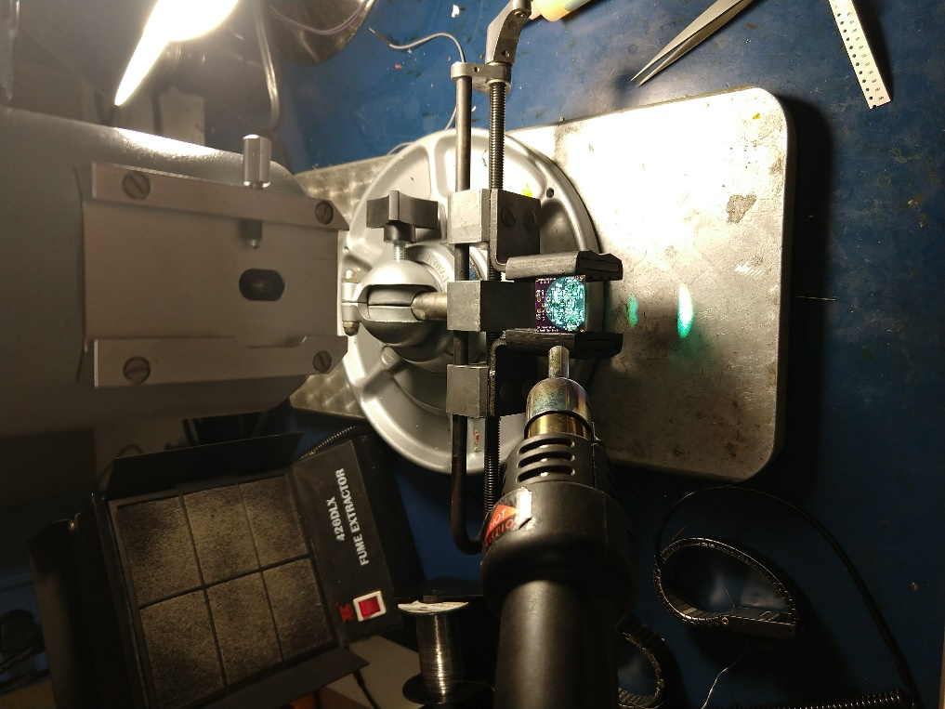
Inspect solder joints and add any missing components. Add the large through hole SMA connector to the board. This connector will be slightly more difficult to solder due to it’s metal casing.  It is recommended to solder the SMA connector with a soldering iron. | 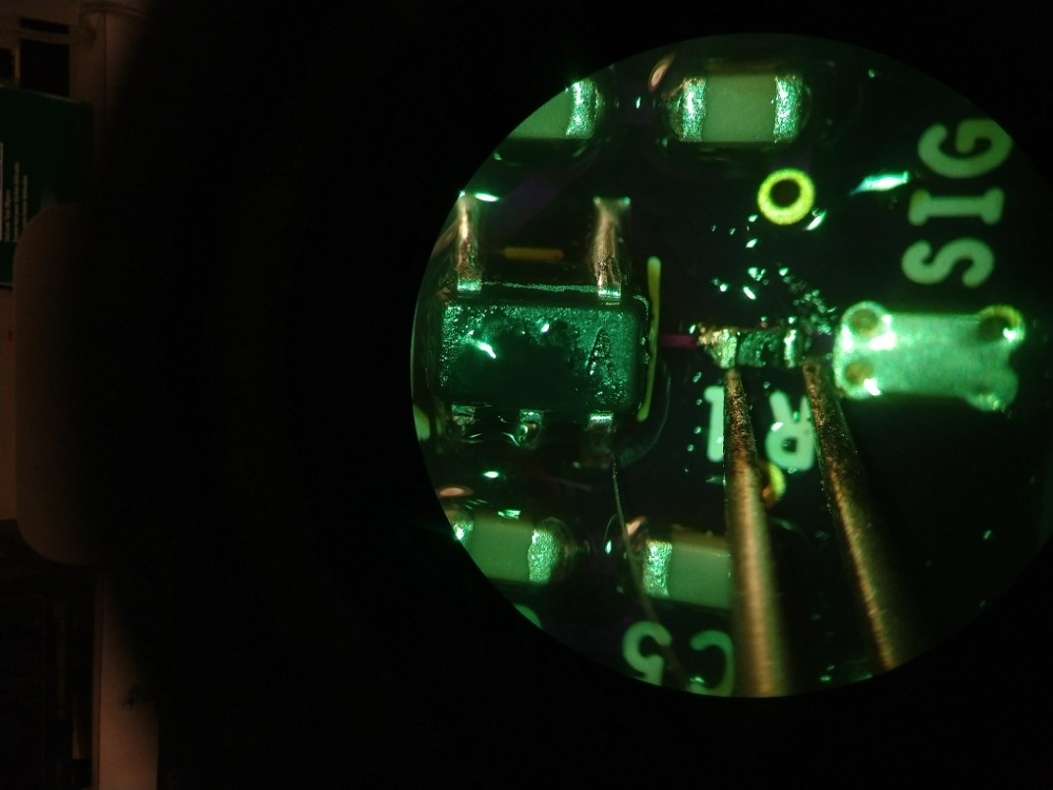
Rinse the board in an IPA bath and use a brush to clean off any residual flux. | 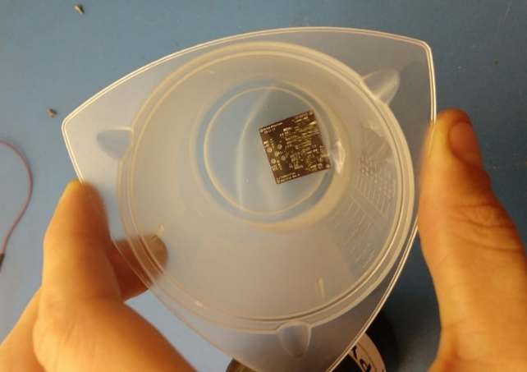
Assemble measurment device in protective housing | 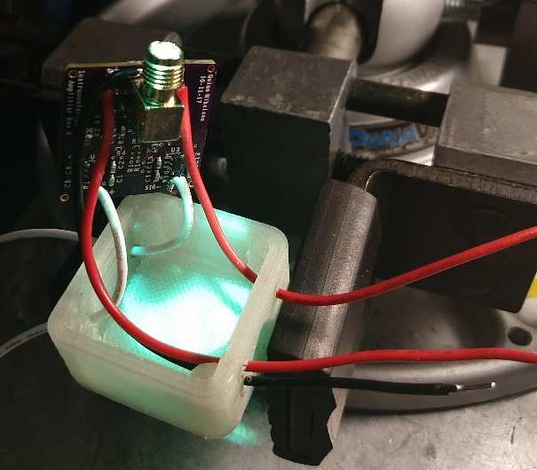

- Testing

My test equipment list is as follows:
- Tektronix MSO2024B Oscilloscope
- SMA to BNC Adapter
- BNC to BNC Cable
- 1 PSU with >5V bipolar supply
- 3 Banana-Grabber power cables
- Signal generator
- Signal generator probes

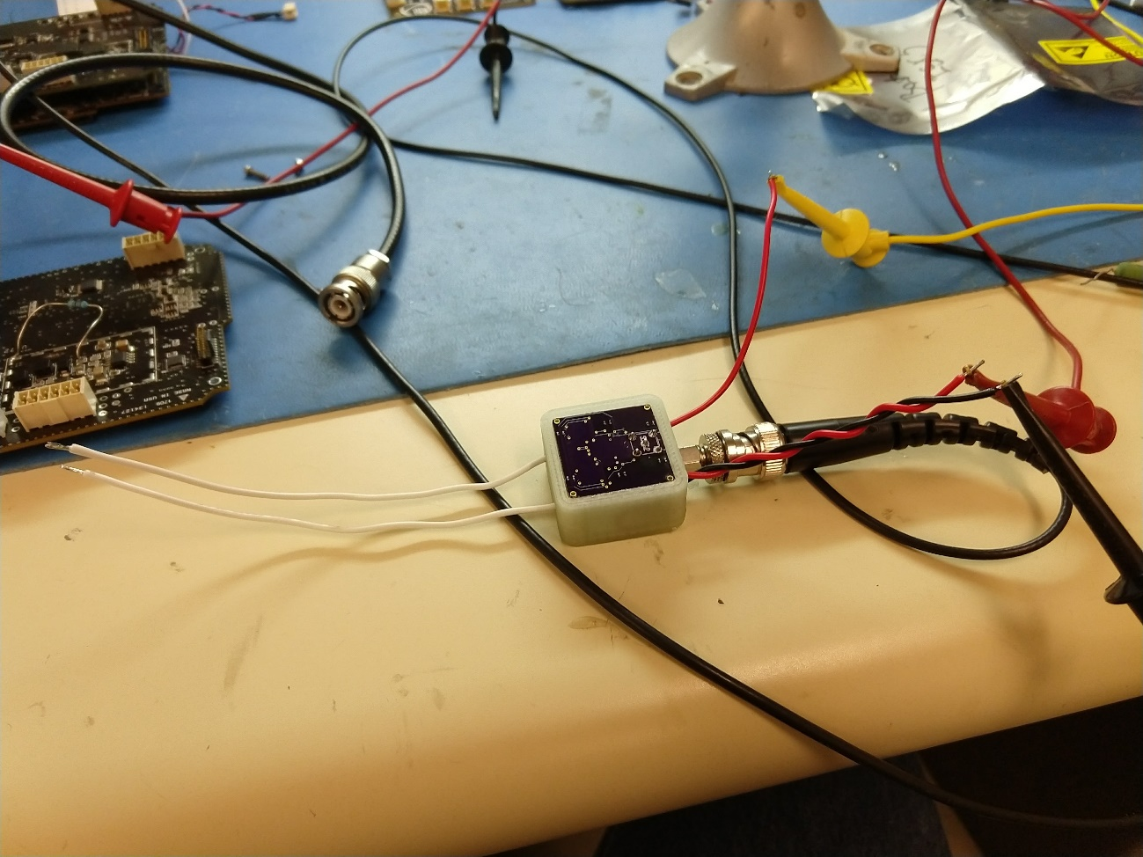
Following review of my design, and reading a few textbook entries, I discovered that I had accidentally set the design for a 3x differential gain followed by a 5x common gain. This matched the behavior I noted while performing my initial tests. My initial test with a 100mVpp sinewave resulted in a 1.3V output signal. The following images are the only pictures I have as the flash drive containing the original images has been lost.
Original Test Setup
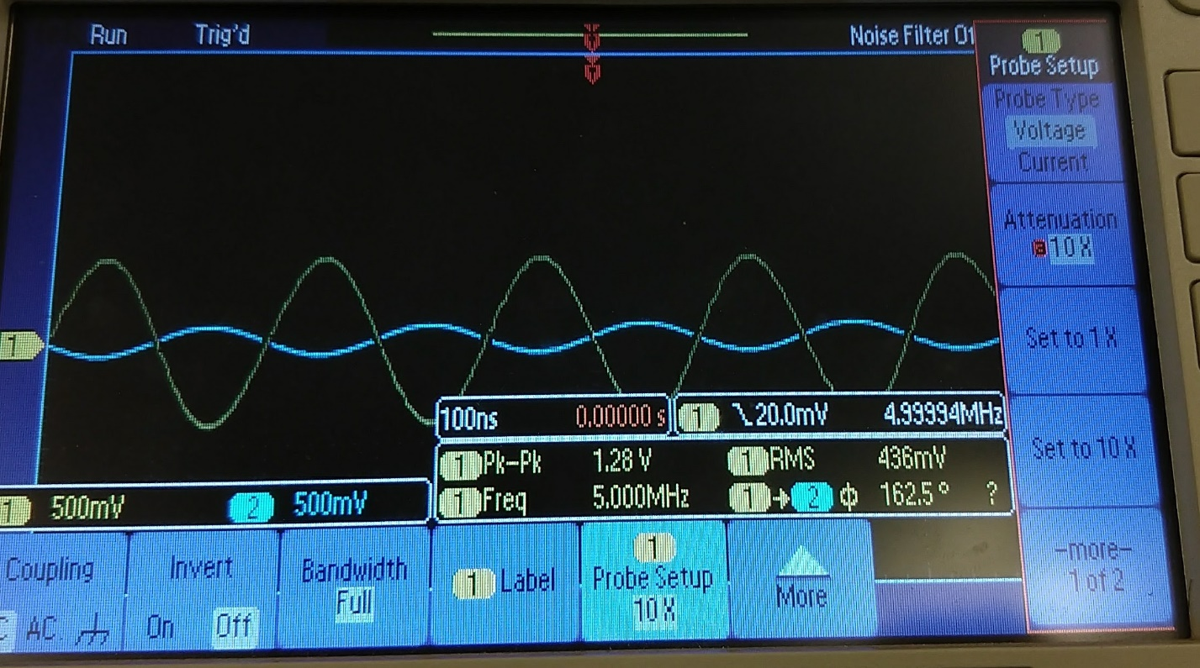
Scope output of test 1. Intended Gain is 10x, measured gain is 12.8. (hmm, something’s not right)

Although impossible to see, the unamplified input signal (blue) has an amplitude of 100mV and its amplified output (yellow) has a peak to peak voltage of 1.28V with an RMS of 436mV. There is also a small amount of phase difference with the amplified signal being shifted by 17.5 degrees. The RMS voltage suggests an offset that was likely induced by the incorrect common gain used by this test circuit. The phase difference may have been caused by the reservoir capacitor array on each of the op-amp’s supply input. Because the capacitors are referenced to common, and because of the 5x common gain, it is reasonable to assume they may have affected the signal response of the circuit.
Further analysis needs to be performed to investigate this behavior further; I do not have the understanding at this time to provide any further meaningful insight on the observed behavior.

Further Testing
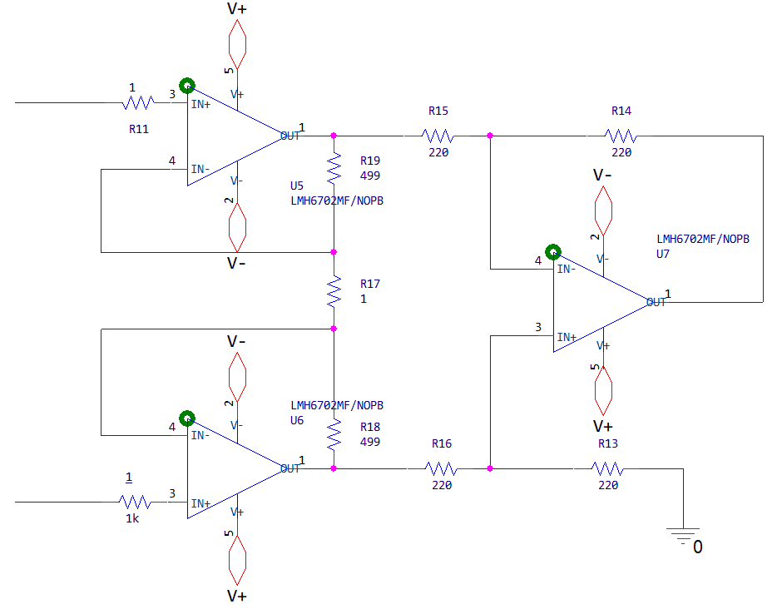
Following the initial tests of my device I wanted to improve its signal-measurement ability further as the signal amplitude I intended to measure was much smaller than I had originally thought. I replaced various components on the circuit to reduce the common-mode gain I had inadvertently introduced. I also modified the differential gain to allow for measurement of microvolt ground-plane voltage fluctuations, as this was the original goal of the project.

The system was now configured for a gain of G = 1+(2*499/1), or 999x. This was the closest I could get, using standard resistor values, to a gain of 1000.
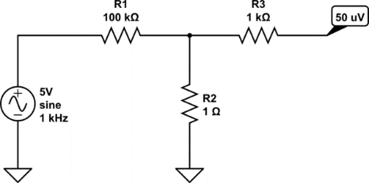

To test the device, I set up a resistor divider as shown in the schematic above. I set the signal generator to output a 5Vpp 1KHz sine wave through a divider network with a calculated output of 50uVpp.
I measured a ~5mV signal that had a very high distortion. The effect, while I do not have images as explained below, was very pronounced making further testing difficult. The signal also showed a DC shift of -2mV (that’ almost 50% of the output signal!) which was quite unexpected. Ideally, an instrument amplifier is highly tolerant of resistance mismatch has extremely high common-mode rejection characteristics. To see this much of an offset most likely meant that my test setup was flawed.

Unfortunately, after unplugging the test setup to verify solder joints, I accidentally reversed the polarity of the power supply connections. Although this is not incredibly dangerous for a single op-amp under normal conditions, this ultimately created a positive feedback loop with a per-cycle gain of 1000x that instantaneously destroyed the op-amps. Due to the expense of the implemented ICs and the time constraints I was under, I was unable to demonstrate a working design for the final project. I am documenting my tests and application intentions to the best of my ability following the circuit failure.
I have no images of this test setup, but I want to further investigate the noise and offset as a future project. Initial investigation led me to my presumption that Johnson-Nyquist noise was being introduced due to the large offset in division resistors on my signal generator (1 vs 100,000 ohm). Simply put, this is random noise introduced when current flows through a resistive element and my test setup was to blame. In the future I would need to have access to a high-precision microvolt signal generator to conduct further tests on this behavior.
While Johnson noise normally has a negligible impact on a circuit’s performance, the large amplification and very low signal to noise ratio on my signal generator setup was, assumptively, enough to create the distortion I observed. Again, further testing and analysis would need to be completed to gather any meaningful data or observations. One application of this device, once properly calibrated, could be to show the significance of correct selection of a resistor divider’s total series resistance. For example, every EE can recognize that a 10 ohm/10 ohm and 10K/10K divider both output a junction voltage of roughly half the primary input; their overall circuit effects are quite different however.

- Application
The following is well outside the scope of the material presented in EE-211, the conception of the original design was prior to my enrollment in the class; EE-211, and the new PCB design section, allowed me to do research I would have otherwise not had the time or resources to conduct.
The intended use of this design was to allow for analysis of noise signals present on a proprietary switching regulator supply designed by a former PolySat member and redesigned by myself. The project involved analysis on Satellite CP-11 (ISX).
I was looking to understand extremely strange behavior that was occurring when the specific device was placed under load. To summarize the observed macroscopic behavior, the power supply portion of the device would catastrophically self-destruct when placed under load for time periods exceeding roughly half an hour.
This was not due to thermal runaway as originally proposed, circuit temperatures were verified using a thermal camera. My theory was that harmonics propagating on the ground plane, present due to improper circuit layout, created a voltage cascade by feeding noise back into the amplified portion of the switching regulator. This created an instability that grew with time and ultimately led to voltages exceeding the limits of the regulator. I have notes detailing my actual investigation into this observed phenomenon, but again this is outside the scope of the paper.

The class presentation was meant to be much more understandable. The demonstration setup would have been very similar to the original test setup; the same power supply and device configuration would have been used. I would have used the in-class oscilloscope to generate a microvolt signal with the help of a modified resistor divider to demonstrate the actual amplification ability of the circuit. I would have then connected the differential inputs of the device to a piezo-resistive strain gauge and configured the device in a common Wheatstone quarter bridge configuration as represented in the image below.
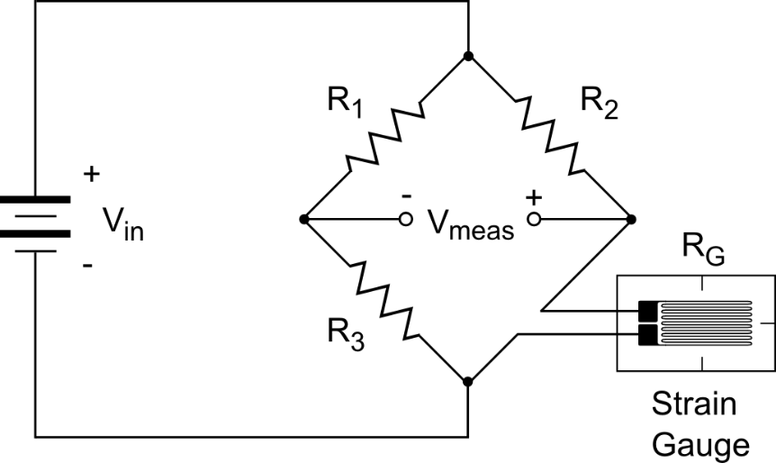

By connecting the inputs of my instrument amplifier to the Vmeas terminals on the circuit, assuming proper resistor division and gain settings on the demonstration device, the output would have been fed into the ADC of an Arduino microcontroller breakout board. The maximum output of the differential amplifier has a voltage swing of +5V to -5V and would therefore require a primary divider stage to half the output voltage and an external reference of 2.5V applied to the Arduino’s AREF pin to bring the signal to within expected operating voltage.
These modifications would need to be accounted for in the Arduino code. The program would ultimately display the current strain based on calibration and analysis of known values. Had I more time I would have detailed these tests better.

- Conclusion and Acknowledgments
First and foremost, everything I have accomplished in this project is a direct result of the work that Dr. Bridget Benson has exerted with the introduction of a PCB portion to the EE-211 curriculum. This is not an attempt to better my grade, I deeply appreciate the progressive actions of Professors who work to better the EE curriculum and I only hope that my results can provide proof that these introductions are a great benefit to the learning environment.
Hopefully this paper can provide the foundation for future work or contribute knowledge either as a part of the EE-211 curriculum or as a reference to my future work in the field of analog electronics. I wish to investigate many of the mentioned anomalies in future reports, and I hope to be given the opportunity in my future studies at Cal Poly.
This paper is meant as an internal reference to my colleagues in PolySat as well as a project report for my EE-211 class, hence the occurrence of certain references such as mission details and classifications.
The original design met the expected operational criteria and performed admirably despite the numerous errors I made throughout my research process. I have successfully demonstrated good PCB layout practices on a two-layer PCB, the design itself required no serious modifications other than direct component swaps (PS Class-1), and all aspect of the circuit worked within the margin of uncertainty I had in their actual operation.
Unfortunately, with respect to the original project requirements, the results of this research paper failed to accurately demonstrate many of the original project goals. I however have learned a great deal about the theory and operation of this class of amplifier. This investigation has been incredibly beneficial to my overall knowledge in analog circuit design. While technically a failure, the experience I gained was by no means trivial. I now have a good grasp on advanced operation of these devices that goes far beyond the current scope of EE-211.

- REFERENCE

Instrumentation amplifier. (2017, October 17). Retrieved November 09, 2017, from https://en.wikipedia.org/wiki/Instrumentation_amplifier

Weinigel, C. (2016, February 26). An almost-GHz active differential oscilloscope probe. Retrieved November 09, 2017, from
http://blog.weinigel.se/2016/02/26/ghz-differential-probe.html

Sackinger, E., & Guggenbuhl, W. (1987). A versatile building block: the CMOS differential difference amplifier. IEEE Journal of Solid-State Circuits, 22(2), 287-294. doi:10.1109/jssc.1987.1052715

Huijsing, J. H. (1976). Instrumentation amplifiers: A comparative study on behalf of monolithic integration. IEEE Transactions on Instrumentation and Measurement, IM-25(3), 227-231. doi:10.1109/tim.1976.6312351

Gilbert, B. (1974). A high-performance monolithic multiplier using active feedback. IEEE Journal of Solid-State Circuits, 9(6), 364-373. doi:10.1109/jssc.1974.1050529

Horowitz, P., & Hill, W. (2015). Chapter 5: Precision Circuits. In The Art of Electronics (3rd ed., pp. 347-390). New York, NY: Cambridge University Press.

Also See:

AnalogReference(). (2017, November 15). Retrieved December 4, 2017, from https://www.arduino.cc/reference/en/language/functions/analog-io/analogreference/
Details the special steps needed to adjust the Arduino's analog reference bias

Generating microvolt signals.. Retrieved December 04, 2017, from https://electronics.stackexchange.com/questions/181411/generating-microvolt-signals
Discussion of the various difficulties associated with microvolt signal generation

