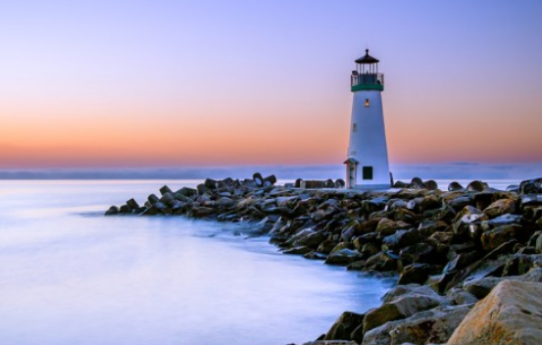
LIGHTHOUSES

A CALM DAY

Day and night a snow white lighthouse stood proud on its rocky thrown. Its light shining round and Round as if it was on a roundabout. No matter what the weather was it always fights back. At night it looks up at the stars and wonders if a boat will ever come, wonders why none has come

STORM VS LIGHTHOUSE

Night came, the lighthouse shone brightly over the dark blue sea. Suddenly a loud roar came and got louder and louder as it got closer and closer. Then an enormous blue wave came over the rocks and slashed against the lighthouse trying to destroy everything and start and war with the lighthouse.
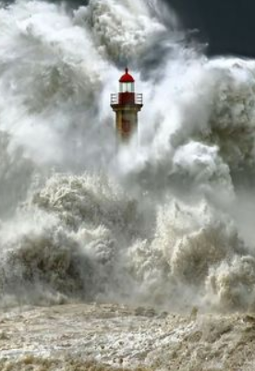By Chloe Watkins 10.6.2020

