Hondo Valley Public Schools
2020-2021 SCHOOL SUPPLY LIST

GRADES 7 AND 8
ENGLISH LANGUAGE ARTS/READING/SOCIAL STUDIES
*One set of supplies can be used for multiple subjects

Ms. Susan Kluthe - susan.kluthe@hondoeagles.org
Text/Call - 575.973.5171

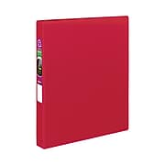
1 - Composition Notebook
no spirals, please
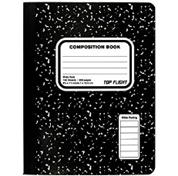
1 - 2” Binder
1 - Set of Dividers

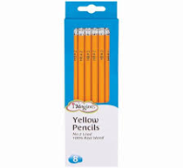
10 pens - black ink
10 #2 pencils
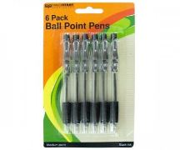
1 - pack assorted highlighters
1 - pack assorted colored pens
1 - pack of colored pencils
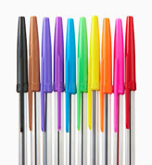
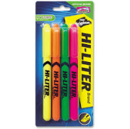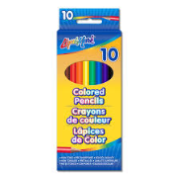

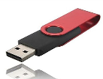
1 - USB flash drive
1 - set of earphones
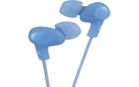
with a microphone

2 - pack disinfectant wipes
2- boxes of kleenex
1-Bottled water
