Goza ENGLISH I, II, III, IV 2020-21
SUPPLY LIST
(If you have supplies left over from last year, feel free to use them!)
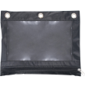
- 1 pencil pouch
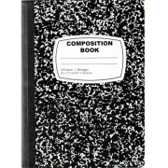
- 1 package colored 3”x3” Post-it Notes
- 1 package colored small Post-it Notes
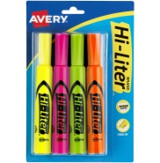
- 2 composition books
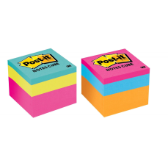
- 1 package highlighters
- 10 blue or black pens
- 20 pencils
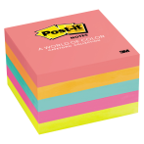
- 1 box of Kleenex
- 1 Clorox wipes
- 1 bottled water

Goza ART I, II, III, IV 2019-20
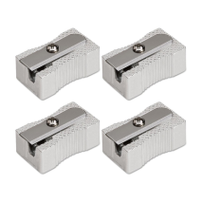
SUPPLY LIST
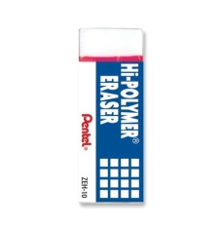
- 1 Blank Artists Sketch Book
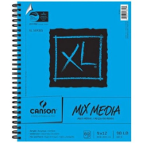
9”x12”
- 1 Pencil Pouch
- 10 pencils
- 1 Handheld Pencil Sharpener
- 1 Large Eraser
- 1 bottled water
- 1 Clorox wipes

