SPEECH-LANGUAGE THERAPISTS  Speech-Language Therapists are trained to support children who have difficulties with talking, listening and understanding language. We also assess and support students with eating and swallowing difficulties and disorders. Support might include working in small groups, classroom strategies for the teacher or an individual therapy programme.  Our main goal is to assist students to communicate and interact with peers, teachers and whanau using the most applicable method of communication for that student. This may include speaking, using visuals, using sign language and gestures and/or using communication devices.  .  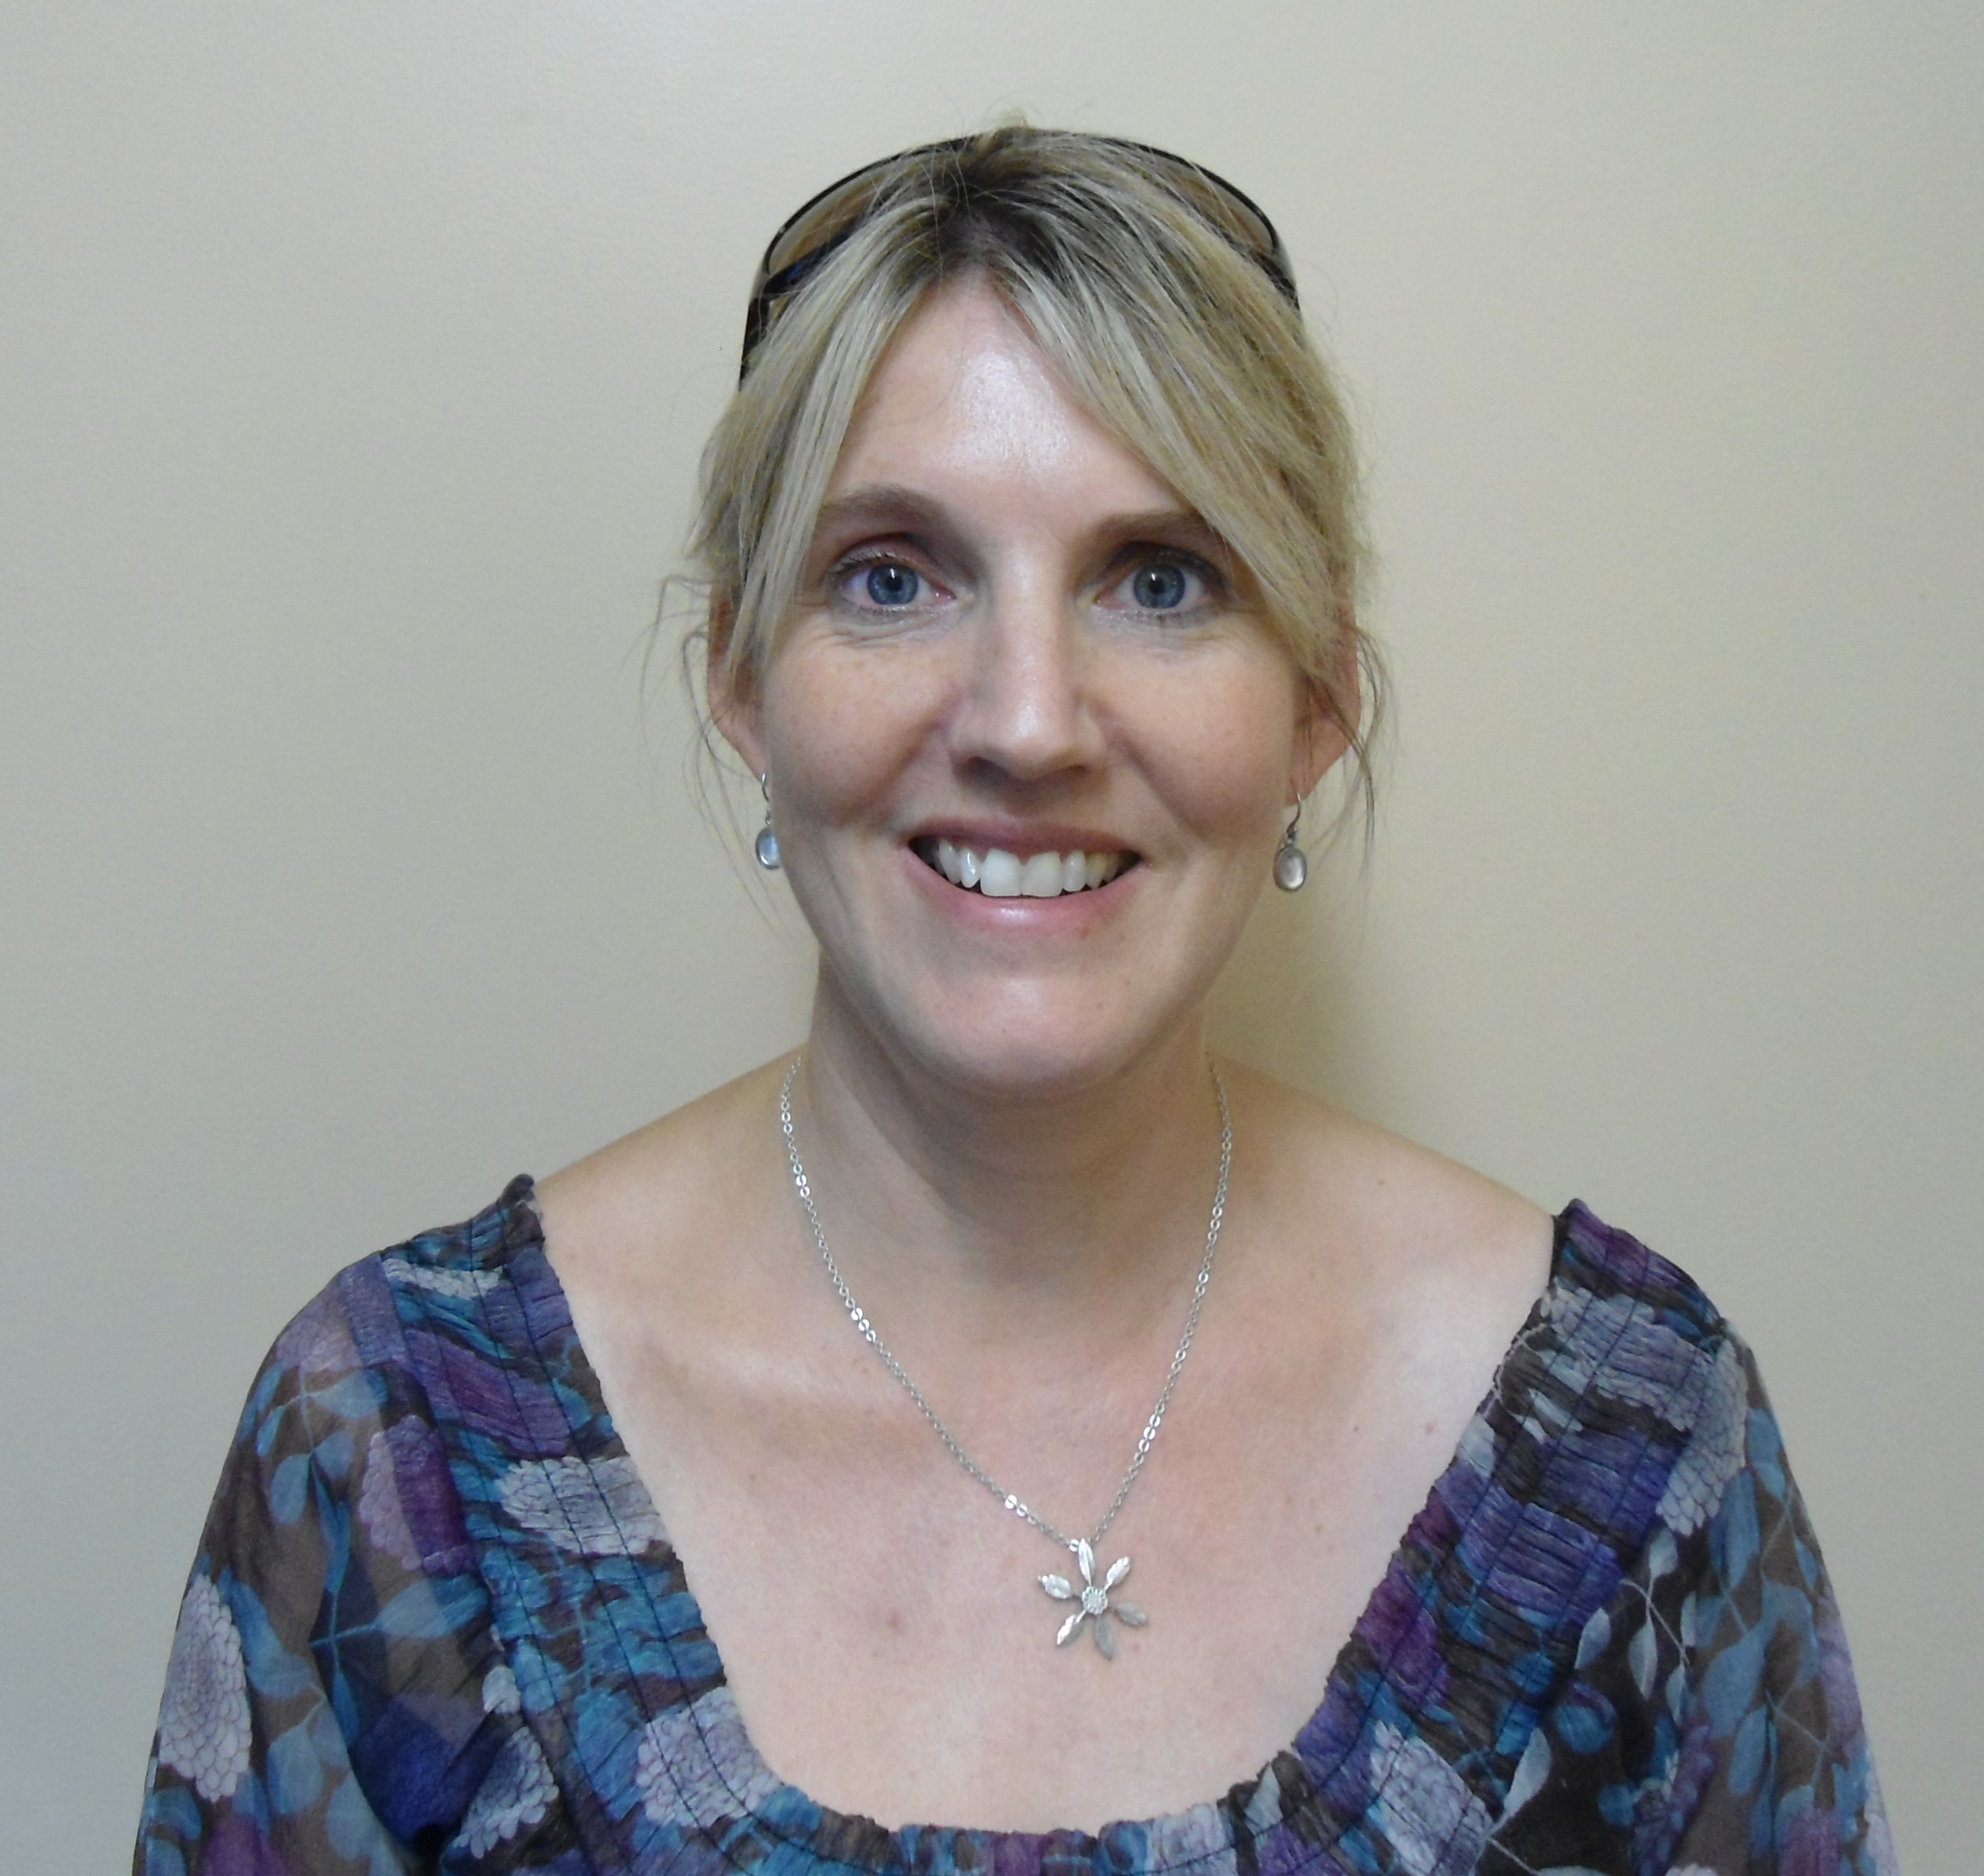Jennifer Higson  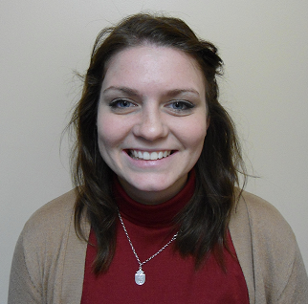Shauna McCabe  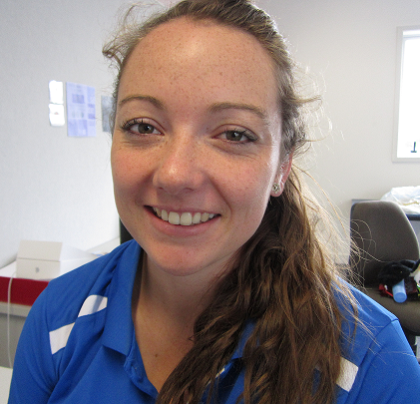Alysa Parker  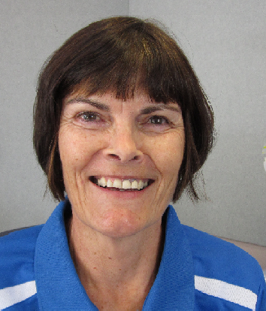Rachel Jones |  | 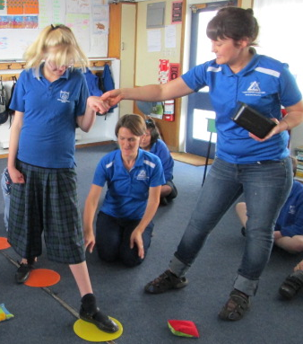  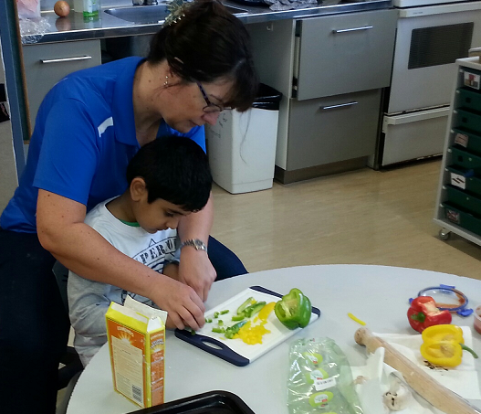  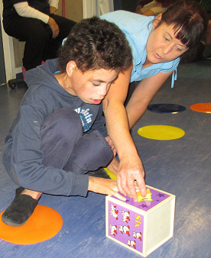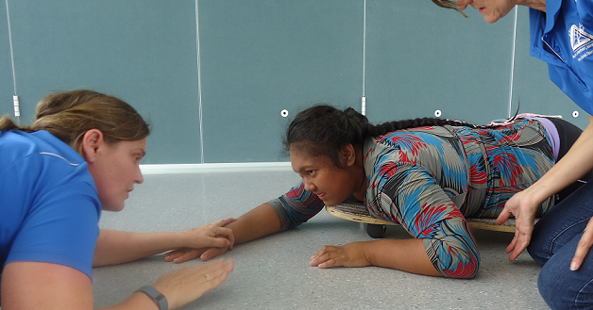  Acceptance, Achievement, A change of Attitude  Te Tautoko, Te panekire, me te wairua  ROSEHILL SCHOOL 48-52 Rosehill Drive Papakura 2113 09 298 4569 office@rosehill.school.nz www.rosehill.school.nz | 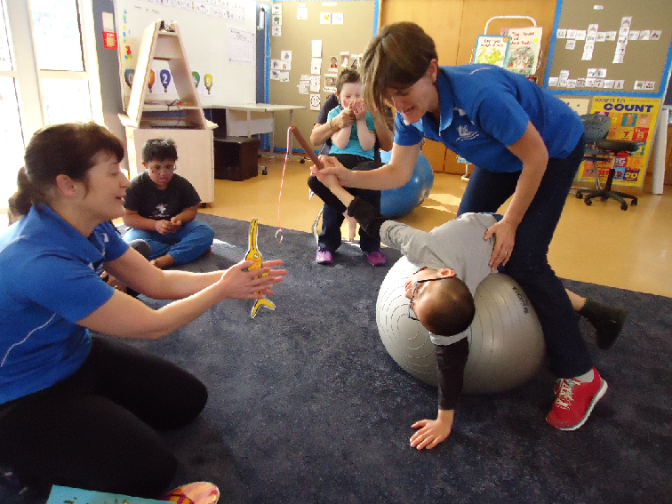  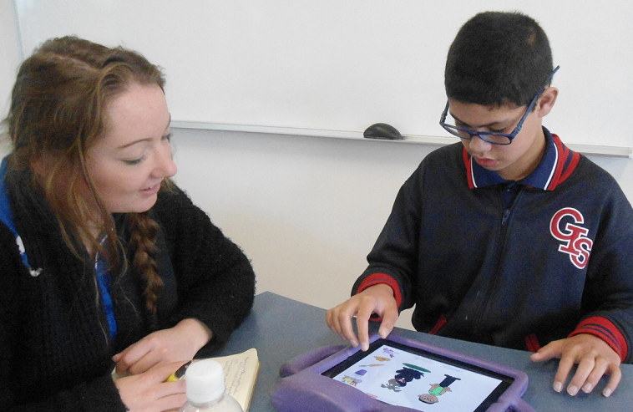  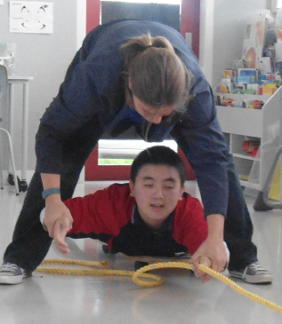
  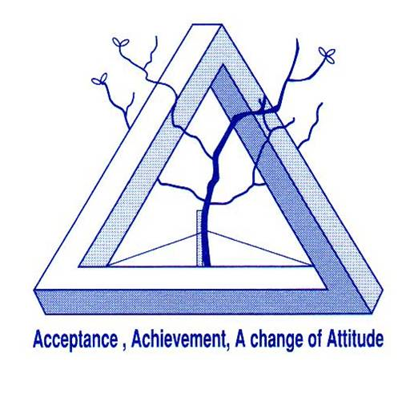
  Acceptance, Achievement, A Change of Attitude Te Tautoko, Te Panekire, me te wairua
  RosehILL SchoOL
    - Our Therapy Team
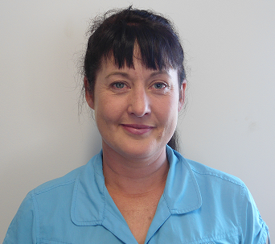 Marianne Warwood  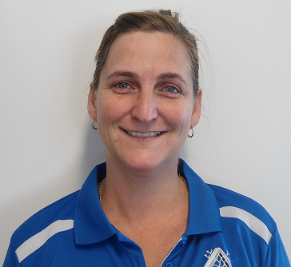Mariette Kritzinger  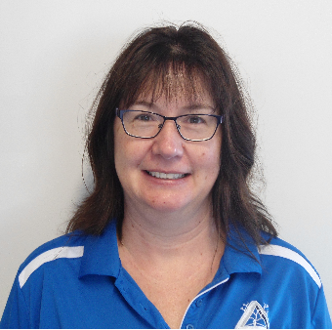Jeanine Bencetti  OCCUPATIONAL THERAPY  We work with children to improve their performance in the classroom, the playground, at mealtimes & at home to help them get the best out of school.  Areas or typical goals could include:  - Self-care tasks, such eating, toileting, dressing skills etc.  - Play activities to develop strength and co-ordination, body awareness, hand-eye co-ordination, confidence & forming friendships  - To improve posture to help students work effectively at their desks.  - To help with developmental skills, e.g. pencil grip, scissor skills, fastening buttons etc.  - To help students to make sense of the world around them; this can include sounds, sights, touch, taste, smell and information from within their own body. |  |  | PHYSIOTHERAPY  Treatment is goal-directed, and what you want to achieve, is very important to us.  Our aim is to improve skills needed for successful learning.  A physiotherapy assessment will help in setting goals.  This may include;  - Posture  - Balance, when still and when moving  - Position of the joints and length of the muscles.  - Muscle tone  - Length and strength of the muscles  - Movement patterns  - Ability to co-ordinate each side of the body.  - Function and independence  For those students with higher, more complex physical needs, the MOVE Programme (movement opportunities through education) principles are used. MOVE focuses on function especially regarding sitting, standing and walking.  The findings of the assessment will be discussed with family, teacher, support staff and other specialists and goals developed together.  Typical goals might be:  • To improve sitting posture by working to improve core stability. |  |  |  | ​  • To improve core and shoulder stability to allow fine motor control (e.g. writing, scissor skills, fastening buttons etc.  • To improve strength and stamina so that they are not so tired by the end of the day  • To improve independence  • To progress through developmental milestones.  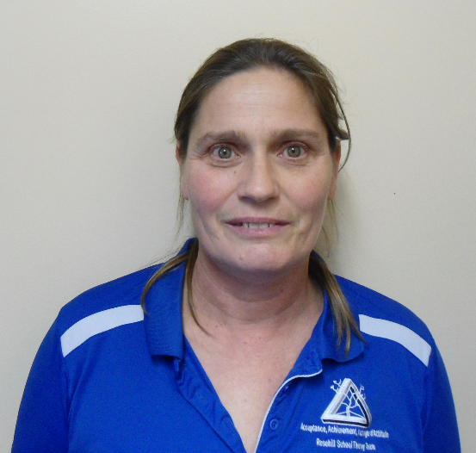Liz Bonnar  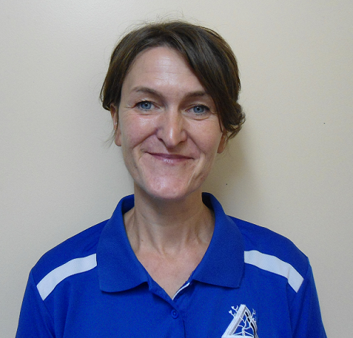Ann Dooley  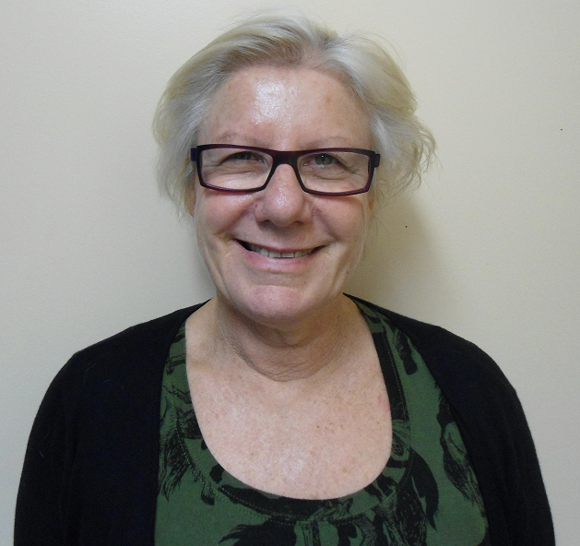Anne Hanna

