Harley Owners Group (HOG) - New South Wales Chapter

HOG Ride – Sunday September 17, 2017

Today’s full day ride is to the Mulla Villa Café/Restaurant just 1 km south of Wollombi. Wollombi is a small village in the Hunter Region of New South Wales about 130 km north of Sydney.
Our meeting and departure point for the ride today is the McDonalds restaurant carpark at McGraths Hill near Windsor. Obviously this is not the direct route to Wollombi from Sydney but we want to take the scenic route and will ride through Windsor, Wilberforce, Sackville, Wiseman’s Ferry, Spencer, Kulnura and then on towards Wollombi. The route via Wiseman’s Ferry Road, Old Northern Road and Great North Road is mostly through national parks which are home to an abundance of native birds, reptiles and other animals including kangaroos, wallabies and wombats. This is obviously a potential road hazard.
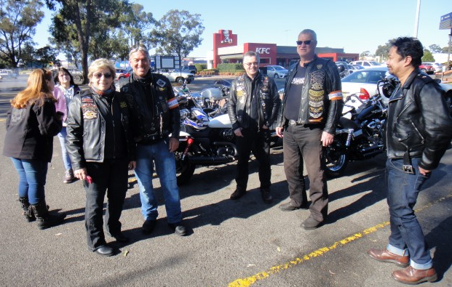
HOG Ride Image 1 – you are always greeted with smiling faces when you turn up for a HOG ride!
This newsletter contains images taken on the day of the ride as well as my images from the Sturgis Motorcycle Rally, South Dakota of 2017 and 1 downloaded image.

Our complementary story this time is part 2 of my Sturgis experience. The world famous Sturgis Motorcycle Rally in South Dakota is something just about every HOG member has on their bucket list. The rally this year, the 77th, was from August 4 – 13.
Part 1 was in the newsletter of the recent HOG ride of Saturday September 2.
Technically, the annual South Dakota gathering of motorcycles and motorcycle culture is known as the “Sturgis Motorcycle Rally”, but just one word will do, Sturgis! That’s really all you need to say! Example, “I went to Sturgis” means “I went to the Sturgis Motorcycle Rally in South Dakota to see the gathering of motorcycles and partake in the motorcycle culture”. We motorcyclists are quite efficient when communicating!

Part 1 dealt with downtown Sturgis but as mentioned previously, the rally is not just confined to the town of Sturgis. The average 450,000 annual visitors to the Sturgis Motorcycle Rally are spread all over South Dakota at places such as the Black Hills, the Badlands, or visiting many of the historic towns like Deadwood, Keystone, Spearfish, Wall, or visiting Mount Rushmore or Crazy Horse Memorial for instance. There are so many interesting places to visit. And on all the surrounding roads and highways you will find a constant stream of motorcycles during the rally.
This newsletter covers a visit to the Black Hills Harley-Davidson dealership near Rapid City which is located about 20 miles from Sturgis. It too is in party mode for the rally.
Each year Black Hills Harley-Davidson plays host to over 100 of the industry’s best brands and companies who showcase their products spread over their 40 acre layout during the Rally. I was told this is not to be missed.

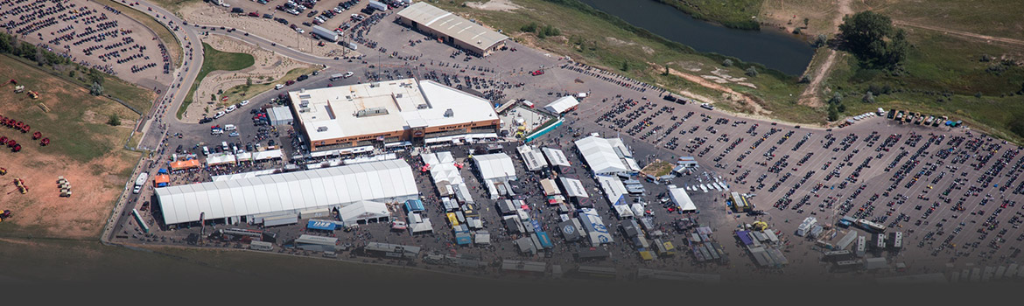
Sturgis Rally Image 1 – Downloaded image of the Black Hills Harley-Davidson dealership and surrounding property. The retail shop is the large building with the flat roof and orange coloured wall, the bike showroom and sales area is that long grey building at left with the pitched roof, the temporary vendors are all those other small buildings, and the main carpark is on right hand side and extending past range of photo. Later in this newsletter you will see images from within these buildings. (This image is not of the 2017 Rally).

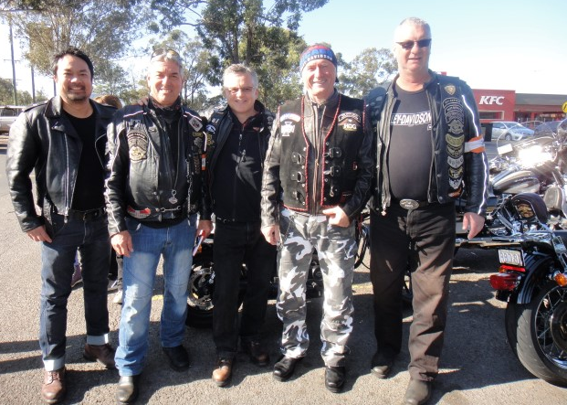
HOG Ride Image 2 – Smiles all around from left Jeff, Hammer (Don), Tarzan (Steve), myself (Sergio), and Smiddy (Ian).

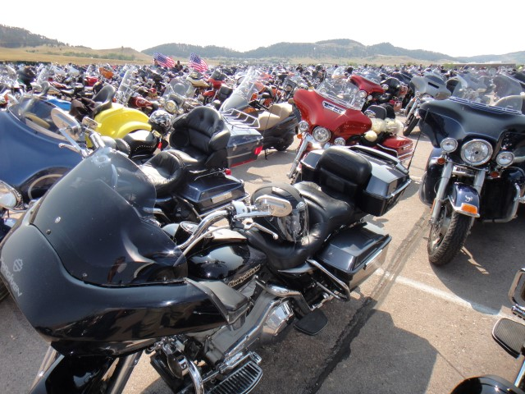
Sturgis Rally Image 2 – I get to the carpark and it’s absolutely chokkers! You could spend a day here just checking out the bikes in the carpark!

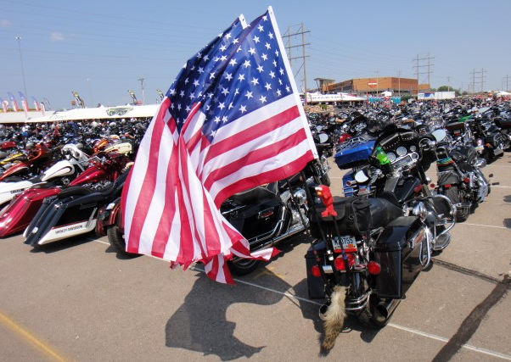
Sturgis Rally Image 3 – This time looking the other way with the Black Hills Harley dealership in the background. Surrounding it are 100+ industry vendors and manufacturers showcasing their products. This should be fun!
As a guess I would say at least 90% of the bikes parked here are Harley-Davidsons. Sturgis must be the mecca for Harleys!
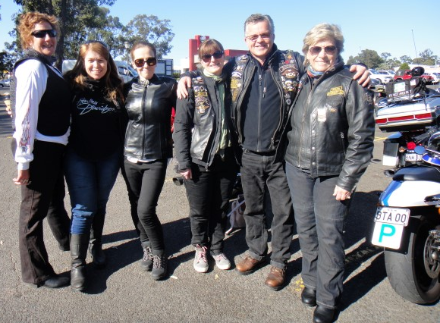
HOG Ride Image 3 – Now a shot of the girls and from left Linny, Kelly, Nat, Jane, Tarzan (Hey Steve, I did say now let’s get a shot of the girls!!), and Sylvia.

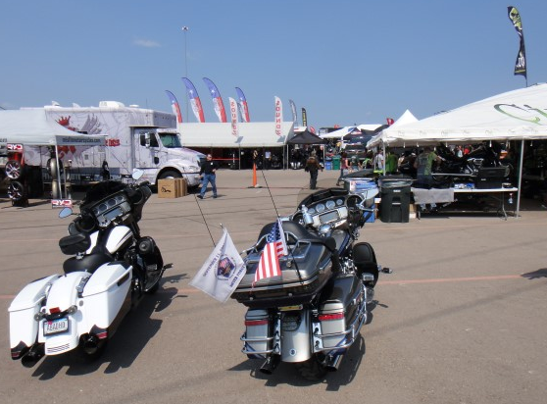
Sturgis Rally Image 4 – Approaching the industry displays you immediately see it’s quite extensive. All this is on just for the rally and everything seen here will be gone after the rally ends. This dealership is lucky to have such extensive grounds to facilitate this exhibition.

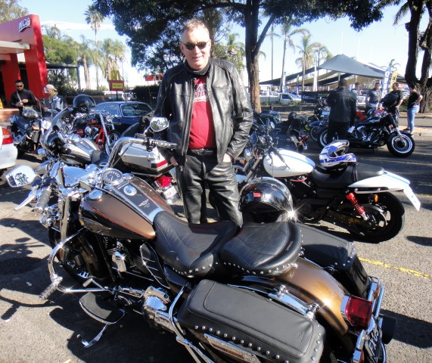
HOG Ride Image 4 – As usual, lets meet some HOG members. This is Mark with his 2013, 110th Anniversary Road King, his second Harley. Mark has been a HOG member for 14 years.

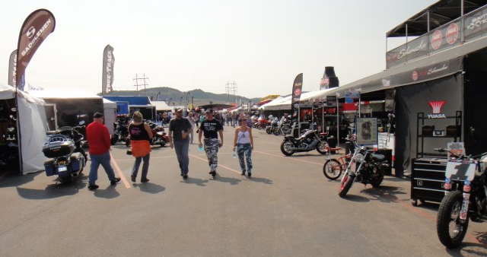
Sturgis Rally Image 5 – Again all this is part of the temporary exhibition for the rally. The dealership buildings are way over to the left of this image.

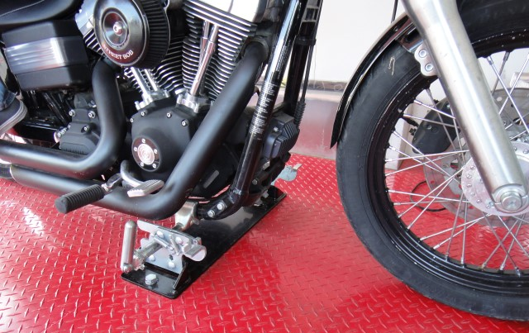
Sturgis Rally Image 6 – So let’s see some of the products showcased as part of this exhibition before checking out the dealership and the bike sales area. I can’t show you everything because this newsletter needs to be reasonably concise so let’s just see a few of the more interesting items.
Seen in this image is an innovative way to trailer your bike without the need for tie-down straps. It’s called a “Biker Bar” which quickly locks down your bike before you dismount, you just ride onto it. Two more images follow.

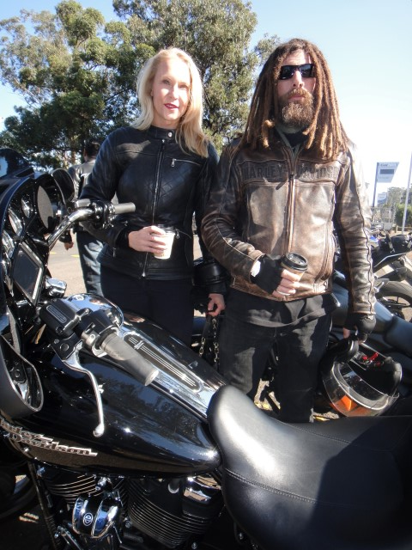
HOG Ride Image 5 – Another HOG member is Ashley with his partner Sarma beside his 2017 Street Glide. Ashley also has a 2014 Fat Bob in his garage and is a new HOG member.

Sturgis Rally Image 7 – The Biker Bar has this trailer-mounted latching base affixed to the trailer bed.

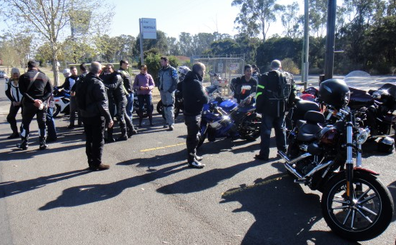
HOG Ride Image 6 – This is a popular meeting place for bikers on the weekend and we see other groups gathering for their ride.

Sturgis Rally Image 8 – Here you see the latching base with the biker bar installed. The biker bar is neoprene-lined and is temporarily and quickly affixed to the bike’s frame. It’s more convenient than using tie-down straps. For more information go to: ditchthestraps.com

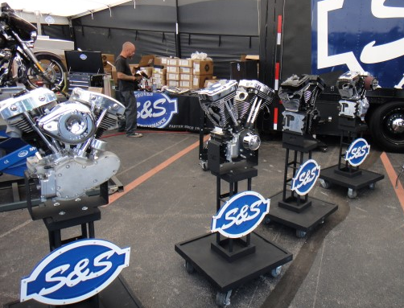
Sturgis Rally Image 9 – S&S Cycle offers motorcycle engines for custom motorcycles and replacement engines to suit just about any Harley big-twin model from 1936 onwards, which includes the Harley Knucklehead, Panhead, Shovelhead and Evolution engines. They also supply high-performance parts for Harley engines.
They obviously have quite a list of engines, but their latest, which will bolt straight into a stock Harley Touring frame from 2008-on, is the T143. Its capacity is 143 cubic inches (2343 cc)!
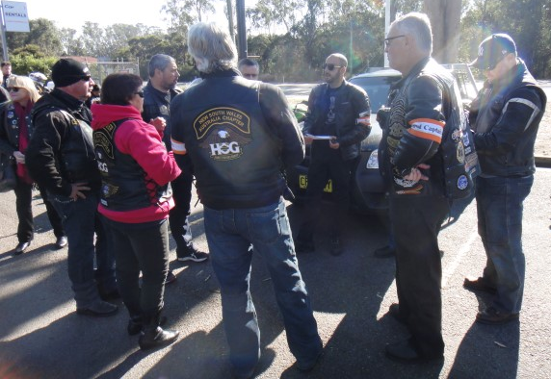
HOG Ride Image 7 – As usual, the Road Captains meet to discuss aspects of today’s ride. The Lead Road Captain for today is Gypo (Rob) seen here holding some notes.

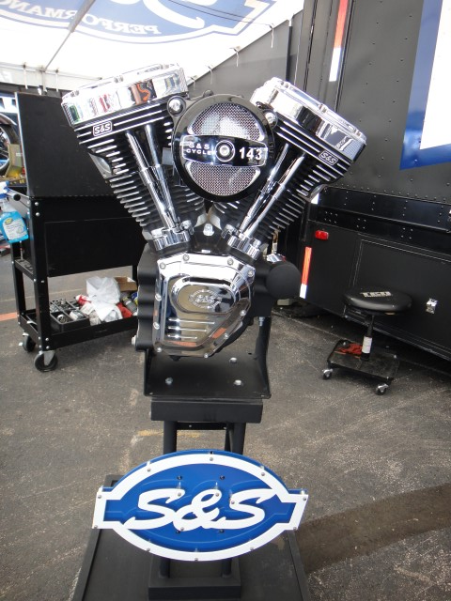
Sturgis Rally Image 10 – The S&S Cycle T143 engine. This is currently the largest S&S engine that will fit in a stock Harley-Davidson touring chassis. At double the horsepower of a stock motor, it will require an experienced rider.
S&S also produce a 160 cubic inch motor for competition use only. It has an integral 6-speed automatic transmission.
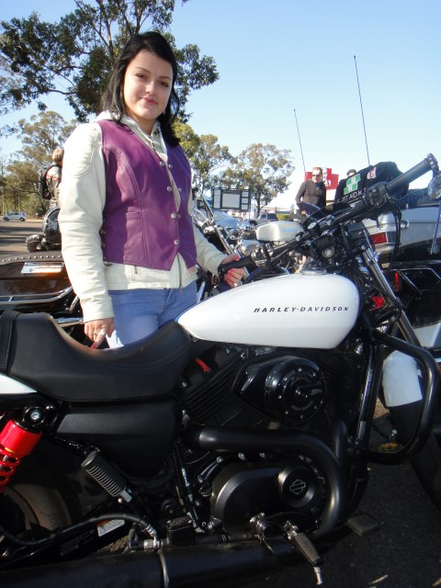
HOG Ride Image 8 – Also on our ride today is Belle seen here with her Street 500 model. Belle recently took part in an advanced rider motorcycle course to hone her skills and apparently excelled over her instructors! Riding with the HOGS is beneficial in so many ways!

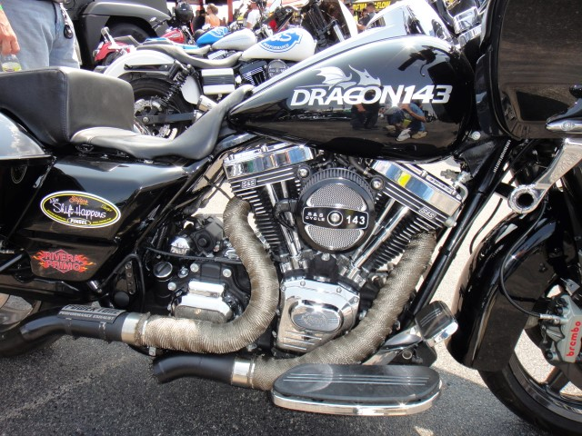
Sturgis Rally Image 11 – A T143 engine installed on a Harley Road Glide touring bike. This engine was designed to make it fit into a 2008 and later Harley-Davidson Touring chassis requiring no cutting or frame modifications. On the Dyno, S&S claim the T143 puts out 162 horsepower and 151ft-lb of torque at the wheel. That’s some serious power no matter what it’s bolted to! S&S also advise that this engine is intended only for closed course competition use and is not legal for use on pollution controlled vehicles.
For more information go to sscycle.com

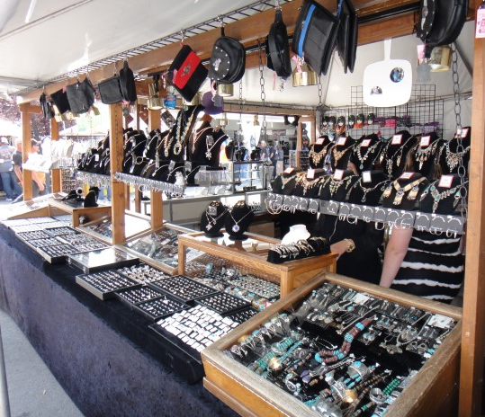
Sturgis Rally Image 12 – All biker industry displays will include biker jewellery vendors. This one is in the mid-price range.
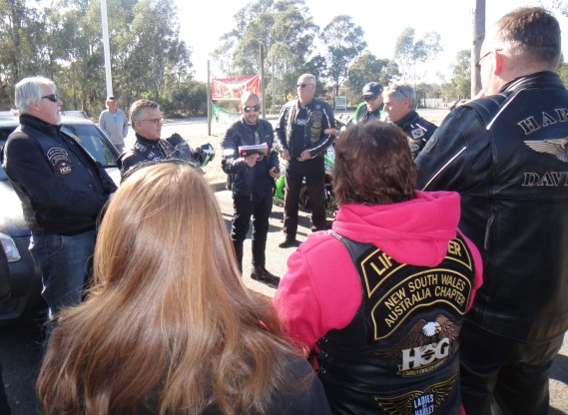
HOG Ride Image 9 – Now we see Gypo (Rob) addressing HOG members and advising on all aspects of today’s ride.
Before proposing a ride to the HOGS the route is thoroughly investigated and assessed by a Road Captain. This usually involves a reconnaissance run to determine degree of difficulty, potential hazards, fun aspect, etc. Gypo proposed this ride and did the reconnaissance run twice to be sure he covered every possible contingency. We Hoggies always do our best for our Chapter!

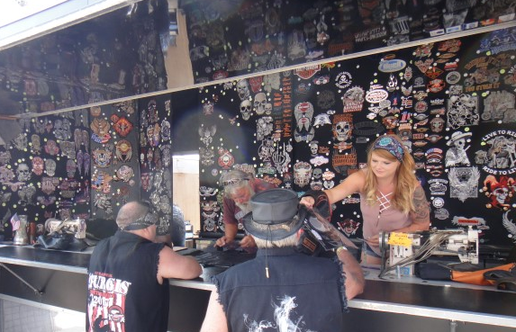
Sturgis Rally Image 13 – And there is always a patch vendor. There were hundreds to choose from to make your biker vest reflect your personality.
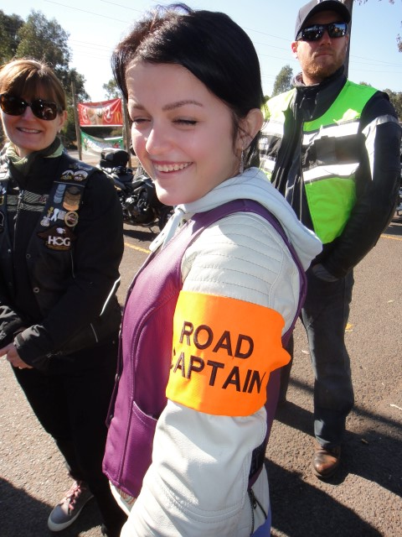
HOG Ride Image 10 – In recognition of her outstanding efforts in her Advanced Rider course, Belle was promoted to Road Captain duties for today’s ride. She was totally undaunted by this proposal!

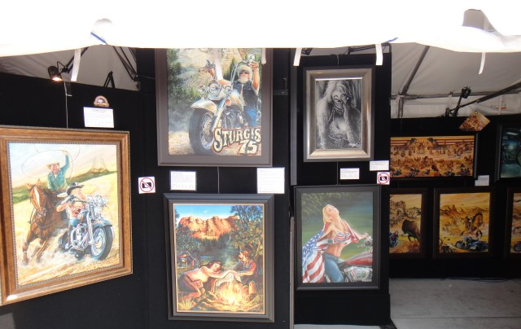
Sturgis Rally Image 14 – Here is a vendor selling art from internationally known artist Marc Lacourciere, also known as “Motor Marc”. He became more widely known to the public after showcasing his automotive art on the hit television series American Chopper.
These limited edition prints would make a great addition to the man cave!
For more information go to www.motormarcart.com

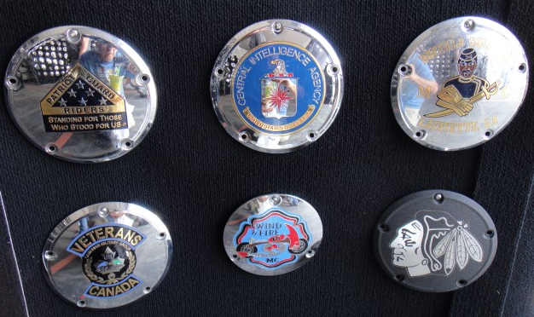
Sturgis Rally Image 15 – Here is a company that does “Personalized Art for Motorcycles”. These images can be added to derby covers, air cleaner covers, fuel lids, and timer covers making your bike more personal. They offer standard designs (many to choose from) or can arrange a one-off image just for you. This photo shows some examples. They can even do portraits of loved ones such as grandchildren for instance.
For more information go to: www.custom-engraving-ltd.com
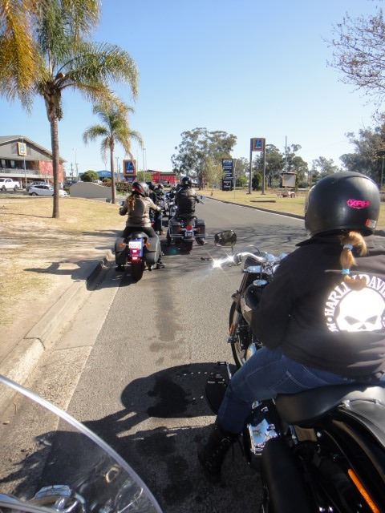
HOG Ride Image 11 – We normally regroup on the road before actually setting off on the ride. This ensures we travel in a cohesive group which is much more fun!
Today we have a group of 20 riders with an additional 5 pillion passengers. A relatively small group, this being partly due to some HOG members partaking in another event yesterday.
Weather conditions for the ride today are close to optimal with temperatures only reaching the low 20’s Celsius.

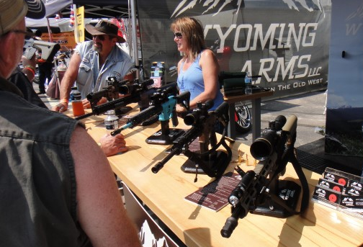
Sturgis Rally Image 16 – Gun laws in the United States regulate the sale, possession, and use of firearms and ammunition. State laws however, vary considerably, and are independent of existing federal firearms laws. Forty-four states have a provision in their state constitutions similar to the Second Amendment to the US Constitution, which protects the right of individuals to keep and bear arms.
In South Dakota you do not require a permit to purchase firearms, there is no need for firearm registration, no owner license is required, open carry is permitted, there are no assault weapons laws, there is no magazine capacity restrictions, and there are no background checks required for private sales.
Thus, not surprisingly, guns of all descriptions are openly offered for sale. In this image we see a gun retailer showcasing their wares like any other consumer good, something that could not even be imagined now in Australia. This retailer is Wyoming Arms and their website says “Wyoming Arms aim is to provide the best available firearms and components to the discriminating hunter and shooter”.
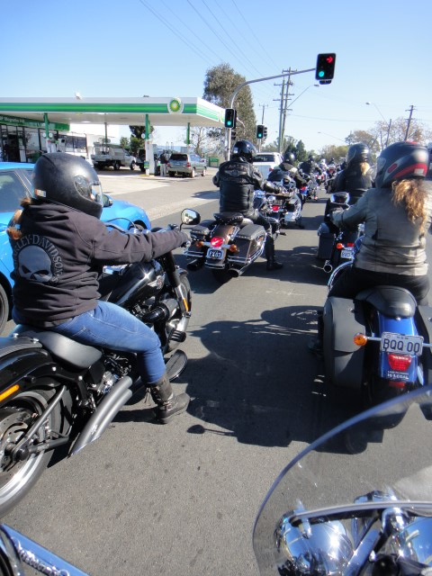
HOG Ride Image 12 – I always try to take a photo at a red traffic light but this one changed to green quicker than I expected making me rush to keep up with the pack (you have to put away the camera, whack the bike into gear and go!).

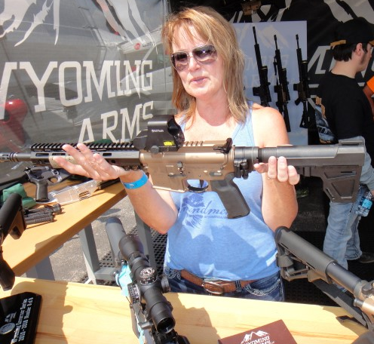
Sturgis Rally Image 17 – Highlighting the WY-15 Series 5500 Pistol from $US2,599.00. Its lightweight, comes with a 10, 20 or 30 shot magazine, and the 2 ends fold against the middle for compact storage. Very convenient! For more information go to www.wyomingarms.com

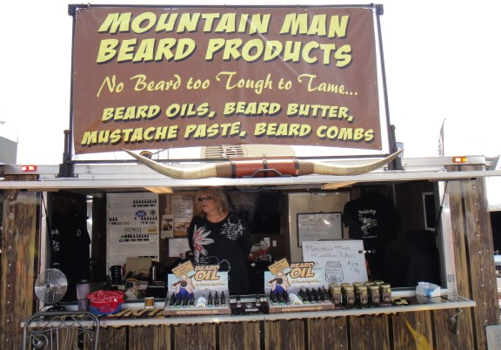
Sturgis Rally Image 18 – They said their products make any beard extremely manageable and are made with 100% all natural and organic ingredients including vitamins, minerals and proteins, along with growth stimulants. Their motto: “No beard too tough to tame”.
For more information, mountainmanbeard.org

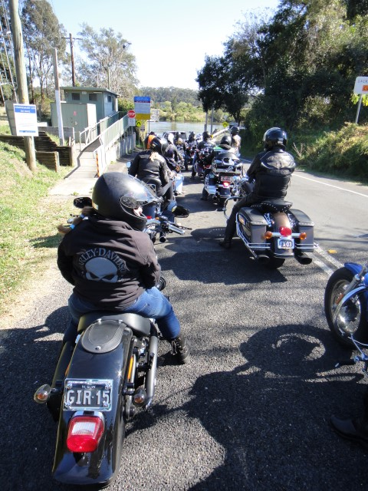
HOG Ride Image 13 – We come to another stop, this time at the river crossing at Sackville. We have to wait for the car ferry to come back from the other side of the river before boarding it.

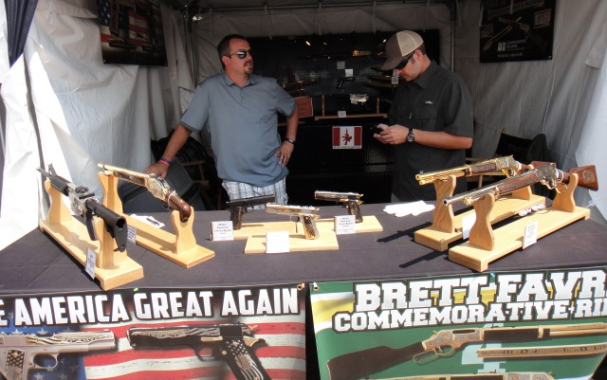
Sturgis Rally Image 19 – And here is another gun retailer with different guns.
Some people I spoke to admitted to carrying a firearm and said you just don’t leave home without it. In Australia, “don’t leave home without it” usually refers to a credit card!

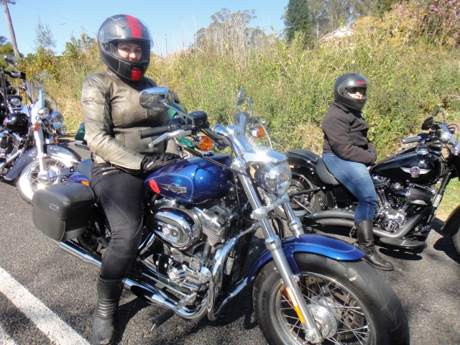
HOG Ride Image 14 – Whilst waiting for the ferry we see Sara on her Sportster model with Kelly (at right) on her Fat Boy Lo model.

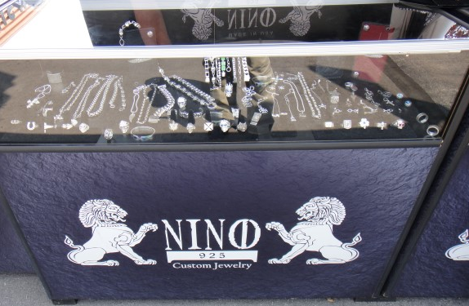
Sturgis Rally Image 20 – Well all bikers are familiar with biker jewellery, particularly the inexpensive stainless steel stuff which serves the purpose.
However for those with a more refined taste there is custom jewellery made of precious metals and stones. This vendor, “Nino Custom Jewelry”, specializes in handcrafted custom jewellery made of 0.925 silver, yellow gold, white gold and platinum with or without precious and semiprecious stones. There is stuff for men and women and the pieces do have the biker look about them which is cool. This is top end stuff, way more expensive than the stainless steel stuff.
In recent years, Nino has carved a niche in the biker segment and is found regularly at biker events in the U.S.
For more information go to www.nino925.com

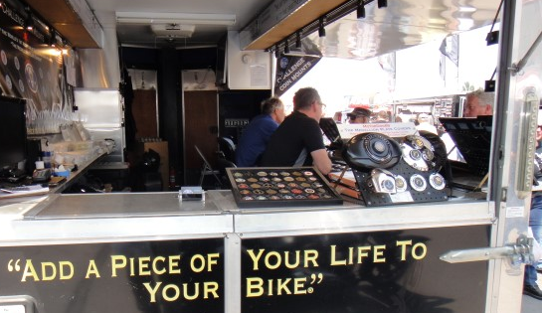
Sturgis Rally Image 21 – This vendor manufactures custom made Challenge Coins with mounting plates to attach to your bikes cam covers, fuel door, horn cover, timing cover, air cleaner cover, front axle, primary cover, derby cover, gas cap, or anywhere else you may want to install it.
The Challenge Coin will have on it an image of your choosing or you can choose from their stock range. See following image for examples.

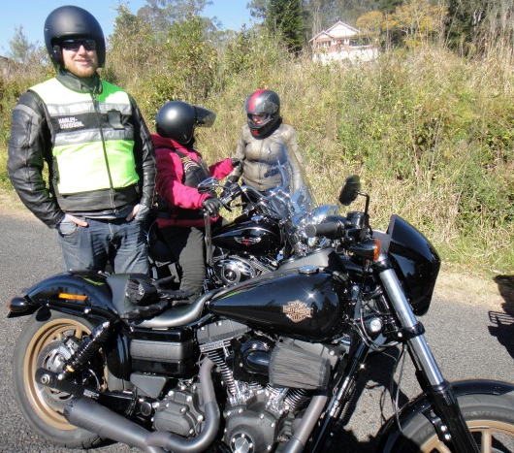
HOG Ride Image 15 – Travis, a Road Captain, is Tail End Charlie today. He is the end rider of the pack and will attend to any breakdowns or stoppages for any reason. He is beside his 2017 Dyna Low Rider S model, his second Harley. He has been a HOG member for 4 years.

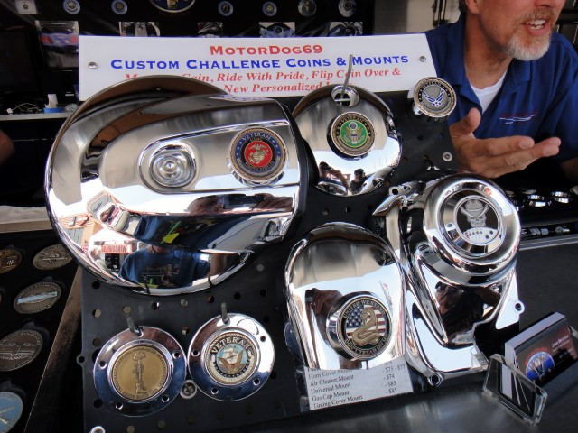
Sturgis Rally Image 22 – Seen here are examples of custom made Challenge Coins. Typical coins include insignia of Army, Navy, Marine Corps, Coast Guard, Air Force, War Service, Military Medals, Religious, Professional (doctor, nurse, etc.), or even Novelty themes. As they say, “Add a piece of your life to your bike”.
For more information go to www.motordog69.com
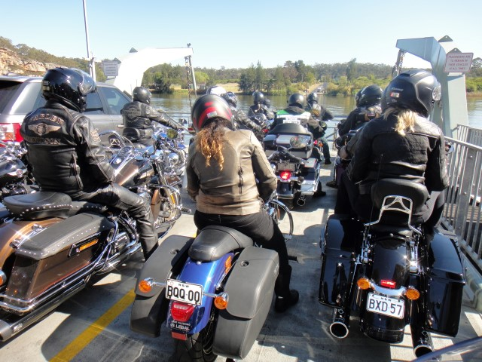
HOG Ride Image 16 – Well we all managed to fit onto the car ferry and it’s about a 5 minute crossing. It’s better to stay on your bike in case the ferry jerks of lunges which could cause your bike to fall.

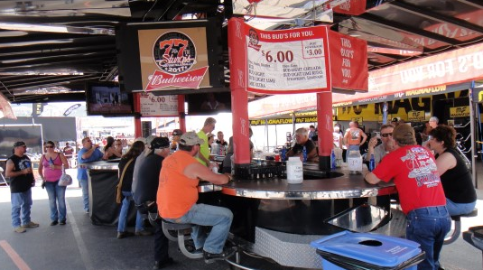
Sturgis Rally Image 23 – You can’t be expected to walk around a trade show without having a drink! So in amongst the trade displays is this walk-through outdoor bar. Very convenient!

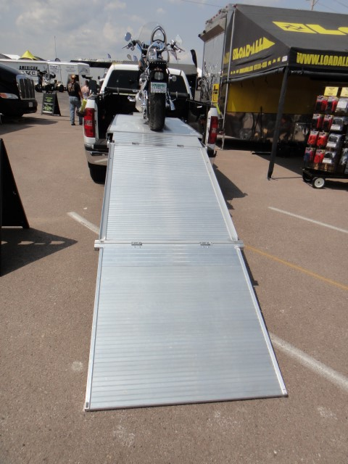
Sturgis Rally Image 24 – If you watch YouTube, you may have seen countless videos of people dropping their bikes while attempting to load/unload them onto trailers and trucks. This task is often underestimated by novices.
This device makes loading/unloading your bike onto a truck a piece of cake! The ramps are stowed within that box seen under the bike when not in use. The box is simply installed by 4 bolts onto the truck bed and can be removed quickly when not needed. The ramp is held captive while loading preventing dislodgement. No weight is borne by the trucks tailgate.
For more information, www.loadall.com
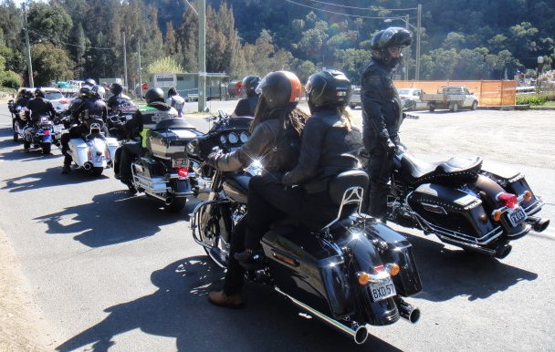
HOG Ride Image 17 – Well we just had a very pleasant 30 minute ride and now we stop again for another river crossing, this time at Wisemans Ferry. Again we await the car ferry to make the crossing.

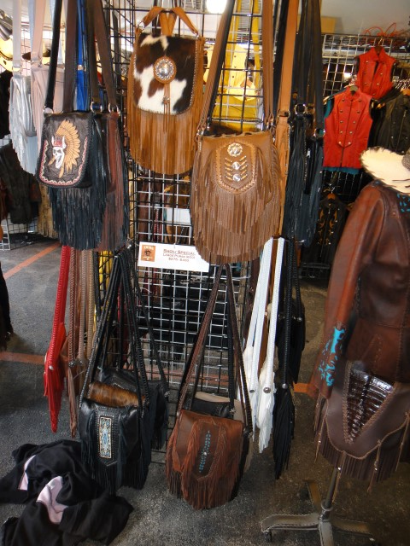
Sturgis Rally Image 25 – This and the following 2 images are from vendor “Tribe America”. I found their products to be highly creative, and of good quality. Shown here is a small range of their products. Their prices seemed reasonable considering their craft appeal.
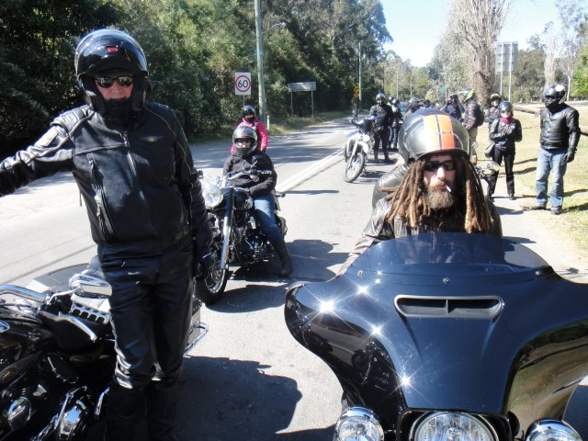
HOG Ride Image 18 – While waiting for the ferry, a photo opportunity. At left we see Mark and at right Ashley.

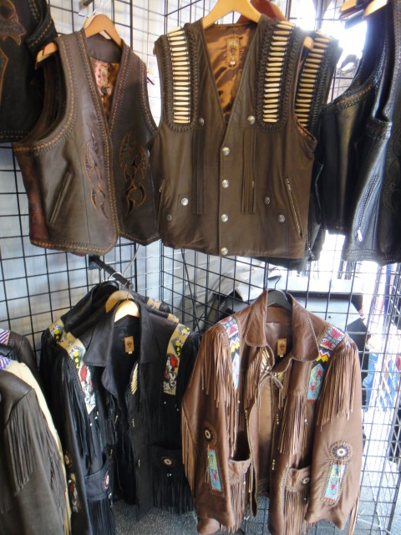
Sturgis Rally Image 26 – Also from Tribe America are these fantastic vests and jackets. These will typically include a gun pocket made to hold your hand pistol securely.

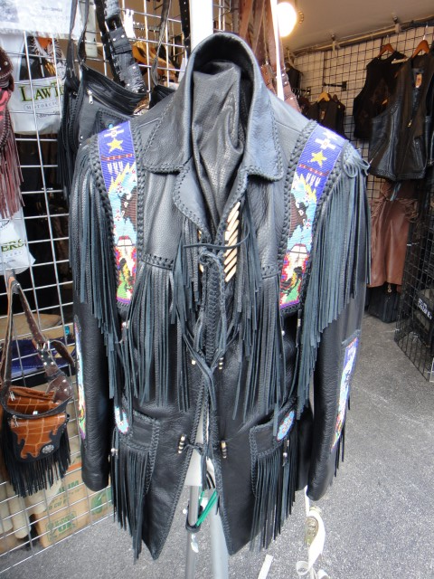
Sturgis Rally Image 27 – Also from Tribe America: What about this piece of art!
For more information go to www.tribeamericaleathers.com or contact owner Gus Lewkowicz at guslewkowicz@yahoo.com

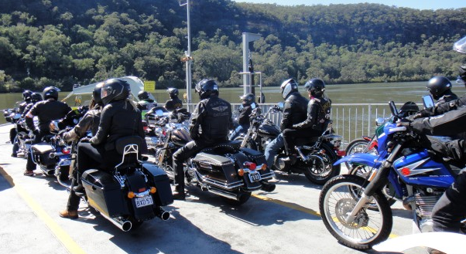
HOG Ride Image 19 – Aboard the second ferry whilst crossing the river.

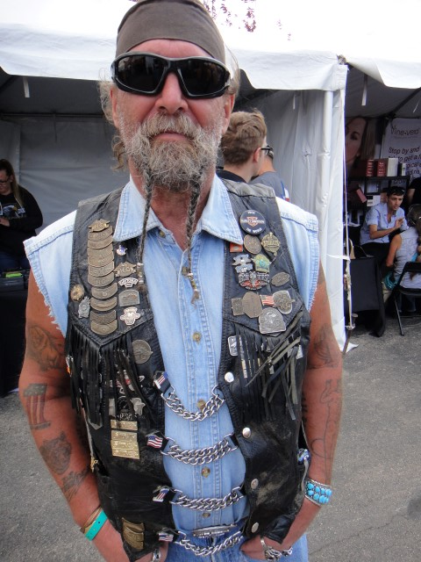
Sturgis Rally Image 28 – At Black Hills Harley-Davidson I noticed this scary-looking dude wandering about with a HOG membership pin on his vest. He was right next to me so I said I’m a HOG member from Australia. Next thing we had a great chat about biker stuff and he turned out to be a very sociable chap indeed! Don’t judge a book by its cover! Anyhow, hoggies are always nice people!
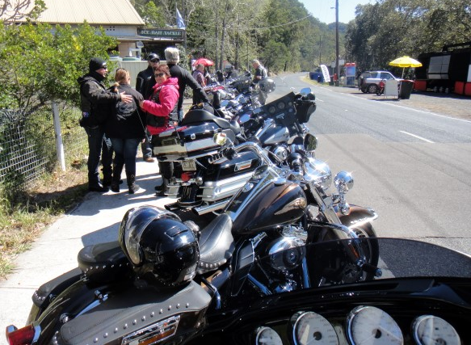
HOG Ride Image 20 – 30 minutes after our second ferry crossing we arrive at the village of Spencer right on the banks of the river. What a cool sight, a row of Harleys!

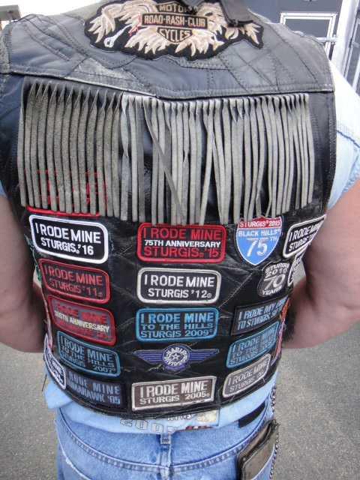
Sturgis Rally Image 29 – The back of the vest of the chap in Sturgis Rally Image 28. It seems you can never get too much of Sturgis!

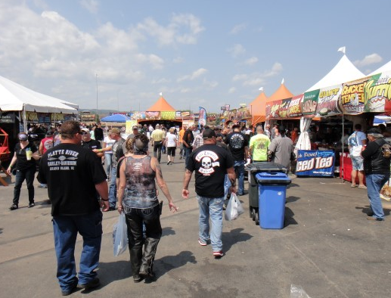
Sturgis Rally Image 30 – There is plenty of fast food on offer amongst the trade displays.

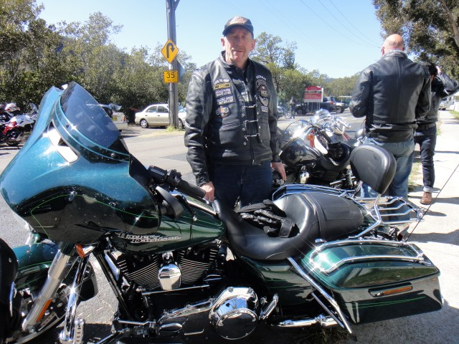
HOG Ride Image 21 – Another stop, another photo opportunity! This time we meet Gary with his 2015 Street Glide, his second Harley. His first Harley was a 1928 model but that was a long time ago. You see, they all come back, eventually!

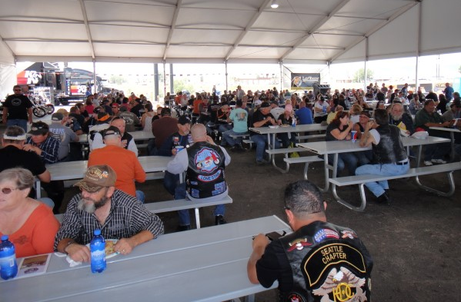
Sturgis Rally Image 31 – Adjacent to the fast food vendors is this undercover seated area where you can relax while enjoying your meal.
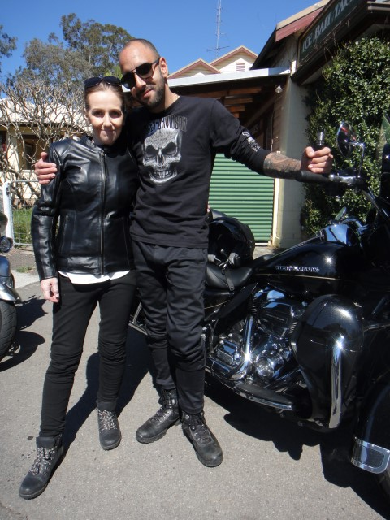
HOG Ride Image 22 – Time to meet Gypo (Rob) with wife Nat. Today Gypo is on a Ultra Limited Harley, a courtesy bike from our sponsoring dealer (Frasers) as his normal ride (a Fat Boy model) is being serviced. We have a fabulous relationship with our sponsoring dealer.

Sturgis Rally Image 32 – Here is a trike from Tilting Motor Works. As you can see, the 2 wheels on this trike are at the front and they lean. It is a simple bolt-on conversion.
Tilting Motor Works claim this set-up makes it much easier and safer to ride a big V-twin without sacrificing a thing in the experience, adding the simplest way to make a trike lean is to put the third wheel up front. The trick is to make both front wheels tilt in tandem and two wheels in front means more rubber on the road and better stopping power. Their motto is “Why would you want a trike that doesn’t lean?”
For more information go to info@tiltingmotorworks.com
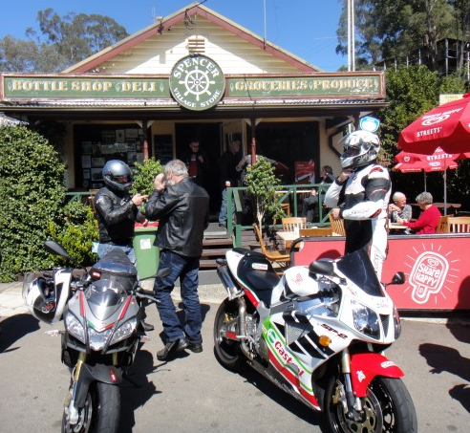
HOG Ride Image 23 – Our stop at Spencer is more of a splash and dash (toilet stop) as we are having lunch at our final destination at Mulla Villa. Some members use this store for a snack and/or coffee.

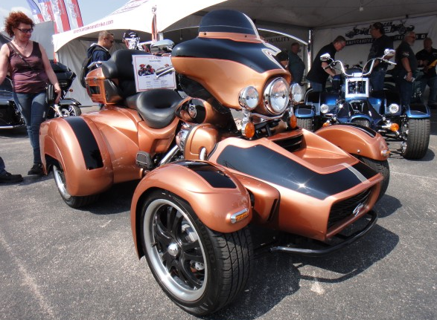
Sturgis Rally Image 33 – What the #*@#???!!! A Harley Quad bike!!! This thing has independent suspension and optional reverse gear. Various models are offered including the Q4, Super Q, and many accessories are also available. More images follow.

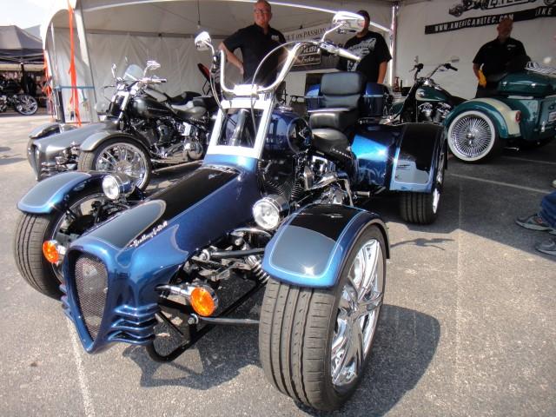
Sturgis Rally Image 34 – As you can see, there are a few different looking models of Harley Quad bikes.
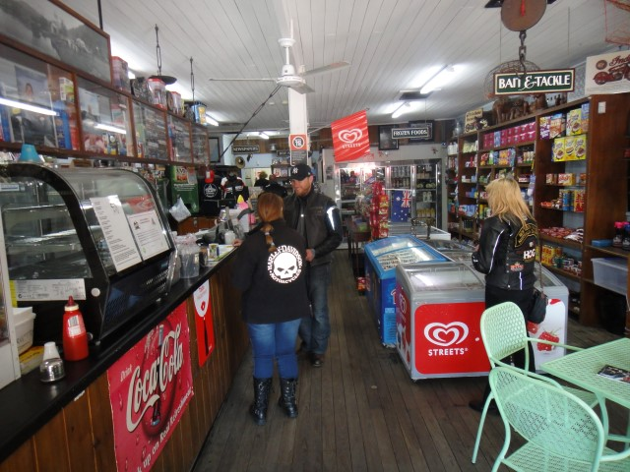
HOG Ride Image 24 – Inside the Spencer village store.

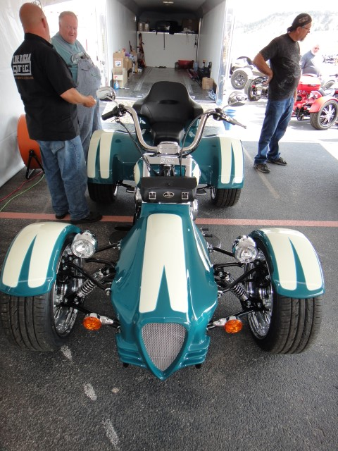
Sturgis Rally Image 35 – Yet another Harley Quad on offer.
For more information go to www.americanqtec.com

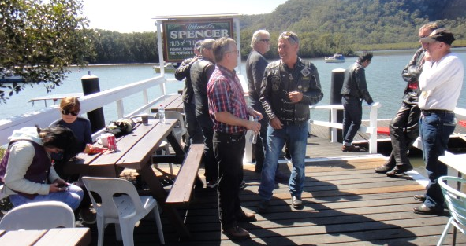
HOG Ride Image 25 – Opposite the Spencer village store is this pier where we relax for about 45 minutes. The mood is very relaxed.

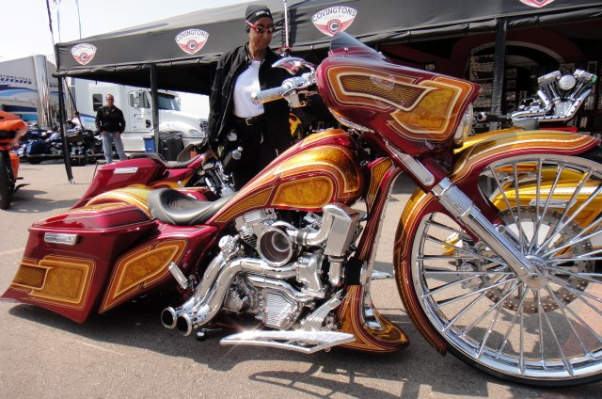
Sturgis Rally Image 36 – There are plenty of wild looking custom bikes on display.

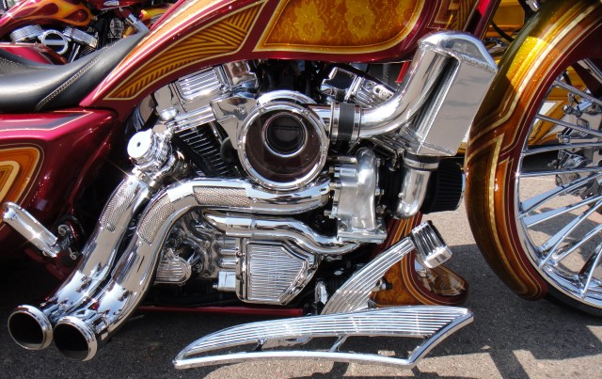
Sturgis Rally Image 37 – Check out the custom engine components and the custom features on this baby!
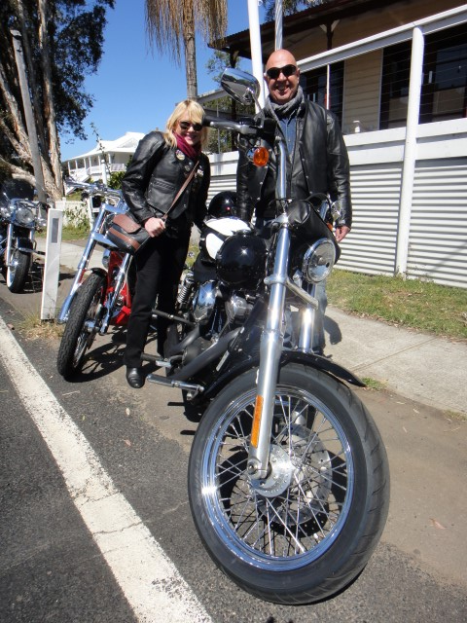
HOG Ride Image 26 – And just before we set off again, time to meet Peter with partner Fifi. This is Peter’s 2008 Street Bob model, his first Harley. He has only recently joined the HOGS and has fitted right in; all you need is a Harley and a smile!

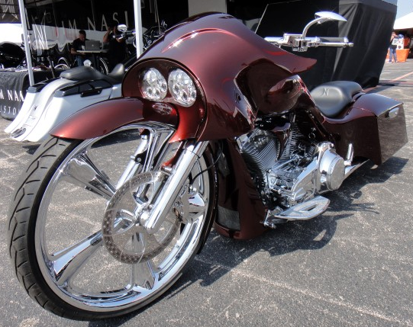
Sturgis Rally Image 38 – A very interesting custom job indeed!

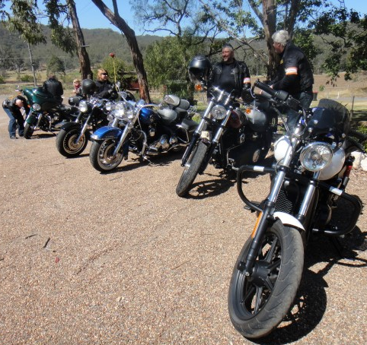
HOG Ride Image 27 – We reach our final destination after a further 75 minute ride from Spencer. The route through national parks was most pleasant indeed with nice twisty bits and very little traffic. Gypo scoped this ride well!
Here we are in the carpark of the Café/Restaurant Mulla Villa. That fine gravel driveway might sound good when driving over it in a car but on a bike it can be treacherous, especially on the steeper parts. Our fine group of Hoggies got through this without mishap.

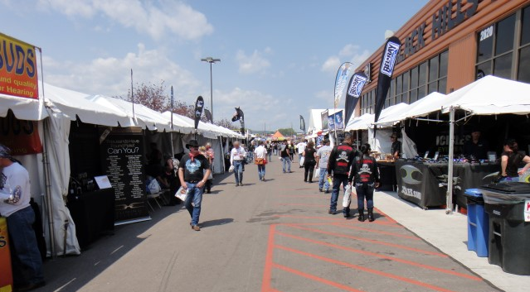
Sturgis Rally Image 39 – I finally make it to the Black Hills Harley-Davidson dealership retail shop seen here at right. At left are some of the temporary vendor displays. You need more than a day here to see everything.

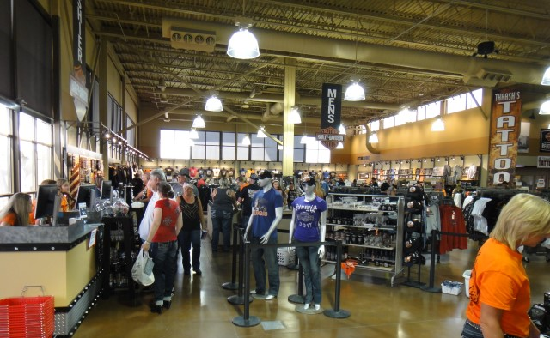
Sturgis Rally Image 40 – Inside the dealership retail shop showing only a small portion of it. It’s the biggest dealership retail store I have seen. Notice at right is a tattoo shop (more on this following).
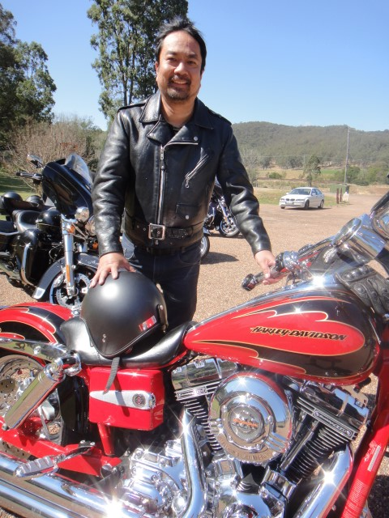
HOG Ride Image 28 – Again another chance to meet a Hoggie, this time its Jeff with his very conspicuous 2007 Screaming Eagle Dyna model, his first Harley. He has been a HOG member since 2012.

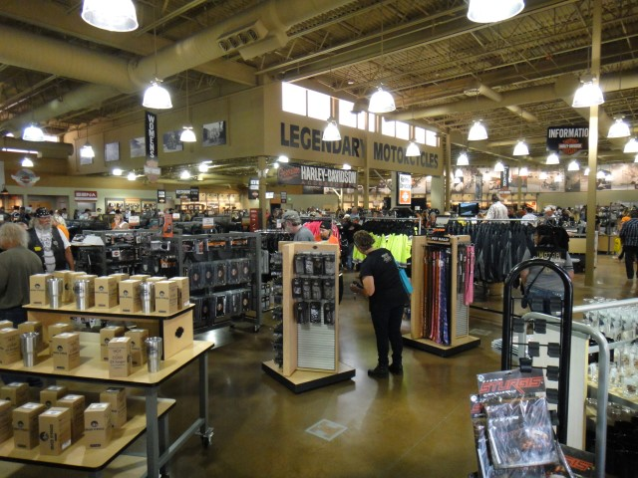
Sturgis Rally Image 41 – Still in the retail shop and now looking in the opposite direction you get a sense of the size of this retail shop. It was busy with bikers browsing and shopping.

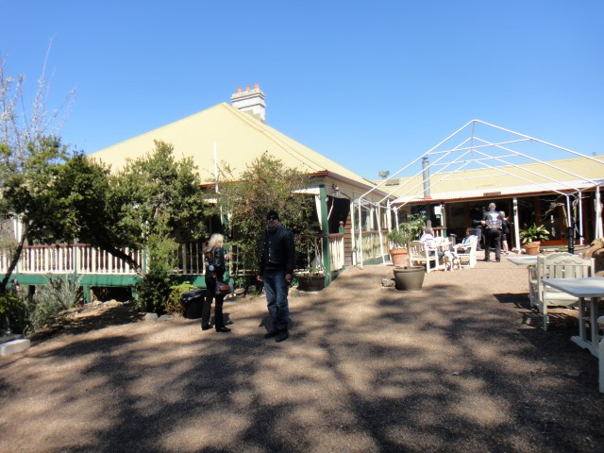
HOG Ride Image 29 – We exit the carpark and make our way to the Mulla Villa Café/Restaurant. To the left is the old homestead and at right the Café/Restaurant. Hey, there’s Peter with Fifi at left.

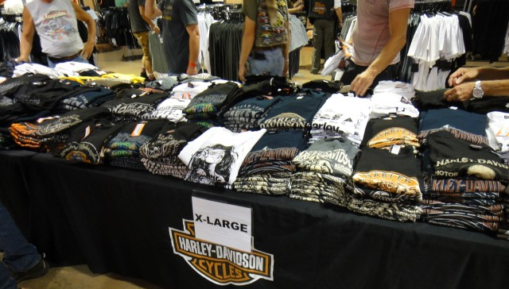
Sturgis Rally Image 42 – Still in the Black Hills Harley-Davidson retail shop - No more sorting through stuff to find your size, there is a separate table for each size. Brilliant!

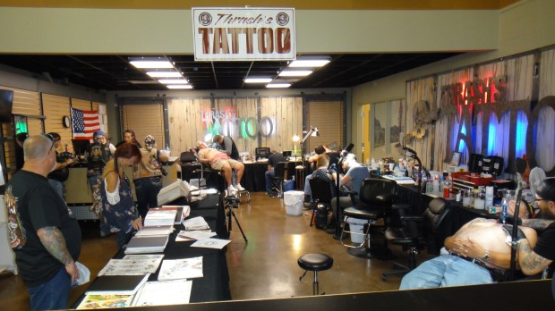

Sturgis Rally Image 43 – The aforementioned tattoo shop within the Black Hills Harley-Davidson retail shop. There are 4 tattoo artists going simultaneously. Business is good nowadays for tattoo shops.

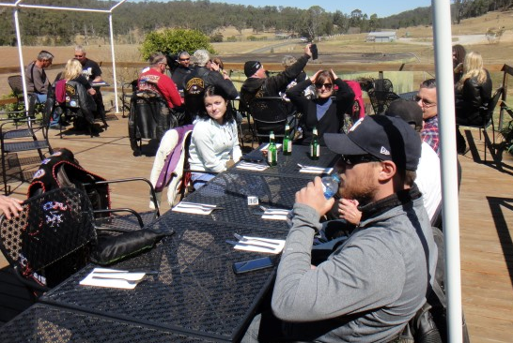
HOG Ride Image 30 – Just on the other side of the Café/Restaurant is this outside eating area. The weather today was quite favourable for al fresco dining with temperatures in the low 20’s Celsius. Very pleasant indeed!

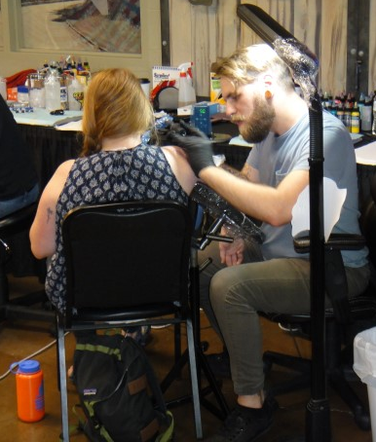
Sturgis Rally Image 44 – A young woman getting a tattoo in the Black Hills Harley-Davidson retail shop.
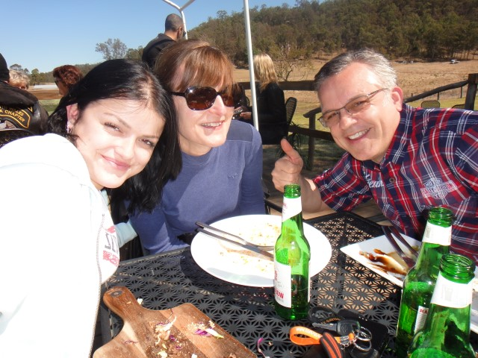
HOG Ride Image 31 – Meet the Mawson’s, daughter Belle at left with parents Jane and Tarzan (Steve). You read about Belle’s achievements on the bike previously and on the Monday following this ride she is partaking in a motorcycle circuit training event at the Eastern Creek Raceway. For this she has a Kawasaki Ninja 300 motorcycle and supporting her will be her Dad on his Kawasaki Ninja 650 (Tarzan also has a glamorous Harley CVO Ultra which he rides extensively throughout the year). And we HOGS can say we saw her skills evolve and we also look forward to hearing of her future motorcycling accomplishments. GO GIRL!

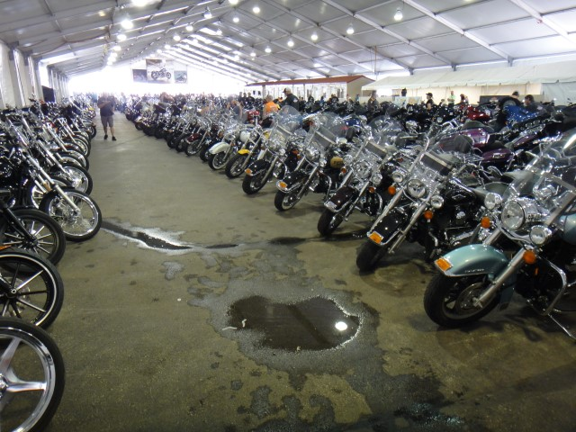
Sturgis Rally Image 45 – Now to the Black Hills Harley-Davidson bike showroom and sales area (also seen in Sturgis Rally Image 1 above), it’s the biggest bike showroom I have ever seen. There are hundreds of bikes for sale here including a small selection of used bikes.

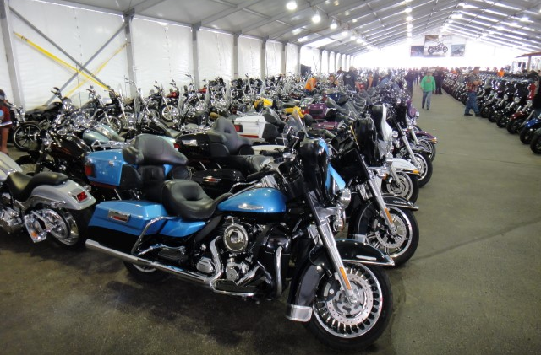
Sturgis Rally Image 46 – Still in the bike showroom, the bikes on the far left row are mostly pre-owned, the rest are brand new, some with custom modifications. I was told only real interesting trade-ins are included with the used bikes.
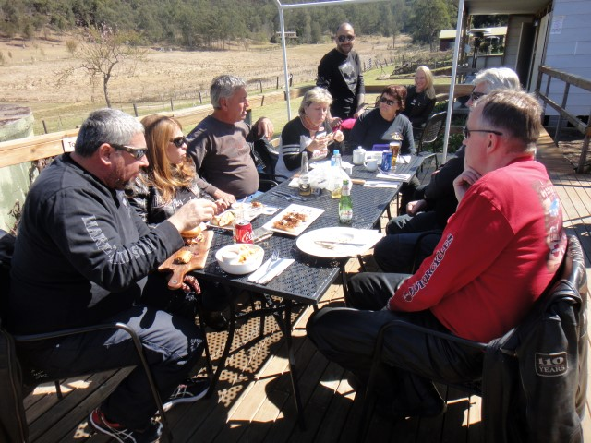
HOG Ride Image 32 – HOGS doing what they do best – enjoying each other’s company!
Total distance travelled from our meet point to this Café/Restaurant was about 150 kms. My round trip door to door was about 350 kms, which is a comfortable outing on the bike for the day.
A fantastic ride and route, even the weather was great. Good job Gypo!!

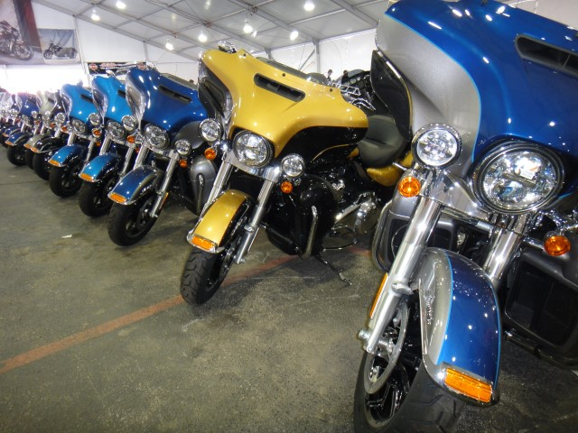
Sturgis Rally Image 47 – At Black Hills Harley-Davidson; that’s what this place is all about, finding the bike you want in the colour you want right here. Here is a row of Ultra models to choose from.

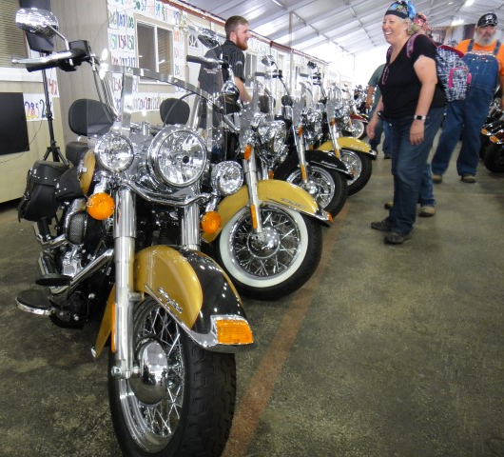
Sturgis Rally Image 48 – And here is a row of Heritage Softail models to choose from. For each Harley model there are many to choose from.
Take notice of that wall on the left hand side with all the numbers on it. More on this later.

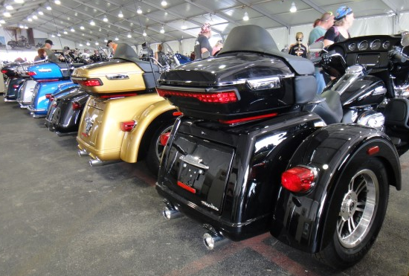
Sturgis Rally Image 49 – Black Hills Harley-Davidson - And here a row of 3-wheller Tri Glide Ultras. Trikes are more popular in the United States than they are in Australia.

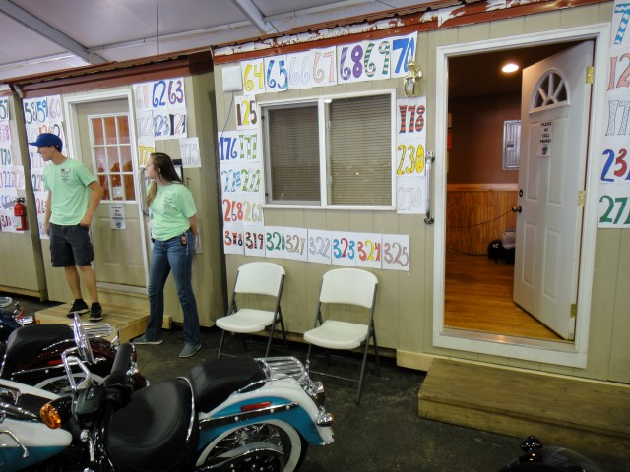
Sturgis Rally Image 50 – Now to that wall mentioned in Sturgis Rally Image 48. These are separate sales booths for the sales people to work from, and there are quite a few of them. Now you must be wondering what those numbers on their walls are for as I did when I was there. Well they are a running tally of the number of new bikes sold during the rally and this is only day 5 or 6. Each time a bike sale is finalized, a new number is pinned to the wall letting everyone know what the running tally is.

Sturgis Rally Image 51 – Here is a staff member pinning a new number to the wall and its number 327. That’s how many new bikes have been sold to this point in the rally and still counting.

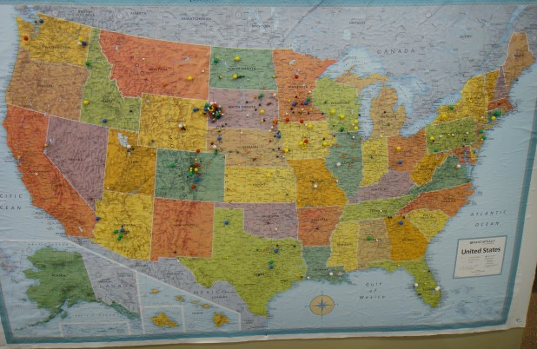
Sturgis Rally Image 52 – After a bike is sold, a pin goes on this map of the United States in the showroom area showing the home location of the purchaser. As you can see, they are from all over. So I asked: why would someone from Florida for instance, come all this way to buy a new bike when there are plenty of Harley-Davidson dealerships in Florida? The reply was that the buyers know they will get a better deal here, and that the bike of their choosing will be available on the floor. Also some buyers plan their trip to Sturgis to include the purchase of a new bike. There are also the impulse buyers making up the numbers.
And where better to test your new ride than in the Black Hills of South Dakota. More on this subject in a later newsletter!
Well, visiting Black Hills Harley-Davidson today was a great day out! The Sturgis experience is everything I was hoping it to be.

