ROLEX CHINA SEA RACE 2018
QUICK FACTS & STATS
www.rolexchinasearace.com
THE RACE
- The start of the historic Rolex China Sea Race is Wednesday 28 March

- Organised by Royal Hong Kong Yacht Club (RHKYC)
- 56th anniversary of the biennial race. 29th edition of the Race

- The non-stop race course is 565 nautical miles (1046.38km)
- A fleet of 29 boats is expected with 300+ crews participating

- The race attracts a diverse fleet of yachts; including performance racing machines, multihulls and cruising yachts.
- The warning signal is at 1110hrs with the boats starting at 1120hrs Hong Kong time from Royal Hong Kong Yacht Club’s Kellett Island Clubhouse in Causeway Bay

- The race starts in iconic Victoria Harbour before the competitors make their way through the east gate of the harbour; a narrow 430m meter passage (Lei Yue Mun Gap). Shortly thereafter they pass the channel markers TCS4 and TCS3 to port and keep the Waglan and Tan Kan Shan Islands to starboard before heading south easterly along the rhumb line towards Subic Bay in the Philippines.
- The race finishes in the vicinity of Latitude N14° 46.6’, Longitude E120° 13.2’ to the northwest of Grande Island at the entrance to Subic Bay.

- Subic Bay is on the west coast of Luzon Island approximately 100km northwest of Manila Bay. Its shores were formerly the site of a major United States Naval Base however now it is a known as the Subic Bay Freeport Zone.
- An international race with boats representing 8 territories and sailors hailing from 20+ countries.

- Rolex has sponsored the race since 2008
RACE HISTORY AND RECORDS
- First run in 1962 and held once every two years thereafter.

- Five boats raced in the first edition in 1962 and Reverie, a Sparkman & Stephens 40’ Yawl owned by Swedish Chris F. Von Sydow, was the first winner
- The Race has ranged in distance since its establishment from 565nm to 624nm and finished in six different locations in the Philippines including Corregidor, Nicholas Shoal, Sangley Point, Manila Yacht Club and Punta Fuego. The sailors have been racing to the current finish in Subic Bay since 1996

- In 2016 Philip Turner’s Alive, skippered by Duncan Hine set a new monohull record of 47h 31m 08s, breaking Karl Kwok’s Whitbread 60 Beau Geste’s China Sea Race 2000 record by a mere 11m 59s
- The multihull race record was set in 2000 by Benoit Lesaffre’s
Crowther 50 Catamaran Atmosphere with a total elapsed time of 48h 01m 47s

IRC AND HKPN
- IRC is a handicap system administered by the RORC Rating Office that accounts for the size and speed of each boat to achieve a truly democratic result. This means the overall winner can come from any IRC class and be any size
- IRC Formula: Corrected Time = (Elapsed Time x IRC RATING)

- HKPN is a performance-based handicap scheme for sailing yachts administered by the HKPN Committee under the authority of the Hong Kong Sailing Federation (HKSF).
- HKPN Formula: Corrected Time = (Elapsed Time x 1000) ÷ HKPN

SAILORS
- The Race attracts a range of sailors both professional and amateur
- The 2016 Race saw 304 sailors compete on 32 boats.
- In 2016 the sailors hailed from 22 territories including: Australia, Austria, Belgium, United Kingdom, Canada, Mainland China, Denmark, Philippines, France, Germany, Ireland, Italy, Japan, New Zealand, Norway, Portugal, Russia, Singapore, Sweden, Switzerland, United States and Hong Kong.
- In 2016 the youngest sailor to take part was 16 with the oldest being 70 years of age.

- Out of the 304 sailors in the 2016, 17 were women.

LARGEST, SMALLEST
- Largest monohull: Shahtoosh (HKG): Warwick PC 75: 22.9m (75ft); owned by Peter Cremers, 3 time Rolex China Sea Race competitor in the IRC Premier Division. Her best result in 2016 placing second in division and 13th overall.

- Smallest monohull: Tbs Aya (HKG): Pogo 10.5: 10.5m (33.5ft); sailed by father and son team, the only double-handed entry in the 2018 edition Philippe Grelon and Cosmos Grelon

- Largest multihull: Mod Beau Geste (Overseas): Mod 70 Trimaran: 21m (68.9ft); owned by successful Hong Kong businessman Karl Kwok, two time Rolex China Sea Race overall winner, line honours and race record holder on his previous boats both named Beau Geste a Whitbred 60 and Farr ILC 40

STATS
- International fleet, yachts are representing 8 territories: 1 x Australia, 1 x Cayman Islands, 3 x Mainland China, 1 x Great Britain, 20 x Hong Kong, 1 x British Virgin Islands, 1 x Philippines and 1 x Singapore

- The largest fleet of mainland Chinese boats are competing in the race history including: Lighthorse Alphaplus, Seawolf, and Tong Ran

RACE WEBSITES
- Official Race website: http://www.rolexchinasearace.com/
- Royal Hong Kong Yacht Club website: http://www.rhkyc.org.hk/

SOCIAL MEDIA
- Facebook: https://www.facebook.com/RolexChinaSeaRace/
- Twitter: https://twitter.com/RolexCSR
- Instagram: https://www.instagram.com/rolexchinasearace/
- YouTube: https://www.youtube.com/playlist?list=PLBUqWFLoBVkmqXtIvg_-RfA8wtUtjimcW
- Official Race Hashtag: #rhkycRCSR
- WeChat:
RACE TRACKER
Keep up with the progress of the yachts online with the fleet tracker. YB trackers are fitted on every yacht so that you can see each boats position, speed and current standing along the course.
http://www.rolexchinasearace.com/yellowbrick-tracker

PLAY THE VIRTUAL RACE
For the first time armchair enthusiasts can race the 565nm course from the comfort of land by playing the Virtual Regatta Rolex China Sea Race Game.
http://click.virtualregatta.com/?li=4874
RHKYC RACE ENQUIRES
Ailsa Angus - Sailing Manager Royal Hong Kong Yacht Club
T: +852 2239 0395 E: Ailsa.Angus@rhkyc.org.hk

PRESS CONTACTS
RHKYC Media Team
Koko Mueller - PR & Communications Manager Royal Hong Kong Yacht Club
T: +852 2239 0342, +852 9488 7497, E: Koko.Mueller@rhkyc.org.hk
Naomi Walgren - Assistant Manager - Sailing and Promotion Royal Hong Kong Yacht Club
T: +852 2239 0391 E: Naomi.Walgren@rhkyc.org.hk
Circle Chair – PR Officer (Chinese Enquires) Royal Hong Kong Yacht Club
T: +852 2239 0307 E: Circle.Chair@rhkyc.org.hk

ROLEX AND YACHTING – PRESS CONTACTS
Hill+Knowlton Strategies
Sharon Ma/ Wini Lam/ Scarlet Chan
T: 2894 6365/ 2894 6359/ 2894 6368
E: Sharon.ma@hkstrategies.com / Wini.lam@hkstrategies.com / Scarlet.chan@hktrategies.com

COURSE MAP
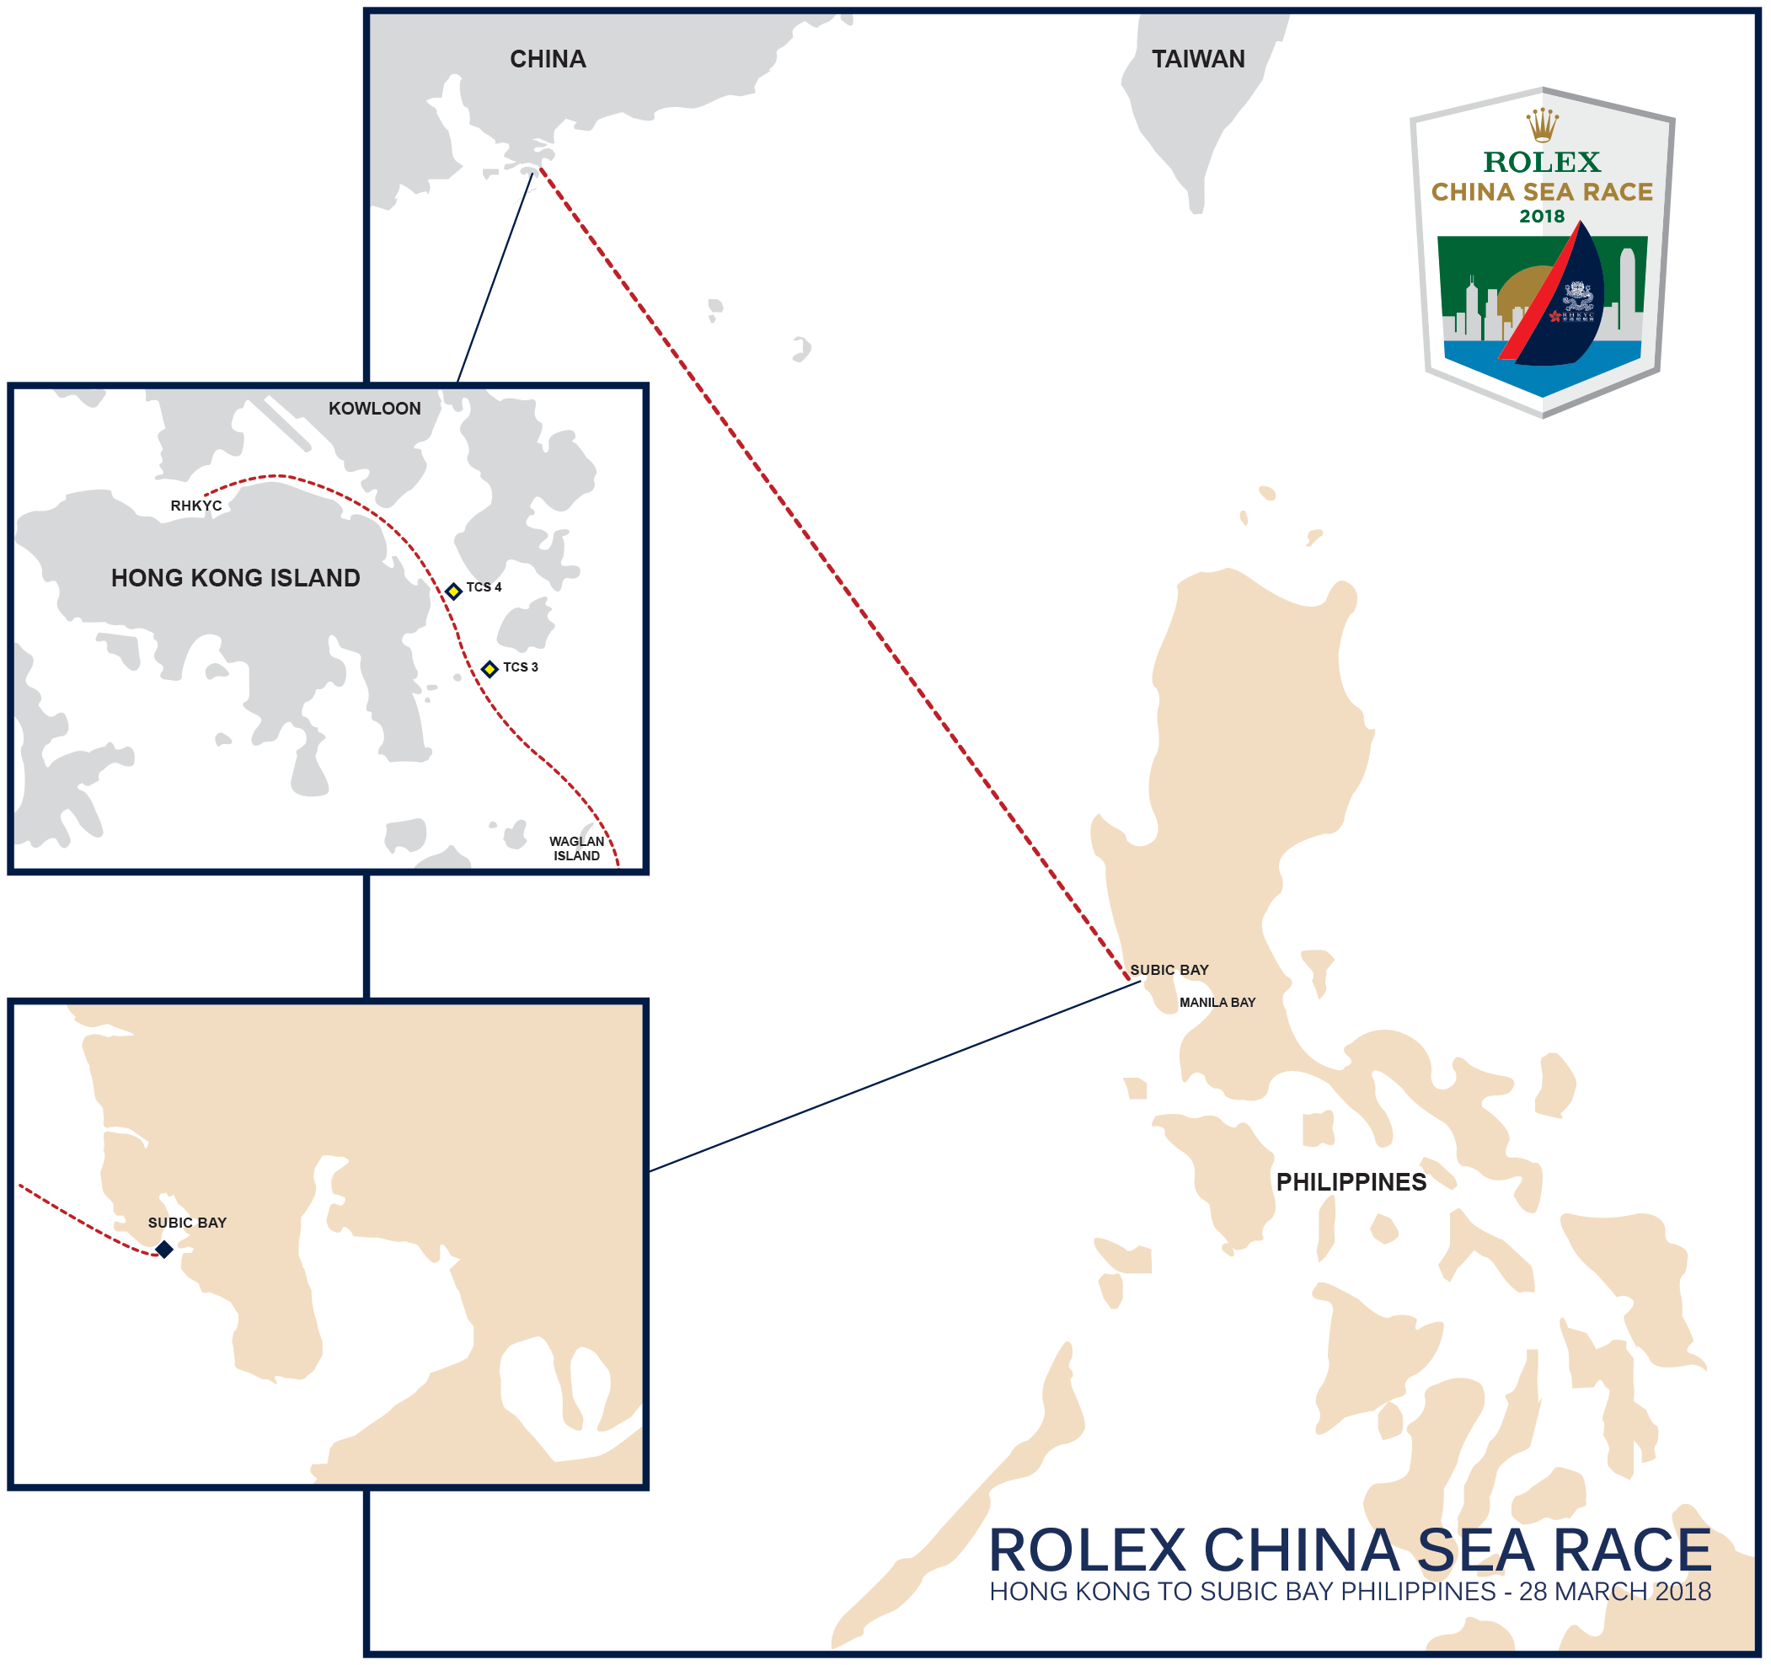

ROLEX CHINA SEA RACE 2018
Photo Caption

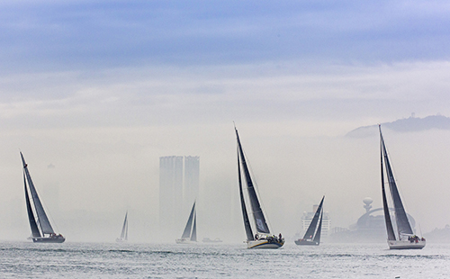 | 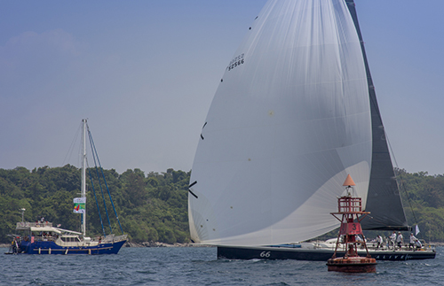
2016 Start of Race  ©Rolex/Daniel Forster | 2016 Race Finish – Alive  ©Rolex/Daniel Forster
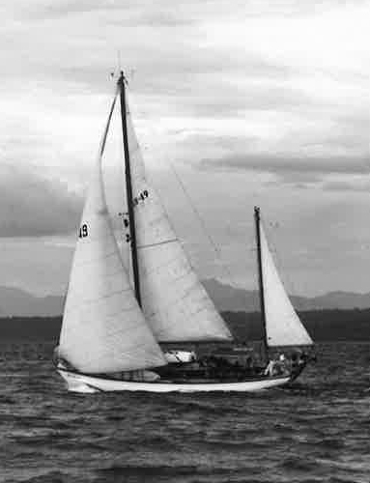 | 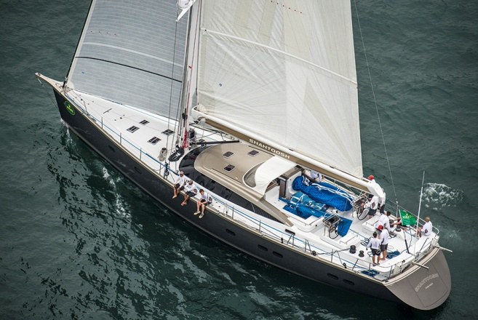
Reverie – 1st China Sea Race Winner | 2016 Start of Race - Shahtoosh  ©Rolex/Kurt Arrigo

