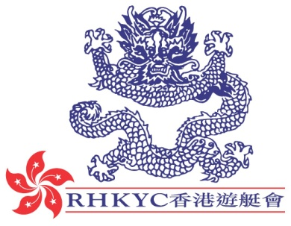 | 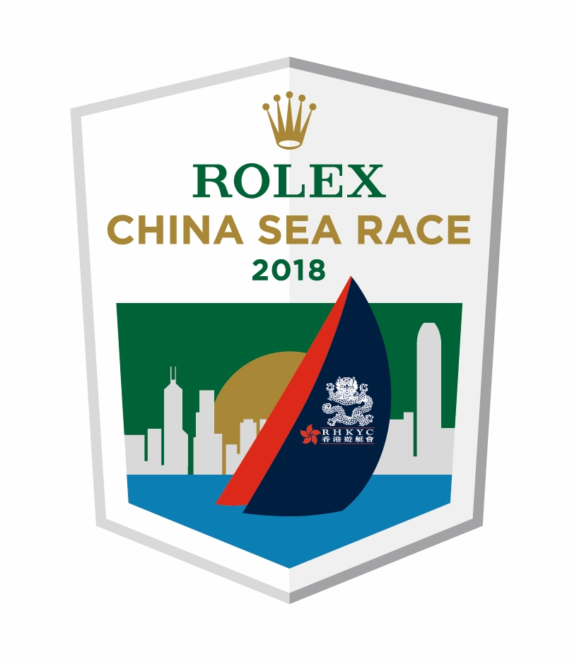

For immediate release
27 March 2018

Rolex China Sea Race
Twenty Nine on the Line Braced for the Race
A press conference was held today at the Royal Hong Kong Yacht Club (RHKYC) for the 2018 Rolex China Sea Race, which starts tomorrow Wednesday 28 March in Hong Kong’s iconic Victoria Harbour. This year will mark the 29th edition of this biennial Offshore Category 1 race, run under the auspices of RORC since 1962. The organising authority, RHKYC, has been hosting 29 local and overseas boats, before the start, including entries from Australia, China, Philippines and Singapore.
In the lead up to the event, competitors go through a stringent preparation period, during which all participants are scrutineered to ensure that they satisfy the World Sailing Category 1 Offshore Sailing Regulations (with RORC prescriptions).
The fleet will gather before the start at RHKYC’s Kellett Island club-house for a lion dance to wish the competitors a safe journey across the ever-challenging South China Sea. The Race traditionally starts in the cooler climate of Hong Kong then, after a bumpy first night, competitors are greeted by clear skies and a full moon as they reach towards the Philippines. As the fleet approaches the northern coast of the Philippines, tactics become supremely important as boats do their utmost to keep moving in the light air that is often found off the coast.
The boats to watch out for record-breaking times and Line Honours win are Karl Kwok’s multihull MOD 70 Beau Geste and Philip Turner’s monohull RP66 Alive. The current race record stands at an impressive 47h 31m 08s for monohulls set in 2016 by Alive and 48h 01m 47s in the multihulls set in 2000 by Benoit Lesaffre’s Crowther 50 Catamaran Atmosphere.
Current favourites for IRC Overall win (on corrected time under IRC handicap) are Lighthorse Alpha Plus, Alive and the two TP52s; FreeFire and Standard Insurance Centennial in IRC Racer 0. However, with conditions being a bit of a lottery as the boats make their way along the race course means that timing is everything and, given a perfect set of circumstances, any of the IRC entries could lift the coveted China Sea Race trophy.
Rolex China Sea Race Chairman Simon Powell summed up his racing experience in his speech today, “I have competed in every edition of this race since 2008 and will be racing down again this year. As amateur racing yachtsmen and yachtswomen we love and relish the chance to compete in this very special event. It’s a race where competitors start off in warm clothes and wet weather gear for the first 100 to 150 miles and end up in shorts and T-shirts. We see amazing sunrises and sunsets, and usually have some fast reaching under moonlight skies – it’s all great stuff and who could argue with finishing in the welcoming, relaxed, warm waters of the Philippines. More than anything that seems to draw us all back race after race for this event is that we are trying to repeat those unique, sublime moments again and again – they are priceless.”
Armchair enthusiasts can follow the action by checking the Yellowbrick trackers which update twice an hour. For the more competitive armchair enthusiast, they can join 1000s of competitors racing against the actual fleet on Virtual Regatta.
The Rolex China Sea Race 2018 will start in Victoria Harbour, Hong Kong, at 1120hrs (HKT) on Wednesday 28 March.

The Notice of Race for the 2018 Rolex China Sea Race starting on 28 March 2018 is available online at www.rolexchinasearace.com.
Video Preview: https://hkstrategies.egnyte.com/fl/d7ZNqw0Zdq
Virtual Regatta: http://click.virtualregatta.com/?li=4874
Yellowbrick tracker: http://www.rolexchinasearace.com/yellowbrick-tracker
Facebook:@rolexchinasearace
Twitter: @rolexcsr
Instagram: @rolexchinasearace
WeChat:

About Royal Hong Kong Yacht Club
Royal Hong Kong Yacht Club (RHKYC) is one of the oldest sports clubs in Hong Kong and is proud of its rich, colourful history, which stretches back over 160 years of social and competitive sailing and rowing. RHKYC organises a full calendar of local and international racing for both keel boats and dinghies, ranging from round-the-cans to Category 1 offshore races. The Club also provides sailing courses for members and non-members at various levels to nurture the development of sailing. For more information on the Royal Hong Kong Yacht Club please visit www.rhkyc.org.hk.

About Rolex
Leading brand of the Swiss watch industry, Rolex, headquartered in Geneva, enjoys an unrivalled reputation for quality and expertise the world over. Its Oyster and Cellini watches, all certified as Superlative Chronometers for their precision, performance and reliability, are symbols of excellence, elegance and prestige. Founded by Hans Wilsdorf in 1905, the brand pioneered the development of the wristwatch and is at the origin of numerous major watchmaking innovations, such as the Oyster, the first waterproof wristwatch, launched in 1926, and the Perpetual rotor self-winding mechanism invented in 1931. Rolex has registered over 400 patents in the course of its history. A truly integrated and independent manufacturing company, Rolex designs, develops and produces in-house all the essential components of its watches, from the casting of the gold alloys to the machining, crafting, assembly and finishing of the movement, case, dial and bracelet. Rolex is also actively involved in supporting the arts, sports, exploration, the spirit of enterprise, and the environment through a broad palette of sponsoring activities, as well as philanthropic programmes.

For enquiry:
Koko Mueller  PR & Communications Manager  Tel.: +852 2239 0342 / +852 9488 7497  Fax: +852 2838 5738 +852 2572 5399  email: koko.mueller@rhkyc.org.hk  Royal Hong Kong Yacht Club  Kellett Island, Causeway Bay  Hong Kong  RHKYC website: www.rhkyc.org.hk  Media enquiry: | Naomi Walgren  Assistant Manager - Sailing and Promotion  Tel.: +852 2239 0391  Fax: +852 2239 0364  email: naomi.walgren@rhkyc.org.hk  Royal Hong Kong Yacht Club  Kellett Island, Causeway Bay  Hong Kong
Hill+Knowlton Strategies
Wini Lam + 852 2894 6359 wini.lam@hkstrategies.com
Sharon Ma + 852 2894 6305 sharon.ma@hkstrategies.com
Scarlet Chan + 852 2894 6368 scarlet.chan@hkstrategies.com

