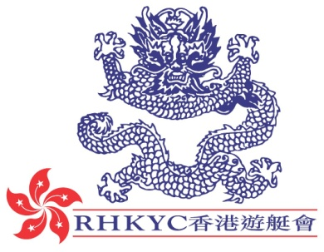 | 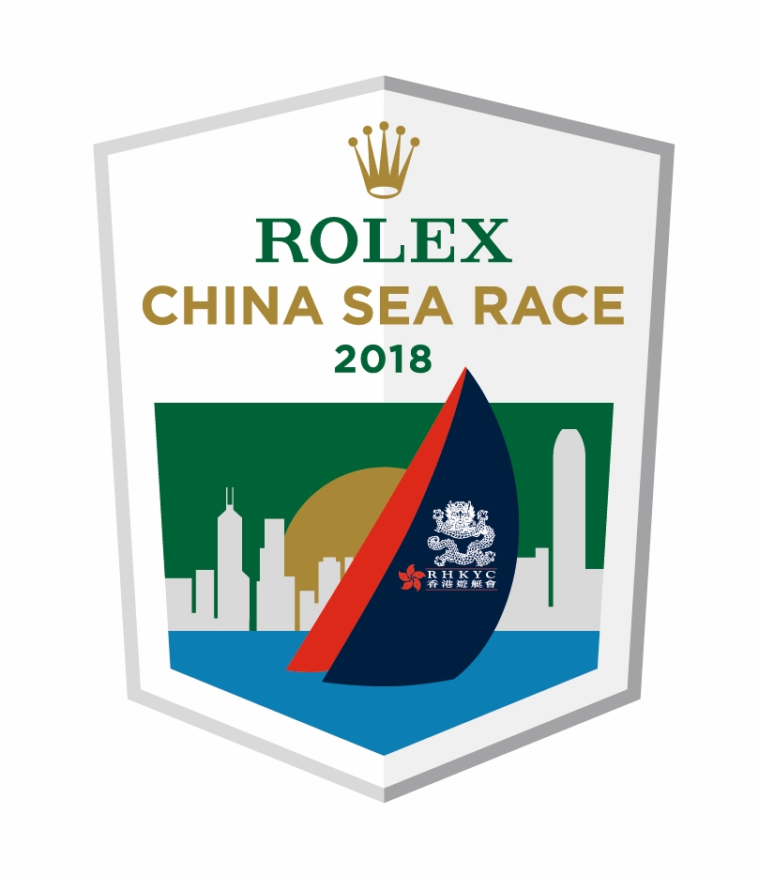

For immediate release
1 April 2018

Rolex China Sea Race 2018
Wraps up under idyllic conditions in Subic Bay
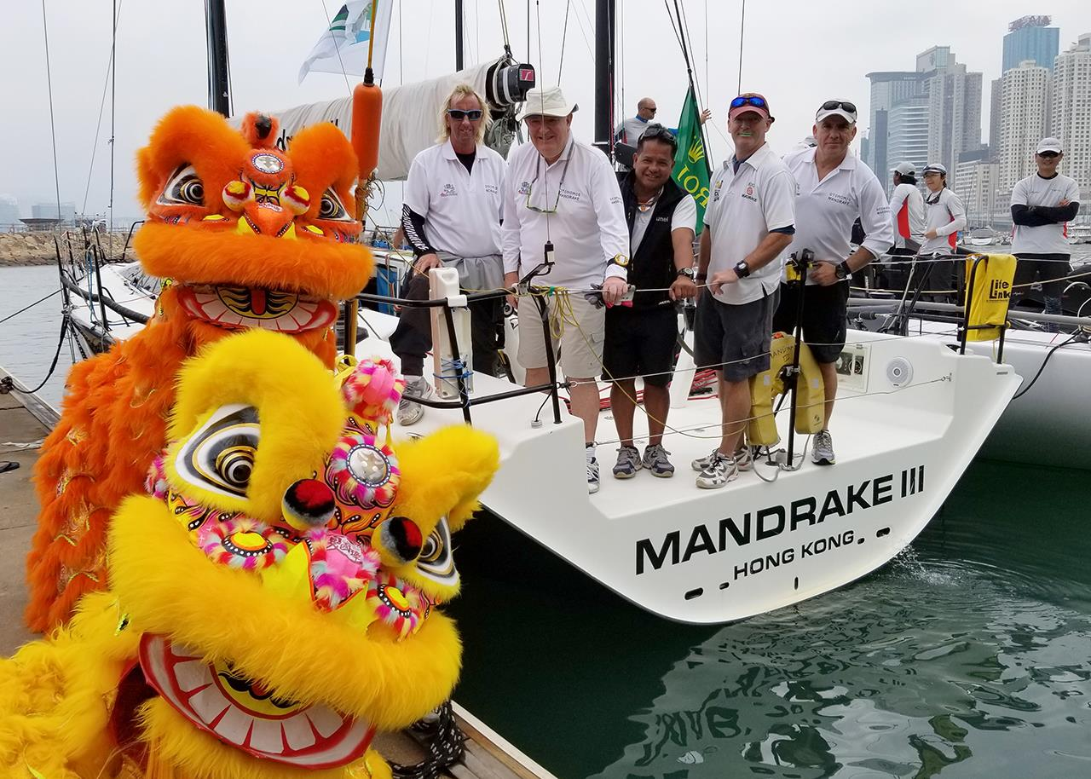
The Lions certainly brought Mandrake III luck! - Rolex China Sea Race 2018

(image: RHKYC)

The final yachts arrived in Subic Bay this morning, wrapping up the 2018 Rolex China Sea Race. 29 boats took part in the 2018 edition with 265 competitors hailing from 22 territories.

The 18 year old multihull record was broken by Karl Kwok's MOD 70 Beau Geste with top speeds of 37kts and her impressive elapsed time of 38h 30m 07s wiped 9h 31m 40s off the previous race record set in 2000.
It wasn t a traditional Rolex China Sea Race in terms of wind strength and angle; however it still provided competitors the challenge that they seek with offshore racing. There was a difficult weather picture for the latter stage of the race for the faster IRC 0 division yachts and with the breeze filling in behind the other divisions as they made their way towards the Philippines.
The IRC Overall win, from IRC 1 Division, went to Fred Kinmonth and Nick Burns GTS 43 Mandrake III (HKG), followed by YY Yan / YF Liu Ker 42 Custom Seawolf (HKG / China) also from IRC 1.
Tiger Mok commented on Seawolf s 2nd overall, This was the second or third major offshore race for Seawolf and I am delighted to see the improvement and willingness to push harder in the race. The boys did a great job! I hope we can be an example for other boat owners from China, who are new to offshore sailing so that more owners take part in this type of race, as well as to prove that anyone with good training, knowledge and experience can perform well in world class offshore racing.
Third overall from the IRC 0 division went to Philippines entry, Ernesto Echauz s TP52 Standard Insurance Centennial. We had a very good race. It was trouble free. Out of all the races we have done it was the most relaxing; no problems at all. It's very meaningful for us as we have been racing together for more than ten years. said Echauz.
Father and son double-handed entry Philippe and Comos Grelon s Tbs-Aya finished last night taking 15th overall and second in the IRC Class 2 behind Glenn Smith s Grand Soleil 45 Blackjack. On arrival they commented We wanted to have fun that s for sure and to finish - which was probably not too difficult as the conditions were absolutely perfect for us. I think we only had maximum breeze of 30kts. Sailing double-handed, I think it takes quite a bit of skill; you need to know what you re doing and have a lot of trust in the other person too. The good news we have been sailing a lot together, we know each other perfectly, we don t argue and that s amazing. We had a very cool and quiet race. On decisions Philippe commented, One says let s do this or that and the other says yes okay. I prefer to sail double handed because we know each very well there s no problem.
In IRC Premier Division, Peter Cremers Warwick 75 Shahtoosh had an awesome run taking the division win and 5th Overall; climbing up the ladder from 13th in 2016 edition. In the IRC Cruising Division, first time Rolex China Sea Race competitor Michael Ashbrook s Jeanneau Sitka took the division win.
The on location prize giving will be held tonight with the official prize giving at the Royal Hong Kong Yacht Club later in April.
See you at the next edition of the Rolex China Sea Race, which starts 8 April 2020.

The Notice of Race for the 2018 Rolex China Sea Race starting on 28 March 2018 is available online at www.rolexchinasearace.com.
Photos Download: https://corplogin-my.sharepoint.com/:f:/p/scarlet_chan/Et9I05MnGLFIvqmqa6q9h7IB8GSB8kbfVx3oNbg6fYfx2g?e=F2Wr7n
Video Preview: https://hkstrategies.egnyte.com/fl/d7ZNqw0Zdq
Start of Race Video: https://corplogin-my.sharepoint.com/:f:/p/scarlet_chan/EiNn94Ssjp9KuYaVBaLP4uABHTas6ADVoN1kd__KzgrKag?e=7LTBOt
Virtual Regatta: http://click.virtualregatta.com/?li=4874
Facebook:@rolexchinasearace
Twitter: @rolexcsr
Instagram: @rolexchinasearace
WeChat:
About Royal Hong Kong Yacht Club
Royal Hong Kong Yacht Club (RHKYC) is one of the oldest sports clubs in Hong Kong and is proud of its rich, colourful history, which stretches back over 160 years of social and competitive sailing and rowing. RHKYC organises a full calendar of local and international racing for both keel boats and dinghies, ranging from round-the-cans to Category 1 offshore races. The Club also provides sailing courses for members and non-members at various levels to nurture the development of sailing. For more information on the Royal Hong Kong Yacht Club please visit www.rhkyc.org.hk.

About Rolex
Leading brand of the Swiss watch industry, Rolex, headquartered in Geneva, enjoys an unrivalled reputation for quality and expertise the world over. Its Oyster and Cellini watches, all certified as Superlative Chronometers for their precision, performance and reliability, are symbols of excellence, elegance and prestige. Founded by Hans Wilsdorf in 1905, the brand pioneered the development of the wristwatch and is at the origin of numerous major watchmaking innovations, such as the Oyster, the first waterproof wristwatch, launched in 1926, and the Perpetual rotor self-winding mechanism invented in 1931. Rolex has registered over 400 patents in the course of its history. A truly integrated and independent manufacturing company, Rolex designs, develops and produces in-house all the essential components of its watches, from the casting of the gold alloys to the machining, crafting, assembly and finishing of the movement, case, dial and bracelet. Rolex is also actively involved in supporting the arts, sports, exploration, the spirit of enterprise, and the environment through a broad palette of sponsoring activities, as well as philanthropic programmes.
Koko Mueller  PR & Communications Manager  Tel.: +852 2239 0342 / +852 9488 7497  Fax: +852 2838 5738 +852 2572 5399  email: koko.mueller@rhkyc.org.hk  Royal Hong Kong Yacht Club  Kellett Island, Causeway Bay  Hong Kong  RHKYC website: www.rhkyc.org.hk | Naomi Walgren  Assistant Manager - Sailing and Promotion  Tel.: +852 2239 0391  Fax: +852 2239 0364  email: naomi.walgren@rhkyc.org.hk  Royal Hong Kong Yacht Club  Kellett Island, Causeway Bay  Hong Kong
For enquiry:

