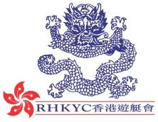 | 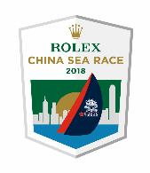

For immediate release
23 March 2018

Rolex China Sea Race

The sole Philippines entry TP52 Standard Insurance Centennial
returns for the Rolex China Sea Race!
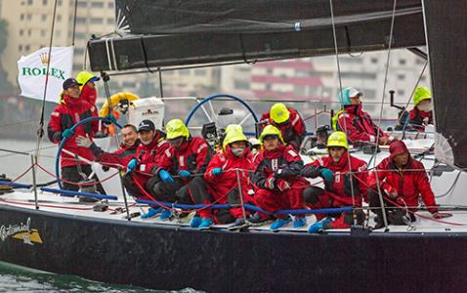
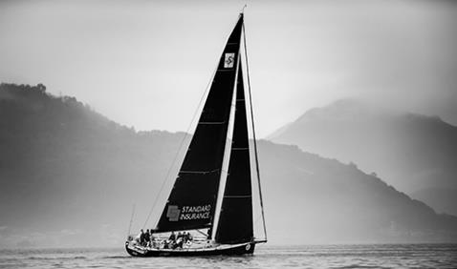
A regular fixture in the Royal Hong Kong Yacht Club’s offshore races, Standard Insurance Centennial owned by Philippines businessman and President of the Philippine Sailing Association Ernesto “Judes” Echauz is taking part in what will be his twelfth Rolex China Sea Race. Judes’ first race was in 1994 in which he sailed with Nestor Soriano on board the X-119 Lethal Weapon. He has only missed one crossing in 2002 and his best results were in the 2008 and 1998 editions taking the overall win, on his previous boat Sydney 46 Subic Centennial.
RHKYC / Aitor Alcalde– 2016 Start of Race

Judes is yet to take the overall win on his Davidson TP52, but persevering to get the title back this year will be Standard Insurance Centennial’s 14 man crew representing Filipino national athletes. The majority of the crew hails from the Philippine Sailing Association and comprises of a variety of dinghy coaches and sailors from various classes including Lasers, 420s and 470s.
We caught up with Philippine Sailing Association athletes, Teodorico Asejo and Ridgely M. Balladares on the dock as they were preparing for next week’s race start. Teodorico commented, “I started sailing in Manila and won gold in the Dragon Class at the Manila Sea Games, then in 1992 I had the opportunity to go to the Barcelona Olympics, I didn’t win, but I am proud. After the Olympics I came back to Manila for more sailing and to boost the kids from the Optimist to the 420s, 470s then the big boats. After that China Sea Race, I think I have done 12 China Sea Races in all now.”
Rolex / Daniel Forster– 2016 Start of Race

Ridgely added, “I have done I think around 10 China Sea Races. I started when I was 19 years old back then in 1996 on a J35. Being part of the national team, I used to sail on a 470 dinghy boat, but four years ago I jumped into keel boats. We have six Far East boats and that’s our training for the keel boat in the Philippines. I compete both for the keel boats and coaching the kids in the 420 and 470. In the lead up to the Rolex China Sea Race we did the inaugural 200nm Subic Bay Verde Island Race, placing first in IRC 1.”
Standard Insurance Centennial will join the 29 strong fleet and 300+ crews for the 29th edition of the Rolex China Sea Race with the ten minute warning signal firing at 1110hrs on 28 March.
In closing when asking Judes about his thought on the race finishing in the Philippines, Judes commented, “The Rolex China Sea Race with Rolex as the major sponsor starting in 2008 has brought prestige to the 565nm race from Hong Kong to Subic Bay. By the mere fact that it ends in Subic Bay in the Philippines brings honour to the Philippines as the final destination of this most popular long-distance race in Asia.”
The Notice of Race for the 2018 Rolex China Sea Race starting on 28 March 2018 is available online at www.rolexchinasearace.com.
Video Preview: https://hkstrategies.egnyte.com/fl/d7ZNqw0Zdq
Facebook:@rolexchinasearace
Twitter: @rolexcsr
Instagram: @rolexchinasearace
WeChat:

About Royal Hong Kong Yacht Club
Royal Hong Kong Yacht Club (RHKYC) is one of the oldest sports clubs in Hong Kong and is proud of its rich, colourful history, which stretches back over 160 years of social and competitive sailing and rowing. RHKYC organises a full calendar of local and international racing for both keel boats and dinghies, ranging from round-the-cans to Category 1 offshore races. The Club also provides sailing courses for members and non-members at various levels to nurture the development of sailing. For more information on the Royal Hong Kong Yacht Club please visit www.rhkyc.org.hk.

About Rolex
Leading brand of the Swiss watch industry, Rolex, headquartered in Geneva, enjoys an unrivalled reputation for quality and expertise the world over. Its Oyster and Cellini watches, all certified as Superlative Chronometers for their precision, performance and reliability, are symbols of excellence, elegance and prestige. Founded by Hans Wilsdorf in 1905, the brand pioneered the development of the wristwatch and is at the origin of numerous major watchmaking innovations, such as the Oyster, the first waterproof wristwatch, launched in 1926, and the Perpetual rotor self-winding mechanism invented in 1931. Rolex has registered over 400 patents in the course of its history. A truly integrated and independent manufacturing company, Rolex designs, develops and produces in-house all the essential components of its watches, from the casting of the gold alloys to the machining, crafting, assembly and finishing of the movement, case, dial and bracelet. Rolex is also actively involved in supporting the arts, sports, exploration, the spirit of enterprise, and the environment through a broad palette of sponsoring activities, as well as philanthropic programmes.

For enquiry:
Koko Mueller  PR & Communications Manager  Tel.: +852 2239 0342 / +852 9488 7497  Fax: +852 2838 5738 +852 2572 5399  email: koko.mueller@rhkyc.org.hk  Royal Hong Kong Yacht Club  Kellett Island, Causeway Bay  Hong Kong  RHKYC website: www.rhkyc.org.hk | Naomi Walgren  Assistant Manager - Sailing and Promotion  Tel.: +852 2239 0391  Fax: +852 2239 0364  email: naomi.walgren@rhkyc.org.hk  Royal Hong Kong Yacht Club  Kellett Island, Causeway Bay  Hong Kong

