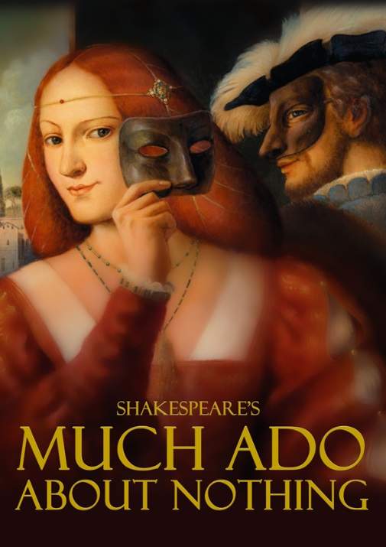
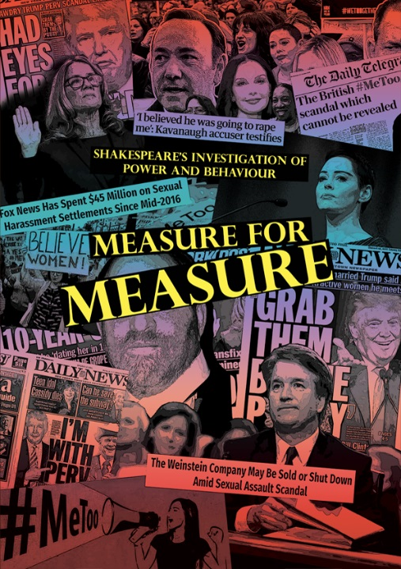
A season to explore identity, power and dark comedy
Mary King and Stewart McGill preview the dark comedies at The Dream Factory this Spring
After the surreal beauty of A Midsummer Night’s Dream our 2019 Shakespeare season takes it leave of a wood near Athens and shares with audiences two very different plays that explore the misuse of power and the way in which
women can be victims of unpleasant and potentially deadly behaviour from the opposite sex. In Much Ado About Nothing, whilst former lovers engage in sparring matches of wit and wisdom, the central figure of Hero is brought to public humiliation and disgrace on her long-anticipated wedding day at the hands of her husband to be, Claudio, and his associates returning from a nameless war. The potential for tragedy is often overshadowed by the star turns of the couple, Beatrice and Benedick and the below stairs humour of
Dogberry and his volunteer police force. In the new SYC/Playbox Theatre production, the storyline of Hero will not be subsumed or played down in a show which takes its visual inspiration from the Pre-Raphaelite paintings of Rosetti, Holman-Hunt, Milais and Burne-Jones. Always a popular play, over the past few years there have been some memorable productions, including the RSC version, Love’s Labour’s Won, set at the end of WWI in a country house with the army returning. There was a Mexican version at Shakespeare’s Globe with much fiesta, dancing and brass band. It will be fascinating to see what Mary and her excellent cast bring to the text for Playbox Theatre.
Mary King, said of the work as rehearsals began, “I have always loved the play, and this is a superb opportunity to explore it with the highly talented young cast who bring a fresh eye to the events that take place in an imagined Messina. It’s often thought of as Beatrice and Benedick’s story, the warring couple who try – with little success – to hide their love for each other. However, running through this series of witty encounters is a dark story of betrayal, deceit and near heart break – the journey of Hero, Beatrice’s cousin and her fiancé Claudio. Surely the church humiliation of Hero on her wedding day is a tragic outcome. Of course, Shakespeare writes a comedy so there are twists and turns a plenty.
In contrast to the starkness of Measure, I wanted to evoke the world of the Pre-Raphaelite Brotherhood (PRB), a name that referred to their painterly preference for late Medieval and early Renaissance art.
A lot of the themes the Brotherhood chose to depict were quite daring for their time including the state of poverty, emigration, prostitution and the double standard of morality in society. At first glance a painting may seem to represent an innocent or religious subject but on closer exploration the different signs in the works come together to suggest a narrative of fall and possible redemption. With this cast we are telling the story as clearly as we can, for a young and hopefully family audience, through visual prism of the paintings. You shouldn’t read too much into that, but it will look gorgeous. The Pre-Raph women seem to reflect a melancholy, ethereal beauty, occasionally in a garden setting. Looking like lone maidens from a Medieval fairy tale. It seems a perfect visual metaphor for the play and the actors seem very at home in the world created.”
Stewart McGill directs Measure for Measure in a very contemporary production. Below we reveal some thoughts from a talk given to the cast as rehearsal began.
“At the first cast gathering for Measure, I asked all of them to approach the work with an open mind, no preconceptions. I have seen many productions where, from the get-go, Angelo is without doubt an exploiter of his power, abuses Isabel and deserves no pity. Yet for the actor playing Angelo this gives
little room for exploration, a predetermined villain. Our version seeks to put the Angelo/Isabel case under the auspices of a select committee our audiences can hear for themselves all the evidence and make their own decisions. It will, I hope, change at each performance and the actors will have no set way of delivering the scenes.
It’s the most remarkable contemporary play in so many ways, power and the abuse of high office, the #metoo revelations over the past year or so revealing the scale of exploitation of vulnerable girls by people like Harvey Weinstein, Brett Kavanaugh and so on. We will consider every aspect of the case before our audience and review the material. We will cross examine the protagonists and the circumstances surrounding Angelo’s behaviour.
During our first rehearsal the cast looked at edited highlights of the Kavanaugh senate hearings in the USA where, once more, nothing is black and white and as with all fine drama ambiguity is very present.
I hope with this cast we can discover much that remains hidden in the play, a very dark comedy and create an evening of potent, powerful and immediate drama. Measure for Measure is very much in focus today. No preconditions, exploration and discovery - as, of course, we should with all Shakespeare’s plays.
Measure for Measure opens 10th April and Much Ado About Nothing opens 11th April.

