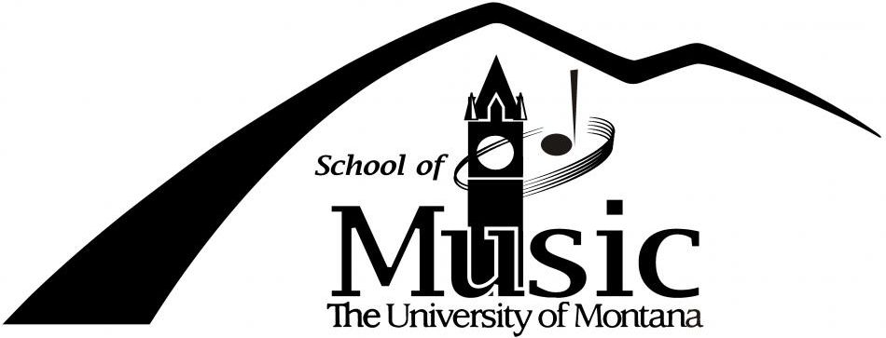
Buddy DeFranco Jazz Festival
March 17^{h} and 18th

The University of Montana College of Visual and Performing Arts in conjunction with the School of Music is proud to announce the 2016 edition of the UM Buddy DeFranco Jazz Festival which will occur on March 17-18, 2016. The emphasis of this instrumental and vocal jazz festival is on education, improvisation and the jazz language.
The 2016 Festival is excited to host the best crew of artists and educators they have ever had the pleasure of having in one place at the same time. Count Basie Alum Derrick Gardner (trumpet) Woody Herman Alum Gary Hobbs (drum set) Jazz at Lincoln Center Educator, Reggie Thomas (piano) New York/Whitefish saxophonist Erica Von Kleist Chicago performing artist Marlene Rosenberg (bass)
On both evenings, experience a spectacular musical event with the High School Best Section Big Band and outstanding soloists from the daytime events along with more musical artistry.
On both evenings, students will experience a spectacular musical event with the High School Best Section Big Band and outstanding soloists from the daytime events along with more musical artistry.
The fun and learning continues throughout each day with clinics, ensemble critiques, workshops, open rehearsals and master classes with guest artists, local musicians and faculty from the University of Montana.
The UM Buddy DeFranco Festival promises to be an exciting opportunity to learn more about the language of jazz and a great weekend of music and jazz education
The cost is 80$ per student.
Feb 29th -- $50
March 14th – The remaining $30
Students should have money for lunch and dinner both days.

Best,
Garrett Stannard

Schedule…
Thursday
7:00am // Thursday: Depart from Park High School
11:00am // Arrive at UM Jazz Fest - Attend Improv classes
12:00pm // Lunch on Campus
1:00pm // Attend Clinics, Master Classes and Performances
3:30pm // Rep Jazz Performance in UM Recital Hall
5:00pm // Jazz Ensemble Performance in UM Dennison Theatre
7:00pm // Night Concert at UM
9:30pm // To Hotel Missoula Comfort Inn University Hotel (1021 East Broadway, Missoula, MT 59802)
11:00pm // Lights Out
Friday
7:30am // Rise and Shine – Breakfast provided.
8:45am // Check Out of Red Lion
9:00am // Watch Performances.
11:00am // Attend Improv classes
12:00pm // Lunch on Campus
1:00pm // Attend Clinics, Master Classes and Performances
2:15pm // To Livingston
6:30pm // In Livingston

*Times and locations are subject to change.
Things to remember:
A. I will send out a Theory Test to help decided what is the best level of improvisation for you. (Beginning or advanced)
B. The festival activities stop at 11am (Improv classes) and at 1pm (Master Classes).
C. Rob Tapper (UM) will pick outstanding soloists (3) for each evening performance
D. Rob Tapper will pick outstanding sections from the Dennison Performance site for the Best Section Big Band each evening (those musicians will rehearse during dinner)
E. Warm up times are generally 30 minutes.

