– PRESS RELEASE –

Italian Australian: Creating Culture, Defining Diaspora

Museo Italiano, Co.As.It., 189 Faraday Street, Carlton
27 August – 16 October 2015
Tuesday to Friday 10am-5pm; Saturday 12.30pm-5pm

Opening event: Wednesday 26 August 2015, 6.30pm
Guest speaker: Professor Ghassan Hage (The University of Melbourne)
RSVP: ihs@coasit.com.au

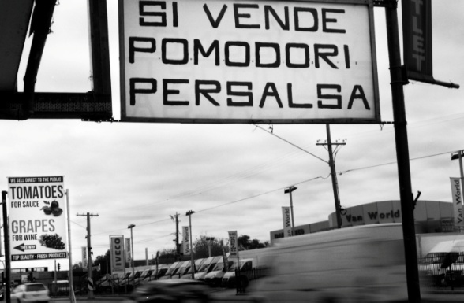

Sometimes we feel we straddle two cultures;
at other times, that we fall between two stools.

Salman Rushdie

Wogs, Dagos, Post-War migrants, New Australians, Zips, Marios, I-Ties, Multicultural Australia. All these phrases have been used to categorise and to describe the Italian diaspora in Australia. This exhibition seeks to subtly address these labels, some embraced, some forgotten and some derogatory by asking the question: Can we define ourselves? Is it possible to document the commonalities of experience and of culture and to start to trace the transition from migrant group to diaspora?

Around 200 participants volunteered to have their portraits taken, to record what it means for them to be Australian and what it means to have an Italian cultural heritage in Australia. The result is an exhibition that may in some ways confirm your impressions of Italian-Australians and may also challenge it. This is not a nostalgic gaze into tradition, nor is it a definitive contemporary document, but rather an introduction to the idea that it is possible to be both Australian and Italian, and it is possible to feel like you are neither.

the
foundling
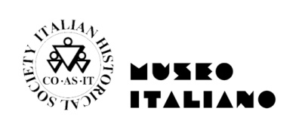
archive
390A Lygon Street
Brunswick East, Vic 3057
thefoundlingarchive.org.au
e: thefoundlingarchive@gmail.com
Gracie Lolicato, m: 0435 845 912

