FULL - CIRCLE LEARNING

2014
AFRICA
ANNUAL
REPORT

Full-Circle Learning helps young people embrace their role as society's helpers, humanitarians and change agents.
Table of content

- Introduction

- Chad: Students Encourage Consistent Farming to Eradicate Hunger

- Zambia: Students become Young Entrepreneur Ambassadors

- Liberia: Humanitarians Unite to Stop Ebola

Introduction

I am pleased to transmit the 2014 Annual Report of our Full-Circle Learning African program. Our programs and projects continue to thrive in the countries and schools we serve in Africa.

Since 2009, we have served more than 15, 500 teachers, and over 40,000 students have directly and indirectly benefited from our program across the continent.

2014 has been an active one for our teachers and students across Africa. Nineteen Habits of Heart were taught in 53 of our regular schools and 11 other schools in three different countries. 78 Students attained Self-Mastery and 7 Service Projects were conducted in the areas of Agriculture, Community Service, Health and Sanitation, respectively. There were many challenges and milestones crossed. We are very thankful to the FCL board for their regular and timely support of the numerous activities that were undertaken by our African teachers and coordinators this year.

In Chad, teachers and students integrated into their school-day lessons the French version of Full-Circle Learning’s Habits of Sages, which features The Dark Child, by Camara Laye, and Things Fall Apart, by Chinua Achebe, both African celebrated writers. Liberia humanitarians joined hands together to stop Ebola and keep students busy at home with our off-school lessons while Zambian students became young entrepreneur ambassadors as they took the Junior Entrepreneurs Scheme Program to another level.

We hope you find this Report informative of the work that our team has done in the year 2014.

Warm Wishes for a Safe, Healthy, and Peaceful 2015

Davidson Efetobore
Africa Program Director
Full-Circle Learning

Chad: Students Encourage Parents to Engage in Consistent Farming to Eradicate Hunger

While practicing the habit of Preparedness, Chadian students looked for better ways to help educate local people of Koundu about the importance of farming and preparing for dry season. They visited communities to conduct awareness campaigns on Agriculture and Farming. They were highly commended by the community people for their initiative. Farming and cattle rearing are major sources of income in Chad, especially for the rural people of Koundu and other villages. The kids’ initiative to encourage their parents and the community people to take their farming seriously, especially in the dry season, is a commendable one for self-support and eradication of hunger.
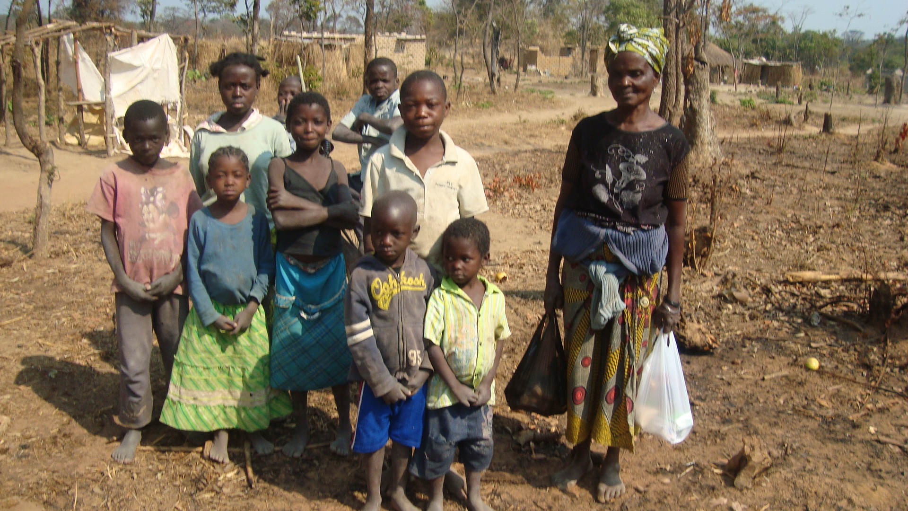
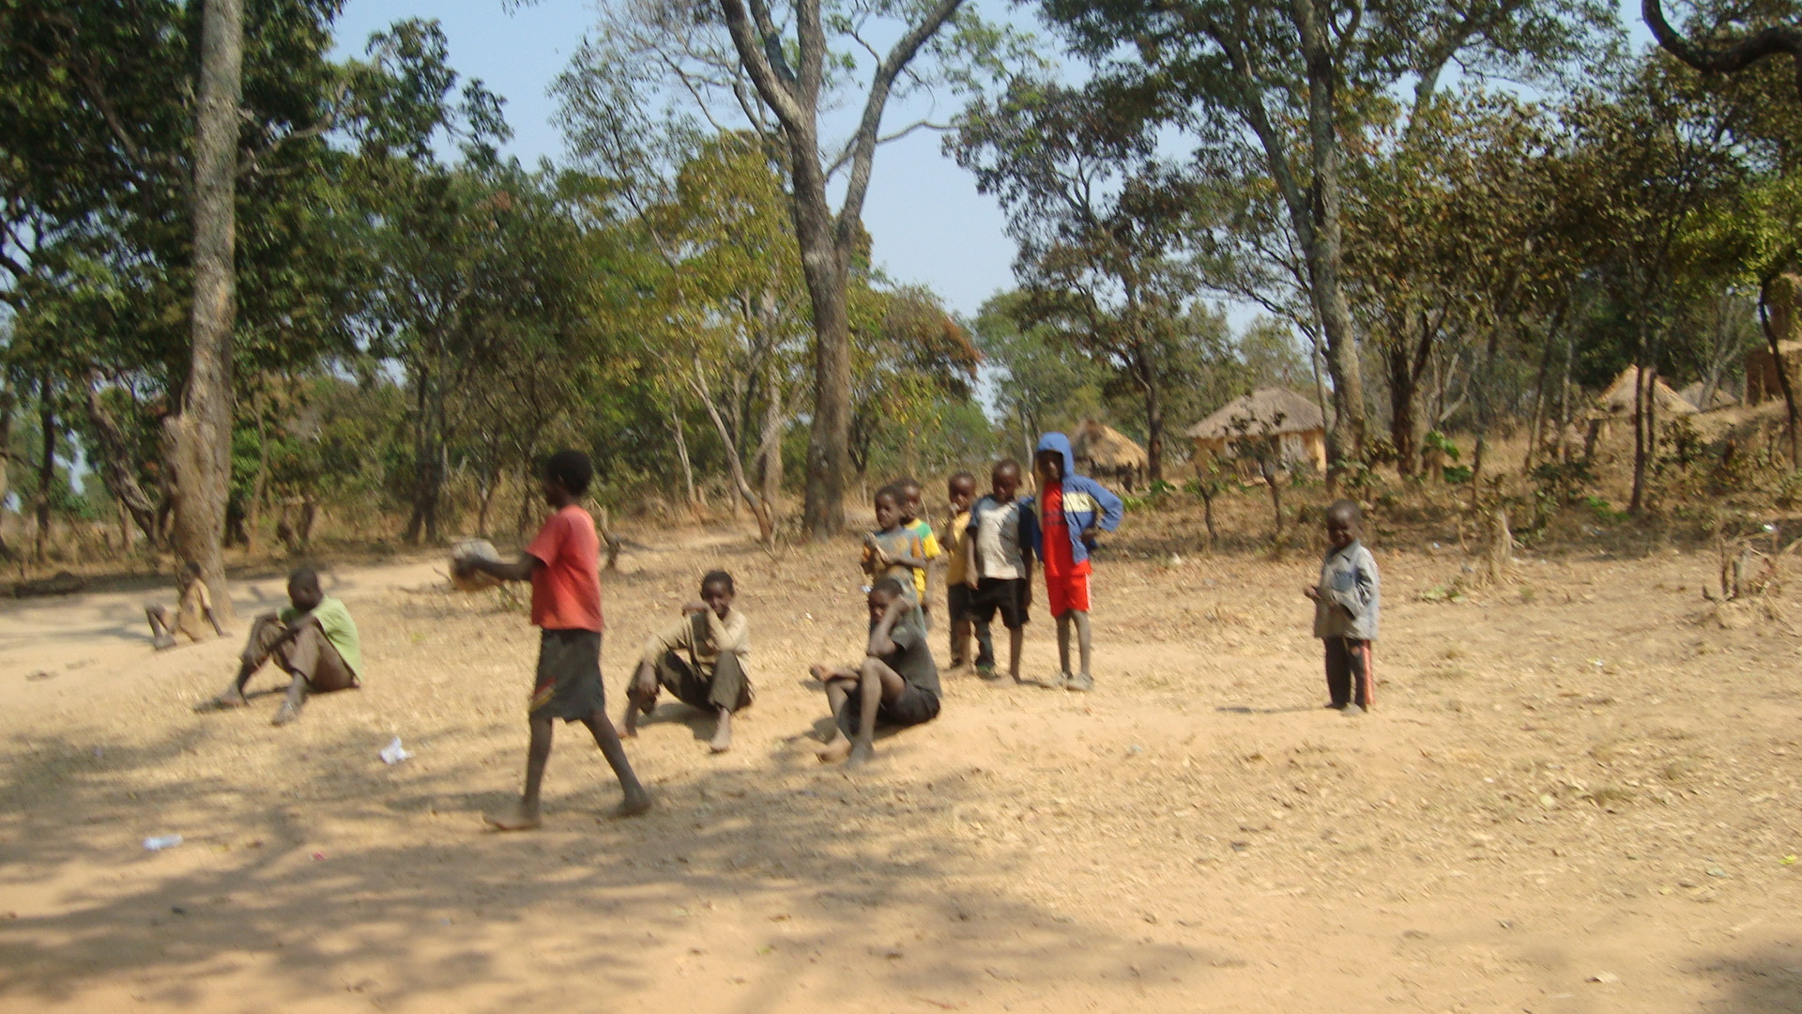
Students took their farming awareness
into the community.

Community members listen as students communicate the importance of farming.

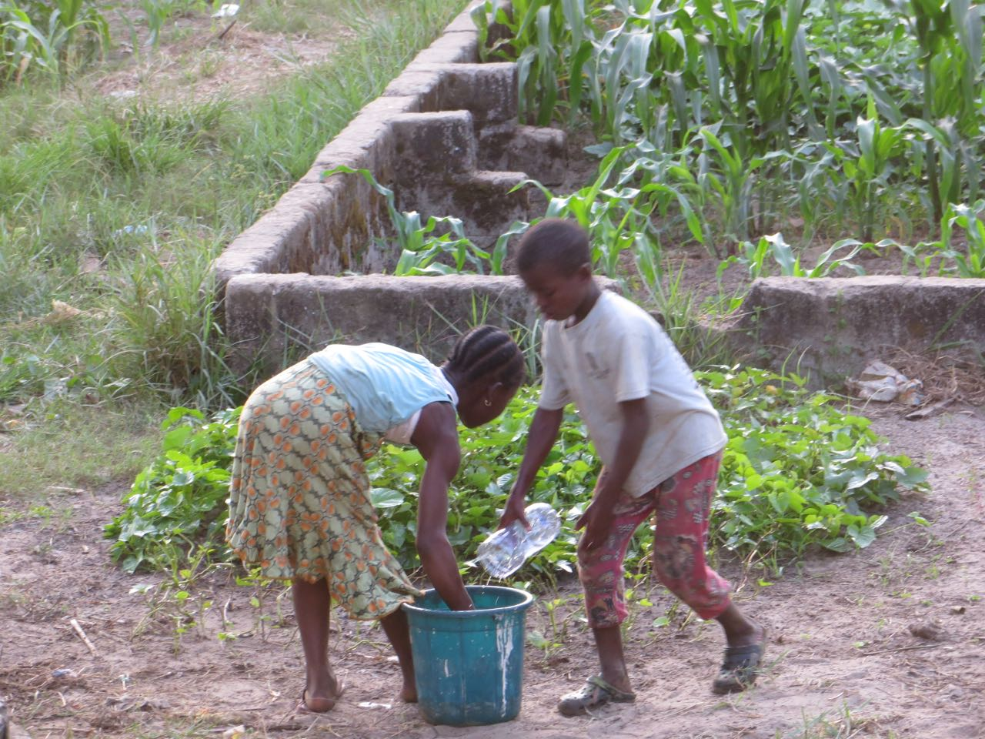
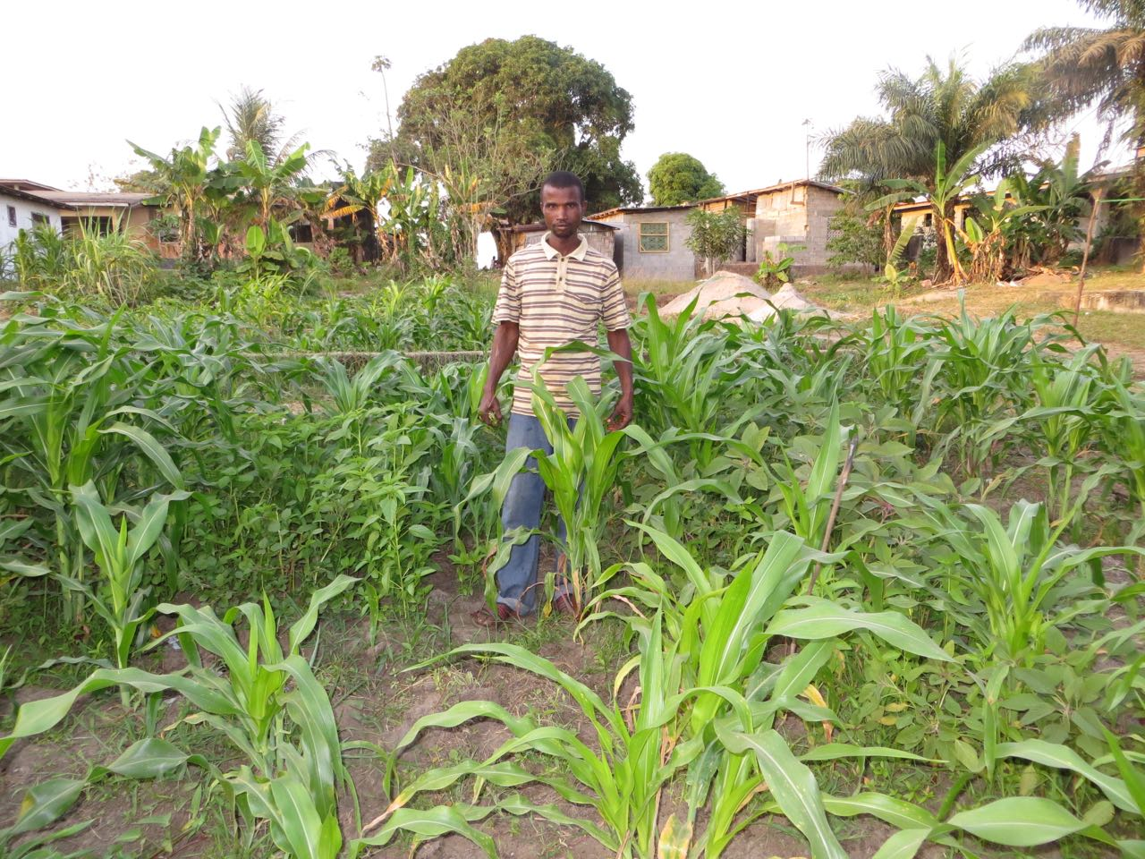

Zambia: Students Becomes Young Entrepreneur Ambassadors

Zambian teachers customized the Junior Entrepreneurs Scheme (JES) and the Habits of Heart into their own culture for students to adapt easily. The first 37 students that studied the integrated version of the JES and Habit-of-Hearts have started thinking like entrepreneurs. They now understand the values and importance of using the habit of hearts to excel in businesses and other aspects of life. They also held a special African Freedom Day project to honor the wisdom of elders. Their teachers, Beauty Lexis Nzila, Mabel Kandongwe, Cecilia Nyasulu and others are dedicated to helping these young entrepreneurs achieve their goals.

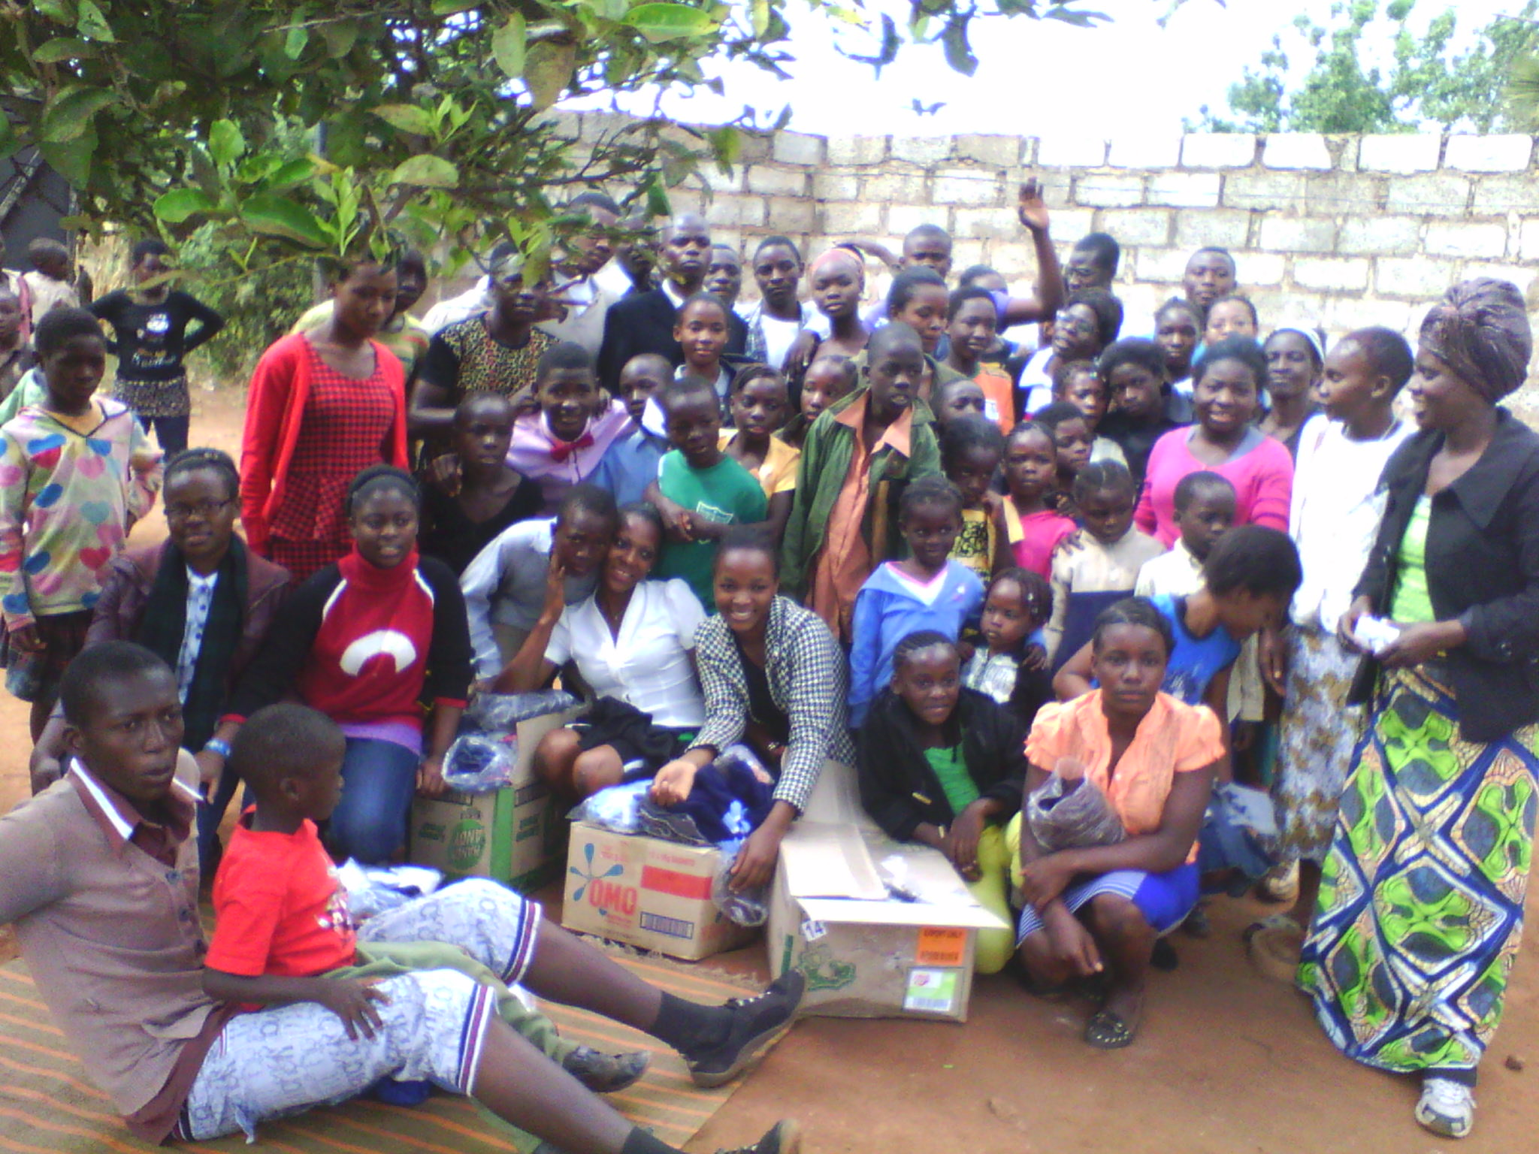
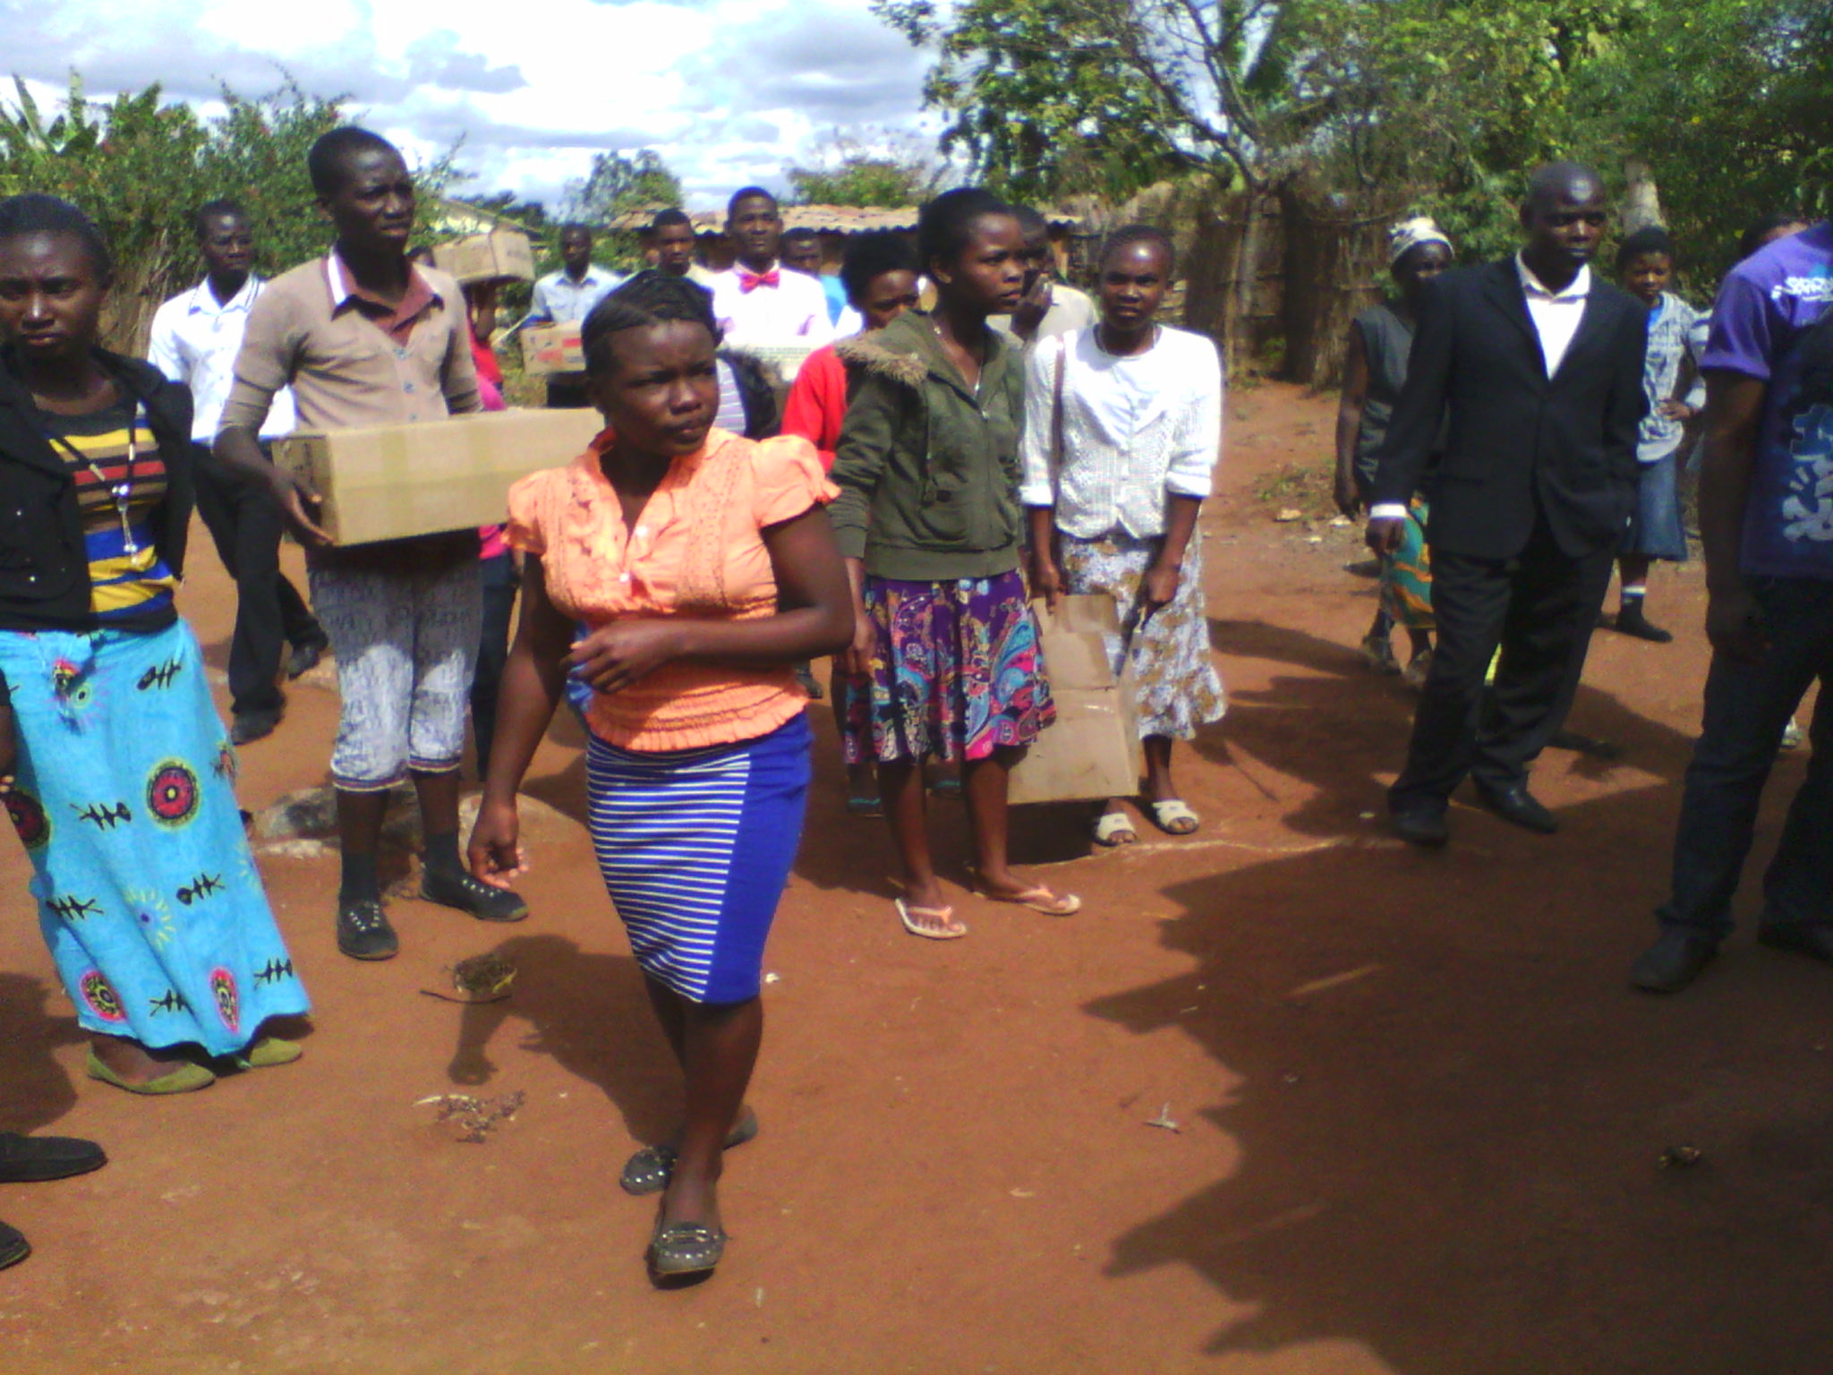

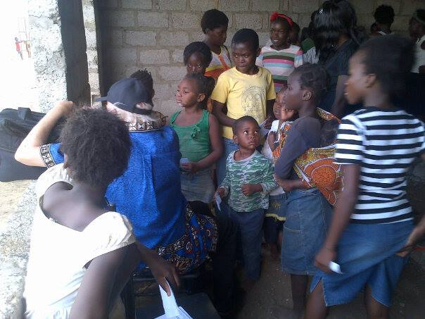
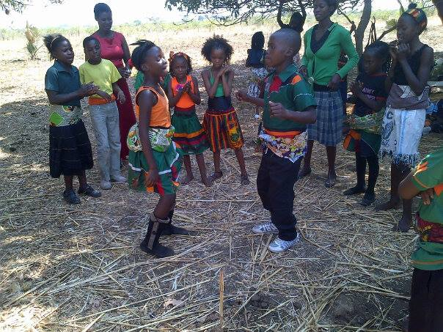

Liberia: Humanitarians Unite to Stop Ebola

The Ebola Virus outbreak brought many activities to a standstill in Liberia. The effects have included the downsizing of government workers, suspension of schools and curtailing of large public gatherings. In keeping with this new development, FCL immediately adapted services for the 31 schools and 315 teachers it serves in West Africa. Our Full-Circle Learning Ebola Project helps prevent citizens-- especially the families of students and teachers--from been infected by the Ebola virus. It also kept students and now-volunteer teachers active in helping their community through the crisis, with a well-developed curriculum for off-school lessons.

Our interventions helped to stem the tide of the Ebola outbreak and reduce food insecurity in the Liberian community we served. Through the dissemination of disinfectant, gloves, buckets, oil, rice, and with Ebola education, our teachers were able to contribute to the rapid downward trend of new cases. Thanks to our volunteer teachers, who took mobile classrooms into communities where schools had been closed, integrating the habit of Steadfastness and coping skills into the academic content, within this affectionate culture hard-hit economically and emotionally by the limitations Ebola had imposed in the community.

In the midst of the Ebola unrest, curfew and national state of emergency, and schools closed, our volunteers were able to keep 120 of our students busy at their various homes in Monrovia, with our well-developed off-school curriculum, Habit of Steadfastness. Thanks to Dr. Teresa, whose tireless efforts helps make our dream of delivery basic education to our students at home a success.
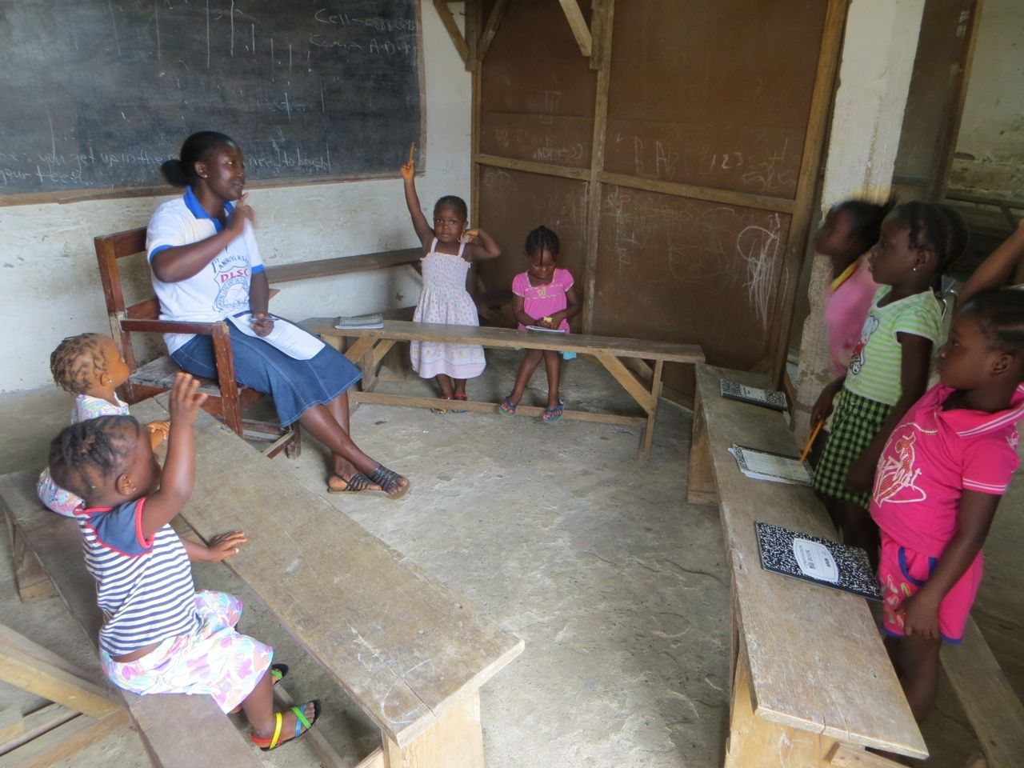
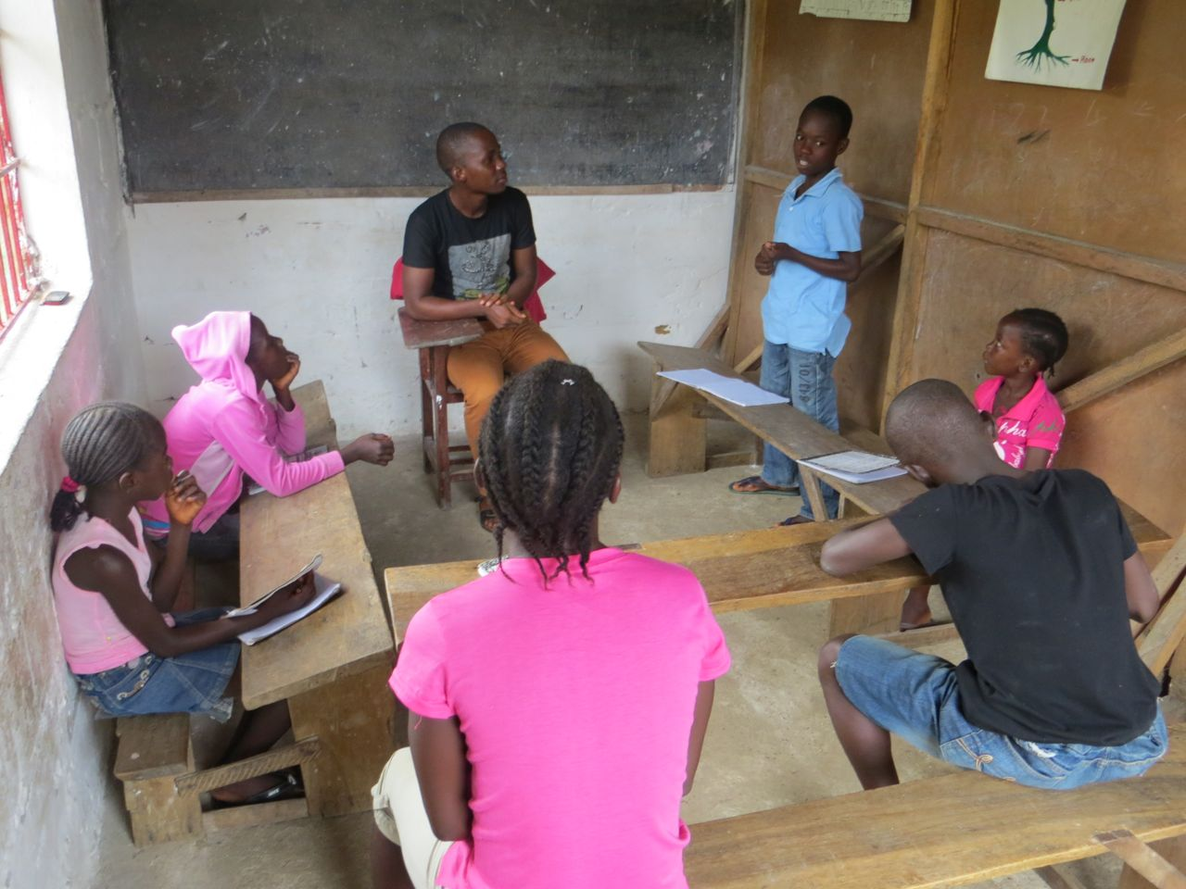

Teacher Samuel listens as kids express gratitude for the opportunity to learn while other kids sits at home doing nothing

Kids are happy to listen to the voice of their teacher after months of staying at home doing nothing as a result of the Ebola outbreak
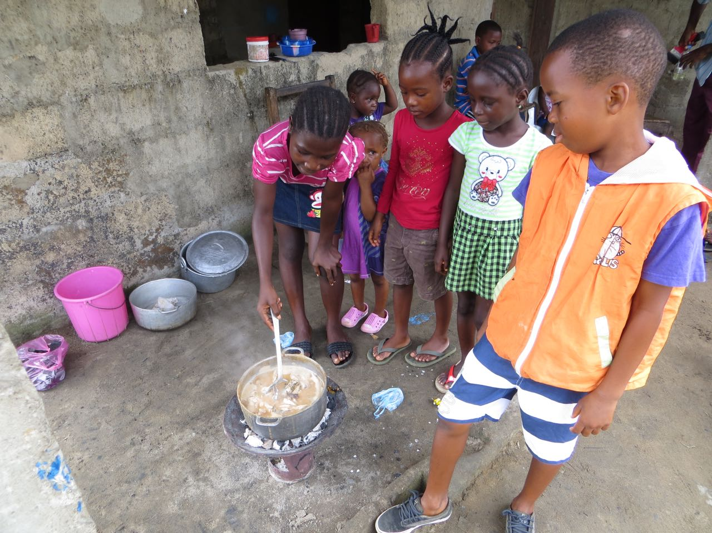

Older children cook soup to serve among themselves as required exercise of the habit of steadfastness lesson. The teachers have the children gathered around the pot of soup at one of the kids home to inhale the aroma. 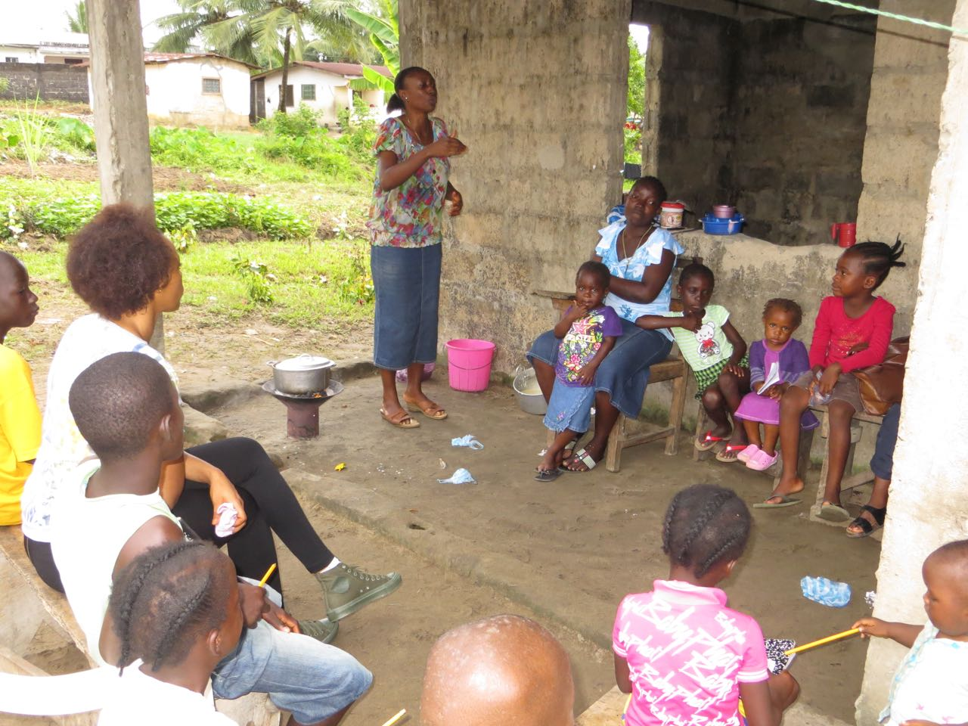
Kids listens as their teacher explains the Soup Exercise Activity on the habit of Steadfastness at one of the kid’s home.
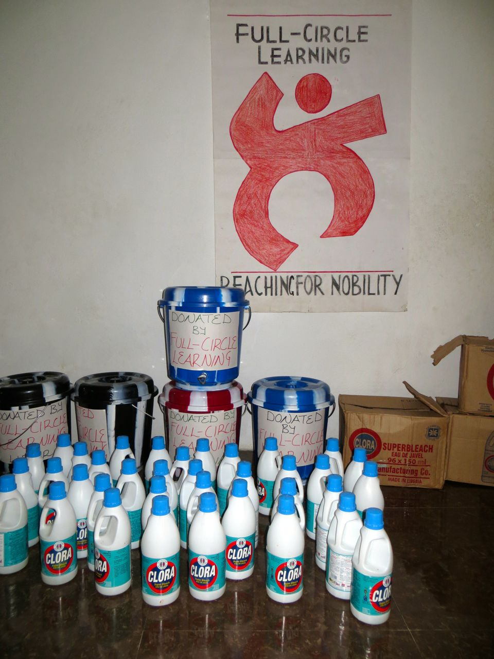
Chlorine, buckets and food were supplied to all our teachers during the heat of the Ebola outbreak epidemic, which brought the Economy of the Country to a standstill and lead to scarcity of basic commodity in Liberia.

Teachers were very happy by the initiative taken by Full-Circle Learning to keep them safe from the Ebola.

Following the closure of schools and curtailing of large public gatherings, FCL immediately introduces Mobile Learning for students to at least have access to basic learning. The kids here wash their hands with chlorine water before siting for their lessons.

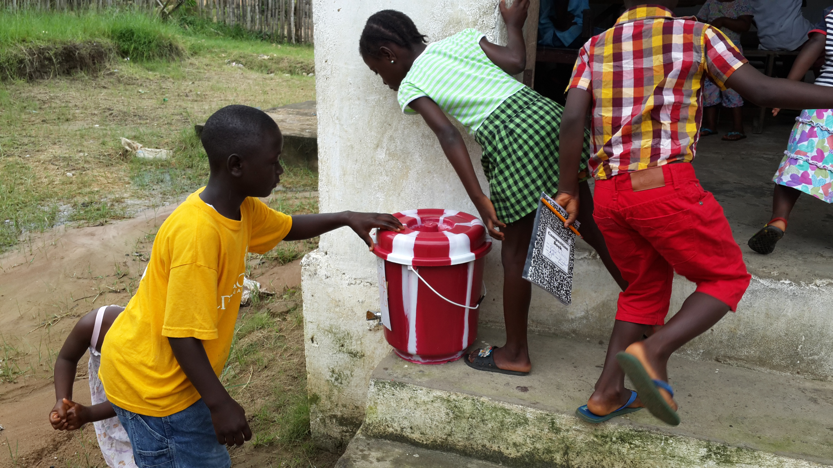
We dedicate the successes we have achieved for 2014 on this project to FCL board and our donors, whose sacrifices and support have kept us going. Without these selfless donations, our intervention would not have been possible.

